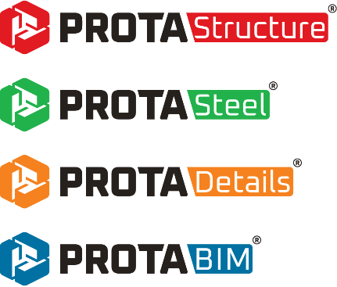

euro

ProtaStructure Suite 2026 – New Features
Version: 1.0 | May 2025

Please get in touch with us for your training and technical support queries.
asiasupport@protasoftware.com | globalsupport@protasoftware.com

Limitation of Responsibilities |  | While Prota ensures every new update is tested, Prota shall not be held responsible for any losses caused by documentation, software, or usage errors.  In addition to Prota License Agreement Terms, it is the responsibility of the user:  - to check results generated by documentation and software,  - make sure that the users of the software and their supervisors have adequate technical capabilities,  - Ensure the software is appropriately used according to the reference manual and documentation.
Intellectual Property |  | ProtaStructure is a registered trademark of Prota Yazılım Bilişim ve Mühendislik A.Ş., and all intellectual property rights belong to Prota Yazılım Bilişim ve Mühendislik A.Ş. Documentation, training, reference manuals, and any program component cannot be copied, distributed, and used in violation of the license agreement.
Trademarks |  | ProtaStructure®, ProtaDetails®, ProtaSteel®, and ProtaBIM® are registered trademarks of Prota Software Inc. Prota logo is a trademark of Prota Software Inc.

Contents
Introduction 6
ProtaStructure 2026: Innovation Meets Excellence 7
Brand-New Technologies 8
New RC Staircase Module 9
New Steel Base Plate Module 10
Subbasement Walls, Beams and Slabs 11
Design of Cruciform Columns 12
New Foundation Pedestals 13
Multiple User-Defined Spectra in All Directions 14
Extended Code Support and Design 15
Performance Assessment and Retrofit to ASCE/SEI 41-17 16
Performance Assessment and Retrofit to Eurocode 8-Part 3 17
Brazilian Codes (NBR) Support - Load Combinations and Steel Design 18
Eurocode Nationally Determined Parameters (NDP) Editor 19
Eurocode 8 Seismic Design for Steel and Concrete Members 20
Eurocode 8 Torsional Irregularity Check using Torsional Radius 21
Eurocode 8 Automated Prevailing Failure Mode Coefficient (k_{w}) Calculation 22
Eurocode 8 - Shearwall Moment & Shear Design Envelope 23
Modal Vertical Earthquake Analysis 26
Customizable Eurocode Vertical Spectrum 27
Eurocode 8 Dual System Wall-Frame Interaction Checks 28
Eurocode 2 Long Term Deflection Checks Including Creep and Shrinkage 29
Eurocode 3: Design of Castellated Beams 30
Crack Width Checks 31
IS Code: Load Transfer Check from Column to Footing 31
Foundation Tie Beam Design to ACI318 32
Enhanced Pad Footing Design 33
Minimum Pad Footing Depth to Use Side Bars 34
Maximum Pad Footing Depth 35
Analysis Improvements 36
Punching Checks with Finite Elements 37
Inclusion of Column Outlines 37
Editable Accidental Eccentricity and Overturning Safety Factors 40
Designate Storeys as ‘Intermediate’ 41
Meshing Same Storey Slabs Positioned on Top Of Each Other 42
Using Quad Mesh for Slabs in FE Analysis 43
Shearwall Stiffness Modifiers Only in Critical Storeys 44
Automated Soil Dynamic Load Cases and Snow Drift Load Cases 45
Automated Body Constraints in Column Outlines 46
Automated Unit Conversion for Ground Motions 47
Modeling and Visualization 48
A Customizable Shortcut Editor 49
Architectural DXF Drawing Overlay in Load Editor 51
Continuous Girts (and Purlins) 54
Display Support Reactions in Analysis Post-Processor 56
Contour Labels in Analysis Post-Processor 57
Contour Legend at the Bottom in Analysis Post-Processor 57
Exclusive Default Materials for Steel Members 58
New Metal Deck Types in Library 59
Extended Cold-Formed Section Library 60
Utilization Ratio Coloring for RC Members 61
Color Assignment to Loads 62
Enhancements in Member Relabeling 63
View Modes in Right-Click Menu 63
Number of Studs and Camber in Frame Labels 64
Support Assignment and Cantilever Frame Members 65
Optimized Ribbon and Right Click Menu 66
Frame Member Storey Assignment 67
Search by Labels in Analysis Post-Processor 68
Section and Material Labels in Analysis Post-Processor 68
Advanced BIM Integration 69
Support for IFC4 Format 70
IFC-Singapore Template 71
Export Internal Forces to IdeaStatica 71
Steel Material Lists in ProtaStructure 72
Filtering and Post-processing Analysis Results 73
Image Export with Transparent Background 75
RC Detailing 76
Building Elevation Section 77
New Bent-Up and Straight Bar Patterns for Slabs 79
Foundation Beams, Rib Beams and Slabs Rebar Schedule 80
Subbasement Wall Details 81
Pedestal Details 82
ProtaSteel: Innovating with Strength 84
Export Internal Forces to IdeaStatica 85
Purlin Connections on Curved Beams 86
Splice Connections in Pipe and Box Sections 86
Fin Plate Connections to SHS and RHS Primary Members 87
Connection Macros for Truss Top and Bottom Chords 87
IFC 4 Support 88
Improved Curved Beam Connections 88
General Stability and Performance Improvements 89
New Design Guides and Videos 89
What’s Next? 89
Thank You 90

Introduction
As Prota, we have been developing leading structural BIM software for over 40 years.
Priority on our product strategy has always been:
- Providing new practical modeling approaches
- Introducing innovative design technologies that will add value to your business and extend your toolset in your daily engineering practice.
- To improve the existing functionalities
- To introduce more localization in our products, so that you can benefit from our technology much better.
ProtaStructure 2025 is our brand-new release, a significant step taken to fulfill this strategy, raise the bar for competition, and meet expectations. Developing a comprehensive structural BIM analysis, design, and detailing solution is challenging teamwork in meeting user and industry expectations. We sincerely thank all our users for their trust in our products.
We are confident that you will enjoy and benefit from the features and improvements in ProtaStructure Suite 2026. You can find the details on the pages to follow.
Thank you for choosing ProtaStructure.

ProtaStructure 2026: Innovation Meets Excellence
In our latest major release, ProtaStructure 2026, we're excited to unveil a range of new features designed to enhance user experience and boost efficiency. Our primary focus has been on expanding existing code support, improving stability and performance, and incorporating valuable user feedback.
Here are the outstanding improvements and new features in ProtaStructure 2026.
- New Interactive RC Stairs Module
- Steel Base Plate Modeling and Design in ProtaStructure
- Design of Cruciform Columns
- Subbasement Walls and Subbasement Slabs
- Modeling and Design of Foundation Pedestals
- User-defined Spectra in three orthogonal directions with streamlined workflow
- Assessment and Retrofit to ASCE/SEI 41
- Assessment and Retrofit to Eurocode 8 – Part 3 (EN1998-3:2005)
- Brazilian Code (NBR) Support for Load Combinations and Steel Design
- Eurocode Nationally Determined Parameters (NDP) Editor
- Eurocode 8 Seismic Design for Steel and Concrete Members
- Customizable Vertical Earthquake Spectrum according to Eurocode 8
- Improved Eurocode 8 Irregularity and Building Checks
- Long Term Deflections with Creep and Shrinkage according to Eurocode 2
- Design of castellated beams according to Eurocode 3
- RC Beam, Rib Beam and Slab Crack Width Checks (US, EC, IS and other codes)
- Customizable Shortcut Editor
- New Support for IFC 4 and IFC-Singapore BCA Template for CoreNetX platform
- New rebar patterns for slabs
- Rebar schedules for foundation beams, rib beams and slab rebars
- Building Section Drawing including all storeys and infill walls
- Comprehensive improvements in ProtaSteel including Internal force export to IdeaStatica, new drawing module with UNDO feature, new and improved connection macros and more…
For detailed explanations and more items please refer to the next pages.

Brand-New Technologies

New RC Staircase Module
We are thrilled to present our new RC stairs module, a result of our dedicated efforts. This innovative module allows you to interactively model RC stairs, seamlessly integrate them into the building model using a library of frequently used stair types. (Create-your-own-stairs functionality will be available in the very near future with more out-of-the-box stair types)
Our new RC Stairs module enables you to easily model the stairs in the building model and create an integrated FE model that includes the stairs with a compatible meshing. Analysis results are automatically extracted from FE model and used in the design of flights and landings backed by a detailed report and detail drawings.
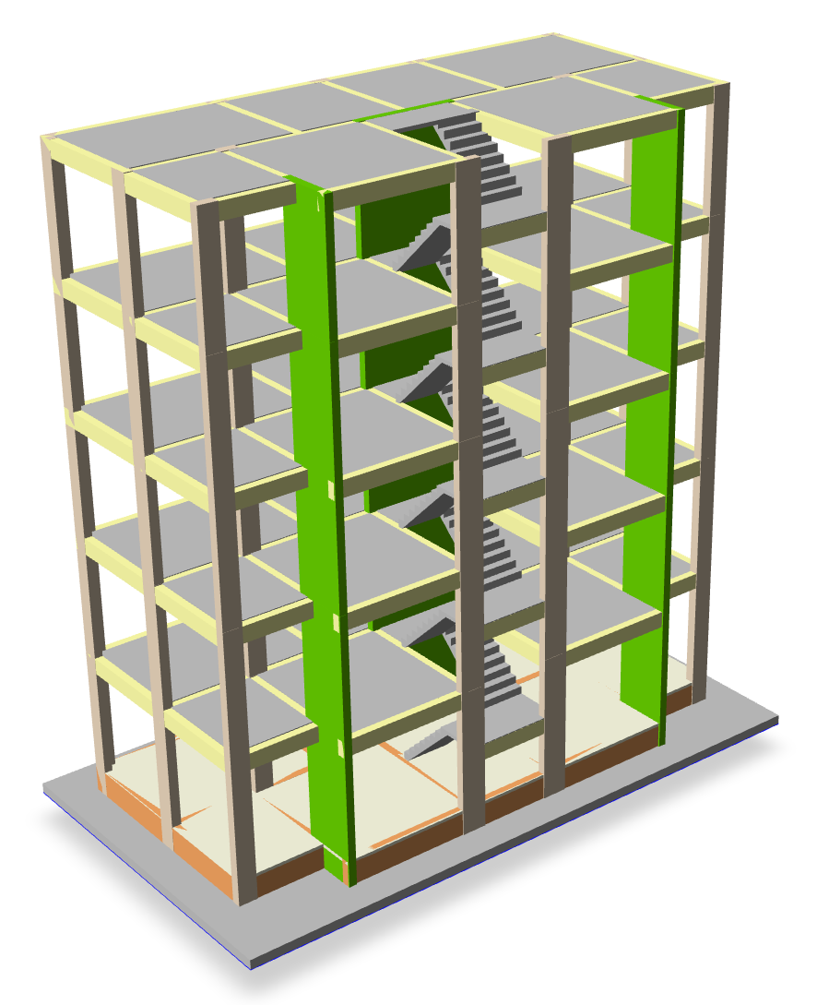
Please refer to our new design guide on the new RC Staircase Module for detailed explanations, modeling tips and more:
ProtaStructure Design Guide – New RC Staircase Module

New Steel Base Plate Module
We have developed a comprehensive parametric macro for inserting base plates under steel columns, also allowing you to visualize them in plan and 3D view.
In addition to what we already have in ProtaSteel for base plates, ProtaStructure 2026 introduces brand-new base plate modeling and design macro integrated with ProtaStructure itself. This powerful tool allows for precise and efficient modeling of base plates, ensuring optimal design and performance. With its user-friendly interface and advanced features, the new macro streamlines the design process following ACI318, AISC360, AISC Design Guides, EC2, EC3 and Turkish codes including anchorage design.
Important:
The new base plate module supports the analytical design of only certain stiffener and bolt configurations for I-shaped and box profiles. A general-purpose base plate design easily becomes too complicated to cover all possible scenarios. Base plates in ProtaStructure can be sent to ProtaSteel for detailing and to IdeaStatica for CBFEM analysis (if required).
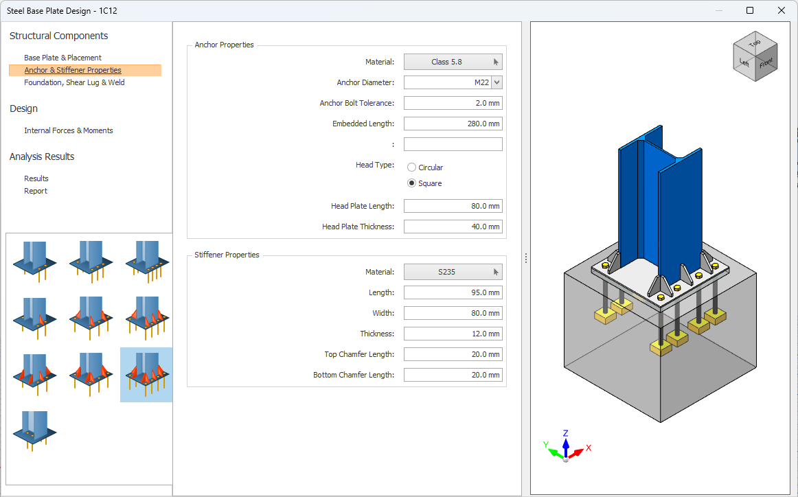
Please refer to our new design guide on the New Steel Base Plate Module for detailed explanations, modeling tips and more:
ProtaStructure Design Guide – New Steel Base Plate Module Connections

Subbasement Walls, Beams and Slabs
Subbasement walls are usually considered as a part of the foundation and provide support for the infills on the ground storey and contains the fill on the foundation. ProtaStructure 2026 enables the users to model these walls on foundation level and optionally consider them in the analysis. Previously it was harder to model these walls, requiring additional storeys or deep beams.
Like subbasement walls, subbasement beams and slabs are also considered as a part of the foundation. They are usually built on top of the fill contained by subbasement walls. Subbasement slabs are reinforced by mesh reinforcement. ProtaStructure now enables you to model these beams and slabs as a part of the foundation and mesh them compatibly with neighboring members. Previously it was not possible to insert and mesh these slabs on top of mat foundation slab (at different elevations).
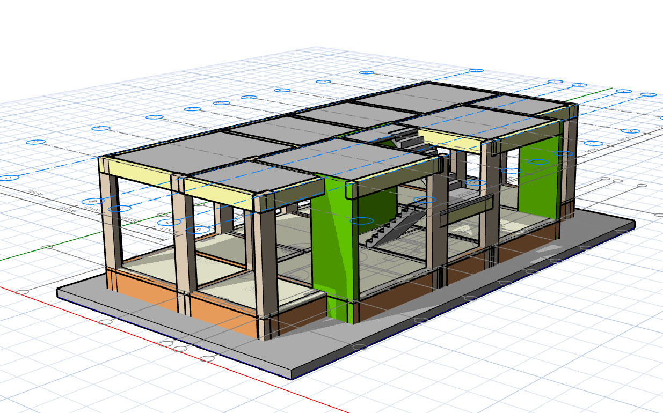
Please refer to our new design guide on Subbasement Walls and Slabs for detailed explanations, modeling tips and more:
ProtaStructure Design Guide – Subbasement Members

Design of Cruciform Columns
In ProtaStructure 2026, we're thrilled to introduce the design of doubly symmetric cruciform columns, offering advanced compliance with AISC 360, Turkish Steel Codes, Eurocodes, BS Codes, Indian, and Brazilian codes. This new feature brings substantial benefits to structural engineers, enhancing their ability to design columns with superior load-bearing capacity and buckling resistance.
Cruciform columns, with their unique cross-shaped cross-section, are now easier to integrate into your structural designs, providing exceptional stability and strength. These columns are ideal for high-rise buildings and bridges due to their high strength-to-weight ratio, efficient load distribution, and reduced material usage.
With ProtaStructure 2026, you can optimize your designs for better performance and faster construction, all while adhering to the stringent requirements of various international standards.
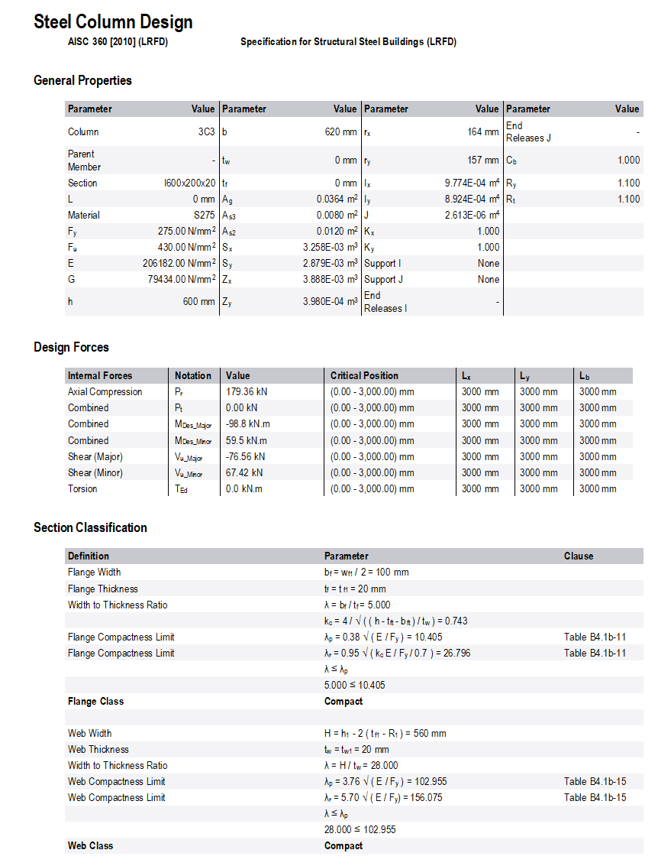
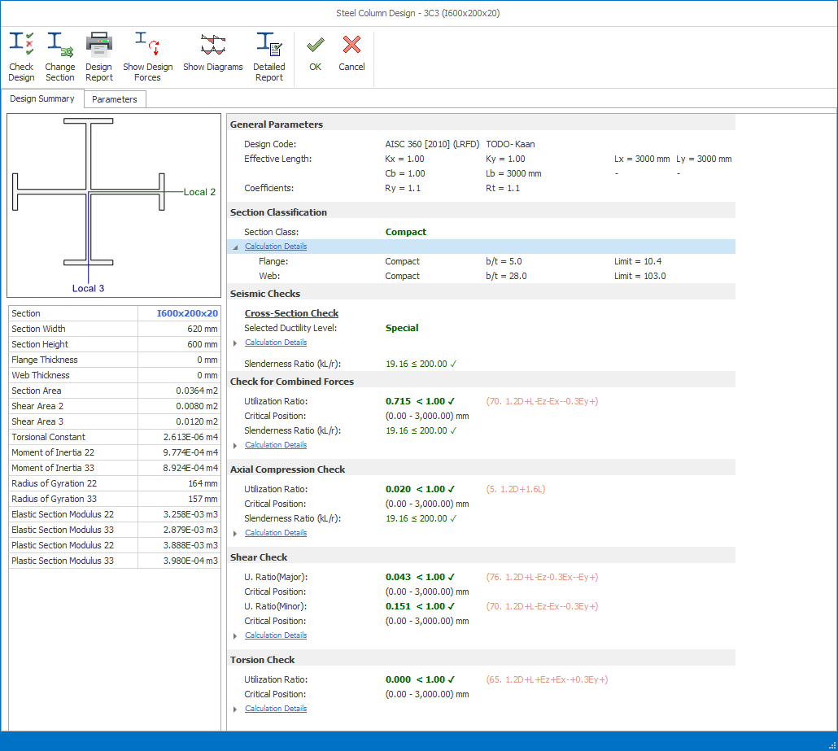
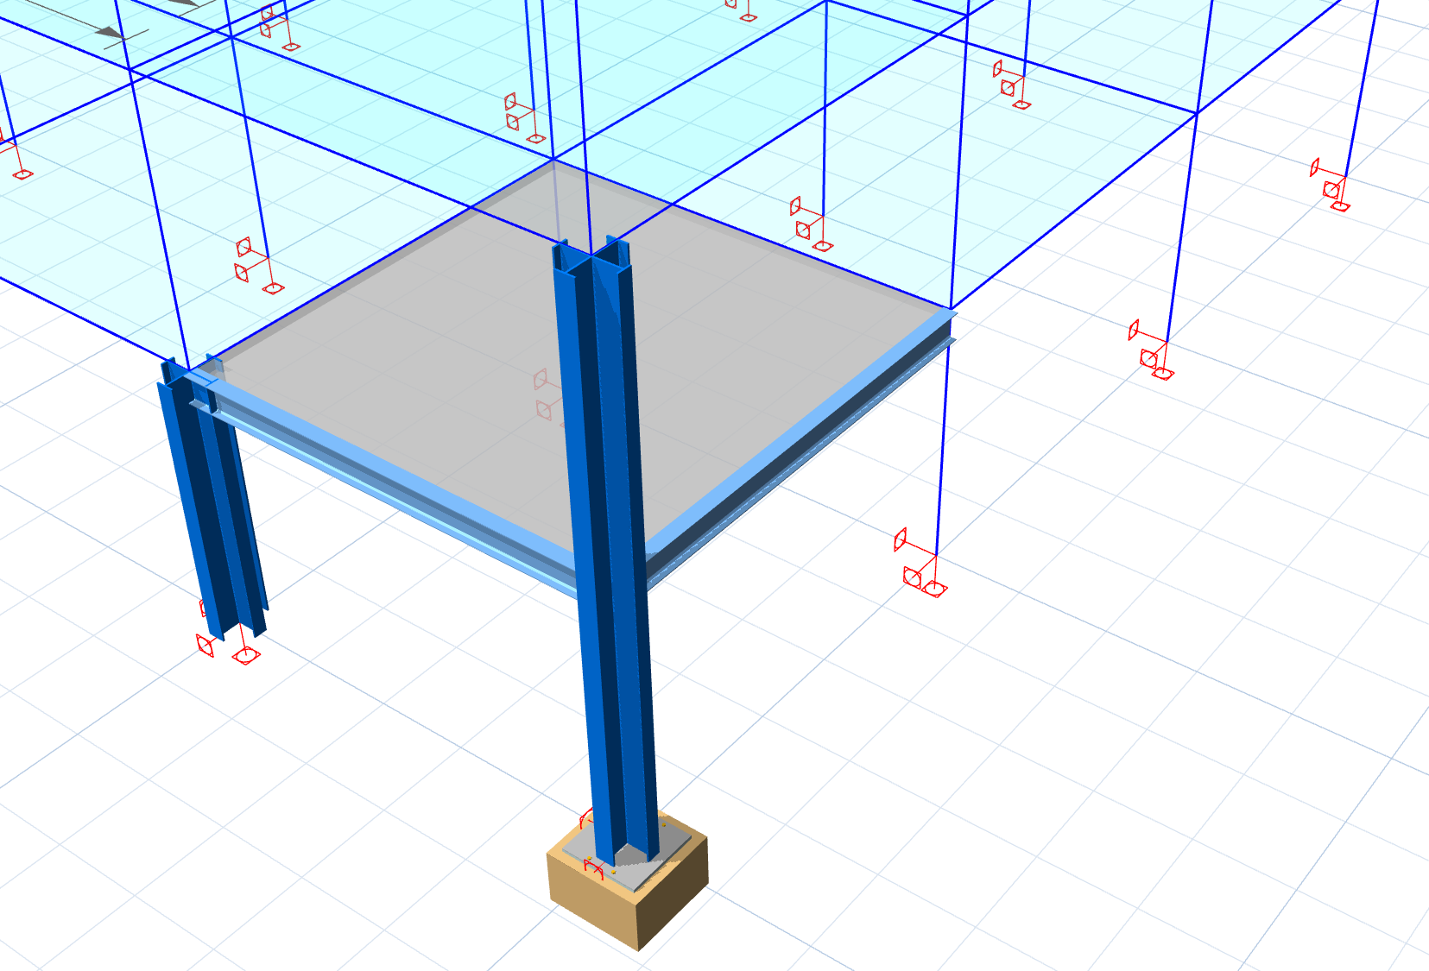

New Foundation Pedestals
ProtaStructure 2026 introduces a powerful new feature that simplifies the design and analysis of concrete pedestals under steel columns. Users can seamlessly insert pedestals, define their dimensions effortlessly, and integrate them into structural models for optimal design workflows. When a base plate is specified beneath the steel column, the system automatically detects the presence of the pedestal, enabling accurate anchor design and ensuring consistency with structural requirements. Moreover, the column design menu facilitates the design of longitudinal reinforcement and links, streamlining the detailing process further. For users employing merged foundation models or finite element (FE) foundation analysis, pedestals are modeled as finite element frame members, ensuring precise structural representation. This enhancement improves both the efficiency and accuracy of foundation modeling, making it an essential addition to the advanced capabilities of ProtaStructure 2026.
Previously, users had to rely on more manual and less integrated methods for modeling and designing concrete pedestals under steel columns, which could lead to additional effort and potential inconsistencies. Anchor design, reinforcement detailing, and integration with base plates were not automated or seamlessly linked within the workflow.
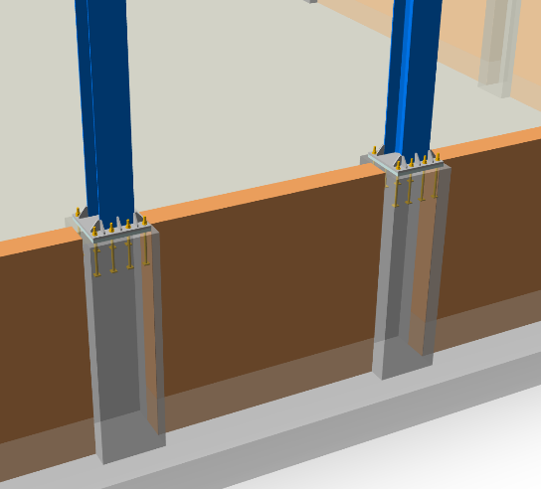
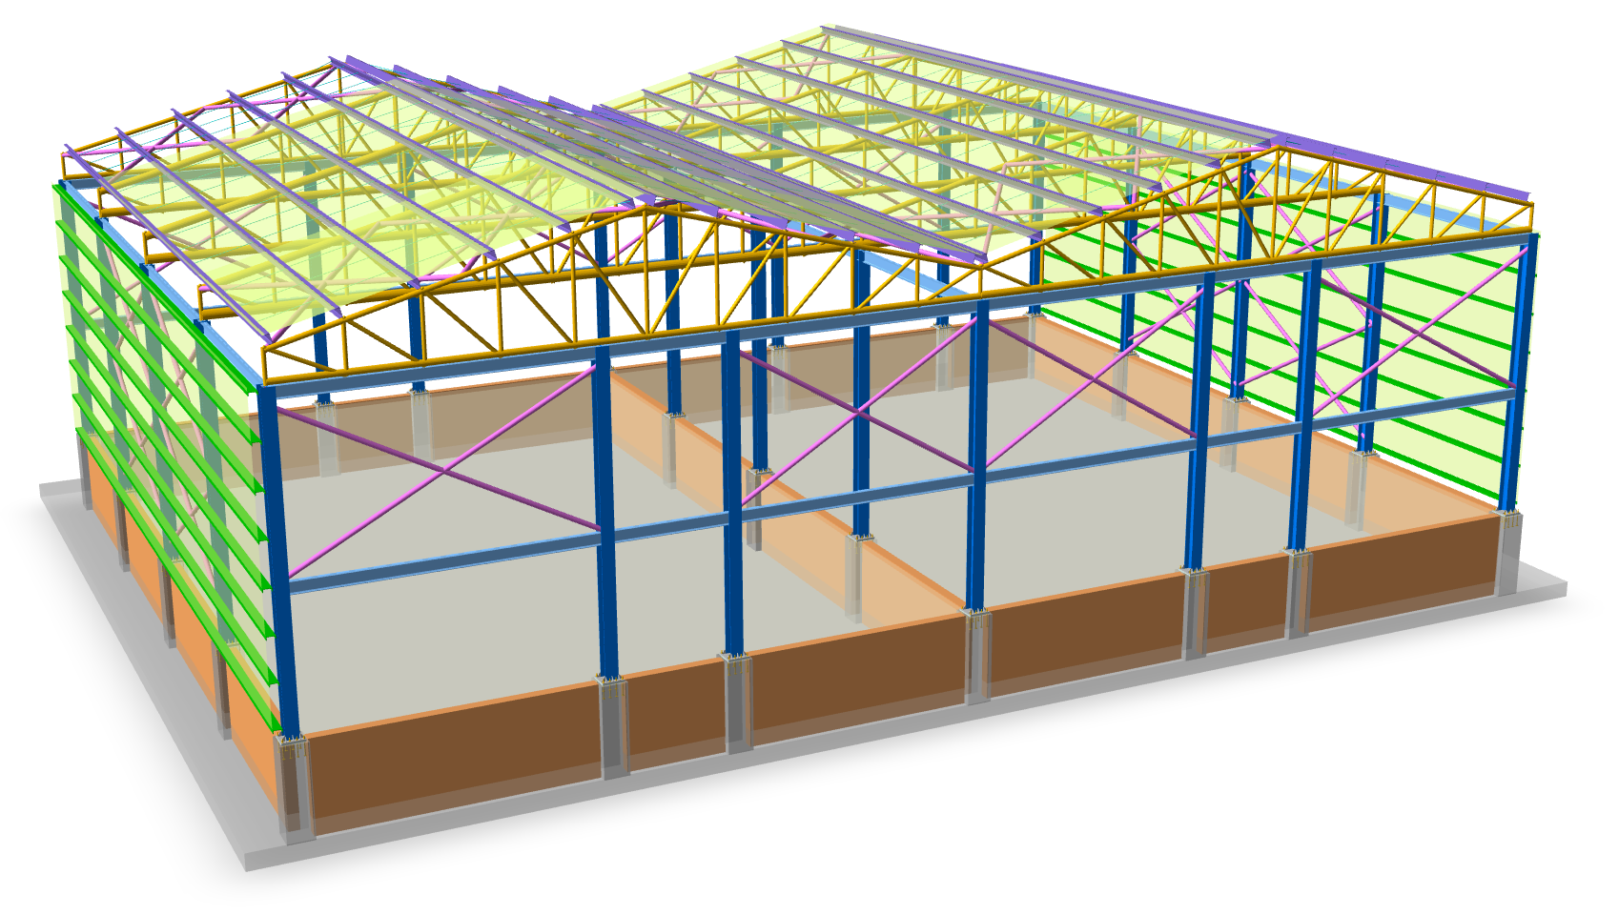

Please refer to our new design guide on Pedestal Modeling and Design for detailed explanations, modeling tips and more:
ProtaStructure Design Guide – RC Pedestals

Multiple User-Defined Spectra in All Directions
ProtaStructure automatically calculates the elastic and design acceleration spectra according to international seismic codes, using a highly parametric UI that encapsulates the code-specific parameters in a user-friendly manner, enabling users to customize them to fulfill their project requirements.
In addition to this, ProtaStructure also allows user-defined acceleration spectra to be used in cases where a site-specific survey is required for specific site conditions.
ProtaStructure 2026 introduces a powerful new feature, allowing engineers to import as many user-defined acceleration spectra functions as they want and assign different spectrum curves in the X, Y, and Z directions. With the new UI, ProtaStructure 2026 offers a more clear visualization, spectrum comparison and easier import/export functionalities.
This enhancement provides greater flexibility and precision in seismic analysis, enabling our users to tailor their designs to specific project requirements and regional seismic conditions.
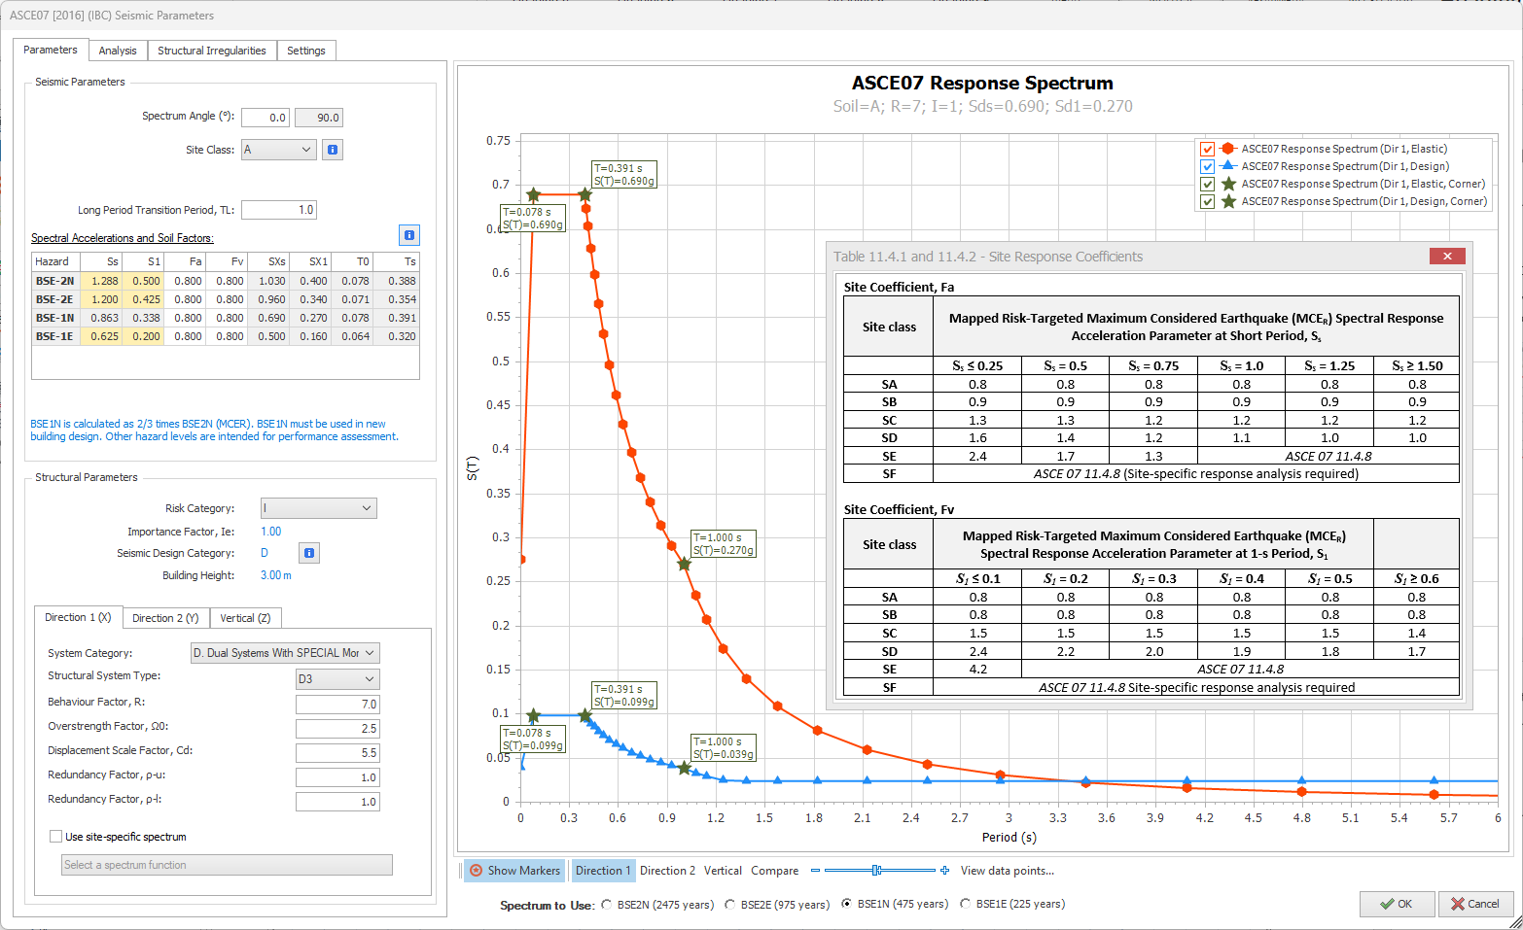
Please refer to our new design guide on User-Defined Spectra for detailed explanations and more:
ProtaStructure Design Guide – User Defined Spectra

Extended Code Support and Design

Performance Assessment and Retrofit to ASCE/SEI 41-17
ProtaStructure provides a unique and powerful workflow for performance assessment and retrofit of buildings backed by nonlinear single-mode pushover, multi-mode pushover and nonlinear time-history analyses with a fully detailed member-by-member assessment report. This entire arsenal of powerful features is now fully compatible with ASCE/SEI 41-17 procedures and seismic hazard levels such as BSE-2N, BSE-2E, BSE-1N, BSE-1E.
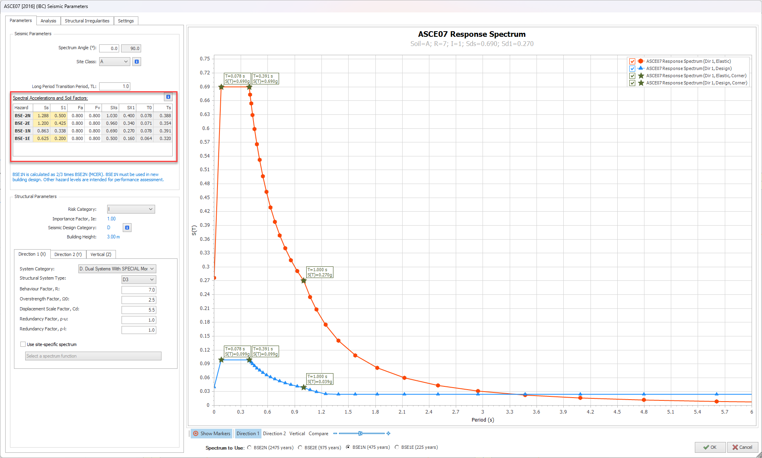
Please refer to our new design guide on building assessment according to ASCE/SEI-17 detailed explanations and more:
ProtaStructure Design Guide – Assessment to ASCE/SEI 41-17

Performance Assessment and Retrofit to Eurocode 8-Part 3
ProtaStructure provides a unique and powerful workflow for performance assessment and retrofit of buildings backed by nonlinear single-mode pushover, multi-mode pushover and nonlinear time-history analyses with a fully detailed member-by-member assessment report. This entire arsenal of powerful features is now fully compatible with Eurocode 8-Part 3 (EN 1998-3:2005) procedures including nonlinear analyses and q-factor approach.
Please refer to our new design guide on building assessment according to ASCE/SEI-17 detailed explanations and more:
ProtaStructure Design Guide – Assessment to Eurocode 8 – Part 3
Note:
This is a work in progress and still under testing. It is slightly behind schedule. We are planning to complete it shortly after the release. That’s why we chose to include this feature in this document. We are also aiming to provide a design guide on this subject. Please stay tuned.

Brazilian Codes (NBR) Support - Load Combinations and Steel Design
ProtaStructure 2026 now includes support for the NBR-8681 loading code and the NBR-8800 steel design code, enhancing its local code compliance capabilities. This addition ensures that engineers can seamlessly integrate these Brazilian standards into their projects, providing accurate and reliable structural designs. By incorporating these codes, ProtaStructure 2026 empowers users to meet regional requirements with greater precision and efficiency, ultimately delivering optimized and compliant engineering solutions.
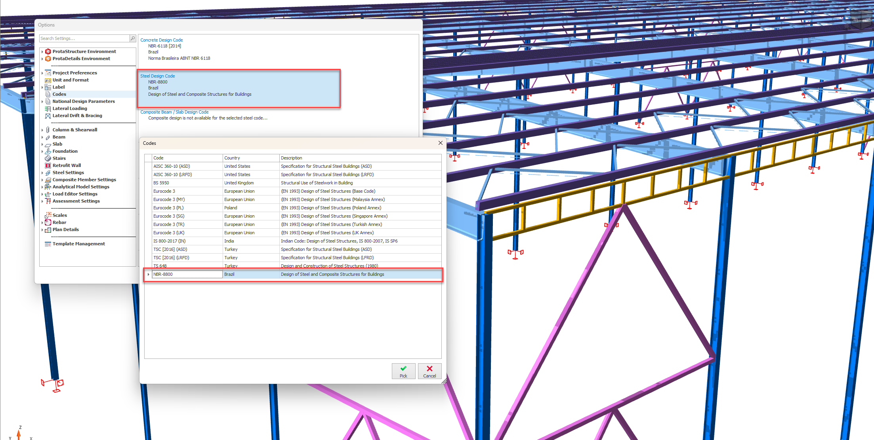
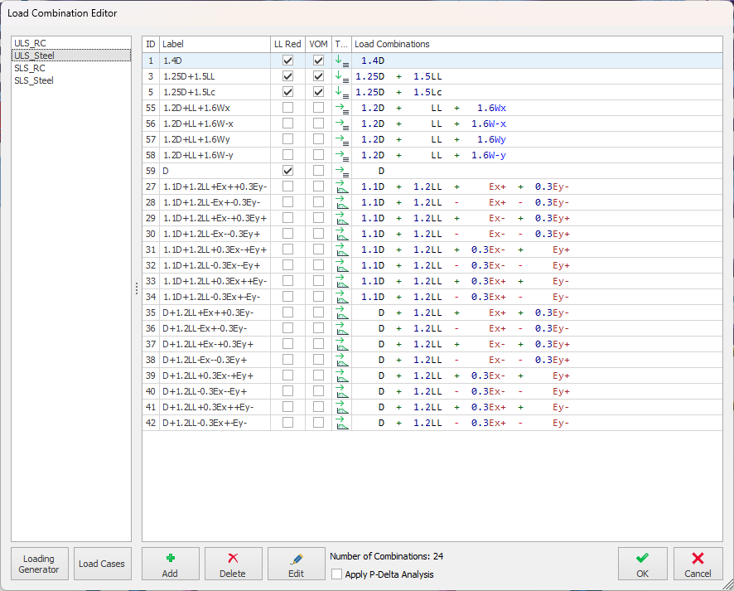

Eurocode Nationally Determined Parameters (NDP) Editor
ProtaStructure 2026 introduces a powerful Nationally Dependent Parameters Editor, enabling users to seamlessly customize Eurocode parameters to align with their national standards. This innovative feature offers unparalleled flexibility, ensuring that engineers can adapt their designs to meet specific regional requirements with ease and precision. By supporting diverse national standards, ProtaStructure 2026 empowers engineers to deliver compliant and optimized structural solutions across various projects. The NDP Editor can be accessed via Options > Nationally Determined Parameters.
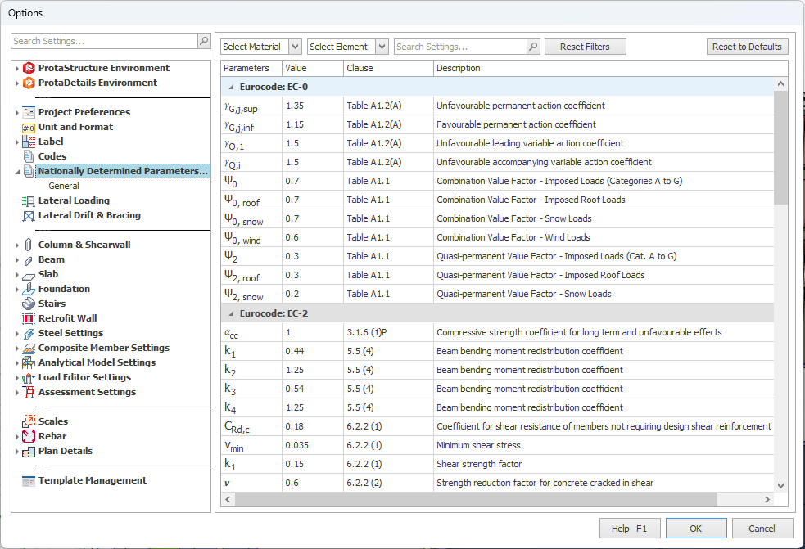

Search and Filter
The brand-new NDP editor provides a handy search and filter functionality where you can narrow down the parameters according to material, designed element or any related keyword. By default, the NDP editor is grouped under supported code categories such as Eurocode 2, Eurocode 3, Eurocode 4 and Eurocode 8.

Re-use The Parameters in Your Other Projects
Nationally Determined Parameters that you customize are saved as a part of the current project. You can also create a new template with these parameters so that you can use them for your other projects.

Eurocode 8 Seismic Design for Steel and Concrete Members
The brand-new ProtaStructure 2026 now includes more comprehensive support for seismic design checks for steel and concrete buildings, following Eurocode 8 provisions, with step-by-step detailed reports.
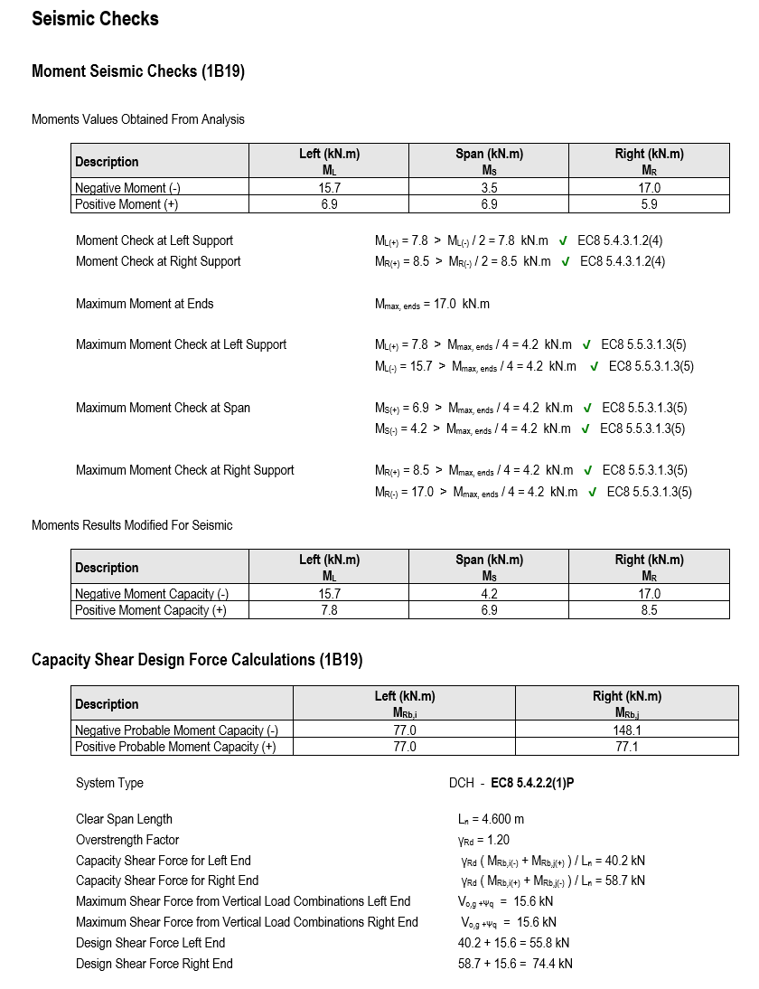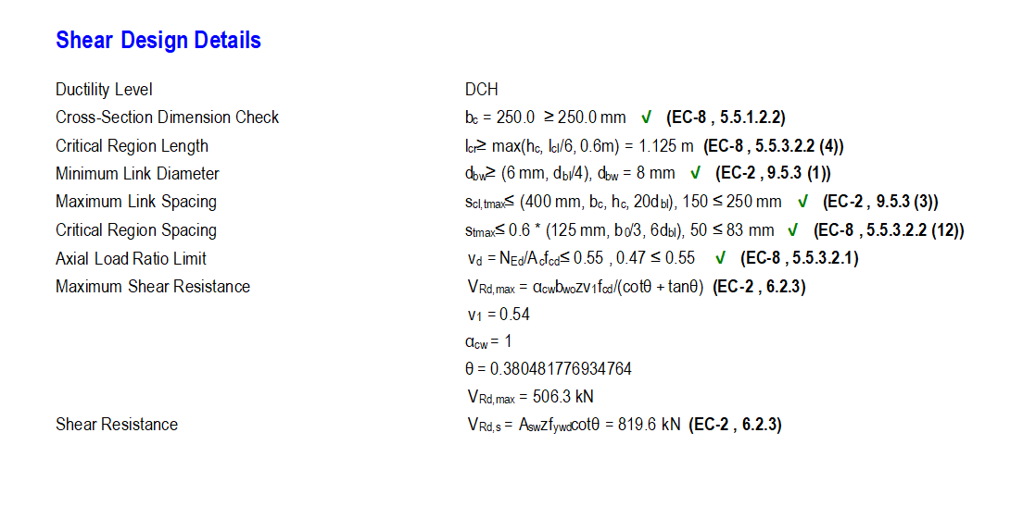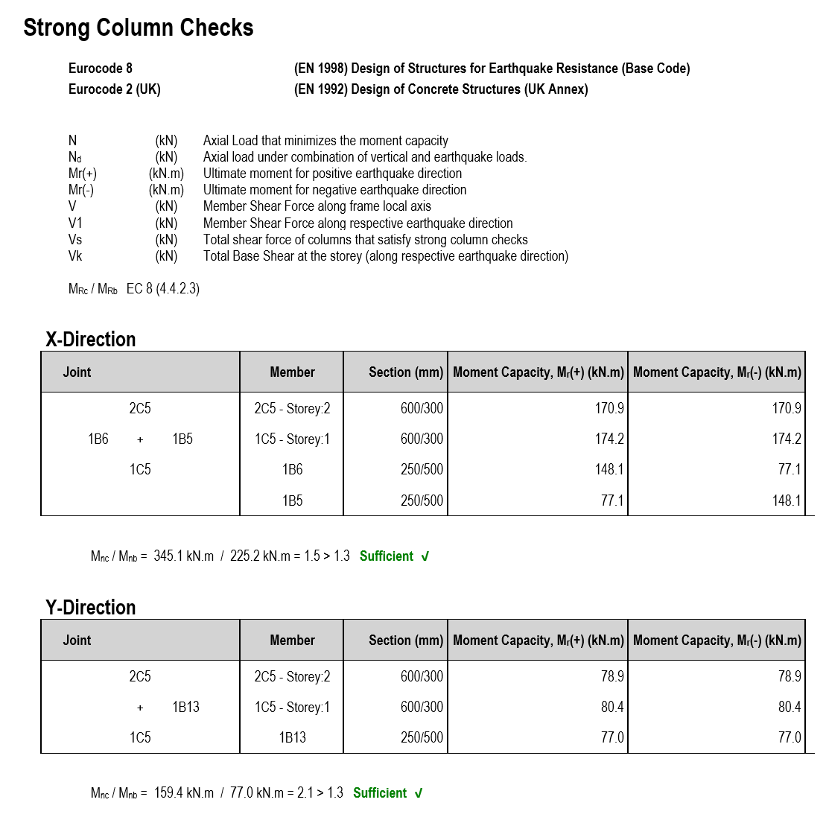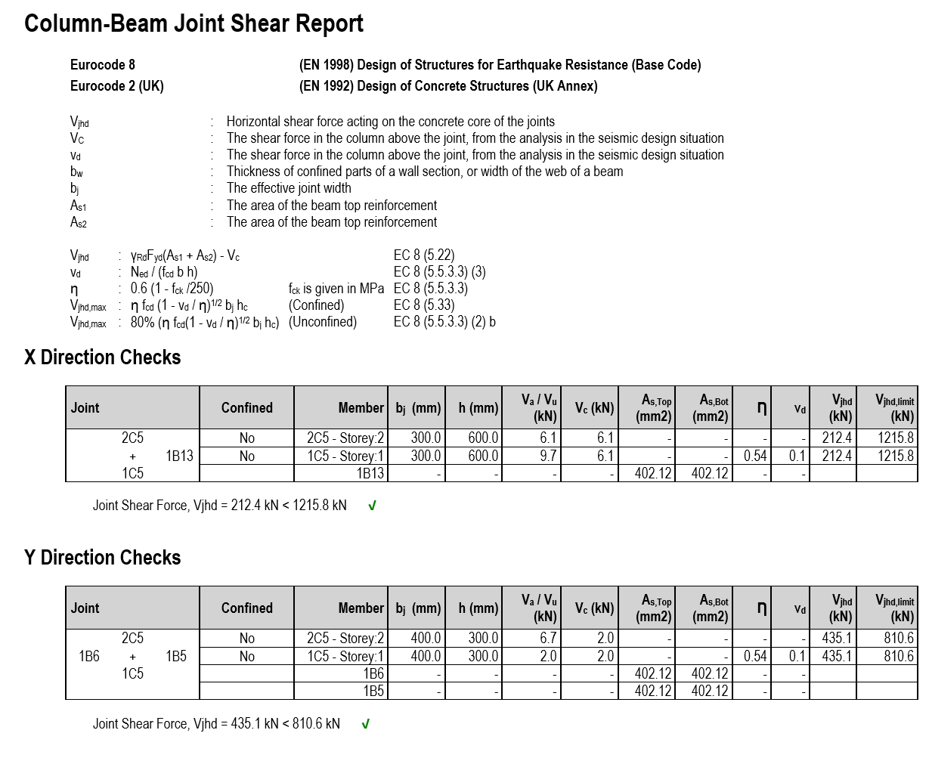

Eurocode 8 Torsional Irregularity Check using Torsional Radius
ProtaStructure already includes the “Relative Drift” method for detecting torsional irregularity even for the complex floor plans and structural systems where the Eurocode “Torsional Radius” approach may not be valid. With ProtaStructure 2026, we have optionally introduced the torsional radius approach enabling users to perform the floor torsion check according to procedure outlined in Eurocode 8 Cl. 4.2.3.2 and relevant design guides.
You can activate the “Torsional Radius” method by enabling the “Torsionally Flexible Plan: Detect Automatically Based on Torsional Radius” option in Seismic Parameters > Structural Irregularities window. By default, the “Lateral Drift” approach is used, which includes the 3D behavior and stiffness of the structure.
Important:
Torsional Radius Method makes use of the Center of Rigidity coordinates, which is ‘approximately’ calculated using column and wall EI values. Center of rigidity is used for display purposes in ProtaStructure and is not normally used in any calculations.
According to Eurocode, determining Torsional Radius using center of rigidity is valid for homogenous structural systems. This method is introduced in the software to provide an alternative to lateral drift method, and it must be used cautiously, considering the structural system of the structure.
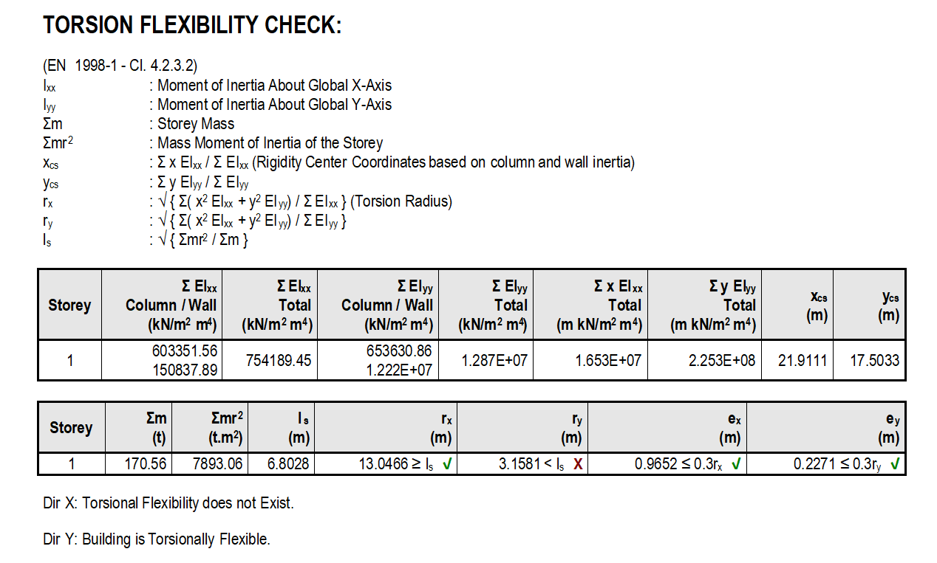
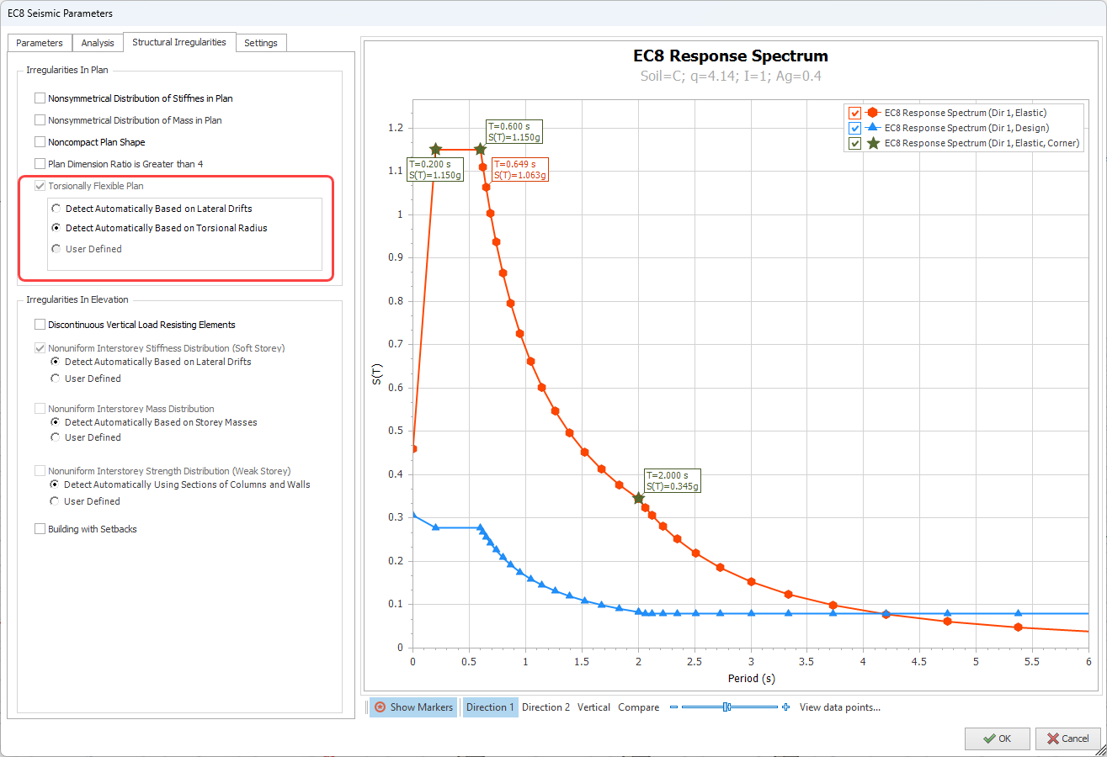

Eurocode 8 Automated Prevailing Failure Mode Coefficient (k_{w}) Calculation
The prevailing failure mode coefficient, k_{w}, in Eurocode 8 plays a crucial role in seismic design. It is used to adjust the behavior factor, q, which represents the reduction in seismic forces due to the nonlinear behavior of structures. The behavior factor is calculated as q = q_{o}.k_{w}, where q_{o} is the basic value of the behavior factor dependent on the structural system and its regularity in elevation.
The k_{w} factor reflects the prevailing failure mode in wall, wall-equivalent and torsionally flexible structural systems. It accounts for the influence of the failure mode on the energy dissipation capacity of the structure. For example, structures with ductile failure modes can dissipate more energy during seismic events, leading to higher k_{w} values. This adjustment ensures that the design accurately reflects the expected performance of the structure under seismic loads. Calculation of prevailing failure mode factors is given by equations 5.2 and 5.3
$$k_{w}=\left\{\begin{aligned}1,00 for frame and frame-equivalent systems \\ 0.5≤\frac{\left(1+α_{o}\right)}{3}≤1, for wall, wall-equivalent and torsionally flexible systems\end{aligned}\right.$$
$$α_{o}=\sum{h_{wi}}/\sum{l_{wi}}$$
To automatically calculate the prevailing mode coefficient in ProtaStructure:
- Open Seismic Parameters window
- Click the Calculate button next to the Prevailing Failure Mode Coefficient (kw) field in Direction 1 or Direction 2.
- Depending on the structural system, program will automatically calculate kw and report the details on a small message box.
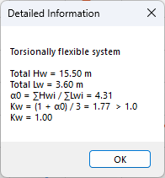
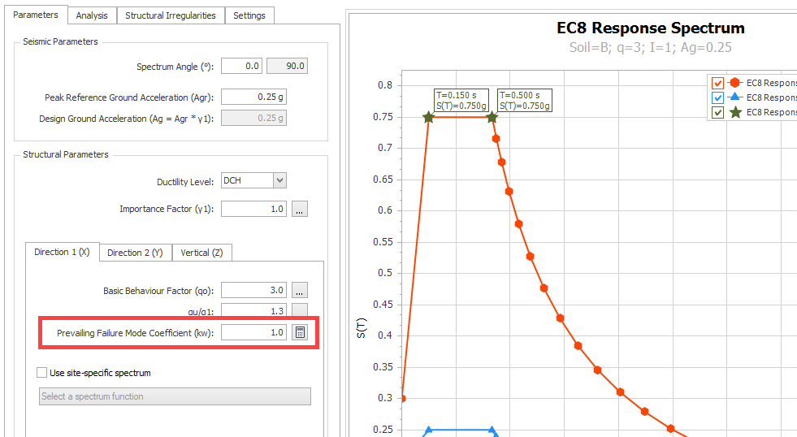

Eurocode 8 - Shearwall Moment & Shear Design Envelope
This feature was a part of ProtaStructure 2025. It is recapped here for the sake of contextual relevance and completeness. Feel free to skip this title if you are already familiar with this feature.
Another important improvement in the new version is the use of bending moments and shear force design envelopes in shearwalls.
To ensure that the ductile shearwalls, with H_{w}/L_{w} ≥ 2, remain elastic above the base hinge considering the uncertainties in the structure dynamic behavior, the design bending moments and shear forces obtained from analysis are magnified.
ProtaStructure will now automatically calculate the tension shift and apply bending moment and shear force envelopes according to the procedure outlined in Eurocode 8 - 5.4.2.4.
You can review and change the design envelope values from Column Reinforcement Design > Wall Design Envelope window.
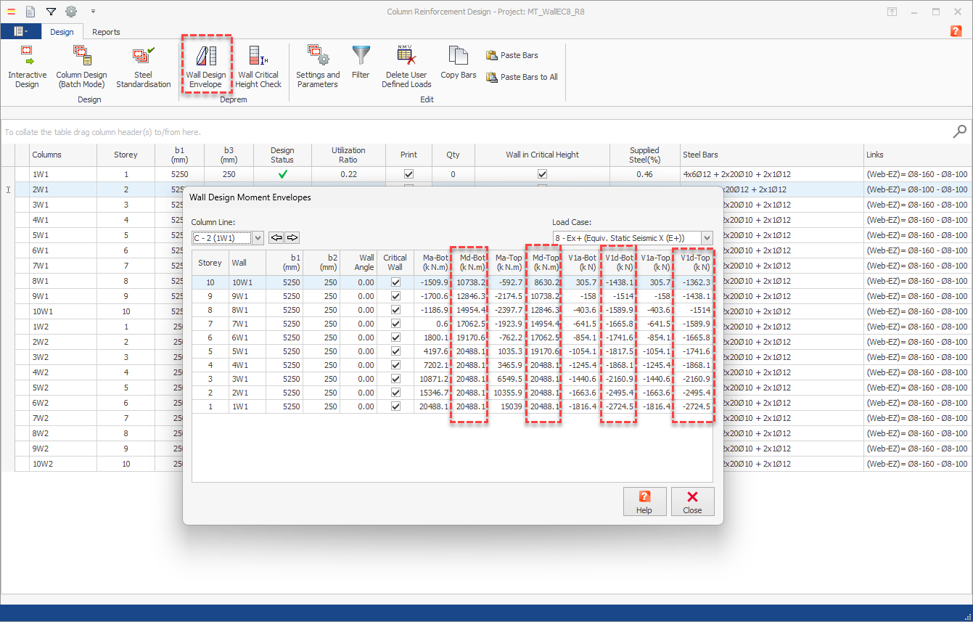

Bending Moment Design Envelope
From the bending moment diagram obtained from the analysis, a linear envelope can be established.
This diagram must be shifted upwards by distance a₁, designated tension shift in Eurocode 8 - 5.4.2.4 (5), consistent with the strut inclination adopted in the Ultimate Limit State verification for shear.
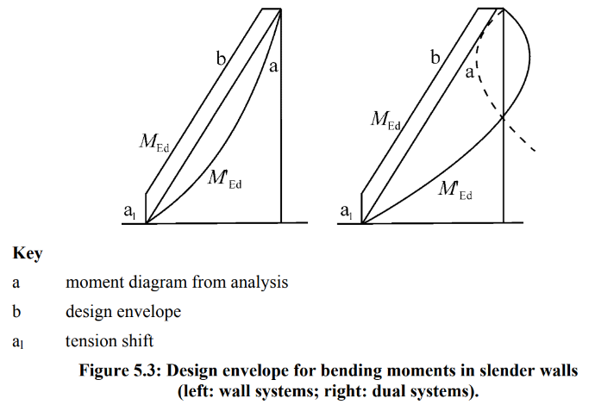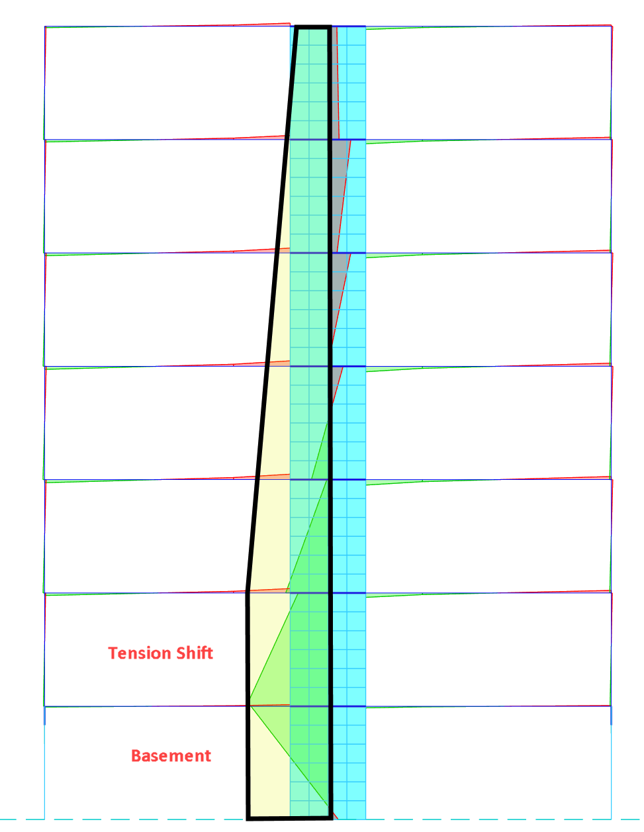

User-defined Strut Inclination Angle (θ) for Tension Shift Length
The default Strut Inclination Angle (θ) for tension shift calculation in ProtaStructure is 21.8°, which yields cot(θ) = 2.5.
The tension shift length is calculated with the formula a₁ = L_{w} cot(θ).
The value of strut inclination angle varies from 21.8 to 45 degrees. To leave room for individual interpretation, we have introduced a new setting, “Strut Inclination Angle for Design Envelope Tension Shift”. It is accessible from Settings > Column & Shearwall > Design.
The value entered here will override the calculated strut inclination angle. When left zero, the tension shift length is calculated using the default cot(θ) = 2.5.
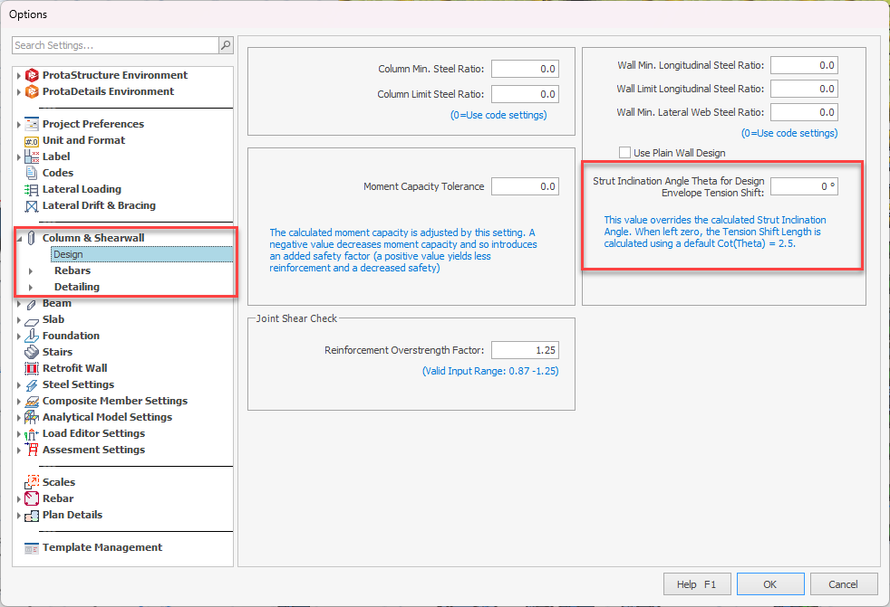

Shear Design Envelope
According to Eurocode 8 – 5.4.2.4 (6), the possible increase in shear forces after yielding at the base of a primary seismic wall, must be considered. This requirement may be satisfied if the design shear forces are increased by 50% (for DCM) than the analysis shear forces in the critical wall height extending Hw/3 from the building base or basement level. For DCH structures, the shear amplification factor is calculated by Eurocode 8 Eqn. 5.25.

User-Defined Shear Amplification factor, ε
ProtaStructure provides a user-defined parameter for shear amplification factor which can be edited for each wall line. The default and the minimum value are 1.5 and the maximum value is the ‘q’ factor used in the analysis in the wall direction. ProtaStructure will magnify the analysis shear forces by this factor inside the critical height. The shear diagram is linearly connected to the value at the top, which is V_{wall,base}/2.
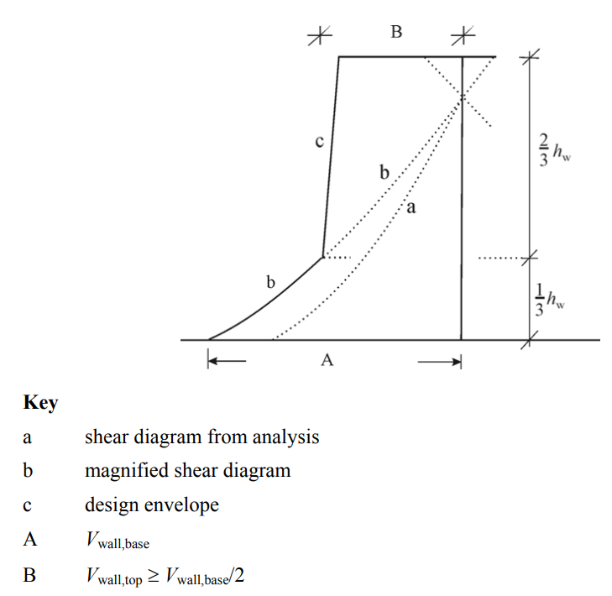
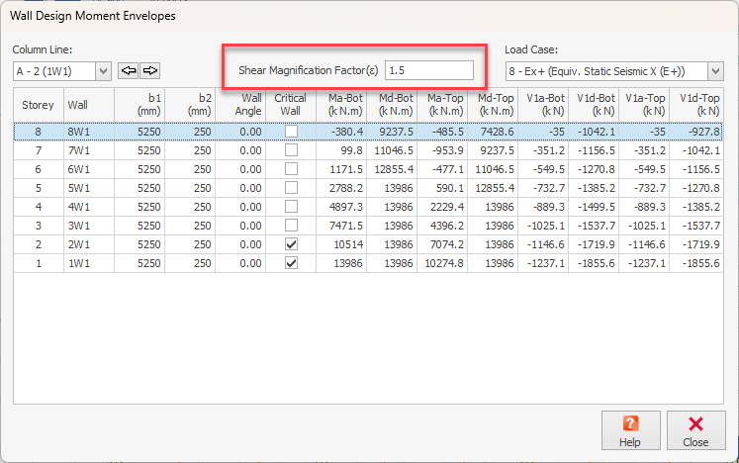

Modal Vertical Earthquake Analysis
This feature was a part of ProtaStructure 2025. It is recapped here for the sake of contextual relevance and completeness. Approximate static approach is not applicable for Eurocode, so the modal vertical earthquake analysis was implemented in ProtaStructure 2025 as a new feature. Feel free to skip this title if you are already familiar with this feature.
ProtaStructure can reflect the effects of vertical earthquake action in the design by providing two methods.
- Approximate Static Approach
- Modal Spectrum Analysis Method

Approximate Static Approach
In the static approach, the result from gravity load case is multiplied with a fraction of horizontal spectral acceleration such as 0.2S_{DS}. Vertical vibration modes and a dedicated vertical spectrum are not considered in this approach.
However, static vertical earthquake calculation may not be sufficient (or allowable by the code) for the buildings with transfer columns, beams or slabs covering large spans, long cantilevers or slanting columns.
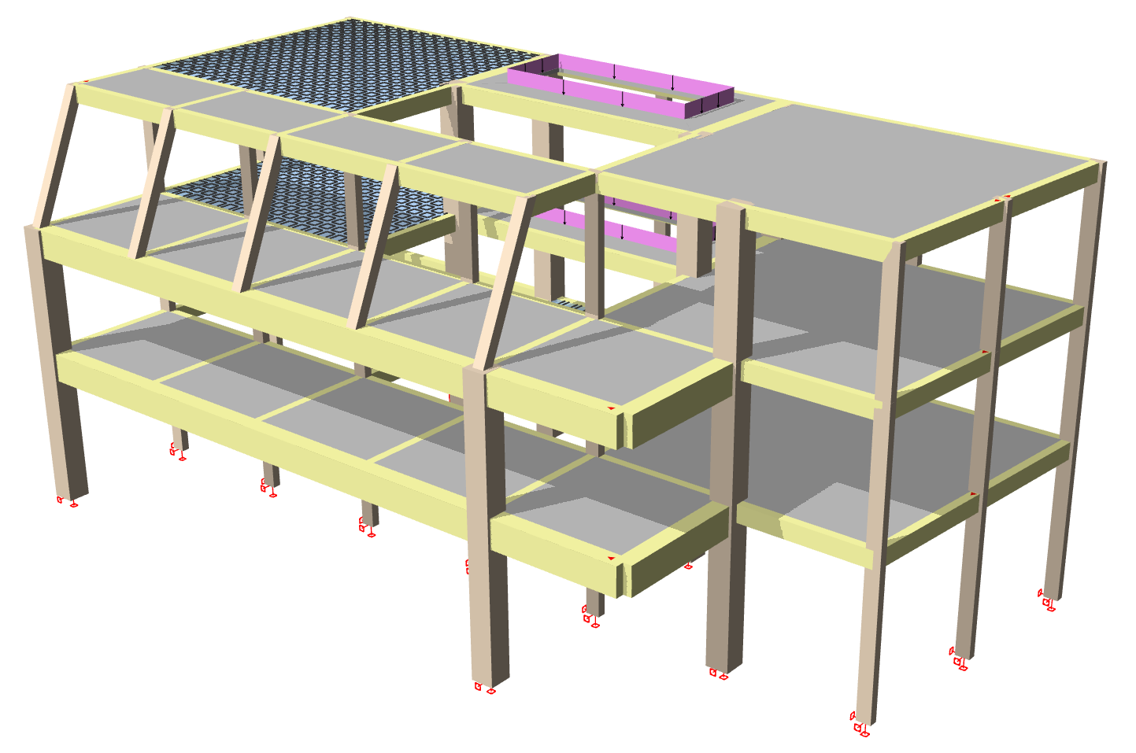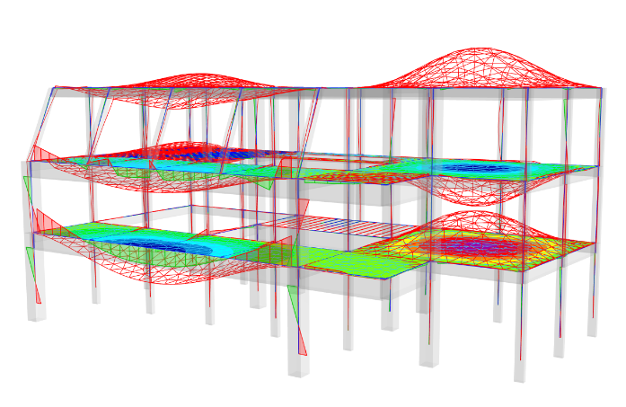
Certain seismic codes require the use of modal vertical earthquake analysis in these scenarios. For example, Eurocode only allows the use of modal vertical earthquake analysis.

Modal Spectrum Analysis Method
In modal spectrum method, vertical vibration modes of the structure are considered together with a vertical acceleration spectrum. With ProtaStructure 2025, you are now able to perform modal vertical earthquake analyses.
Please refer to our new design guide on vertical earthquake analysis for detailed explanations, modeling tips and more:
ProtaStructure Design Guide – Vertical Earthquake Effects

Customizable Eurocode Vertical Spectrum
Although it was originally introduced in ProtaStructure 2025, we have substantially improved the vertical earthquake elastic and design spectrum according to Eurocode 8. You can now display elastic and design vertical spectrum at the same time and customize the parameters such as behavior factors in vertical direction (q-vertical), a_{vg}/a_{g}, S, T_{B}, T_{C} and T_{D} independently from horizontal spectrum. This will allow you to adapt your design to your national requirements.
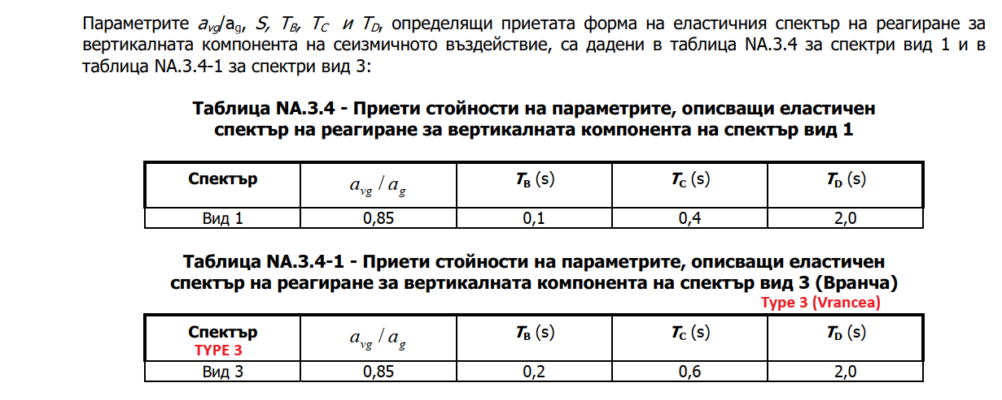
An excerpt from Bulgarian codes that overrides the vertical spectrum parameters.
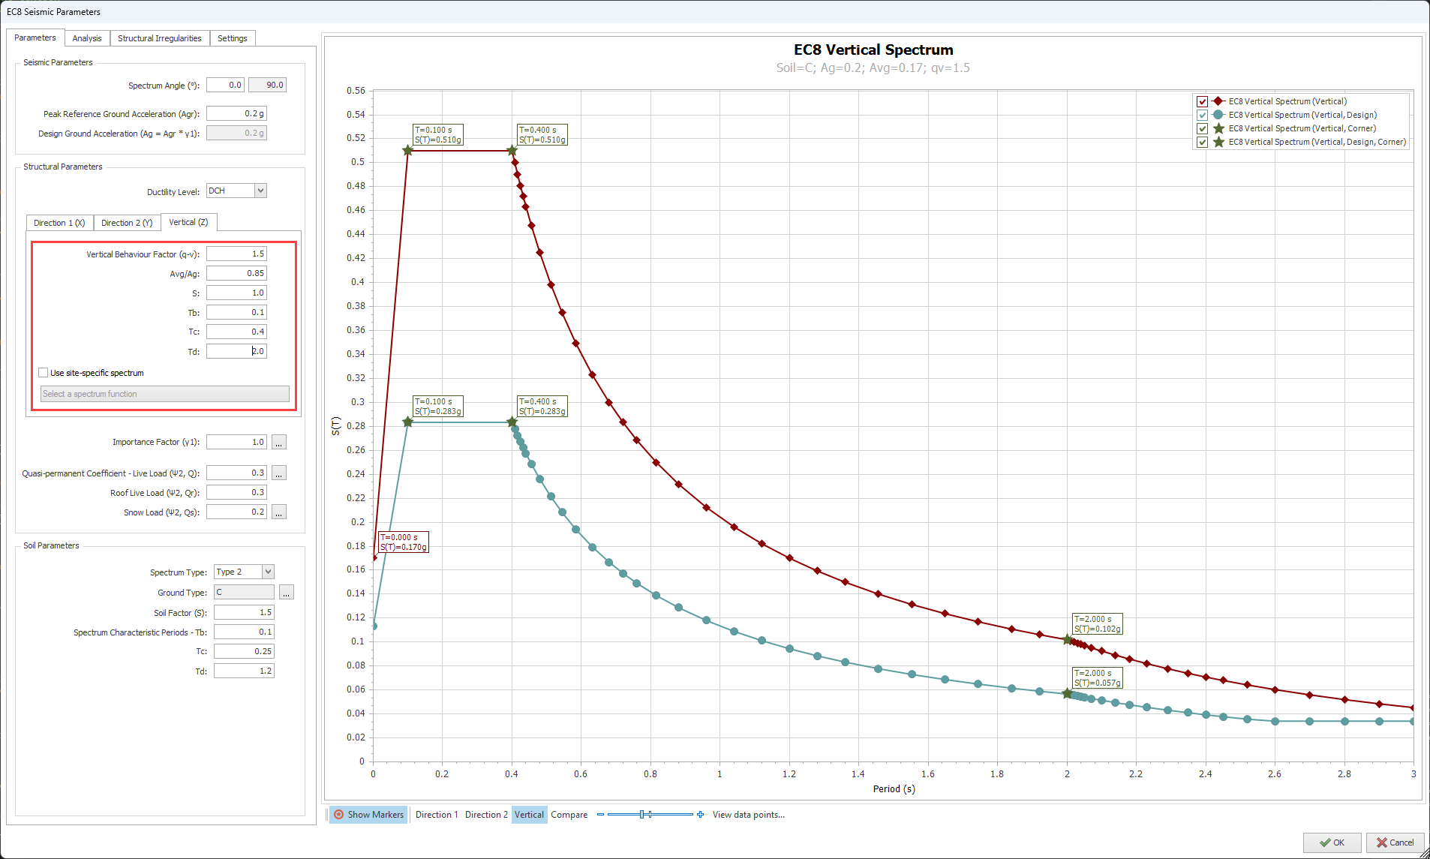

Eurocode 8 Dual System Wall-Frame Interaction Checks
If your structural system is categorized as a Wall System, Frame System, Dual System, Frame-Equivalent Dual System, or Wall-Equivalent Dual System, as outlined in EN1998-1:2004 Clause 5.1.2, you can now assess the total shear contributions of frames and shear walls in your design. This allows you to make necessary adjustments and optimizations according to the specific structural system type. You can see the summary table in the Post-Analysis Checks Report.
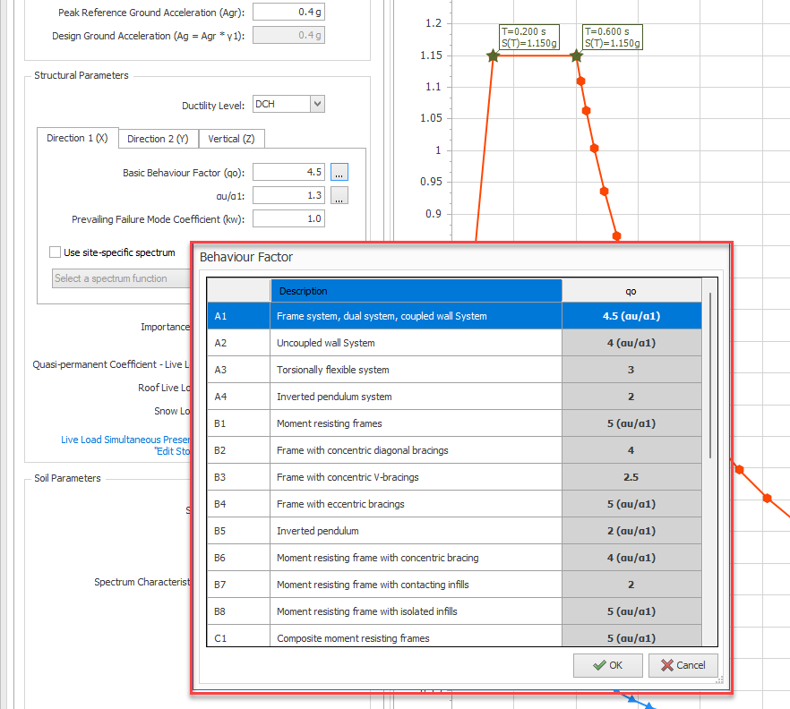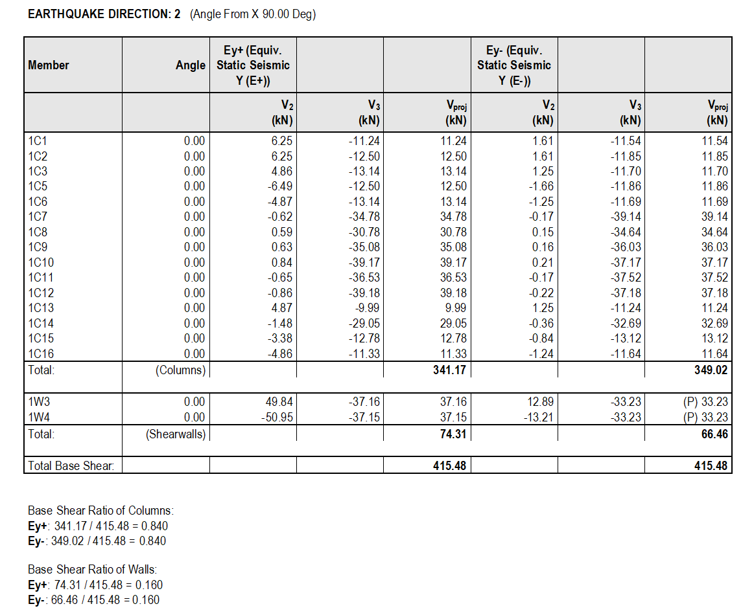

Eurocode 2 Long Term Deflection Checks Including Creep and Shrinkage
With ProtaStructure 2026, you can consider creep and shrinkage in deflection calculations by defining time-dependent material properties according to EN1992-1-1:2004 and CEB FIB 90. Serviceability requirements are automatically checked against obtained long-term deflections according to EC2.
Note:
Detailed deflection checks according to ACI318, IS456, NSR10-C, NSCP, NTE060 and SNI2847 were already introduced with the previous versions of ProtaStructure. ProtaStructure 2026 now supports the detailed RC deflection checks including long-term creep and shrinkage effects.
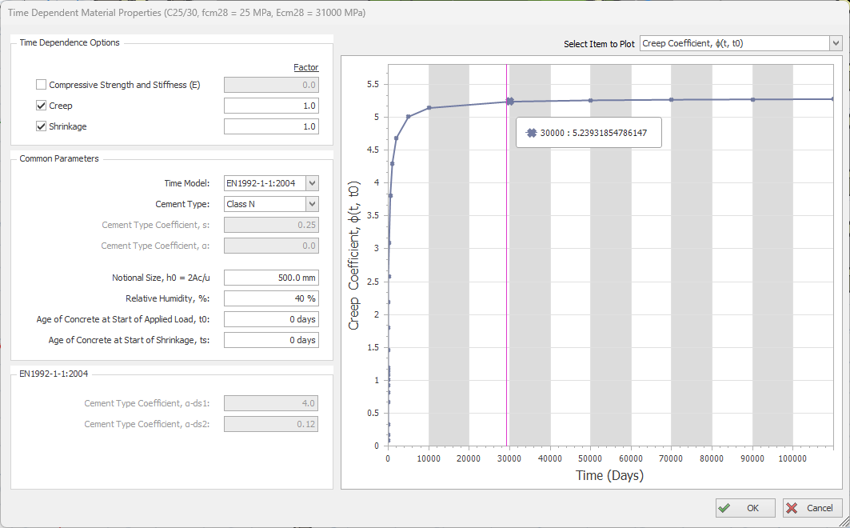
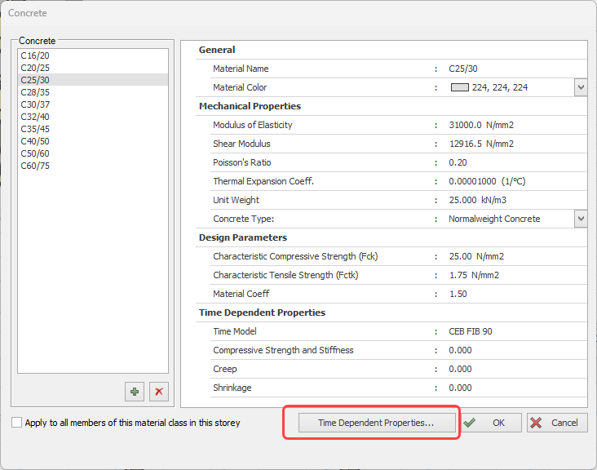
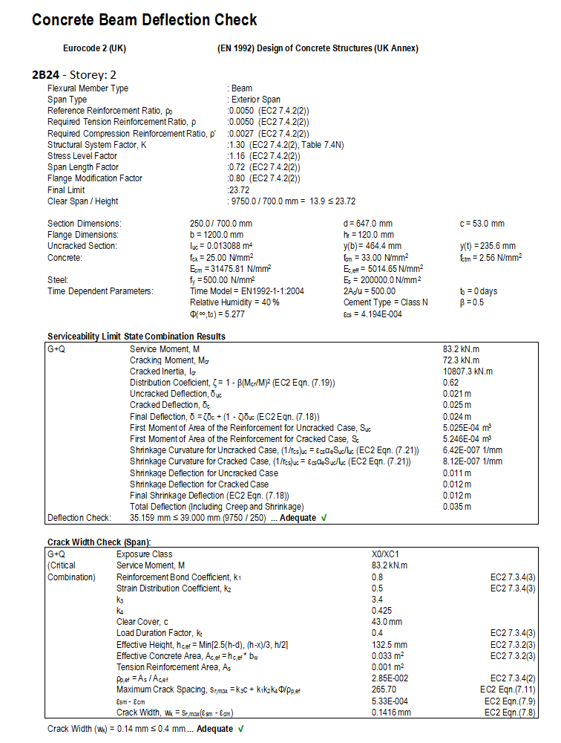

Although highly parametric new models are developed, predicting creep in reinforced concrete structures still maintains its uncertainty. This complexity is due to the material itself and the problem of assessing time-dependent deformations and loss of prestressing forces, which are usually not considered in structural analysis. One can tackle this uncertainty and complexity in creep prediction to a certain degree by adapting the code procedures that give general guidance.
To specify the time-dependent concrete parameters in ProtaStructure:
- Open the concrete material properties dialog.
- Click on the “Time-Dependent Properties…” button.
- Check the “Time Dependence Options” you want to consider in the deflection checks. If you wish to partially consider these parameters’ effect, you can enter values between 0 and 1. Entering ‘0’ or unchecking the related option will deactivate the parameter.

- Select the “Time Model” that you want to use. Available options are CEB FIB 90 and EN1992-1-1:2004.
- Specify other parameters like Cement Type, Relative Humidity, Start of Shrinkage, and Aggregate Type.

Important:
Time Dependent concrete properties will only be accessible if Eurocode 2 design code is selected. These parameters are not used in deflection checks according to other design codes. ACI318, IS456, NSR10-C, NSCP and SNI2847 cater for long term deflections by alternative formulation.
The time models will be automatically considered in Eurocode deflection checks (not in building analysis) once you assign the concrete material that you have edited to structural members.

Eurocode 3: Design of Castellated Beams
We have developed castellated beam design compliant to Eurocode 3, complemented with a step-by-step detailed design report. Castellated beam design was brought to you in the previous ProtaStructure 2025. Eurocode support is new in ProtaStructure 2026.
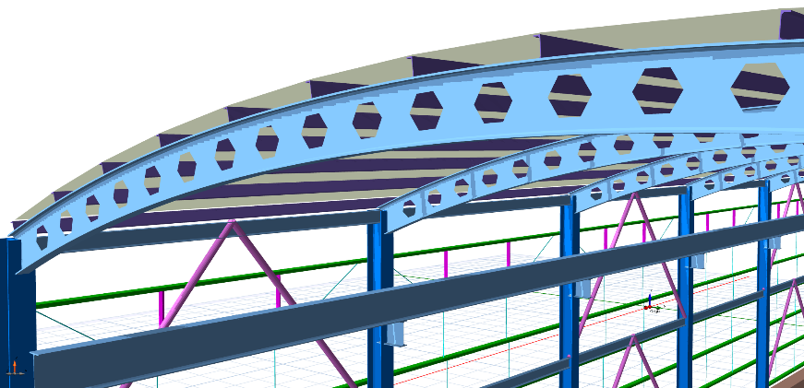
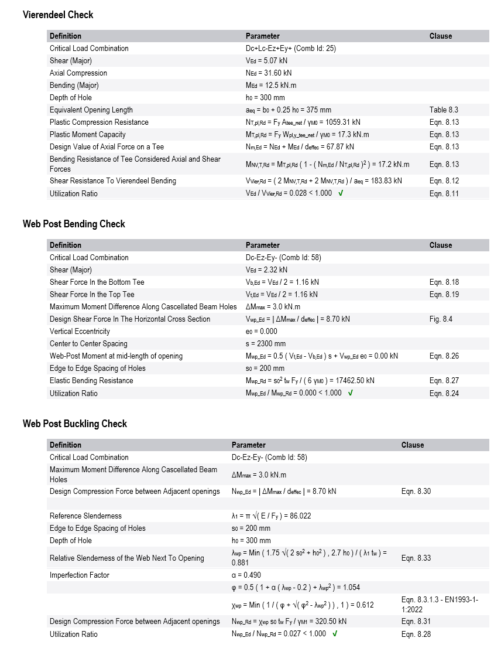

Crack Width Checks
In addition to long term deflection, crack width checks can also be performed again to Eurocode 2, ACI318, IS456, NSR10-C, NSCP, NTE060 and SNI2847 guidelines.
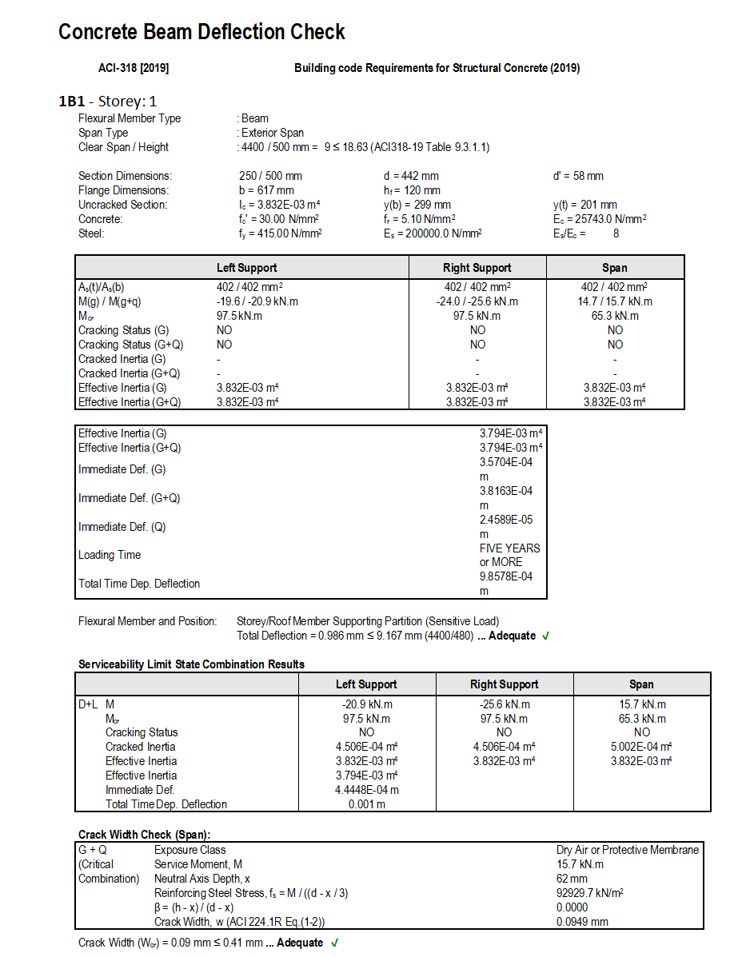

IS Code: Load Transfer Check from Column to Footing
This feature was not a part of the initial ProtaStructure 2025 release, and it was released with 8.0.257 maintenance package. It is included here for our users who may not be aware of this feature. Feel free to skip this title if you are already familiar with this feature.
A new check was added for IS456 cl.34.4 that checks the load transfer from loaded column area to footing.
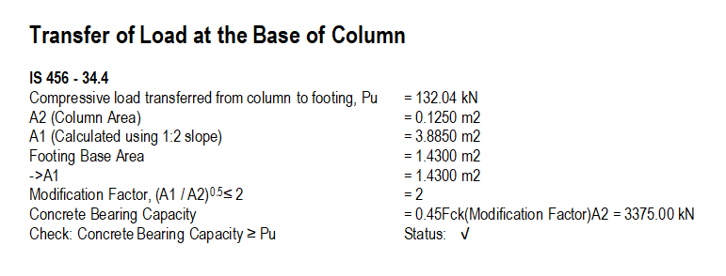

Foundation Tie Beam Design to ACI318
This feature was not a part of the initial ProtaStructure 2025 release, and it was released with 8.0.257 maintenance package. It is included here for our users who may not be aware of this feature. Feel free to skip this title if you are already familiar with this feature.
Foundation tie beams can be defined in ProtaStructure to provide a horizontal connection between two columns at the foundation levels preventing lateral movements and relative displacements, especially if there are pad footings. To insert foundation tie beams, you can use Modeling > RC Beam > Foundation Tie Beam command. Once inserted, their design will be carried out considering the axial forces on the columns or walls they are connected to. Currently, the design can be done to US and Turkish codes.
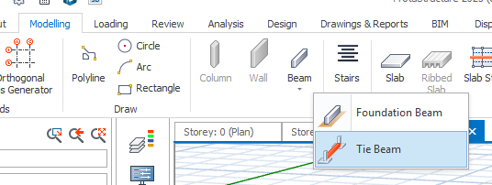
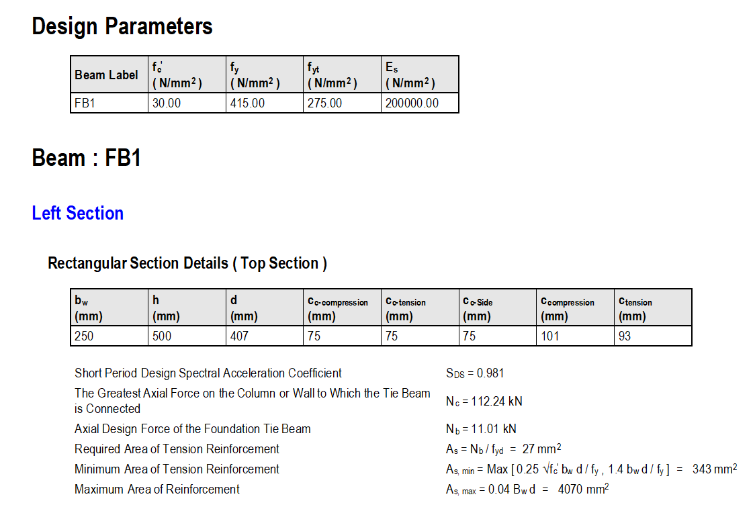

Enhanced Pad Footing Design
With the latest ProtaStructure, you can now enjoy improvements and new features in pad footing design such as design utilization ratio, BOB length control, global and batch settings for preventing rotation and ability to limit the maximum footing depth.
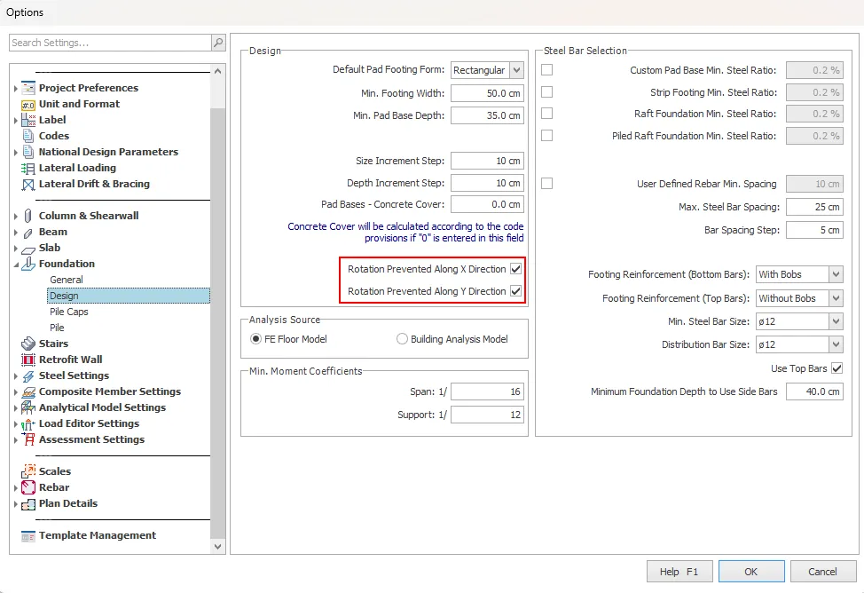
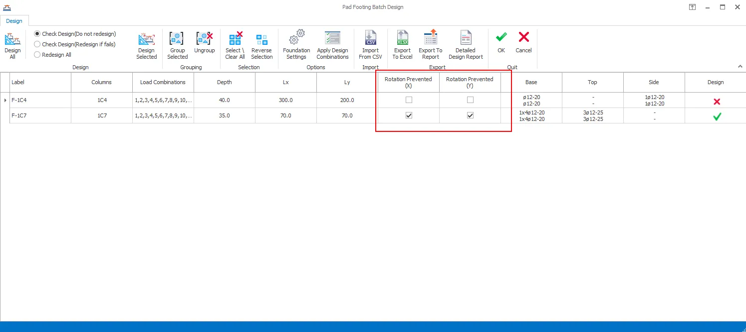

Minimum Pad Footing Depth to Use Side Bars
This feature was not a part of the initial ProtaStructure 2025 release, and it was released with 8.0.257 maintenance package. It is included here for our users who may not be aware of this feature. Feel free to skip this title if you are already familiar with this feature.
A new option was added for side bar placement in pile caps and pad footings. This option works similarly to the “Use Top Bars” option; if the pad footing or pile cap has a greater depth than the specified value, side bars will be provided automatically, vice versa. The default value was designated as 400 mm. You can access this setting via Settings > Foundation > Design.
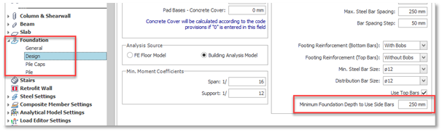
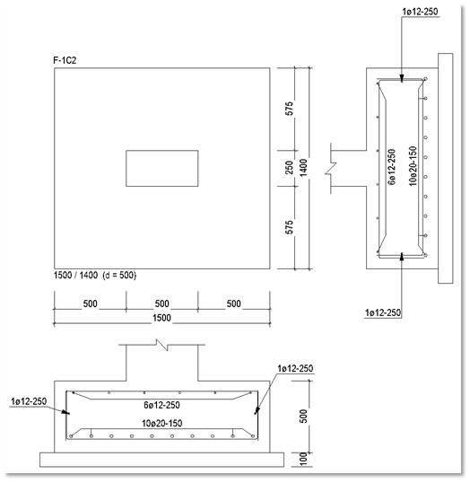

Maximum Pad Footing Depth
ProtaStructure 2026 introduces a pivotal enhancement to pad footing design with the new "Maximum Pad Base Depth" parameter. This feature allows users to define a cap on the maximum permissible footing depth during design calculations, providing greater control over structural specifications. If the design requires a footing depth exceeding this predefined limit, the system will automatically flag the design as invalid. This ensures compliance with user-defined constraints and promotes more precise and efficient design processes.
Please note that incorrectly setting the maximum depth could lead to unnecessary design failures, causing frustration or requiring adjustments. Additionally, accommodating a wide range of design conditions can be demanding while ensuring the parameter remains relevant and effective. In some cases, enforcing a maximum depth could constrain design flexibility, potentially leading to less cost-efficient solutions. Footing depth parameter has a direct effect on one-way shear resistance, punching resistance, moment capacity and reinforcement in the footing.
You can access this setting via Options > Foundation > Design. Pad footing design must be updated after this parameter is changed.
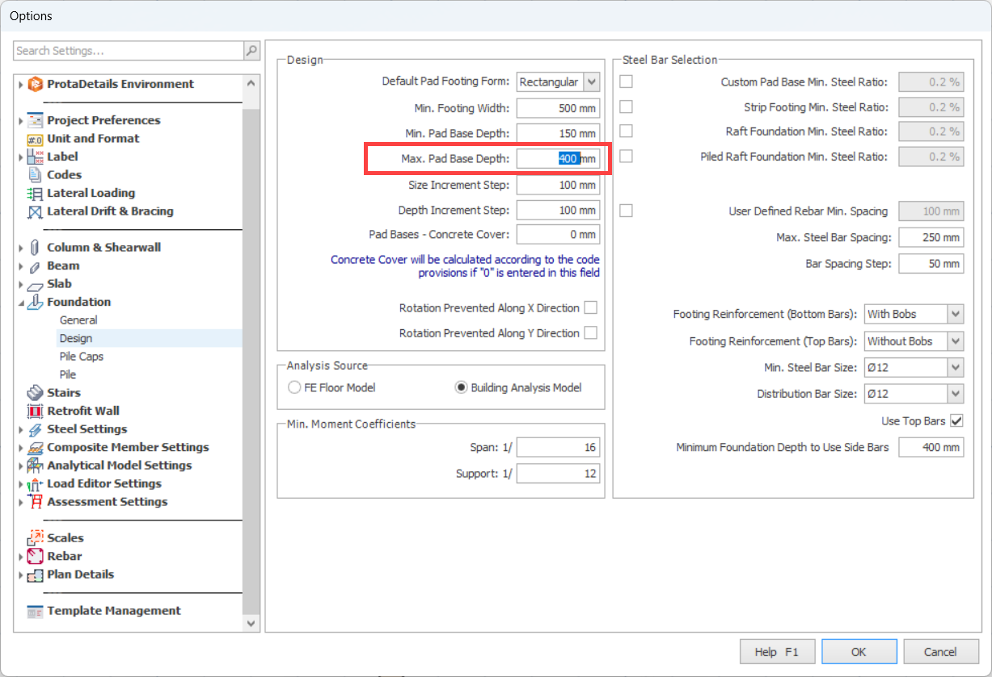

Analysis Improvements

Punching Checks with Finite Elements
This feature was not a part of the initial ProtaStructure 2025 release, and it was released with 8.0.217 maintenance package. It is recapped here for our users who may not be aware of this powerful feature. Feel free to skip this title if you are already familiar with this feature.
ProtaStructure 2026 introduces enhanced support for punching shear checks for flat slabs and raft foundations in compliance with both the ACI318 American and IS456 Indian Codes (and other similar codes including NSR10, NTE030, Dominican Republic, Indonesia, Philippines and Thailand – Eurocodes still in progress). This latest version can automatically calculate the out-of-plane shear forces, V13 and V23, around the punching perimeter and incorporate them into the punching shear analysis.

Inclusion of Column Outlines
To increase the accuracy of punching shear checks with finite element results, the column outlines will always be cropped out of the finite element mesh for flat slabs and raft foundations, if there are no beams connected to a particular column, or the column is not connected to a wall.
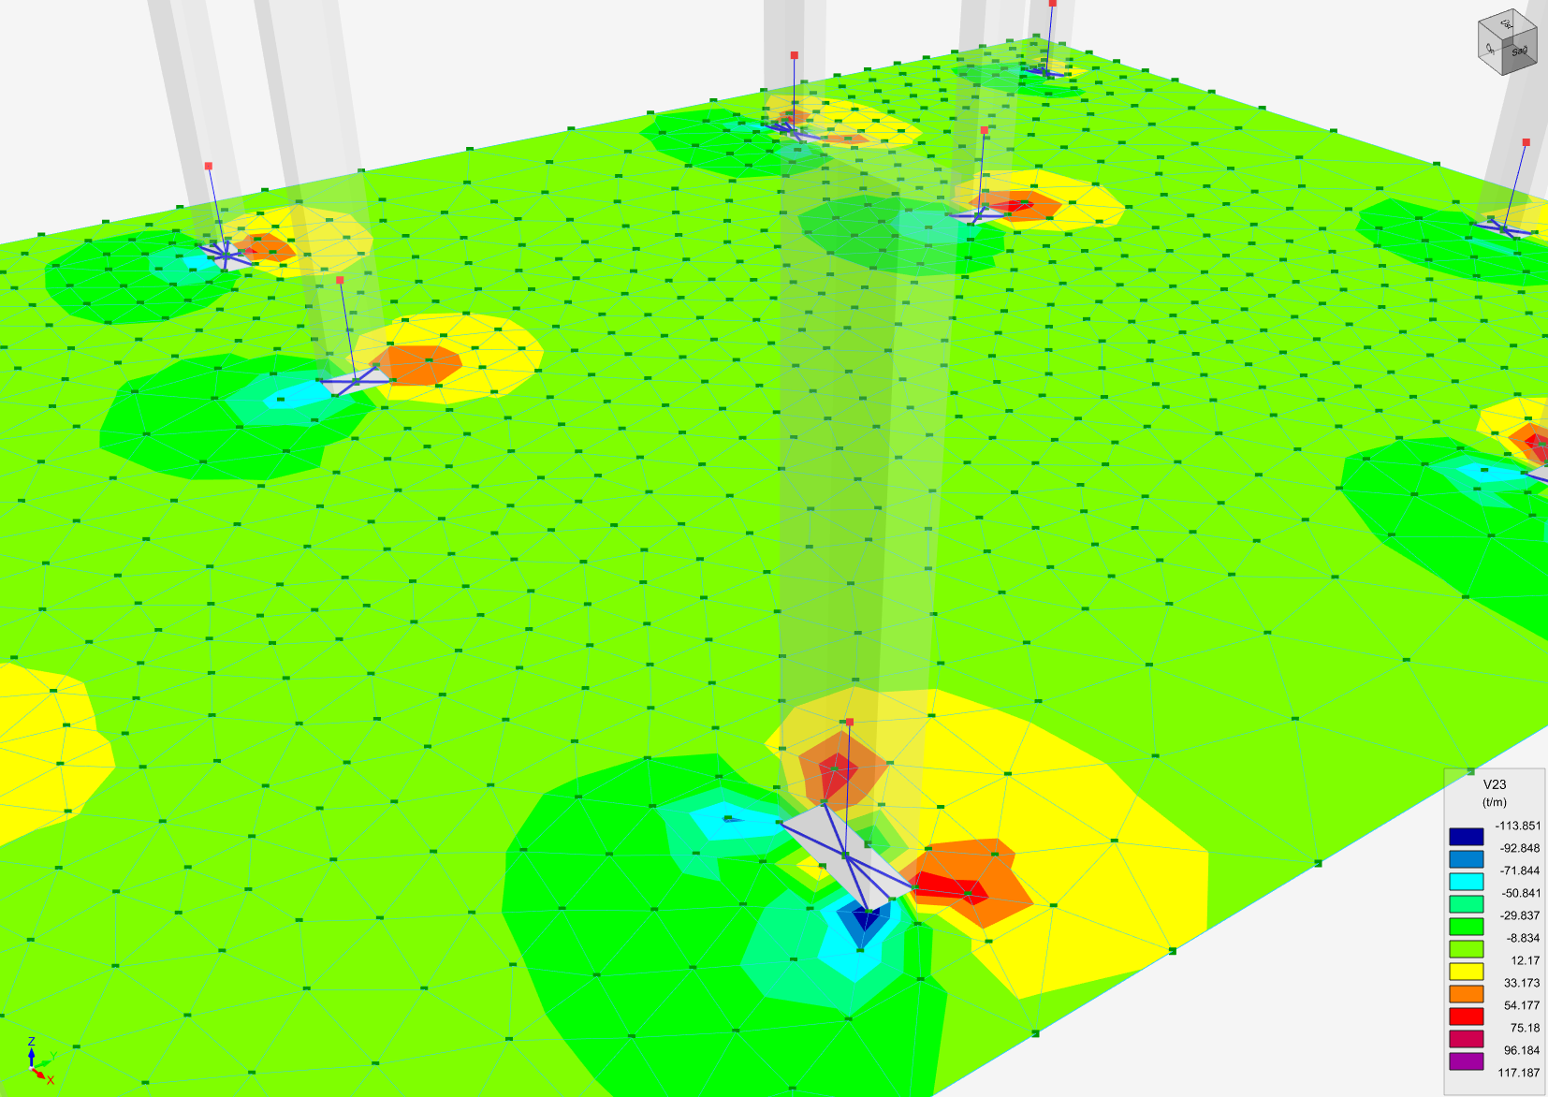
Important
Column outlines will always be cropped from the FE mesh if there are no beams or walls connected to the column. This will increase the accuracy of punching shear checks for flat slabs and raft foundations. The existing setting “Include Column Outlines” is only valid for columns with connecting beams.
Column outlines are not included in FE mesh for columns with column drops or for columns inside or at the corners of shearwalls.

Methodology
The maximum value of shear stress is obtained by collecting results from the punching perimeter which can be rectangular, circular or irregular depending on the column and slab geometry. Results are collected for each combination and the envelope value is used.
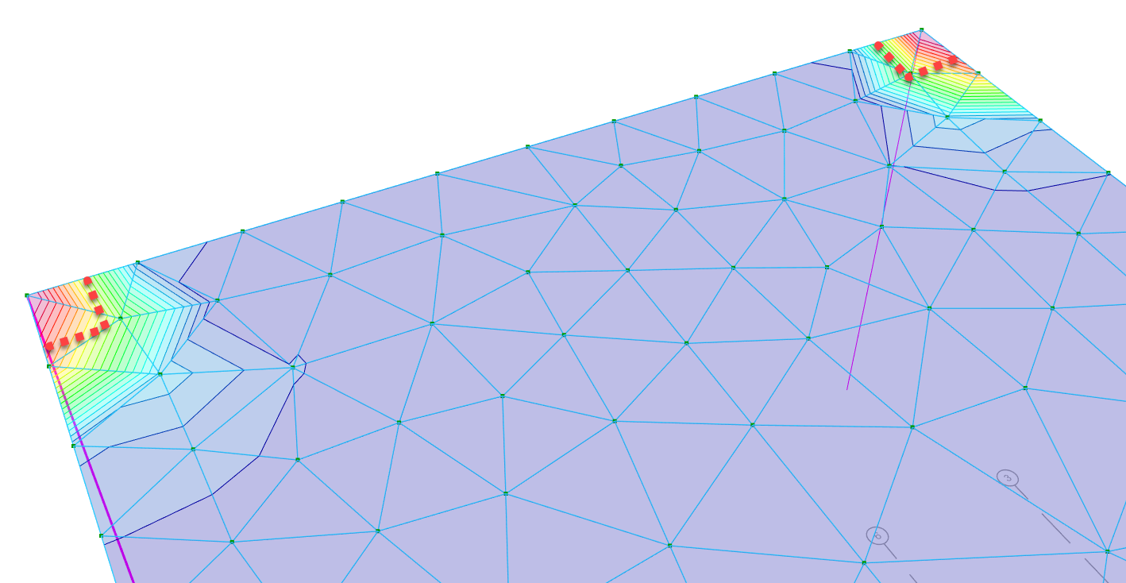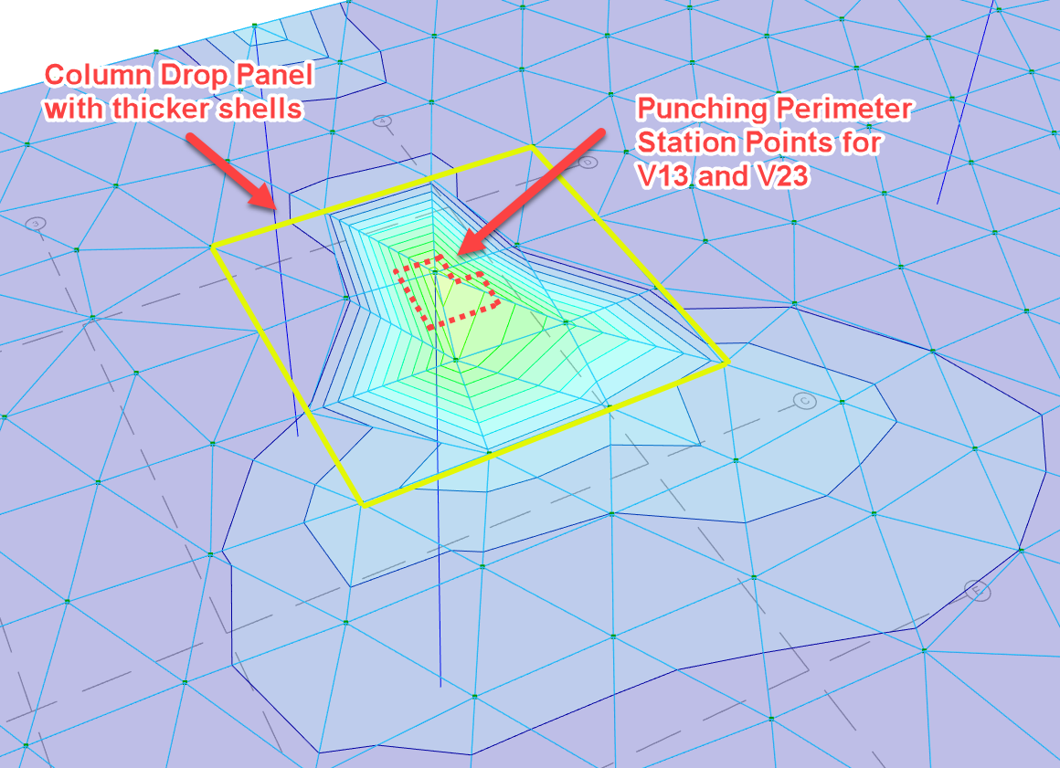
V23 shear contours and punching station points for envelope combinations in analysis post-processor.
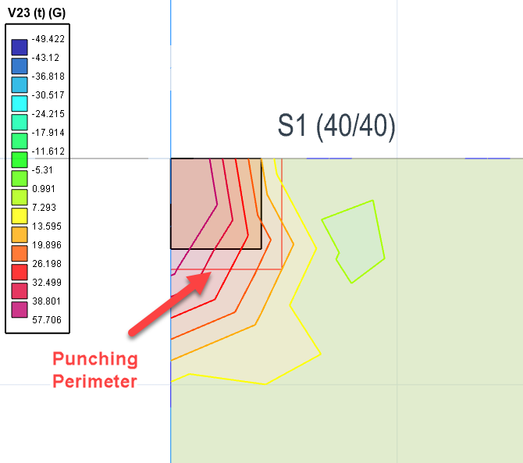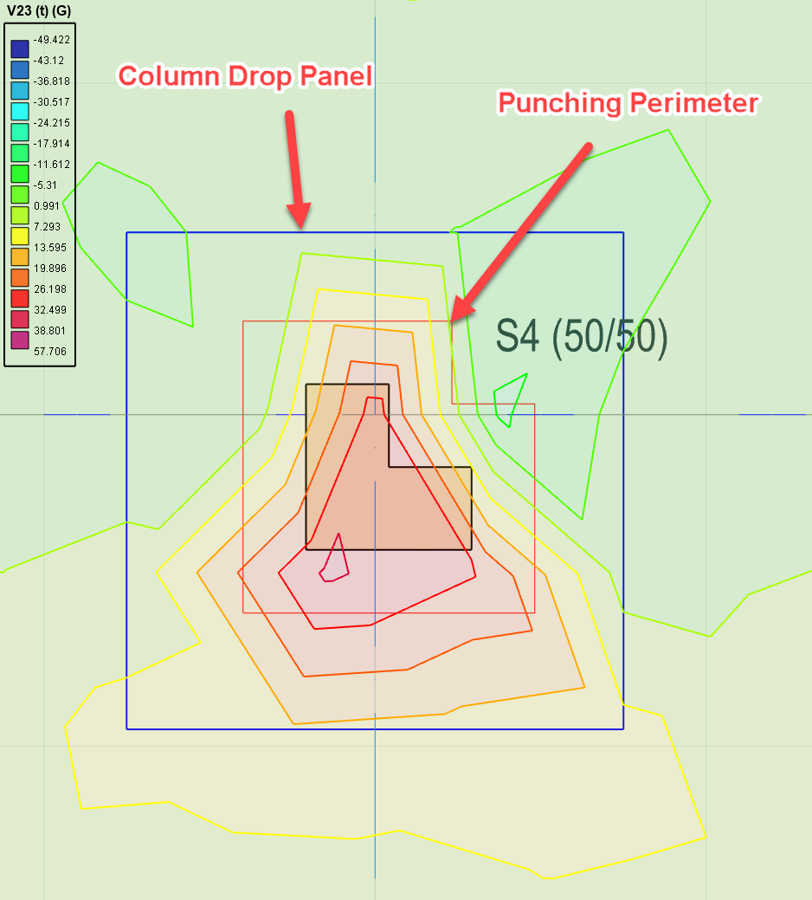
Column drop panels, punching perimeters and shear contours shown simultaneously on physical floor plan
The methodology and formulation are different for different design codes, but in principle, if the concrete tensile strength is solely enough to counteract the punching stresses around the punching perimeter, then no additional punching reinforcement is calculated. However, if punching stress is larger than concrete tensile strength then the punching reinforcement is calculated by ProtaStructure.
Existing slab reinforcement and additional patch reinforcement (if any) will be considered as punching reinforcement.
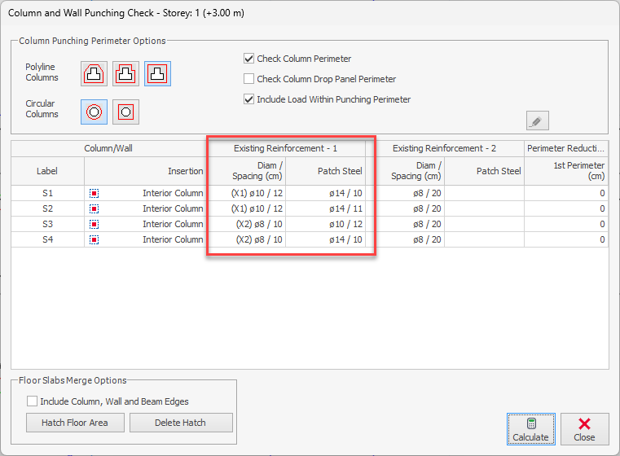
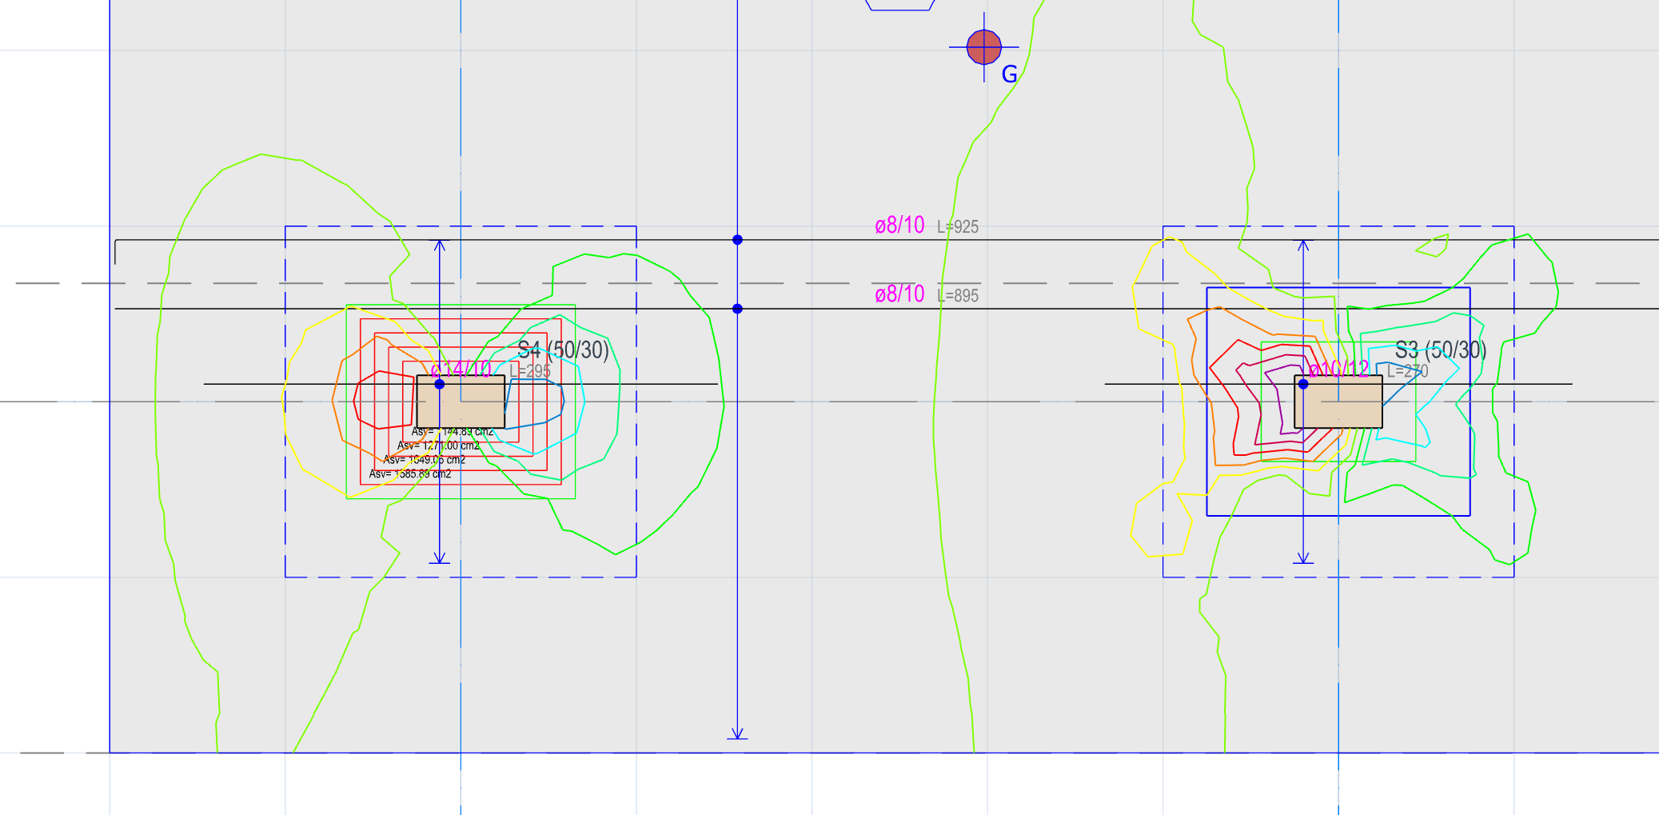
Consecutive punching perimeters, V13 contours, column drops, patch regions, patch reinforcement and slab base reinforcement shown on the plan at the same time.
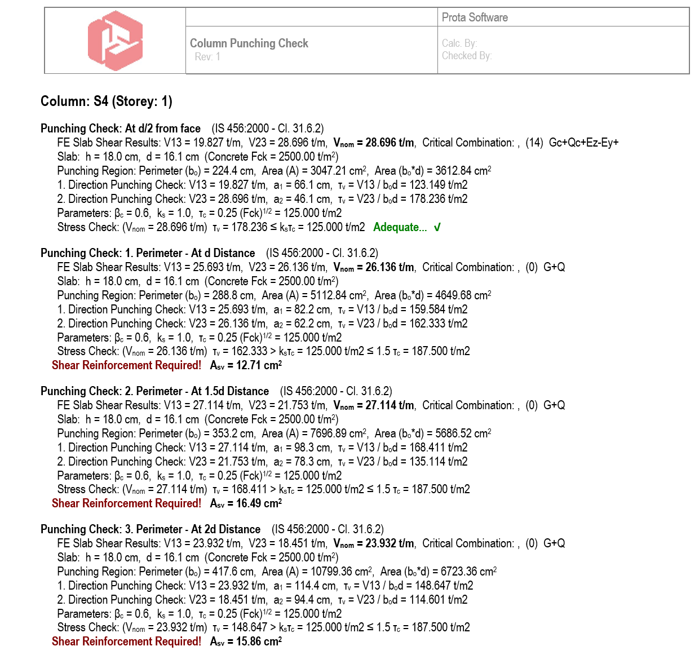
Punching shear check report for consecutive punching perimeters.

Editable Accidental Eccentricity and Overturning Safety Factors
To strike a balance between automation and control, ProtaStructure 2026 now supports user-defined entries for accidental eccentricity and seismic overturning safety factors. This enhancement empowers users to tailor their designs with greater precision and flexibility. These settings can be found in Seismic Parameters > Analysis and Seismic Parameters > Settings locations.
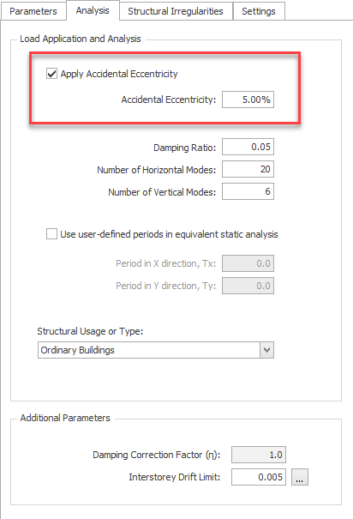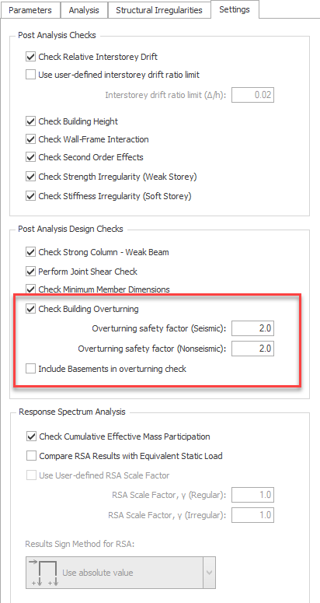

Designate Storeys as ‘Intermediate’
ProtaStructure 2026 allows you to designate any storey as an intermediate storey. Intermediate storeys can be partial installations between two storeys, structural members, or internal setbacks used for various purposes. If these members are defined on a different storey, ProtaStructure will enable you to designate it as an intermediate storey, excluding it from irregularity checks while still considering the full stiffness, mass, and load in the building analysis.
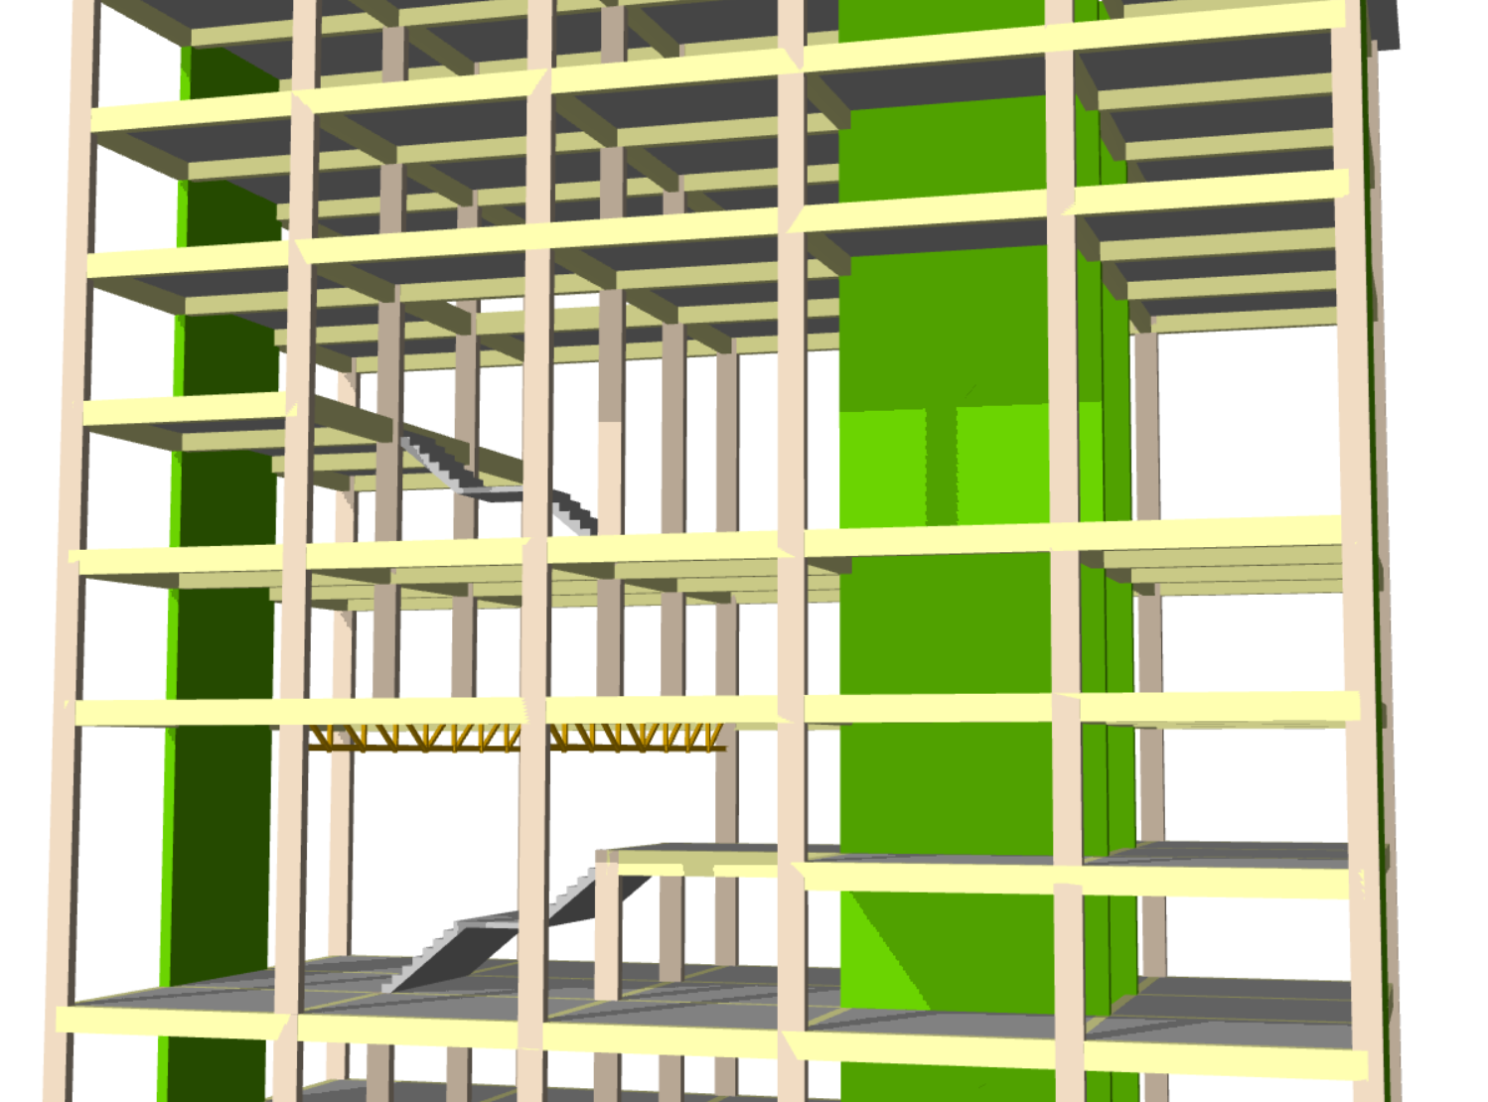
To set a storey as intermediate,
- Open the Storey Editor using the Edit Storey command
- Find the storey row on the table and set Storey Type to Intermediate.
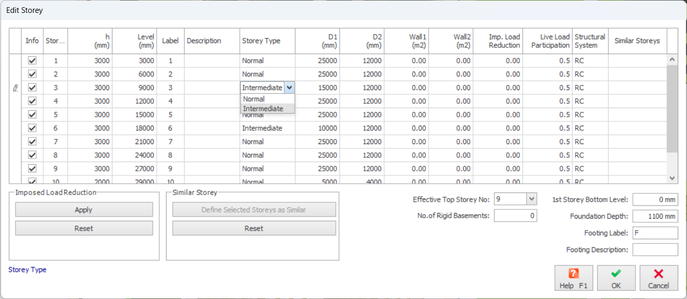

Meshing Same Storey Slabs Positioned on Top Of Each Other
In ProtaStructure 2026, you can now model and mesh multiple slabs positioned on top of each other in the same storey for finite element analysis. This improvement allows you to address more complex structural configurations by enabling the meshing of slabs at different elevations, whether within the same storey or at the foundation level. In earlier versions, only one slab in the same storey was included in the mesh, limiting the accuracy of the analysis.
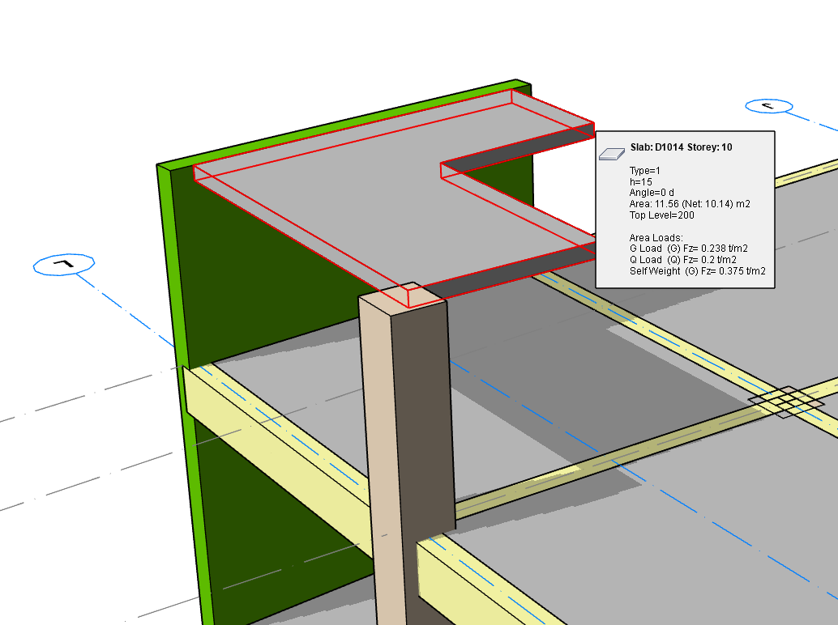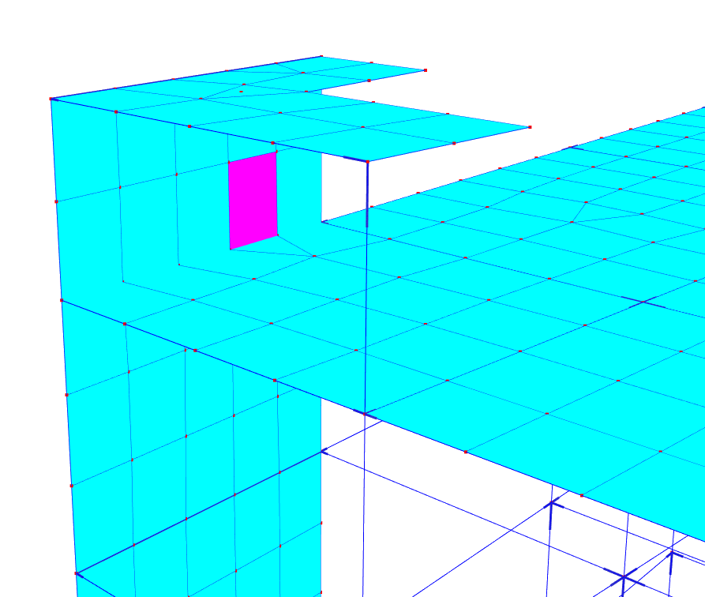
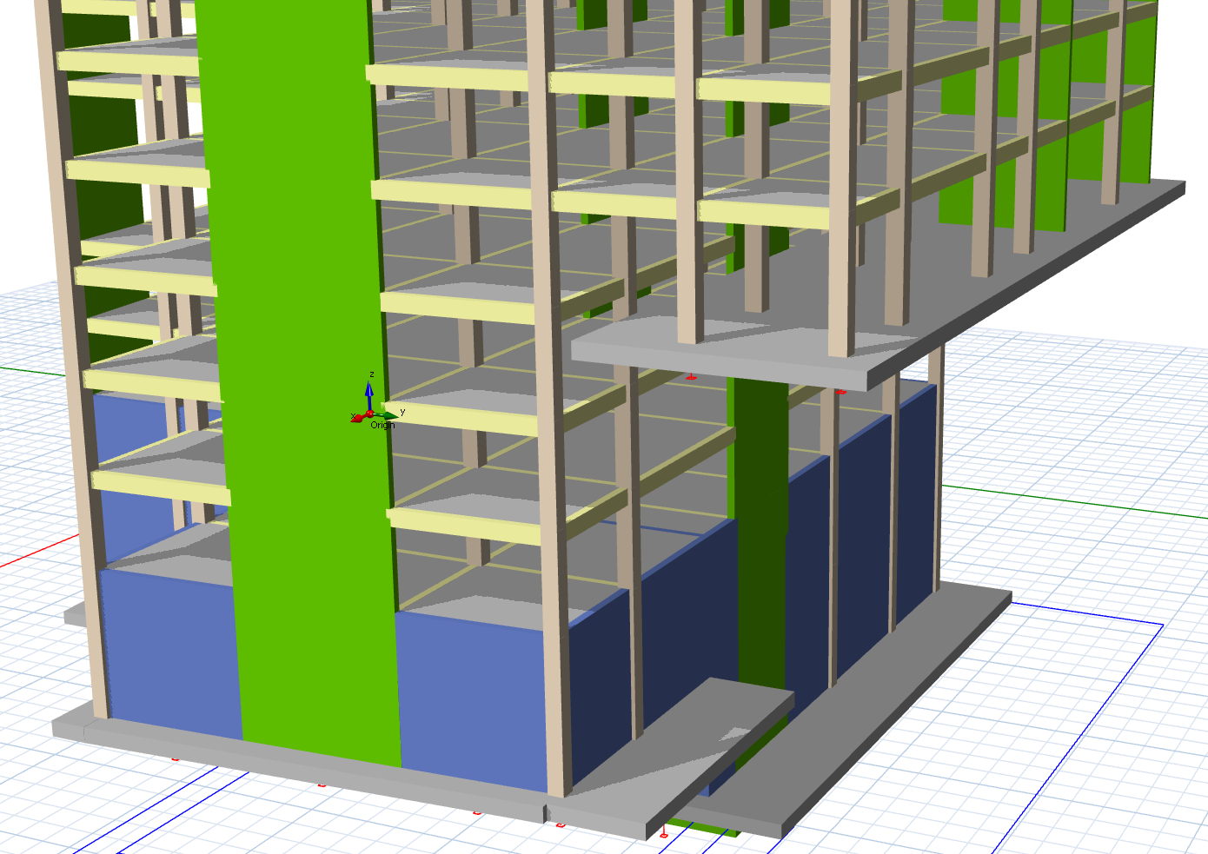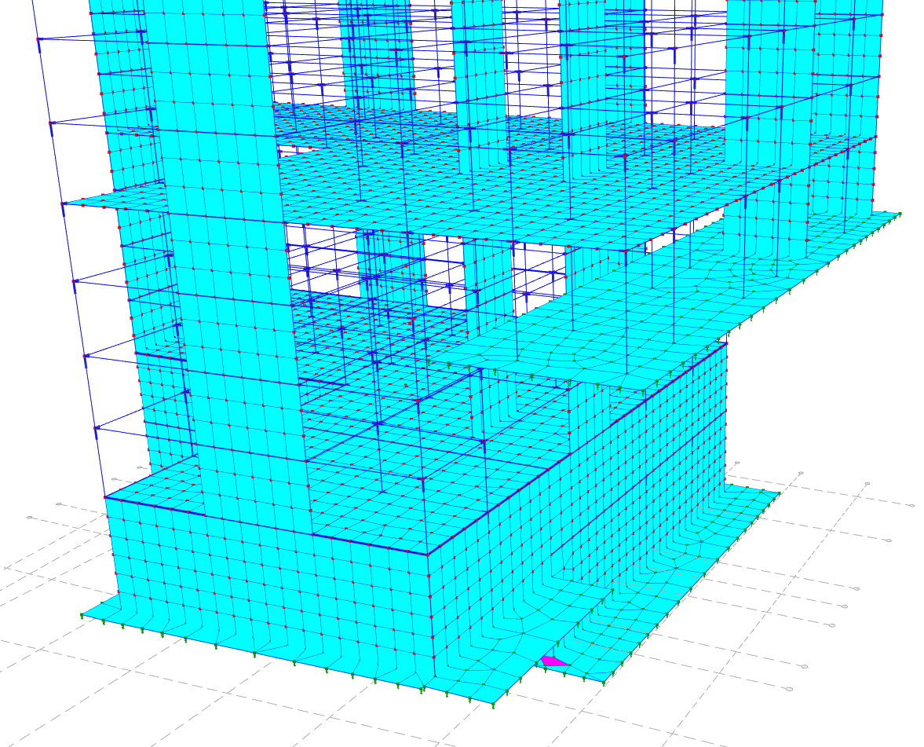
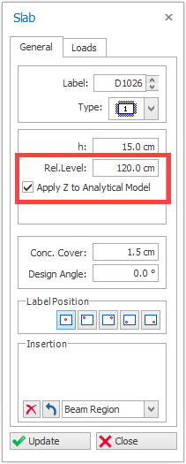
To use this feature:
- Open the Slab Properties window.
- Enter the slab’s relative elevation difference from the storey level into the “Rel. Level” field.
- Make sure to check “Apply Z to Analytical Model” option to consider this elevation difference in building analysis.

Using Quad Mesh for Slabs in FE Analysis
We now introduce quadrilateral shell elements in slabs. The mesh density is automatically adjusted by ProtaStructure considering the minimum mesh size the user specifies.
The default shell element type in ProtaStructure will be the QUAD members from now on. However, our meshing algorithm will automatically resort to triangular elements whenever the geometry demands. In that case, a mix of triangular and quadrilateral elements will be used.
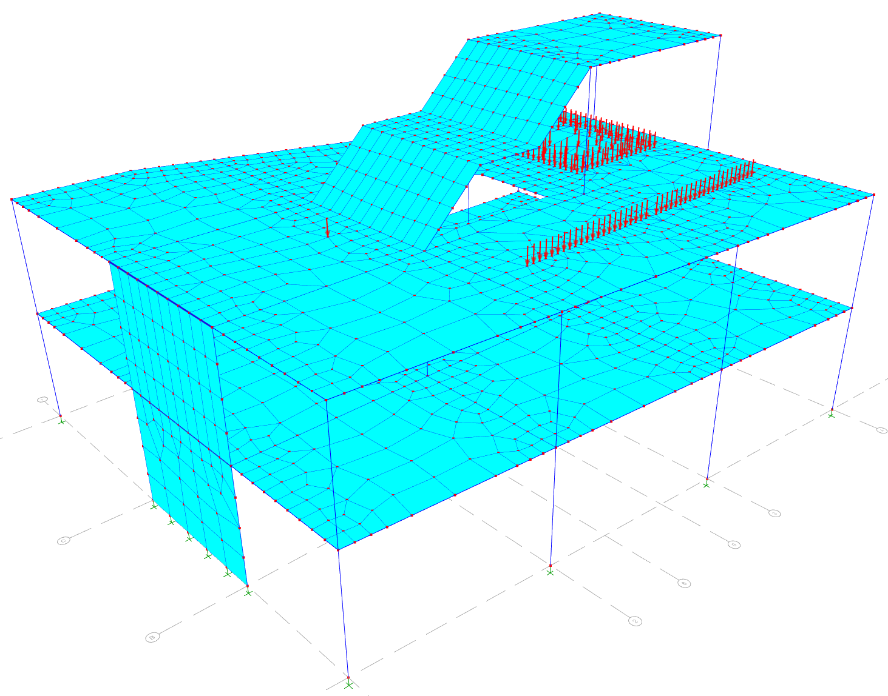
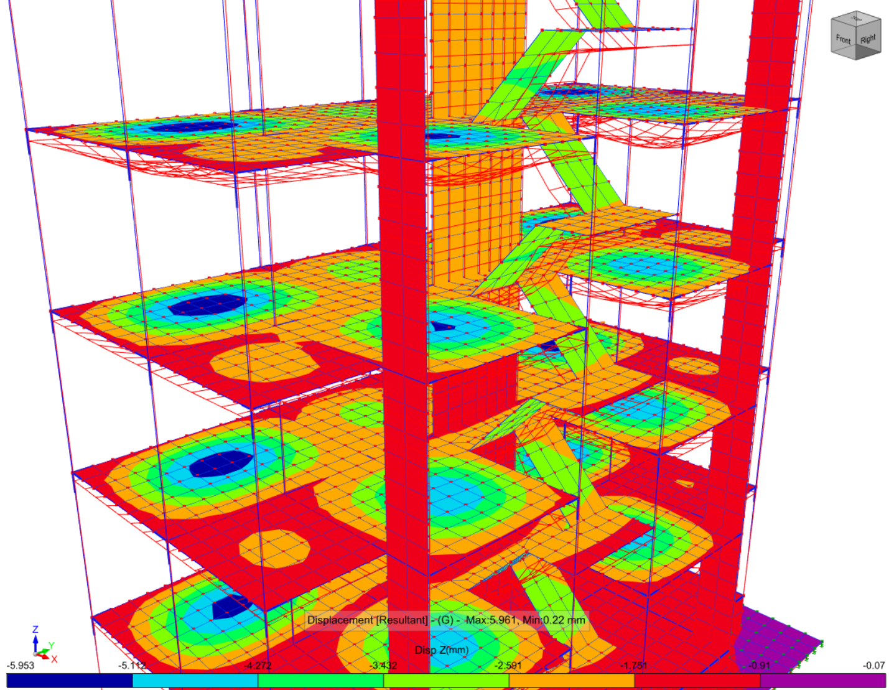

Shearwall Stiffness Modifiers Only in Critical Storeys
We are improving our seismic analysis and design capabilities with each version providing you with more effective tools that create huge differences when it comes to rigorous checks. ProtaStructure now brings a new option for Shearwall Stiffness Modifiers applied only in Critical Storeys for better control on simulating the structural behavior.
To activate this functionality, Check the “Do not Reduce the Stiffnesses of Walls Above Critical Height” option on Building Analysis > Model Options > Model > Material and Section Effective Stiffness Factors window.
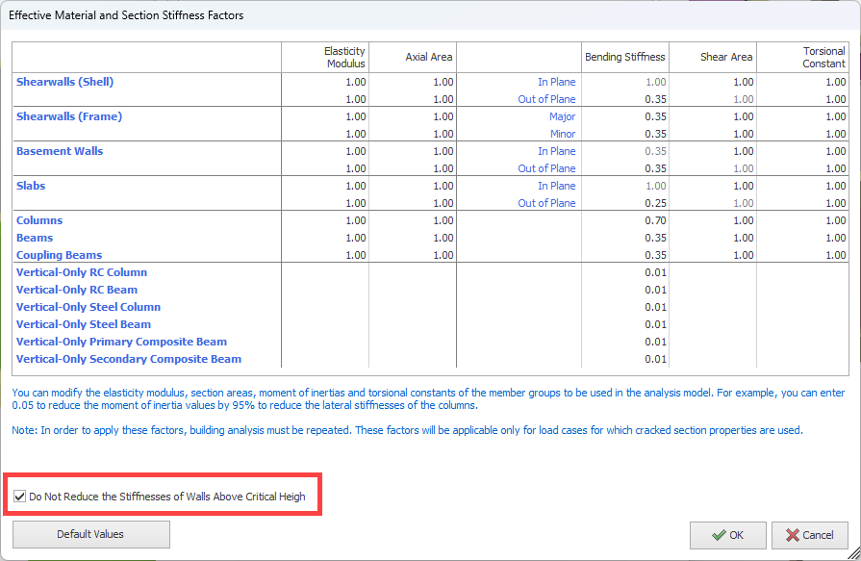

Automated Soil Dynamic Load Cases and Snow Drift Load Cases
In ProtaStructure 2026, we have taken a significant step forward in load calculation and combination capabilities. While ProtaStructure already supports the calculation of dynamic soil thrust and snow drift loads, users previously needed to manually create user-defined load cases to assign these loads.
With the latest version, ProtaStructure now introduces automated generation of soil dynamic load cases and snow drift load cases. These load cases are seamlessly integrated into the analysis process and are automatically combined with other load cases using the appropriate combination factors. This advancement not only simplifies the workflow but also ensures consistency and accuracy in structural analysis by minimizing manual input and potential errors. However, users are still required to manually assign the calculated loads to these automatically created load cases.
This enhancement empowers users to handle complex loading scenarios more efficiently, making ProtaStructure an even more robust and user-friendly tool for modern structural design.
You can define these additional load cases using the Loading Generator in ProtaStructure. Make sure you check “Define Combinations for Snow Drift Loads (Sd1, Sd2)” and “Create Dynamic Soil Load Cases” options.
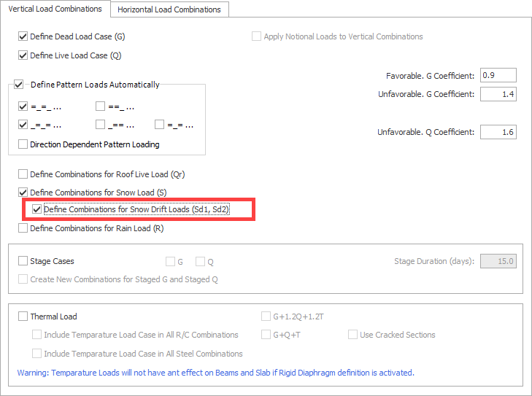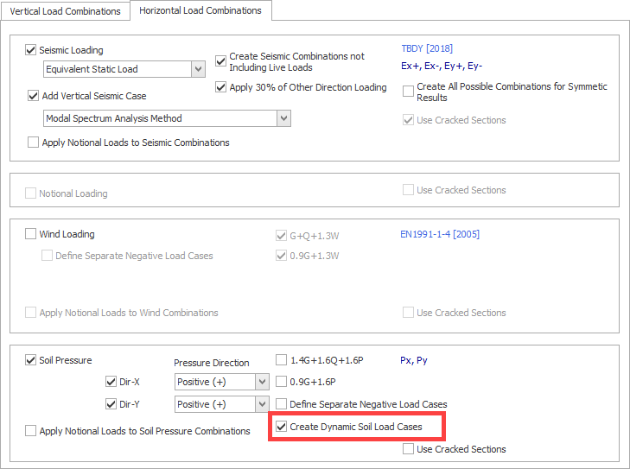

Automated Body Constraints in Column Outlines
We are continuously enhancing the automated analytical model in ProtaStructure to ensure compatibility with industry standards and accurate structural behavior.
ProtaStructure automatically crops column outlines from the finite element (FE) slab mesh in flat slabs and raft foundations. This well-established feature allows for more realistic and economical designs by eliminating the unrealistic peak stress values that occur when a column connects to a slab at a single point.
In ProtaStructure 2026, we have introduced a new feature—automated Body Constraints. This enhancement automatically defines constraints between column joints and adjacent slab mesh points, accurately simulating the effect of the column section on the mesh. The Body Constraints ensure that the joints on the top plane move as a rigid body, offering a more precise mathematical simulation and addressing the relative rigidity limitations of the previous rigid link approach.
Previously, ProtaStructure employed rigid links to connect column joints to slab mesh points. Although widely used in practice, this method introduced additional stiffness and complexity to the system of equations, indirectly affecting simulated behavior and design outcomes.
Note:
Rigid links will continue to be used where necessary, such as for connecting structural members with non-matching eccentricities, to maintain a consistent and well-formed analytical model. The automated Body Constraints feature is specifically applied to cropped column outlines in flat slabs and raft foundations.
Important Remark:
Joints with body constraints will not conflict with diaphragm constraints (if exists) which are also (optionally) defined automatically at floor levels. The DOFs relevant to horizontal diaphragms will not follow body constraint whereas other DOFs will follow it. If there is no rigid diaphragm (flexible diaphragm), all the slave DOFs will follow body constraint master joint, which is the column top or bottom joint.
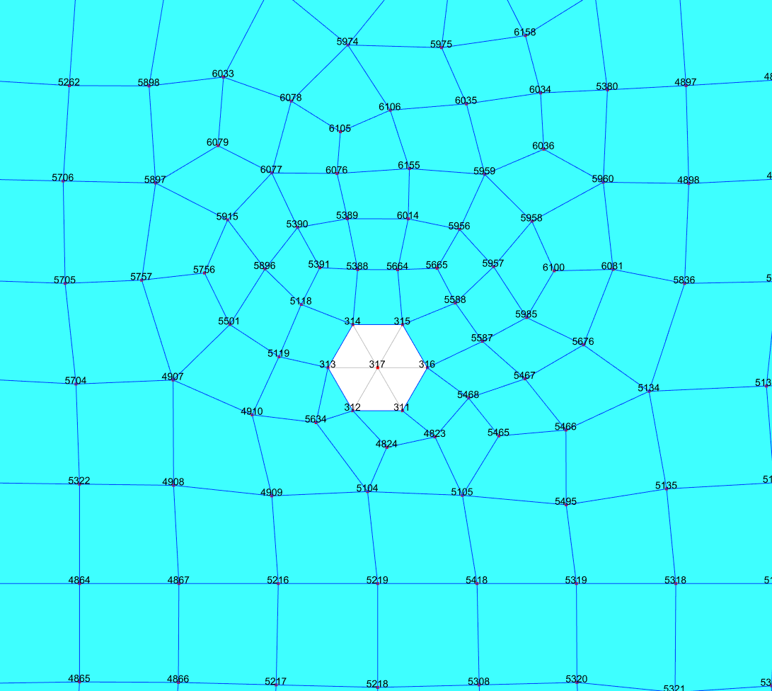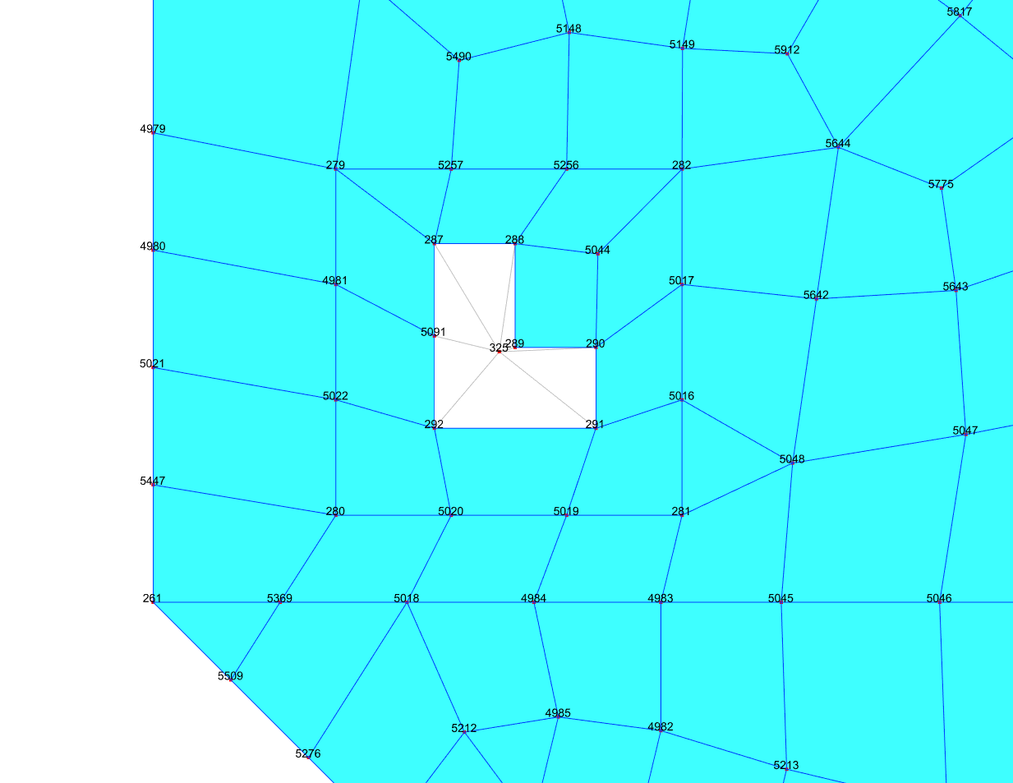

Automated Unit Conversion for Ground Motions
This feature was not a part of the initial ProtaStructure 2025 release, and it was released with 8.0.217 maintenance package. It is included here for our users who may not be aware of this feature. Feel free to skip this title if you are already familiar with this feature.
ProtaStructure allows users to input any ground motion record (accelerogram) manually. Accelerograms should be entered in gravitational acceleration (g) units. However, the downloaded accelerogram may be in one of m/s², gal (cm/s²) or ft/s² units, instead of ‘g’. You can now select the input unit while introducing the accelerogram to ProtaStructure. The accelerogram will be automatically converted to ‘g’ units.
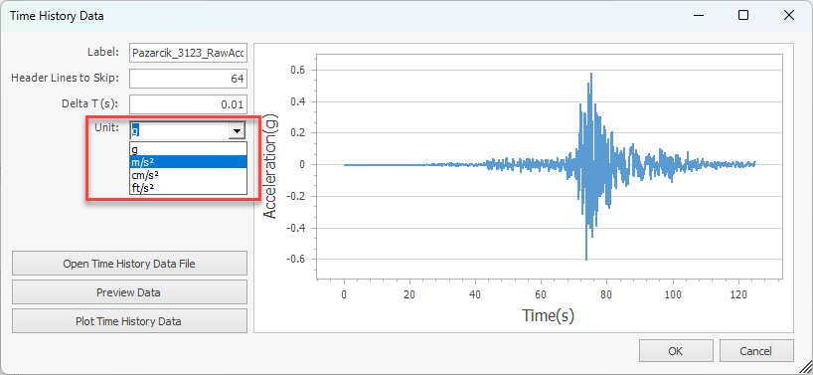

Modeling and Visualization

A Customizable Shortcut Editor
Engineers love shortcuts. But let’s admit some of the useful shortcuts were hidden and not customizable, even easy to forget. We have developed the new shortcut editor where you can review all program shortcuts and assign new key bindings. It was a frequently asked feature, indeed.
The shortcut editor is located at Settings > ProtaStructure Environment > Shortcut Key Bindings menu.
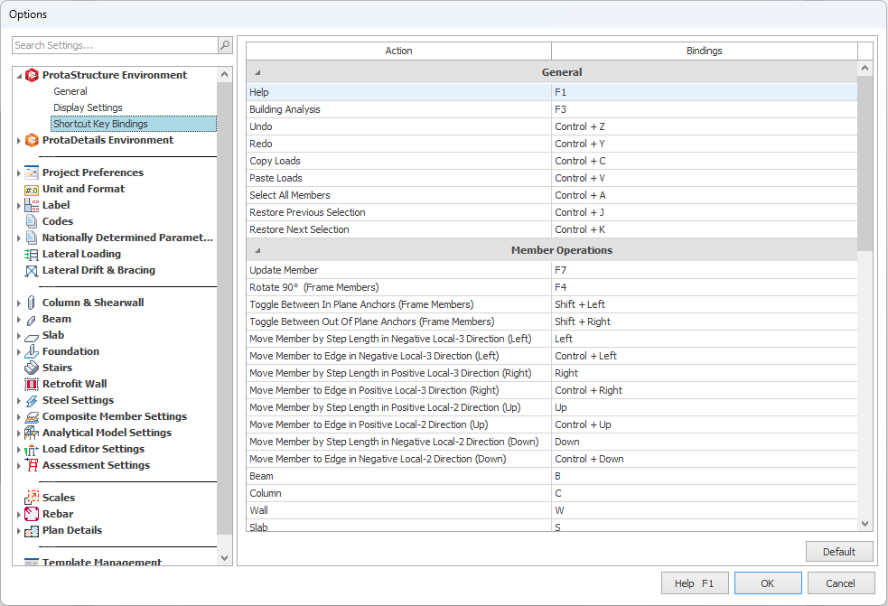

Changing the Key Bindings
To change the key bindings,
- Double click on the Bindings cell next to any action.
- “Please enter shortcut…” prompt will be displayed on the screen and the UI will be in listening mode waiting for you to enter the key combinations using the keyboard.
- Enter the new key combination for the action.
Note:
If the new key combination is used by another action, you must first change the binding for that action and make sure that the new key binding is not used by any action. You can then assign it to the action you want.

Additional Shortcuts
With the New Shortcut Editor, comes additional new key combinations for some of the most frequently used commands. Additionally, the capabilities of some of the commands have been improved.
- Insertion commands of different member types can now be bound to their individual key combinations.
- All members in the arena can be selected using a new key combination (CTRL+A by default)
- Right-Click Context Menu now suggests assigned shortcut keys.
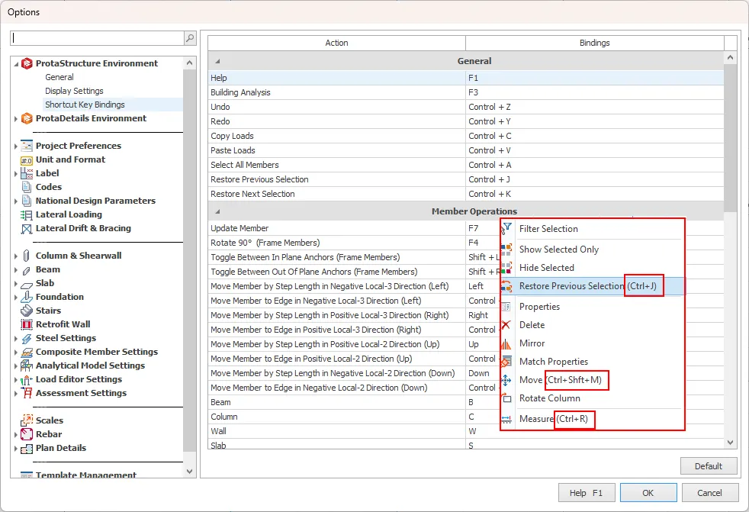

Architectural DXF Drawing Overlay in Load Editor
ProtaStructure 2026 introduces a transformative feature that elevates the load definition process: the ability to overlay architectural DXF drawings on the interactive load editor. With this enhancement, users can seamlessly reference architectural plans while defining loads, ensuring alignment with the design intent. Additionally, the capability to snap directly to points within the DXF drawing enables precise load placement, enhancing accuracy and reducing potential errors. The DXF drawing is meticulously positioned at the exact coordinates specified in the main modeling screen, ensuring consistency and coherence between the structural model and the architectural layout. This feature streamlines workflows, offering greater precision and efficiency in load definition.
To display the architectural drawing in the load editor:
- Load a DXF drawing on the main modeling screen using the Building Setout > External Reference Drawing command. Please note that different DXF drawings can be inserted for different stories. Details of how to load a DXF drawing are out of scope of this document.
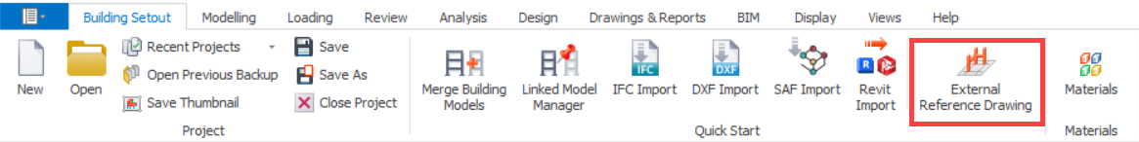

- Open the load editor for the active storey or a selected member.
- Click the Show XRef Drawing button on the vertical toolbar to show/hide the Xref drawing in the load editor.
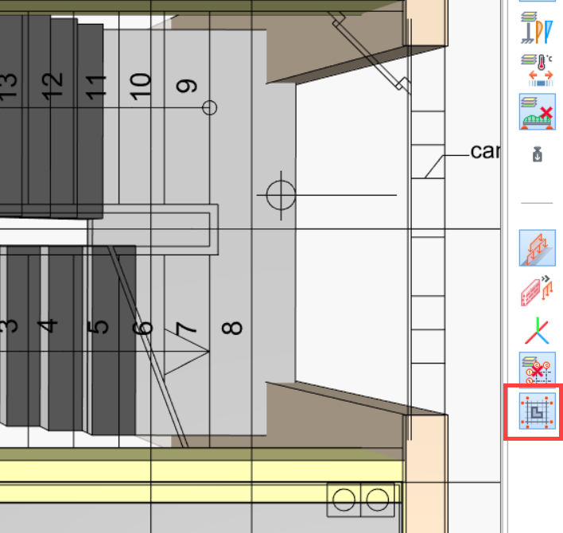
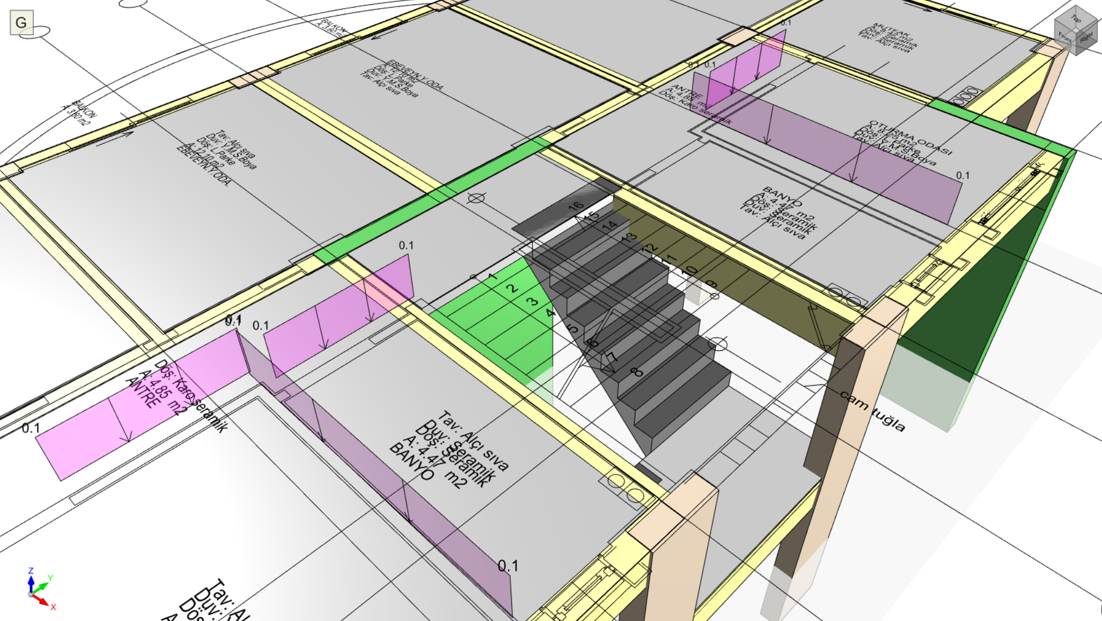
Load Editor opened for the active storey, displaying all members at that storey together with the DXF drawing on top of them.
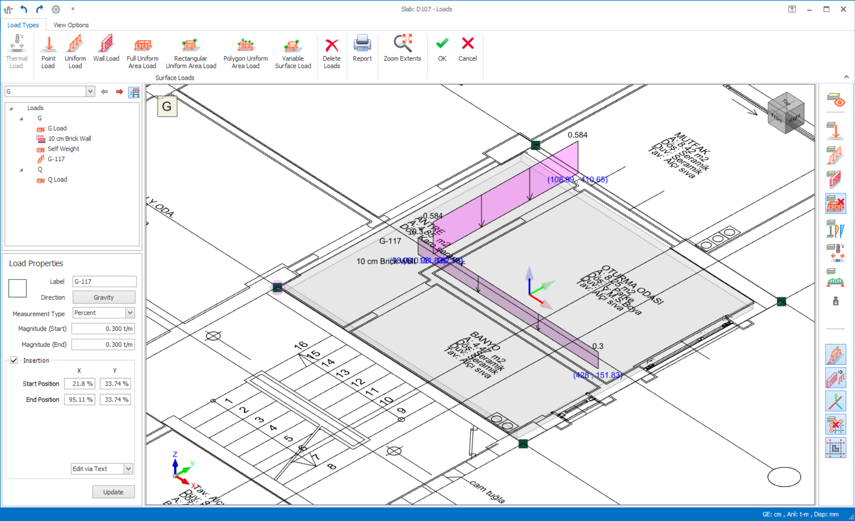
Load Editor opened for a selected slab. The XRef drawing can be shown even if a single member is selected.

Snap to XRef Drawing Points to Insert Loads
Once the architectural drawing is displayed on the load editor, you can start inserting loads by snapping to points on the architectural drawing. You can snap Line End Points, Mid Points and Intersections. Smart Points on the line will also be highlighted at the ends and middle points.
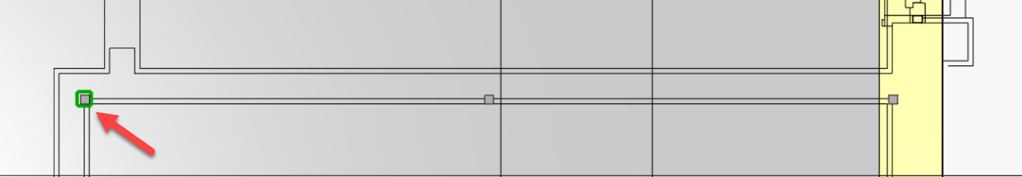
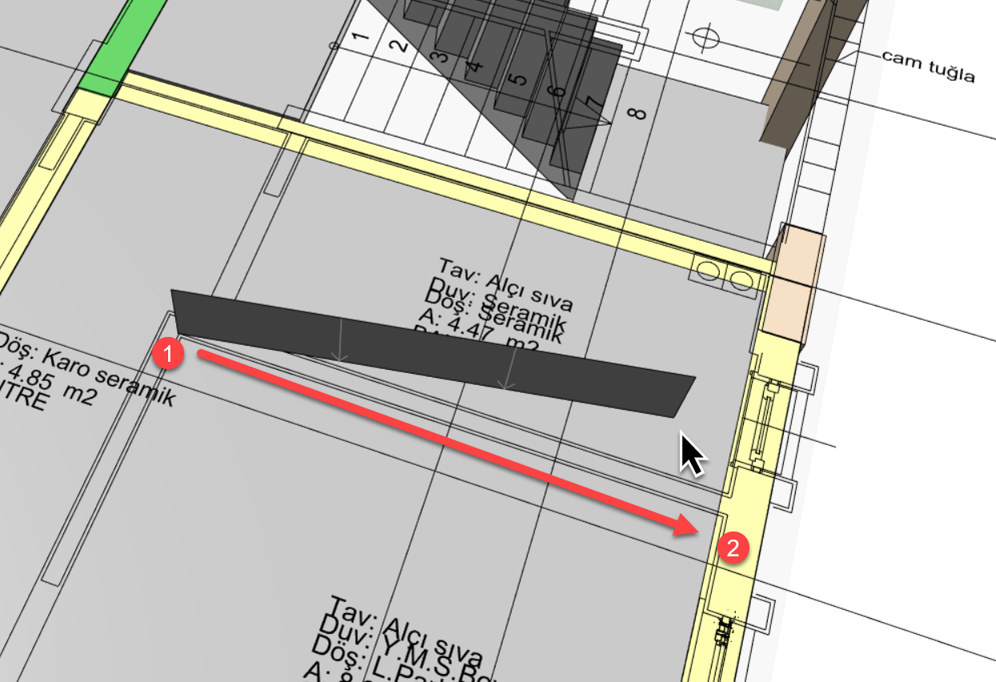
Inserting a line load or a wall load on the load editor by snapping to DXF points.

Continuous Girts (and Purlins)
In previous versions of ProtaStructure, girts were automatically cut at every support, and a new girt frame was inserted after that.
With ProtaStructure 2026, you can now specify a Maximum Member Length (Cut Length) for girts. You can access this setting from Steel Settings > Member Design.
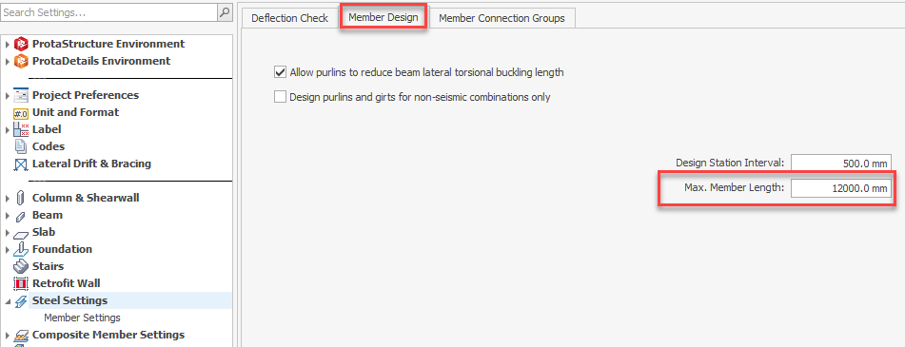
To model a continuous girt:
- Specify the cut length using the Steel Settings > Member Design > Max. Member Length field. The default value is 12 m.
- While inserting the girt, check the Continuous Girt option on the Girt Properties Window.
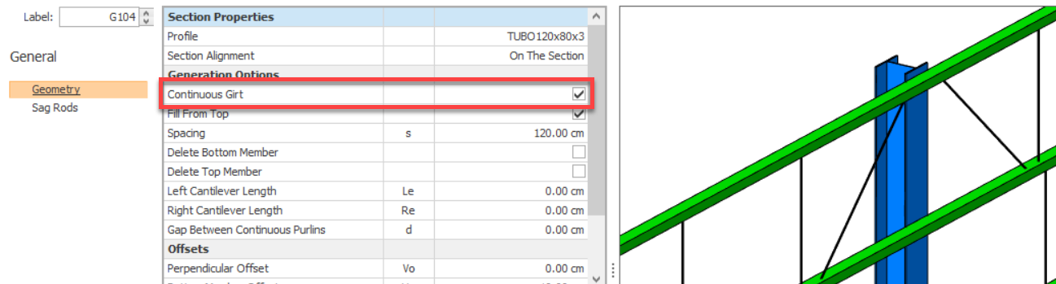
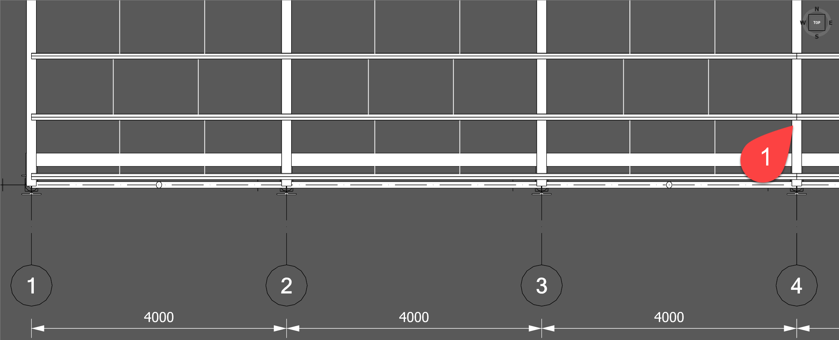
Continuous Girt/Purlin Option Checked: The purlin/girt is only cut at third support. Cut length is specified as 12 m in a 4 m bay frame
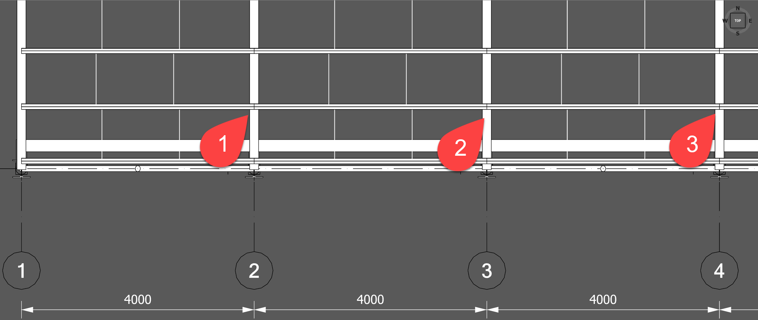
Continuous Purlin/Girt Option Unchecked: The purlin/girt is cut at each support

Continuous purlins were already introduced with the previous version. With ProtaStructure 2026, we are now introducing the same feature for girts.

The purlins and girts will be cut from the closest support to the given cut length, ensuring they don’t exceed the manufactured steel length.
Between the cut points they will be treated continuous and end releases will be assigned accordingly. They are also communicated to ProtaSteel with the correct cut length and end releases so that you have a fabrication-compatible structural model.

Display Support Reactions in Analysis Post-Processor
ProtaStructure now features the ability to display support reactions with vector graphics under the supported members. This highly requested feature is now available, enhancing visualization and analysis capabilities for users.
To display the support reactions:
- Open the analysis post processor window.
- Check Support Reactions button under Members > Nodes ribbon group.
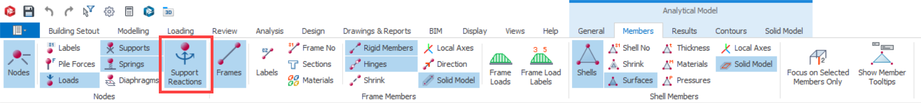
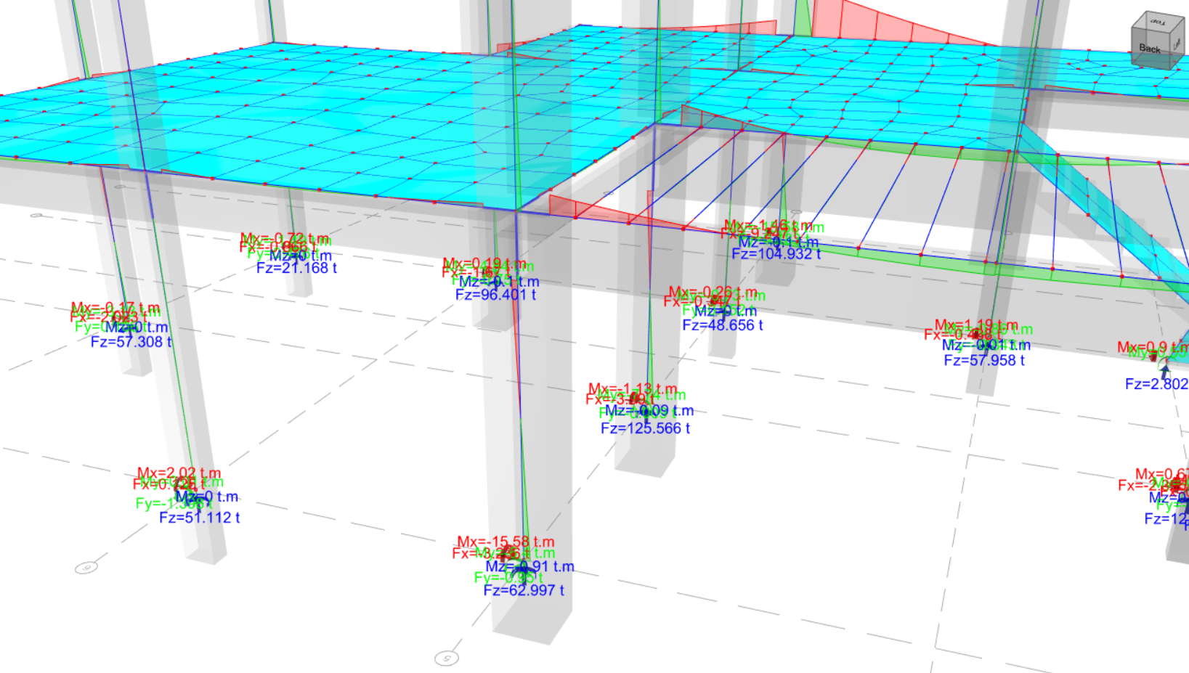
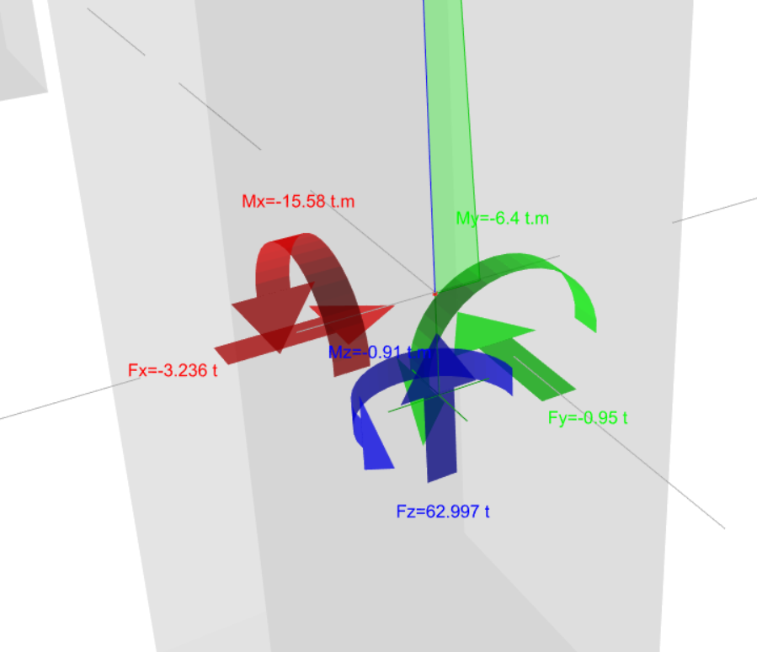

Contour Labels in Analysis Post-Processor
To improve clarity in contour presentation of shell stresses, displacements and forces, we can now display the contour labels on the contour lines in analysis post-processor. You can turn on the contour label display using the Contours > Display Values on Lines option on ribbon bar.
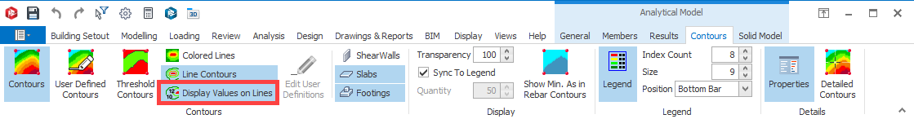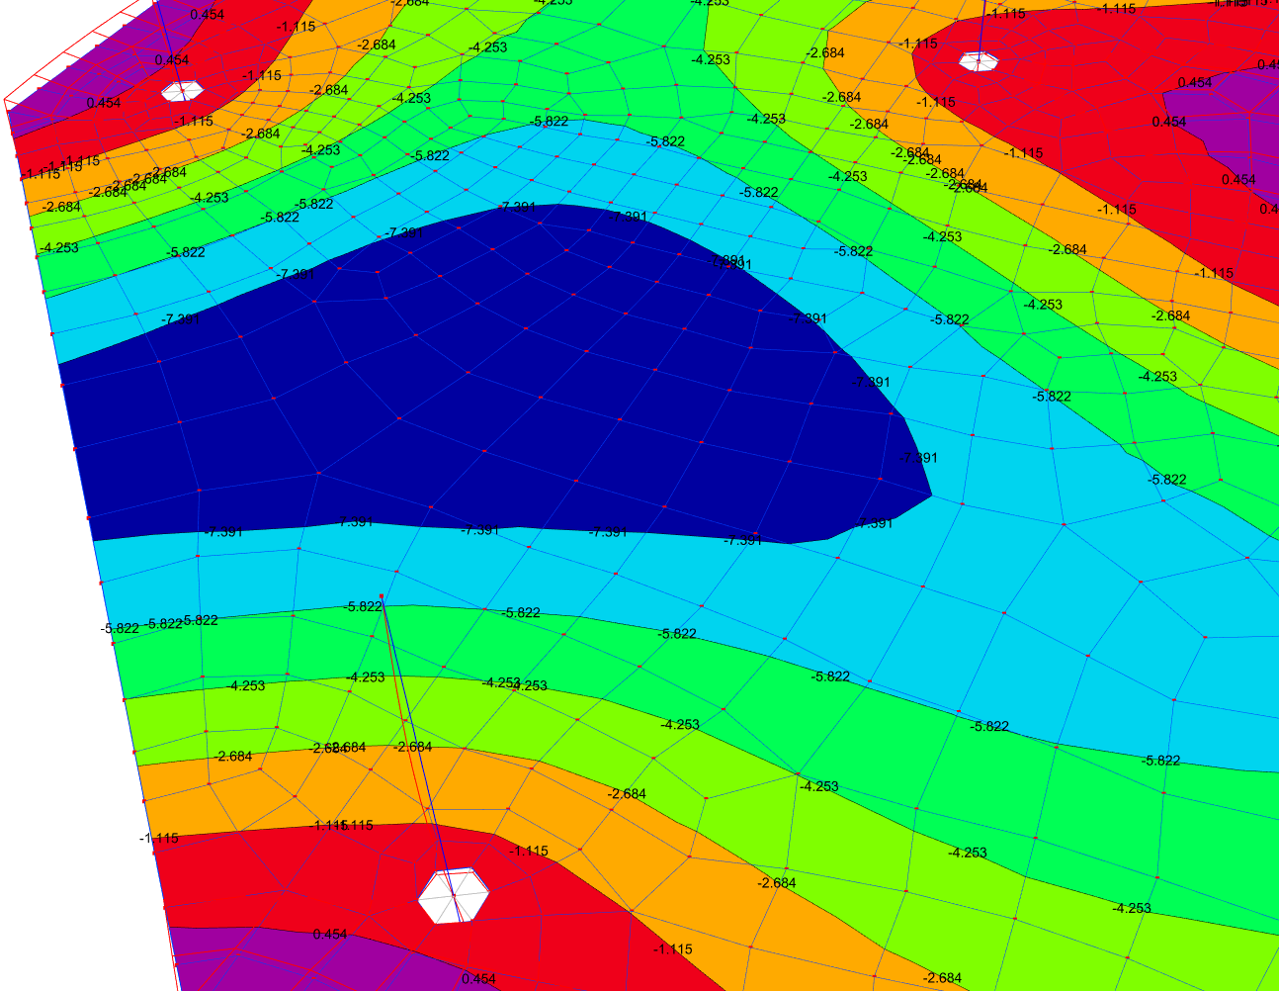

Contour Legend at the Bottom in Analysis Post-Processor
A new placement option for FE contours is introduced in ProtaStructure 2026. The legend can be placed horizontally at the bottom of the screen to preserve more space and to provide better presentation. The new placement can be adjusted using the Contours > Legend > Position option on the ribbon bar.
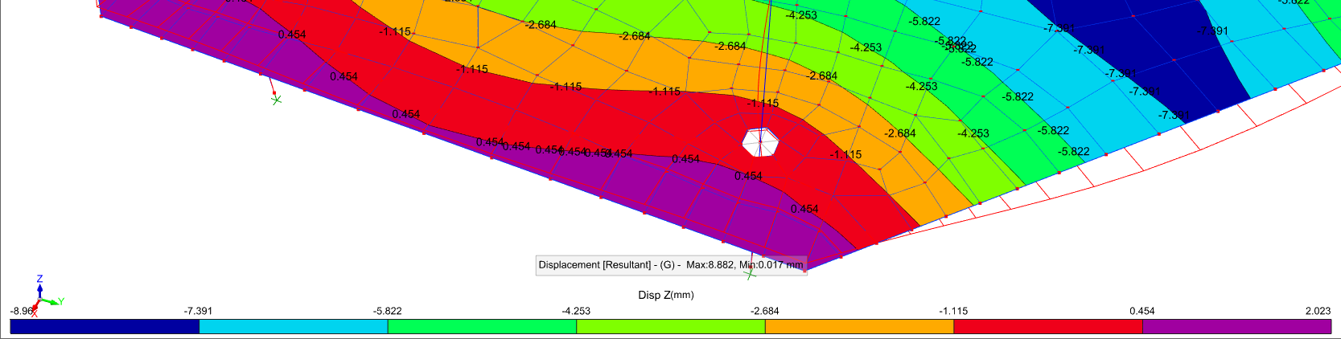

Exclusive Default Materials for Steel Members
With every new version, we strive to develop more efficiency and intuition into ProtaStructure. The “Frame Members" entity is now removed from material library. Instead, the material system will make use of the frame member types to identify the default materials. In addition to this, default materials for welds, bolts and plates are added for base plate design.
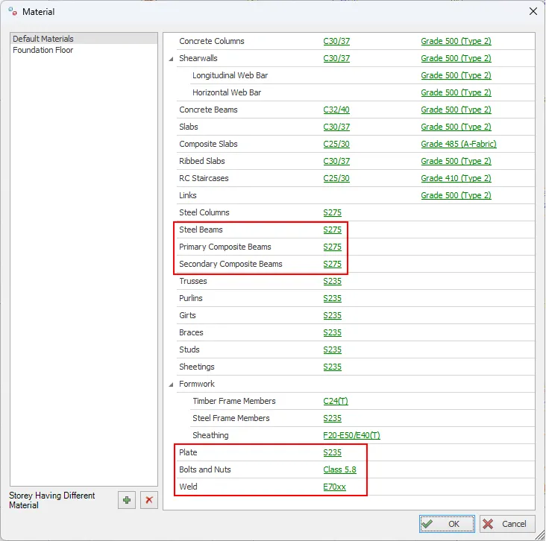
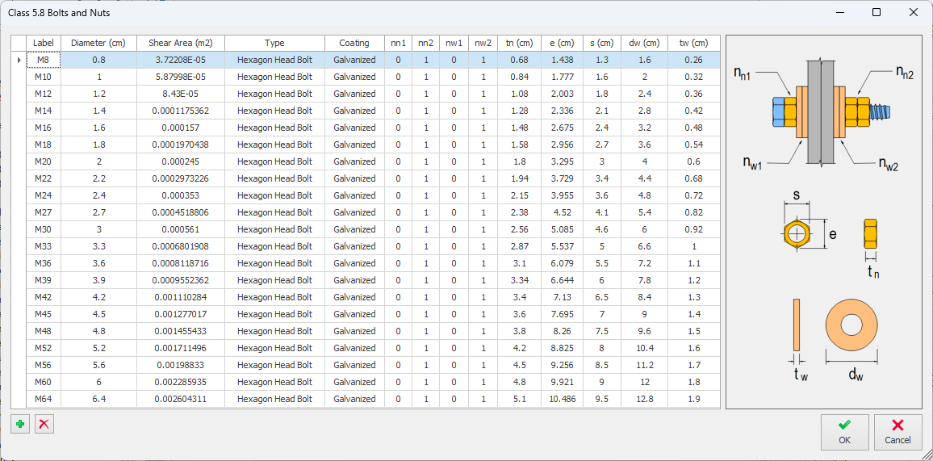

New Metal Deck Types in Library
This feature was not a part of the initial ProtaStructure 2025 release, and it was released with 8.0.217 maintenance package. It is included here for our users who may not be aware of this feature. Feel free to skip this title if you are already familiar with this feature.
RUUKKI metal deck types are now available in Metal Deck library when Poland template is selected.
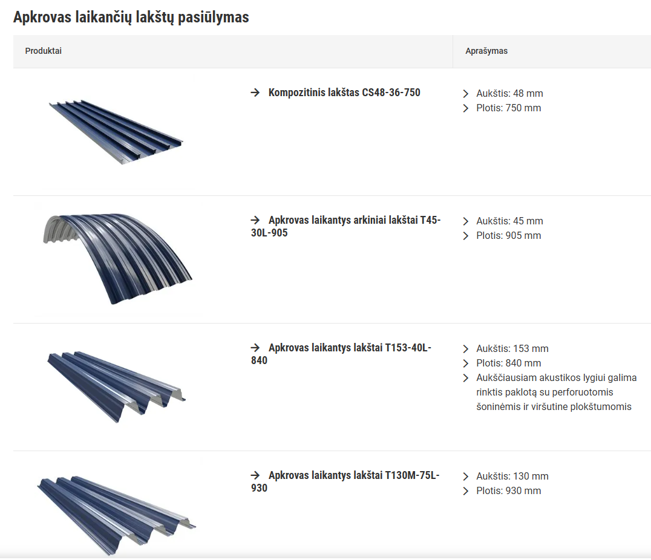
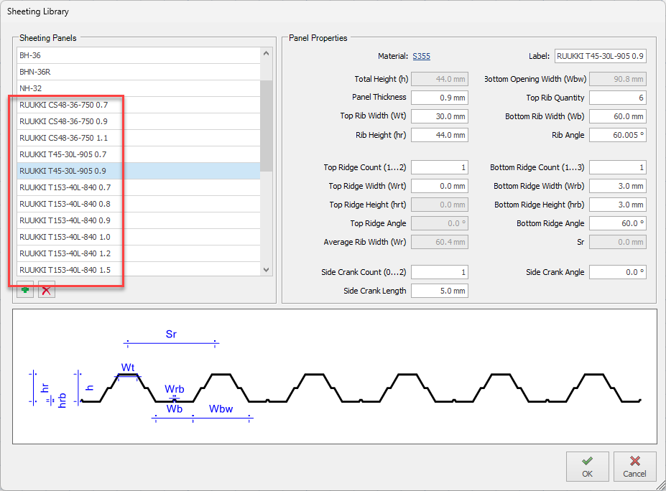

Extended Cold-Formed Section Library
The cold-formed profile catalog in ProtaStructure was extended to support face-to-face and back-to-back C-shaped sections.
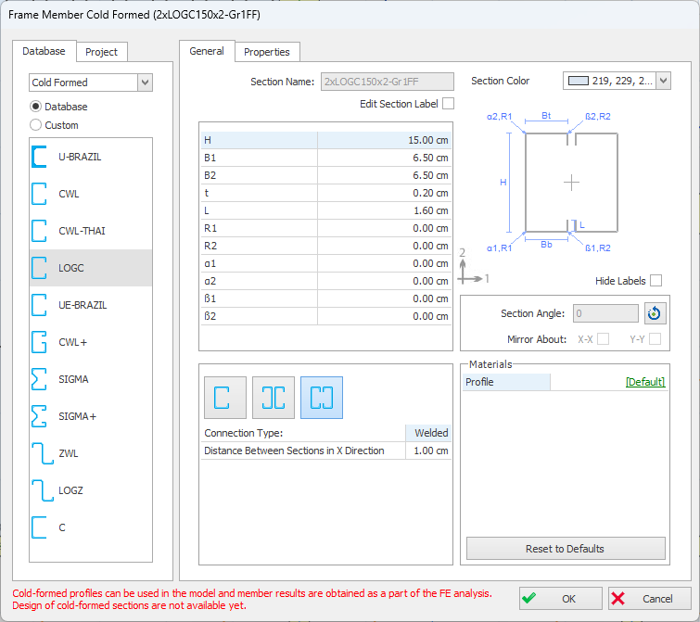
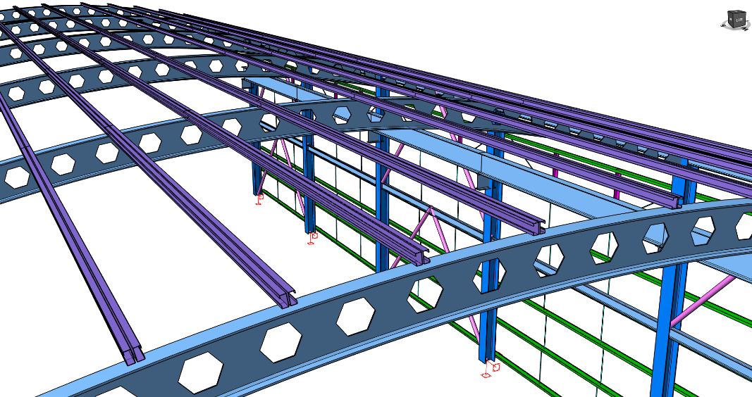

Utilization Ratio Coloring for RC Members
ProtaStructure is famous for interactive and automated design of RC, steel and composite members (composite metal decks). As a result of the design, each member will have governing design utilization ratios. With the help of the powerful visual interrogation feature, you can color-code the utilization ratios based on their severity levels. Previously, only steel members were color-coded. With the latest version RC members are included.
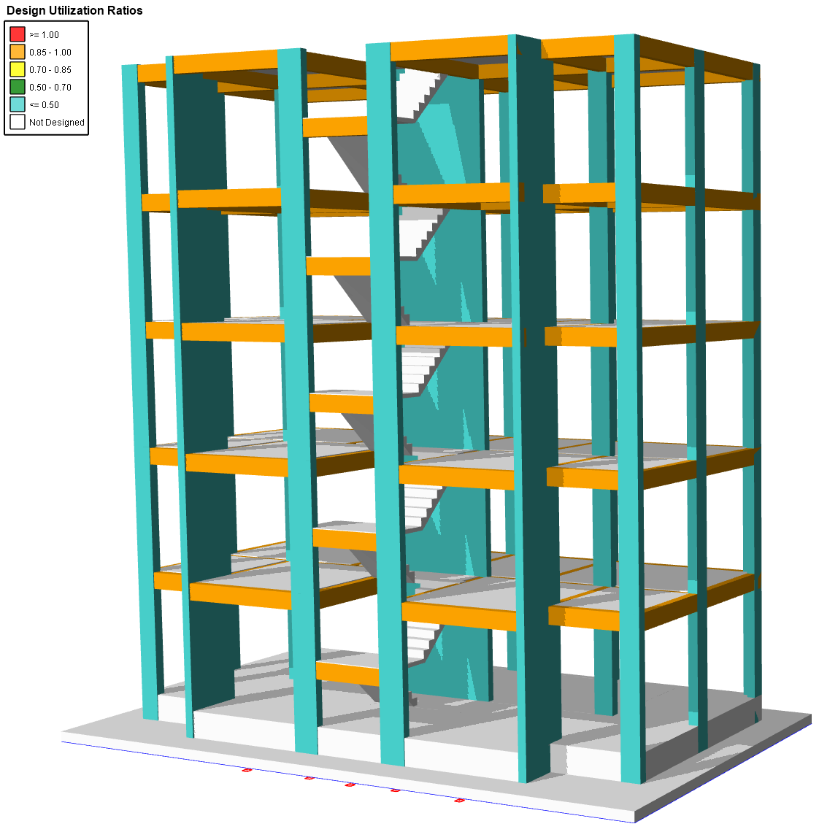
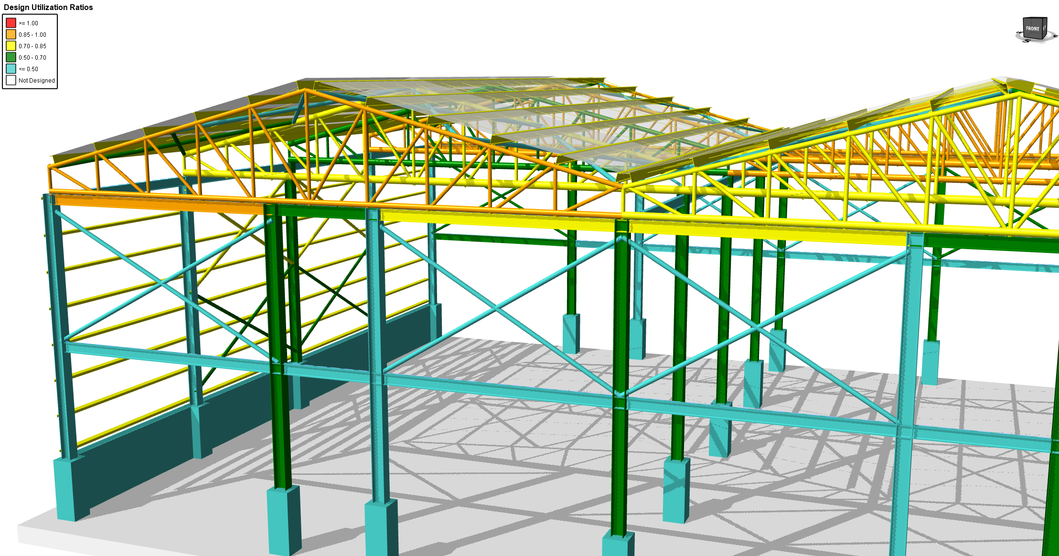

Color Assignment to Loads
ProtaStructure 2026 introduces a highly versatile feature that empowers users to assign unique colors to various load categories, including Self Weight, Additional Loads, FE Loads, Parapet Loads, Compensation/Correction Loads, and Composite Construction Stage Loads. This functionality enhances visual clarity, allowing for easier distinction and management of different load types within structural models.
Furthermore, users can assign custom colors to individual loads, independent of their assigned category, offering additional flexibility and personalization during the design process. Importantly, if an individually colored load is deleted or recalculated, its color will automatically reset and revert to the default color of its category, ensuring consistency and eliminating potential discrepancies in load visualization. By improving the visual organization of load data, this feature not only reduces potential errors but also streamlines the analysis and review process, significantly improving overall design efficiency and accuracy.
This feature is active by default. You can customize the colors for the load categories from Options > Load Editor Settings > Category Colors.
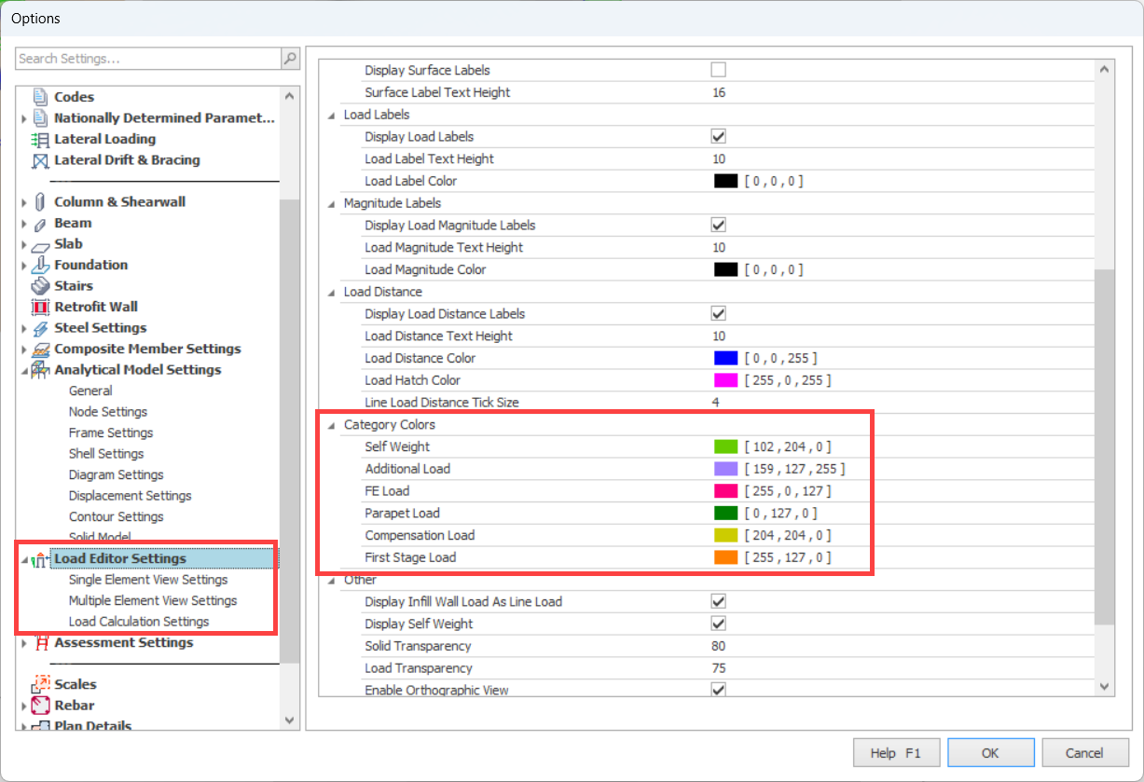
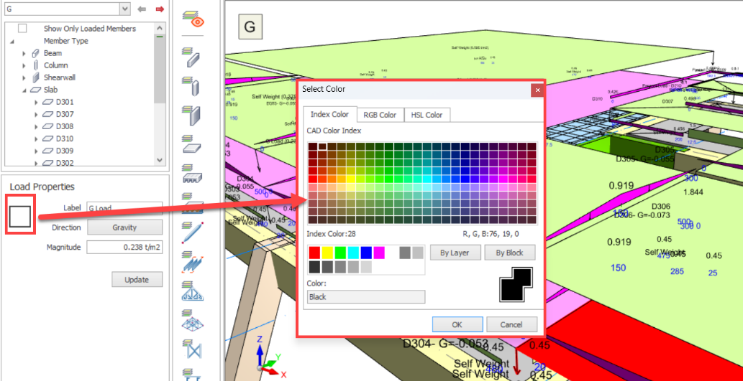
Changing the individual load colors.

Enhancements in Member Relabeling
Member relabeling was extended to cover more member types including axes, steel frames, trusses, space trusses and so on. In addition to this, relabeling algorithm was enhanced for more robustness and flexibility.
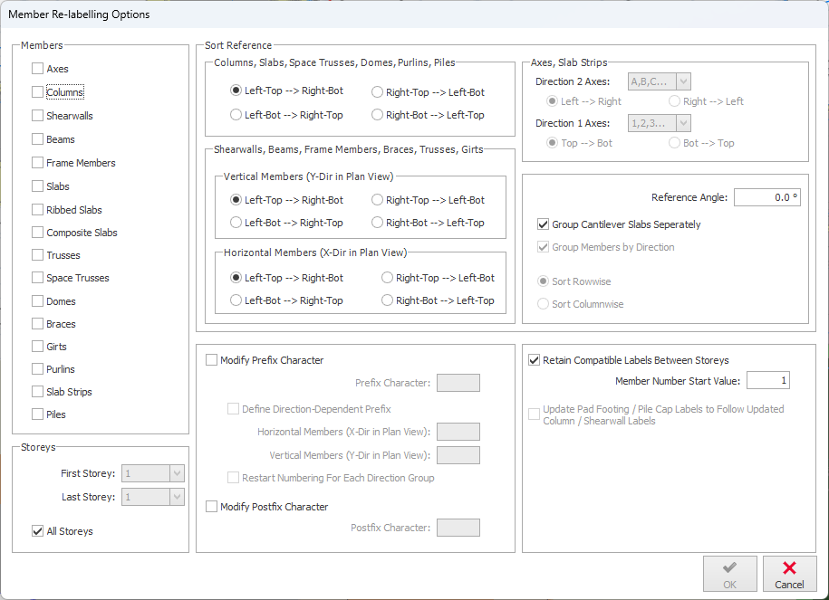

View Modes in Right-Click Menu
3D view display modes are now accessible via Right Click > View menu. View type can also be changed by hitting CTRL+D keyboard shortcut consecutively. This shortcut can be customized using the Shortcut Editor, which was again introduced with ProtaStructure 2026.
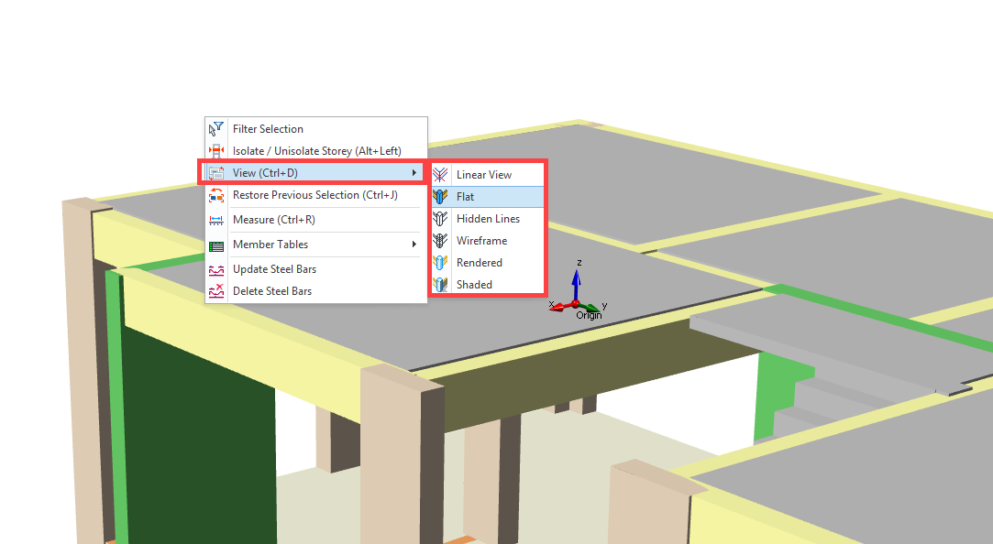

Number of Studs and Camber in Frame Labels
This feature was not a part of the initial ProtaStructure 2025 release, and it was released with 8.0.217 maintenance package. It is included here for our users who may not be aware of this feature. Feel free to skip this title if you are already familiar with this feature.
ProtaStructure is now able to append the “Number of Studs” and “Camber” information to the composite frame labels when you design composite slabs in your model. This information is also visible in ProtaDetails floor plan drawings.
To enable the display of stud and camber information:
- Navigate to Settings > Label
- Check “Display Composite Beam Stud Quantity” and “Display Composite Beam Camber Value” options.
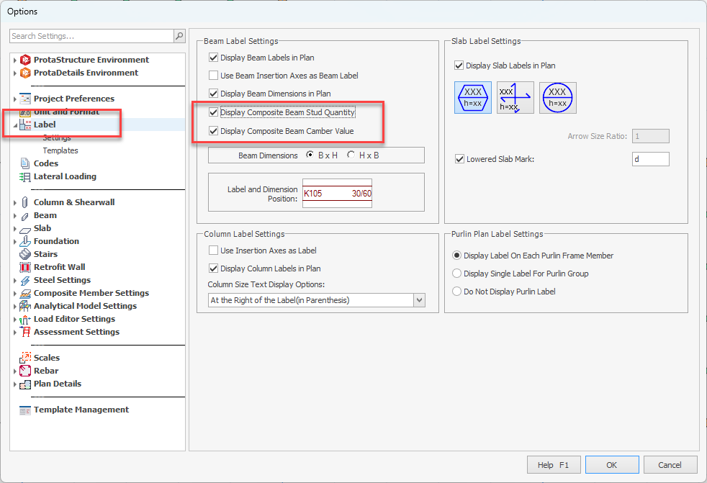
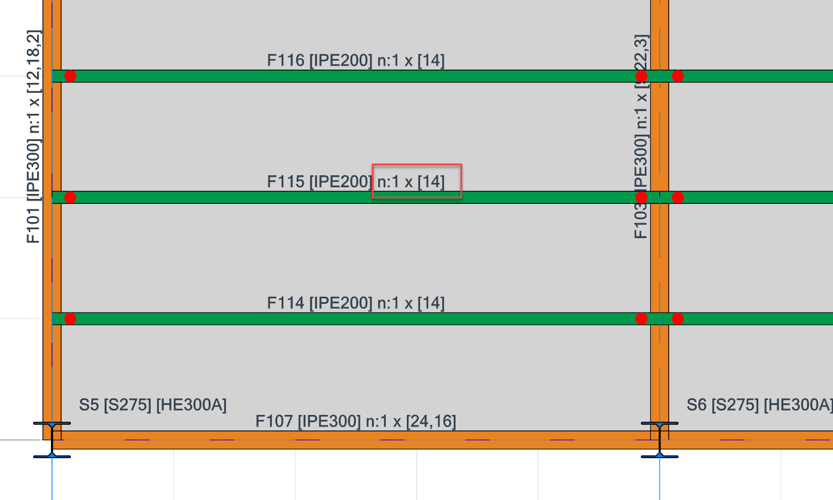
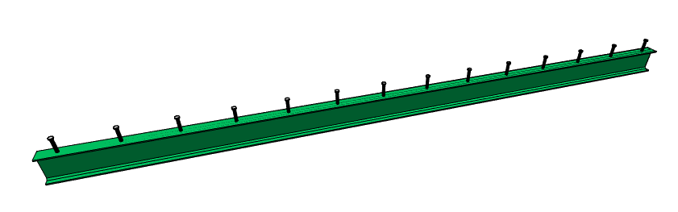

Support Assignment and Cantilever Frame Members
This feature was not a part of the initial ProtaStructure 2025 release, and it was released with 8.0.217 maintenance package. It is included here for our users who may not be aware of this feature. Feel free to skip this title if you are already familiar with this feature.
Support (Restraint) assignment and Free-End Specifications are now moved to ‘General’ tab on the Frame Properties window for easier access.
In addition to this, frame free ends will not be automatically determined by ProtaStructure anymore. It has been evident from various user models and scenarios that automated determination causes modeling and design confusions since frame members have a wide range of flexible usage options and scenarios.
Important
Frame member free ends (cantilever ends) will not be automatically set by ProtaStructure, anymore. Although analytically having no effect in analysis results, the free ends play an important role in steel deflection checks. It is important that you set them manually for cantilever frame members.
ProtaStructure will not allow you to designate member ends as free, if there are columns or walls connected at a particular end.
If one of the member ends is not connected to any column or wall and if you want to designate it as ‘Cantilever’ you have two options:
Alternative 1:
- Select the member
- Pick the Mark Free End of Cantilever Beam command on the Right Click menu.
- Select one of ‘I End Free’ or ‘J End Free’ options.
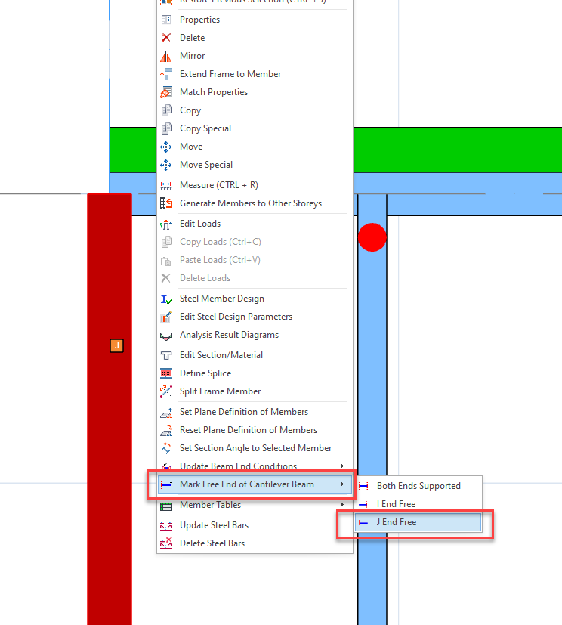

Alternative 2:
- Select the member and open the Properties window.
- Check one of ‘I End Free’ or ‘J End Free’ options under General tab.
- These options will be disabled if columns or walls are connected to the member ends.
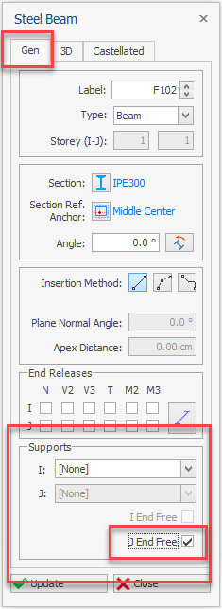

Optimized Ribbon and Right Click Menu
The ribbon menu, contextual menus, and right-click menus have been optimized, and commands have been streamlined for smoother usage.
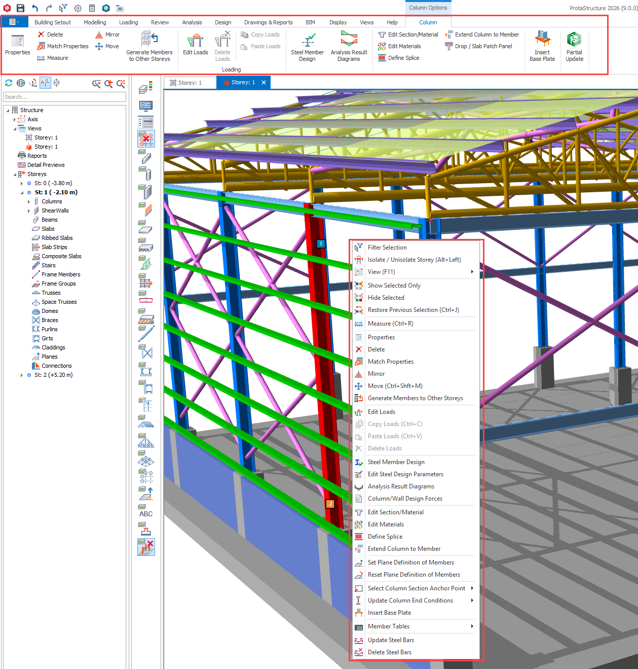

Frame Member Storey Assignment
This feature was not a part of the initial ProtaStructure 2025 release, and it was released with 8.0.217 maintenance package. It is included here for our users who may not be aware of this feature. Feel free to skip this title if you are already familiar with this feature.
Structural members in ProtaStructure are assigned to storeys for easy manipulation, mass and load calculation. However, with the introduction of general-purpose frame members, the models created with ProtaStructure are getting more and more sophisticated, thanks to our creative users and our development team.
When you insert a frame member, ProtaStructure will automatically assign the closest storey to the member. To provide flexibility to our users, we have added a new setting for frame member storey assignment with the latest update.
- Navigate to Settings > ProtaStructure Environment > Storey Assignment Method
- Select “Assign the first storey with greater Z-coordinate” or “Assign the storey with the closest Z-coordinate” option.
The frame members’ I and J end z-coordinates are checked against the storey z coordinates. If you select the “Assign the first storey with greater Z-coordinate” option, the first storey whose z coordinate is greater than the member end coordinate is assigned to that end of the member. If you select the “Assign the storey with the closest Z-coordinate” option, always the closest storey is assigned.
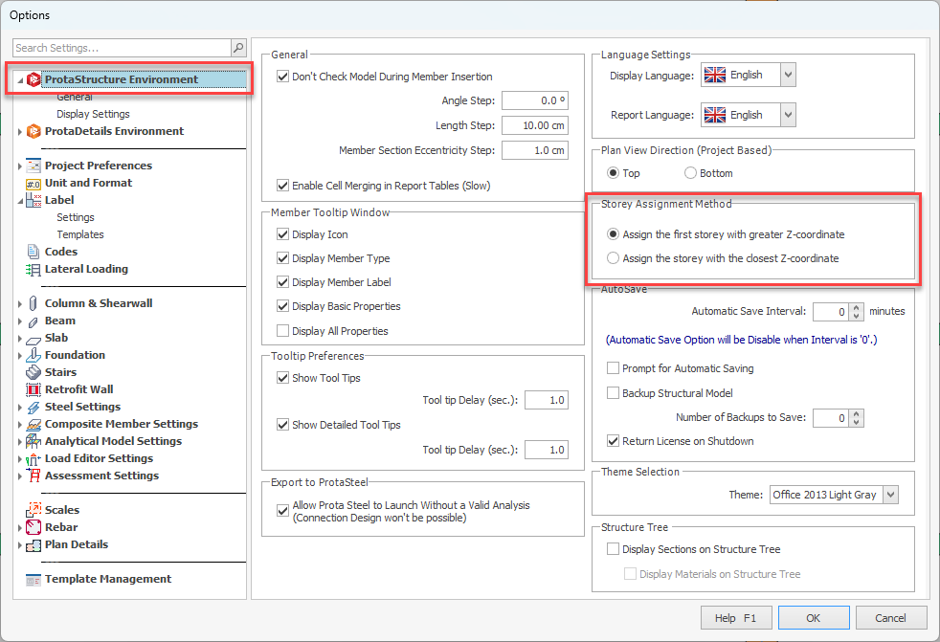

Search by Labels in Analysis Post-Processor
You can now interrogate the analytical model by physical member labels to pinpoint the analytical representation of a physical member.
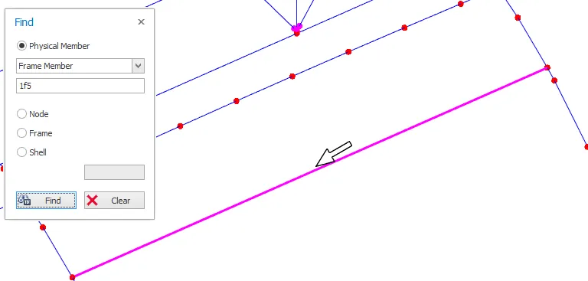

Section and Material Labels in Analysis Post-Processor
The labels shown on analytical lines and shell elements are appended with physical material and section names for easier review. Previously, analytical material and section IDs were displayed which had less practical use.
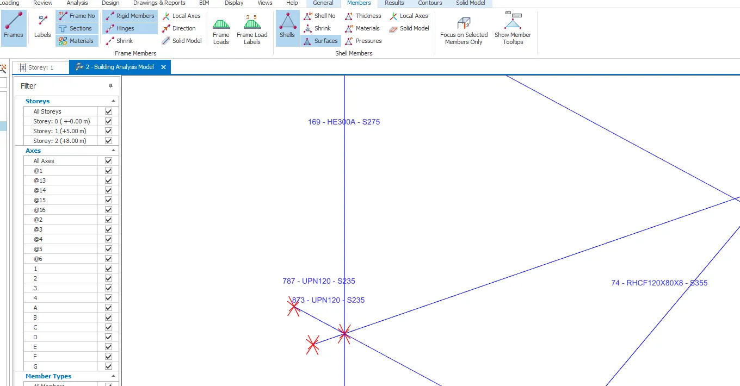

Advanced BIM Integration

Support for IFC4 Format
This feature was not a part of the initial ProtaStructure 2025 release, and it was released with 8.0.217 maintenance package. It is included here for our users who may not be aware of this feature. Feel free to skip this title if you are already familiar with this feature.
IFC4 (Industry Foundation Classes version 4) plays a crucial role in the construction industry by enhancing data interoperability and standardization. It addresses many limitations of its predecessor, IFC2x3, by supporting more complex geometries, such as b-spline surfaces and curves, which improves the performance of models with curved elements. IFC4 also facilitates better energy calculations and advanced simulations, making it easier to integrate sustainability considerations into building designs. Additionally, it enhances BIM (Building Information Modeling) to GIS (Geographic Information Systems) interoperability, which is vital for infrastructure projects. Overall, IFC4 promotes a more seamless exchange of information across different software platforms, improving collaboration and efficiency in construction projects.
At Prota Software, we are dedicated to integrating the latest BIM support, including IFC4, into our solutions. Our commitment ensures that our users benefit from seamless information exchange, improved collaboration, and increased efficiency in their construction projects.
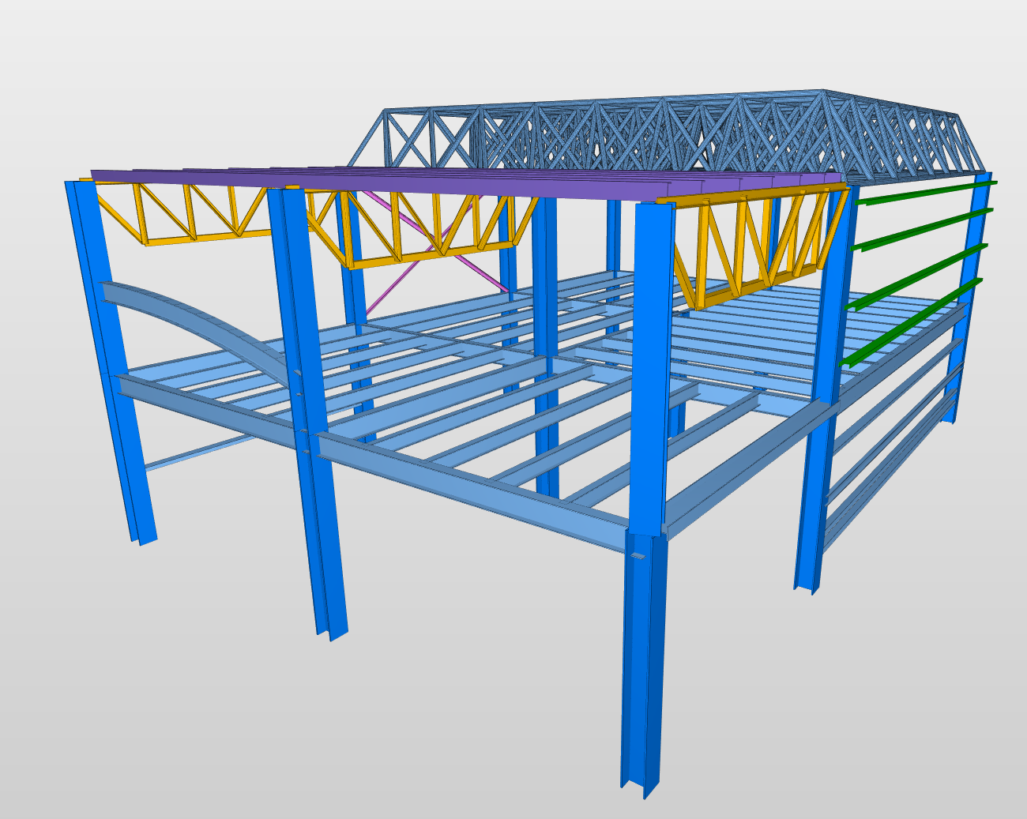
A view of IFC4 file exported from ProtaStructure. IFC4 provides better support for curved members and provides styling of members with custom colors

IFC-Singapore Template
ProtaStructure 2026 now supports IFC-SG (Singapore) template, enhancing its capabilities in Building Information Modeling (BIM). The IFC-SG template support is particularly crucial for digital BIM project submissions as a part of the CoreNetX project by BCA, ensuring compliance with local standards and carbon footprint reduction. Additionally, IFC4 offers greater flexibility in coordination, allowing for more efficient and accurate data exchange between different software platforms. This dual support empowers engineers to streamline their workflows and achieve higher precision in their projects.

Export Internal Forces to IdeaStatica
In our previous version, we introduced the IdeaStatica export feature, which received great feedback from our users. In this version, we have enhanced it further by allowing users to export the internal forces acting on the connections to IdeaStatica in a tabular format.
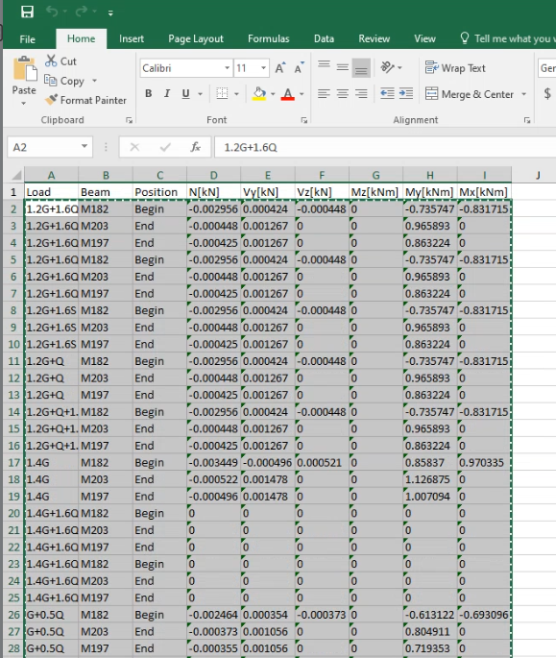
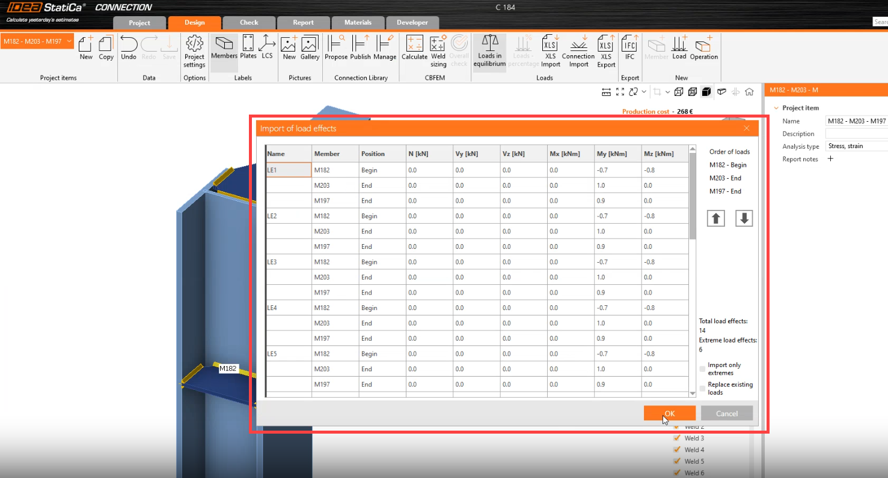

Steel Material Lists in ProtaStructure
ProtaSteel already provides a detailed material list and quantity take-off using the fully connected and non-clashing fabrication model. However, our users also requested steel material lists to be extracted from ProtaStructure models. This is now possible with ProtaStructure 2026.
To obtain the steel material lists in ProtaStructure:
- Click Drawings&Reports > Quantity Extraction Tables ribbon button.
- Previously, only Concrete and Formwork quantities were available. Now, you will see additional options for Steel members, Metal Decks in Composite slabs and Shear studs.
- Pick the Steel option for getting the lengths and weights of steel profiles used in the project.
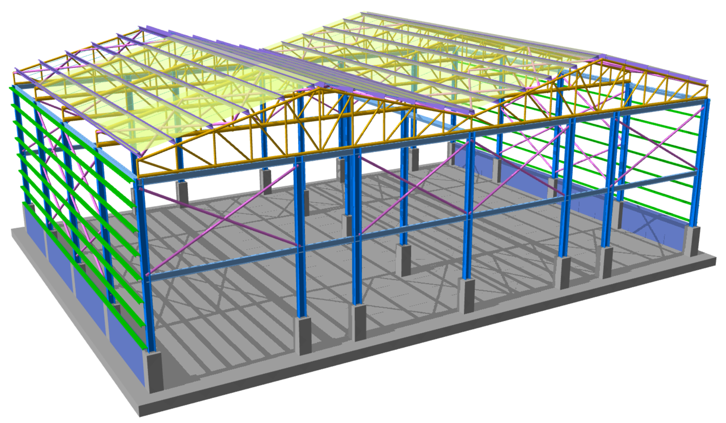
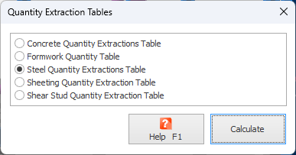
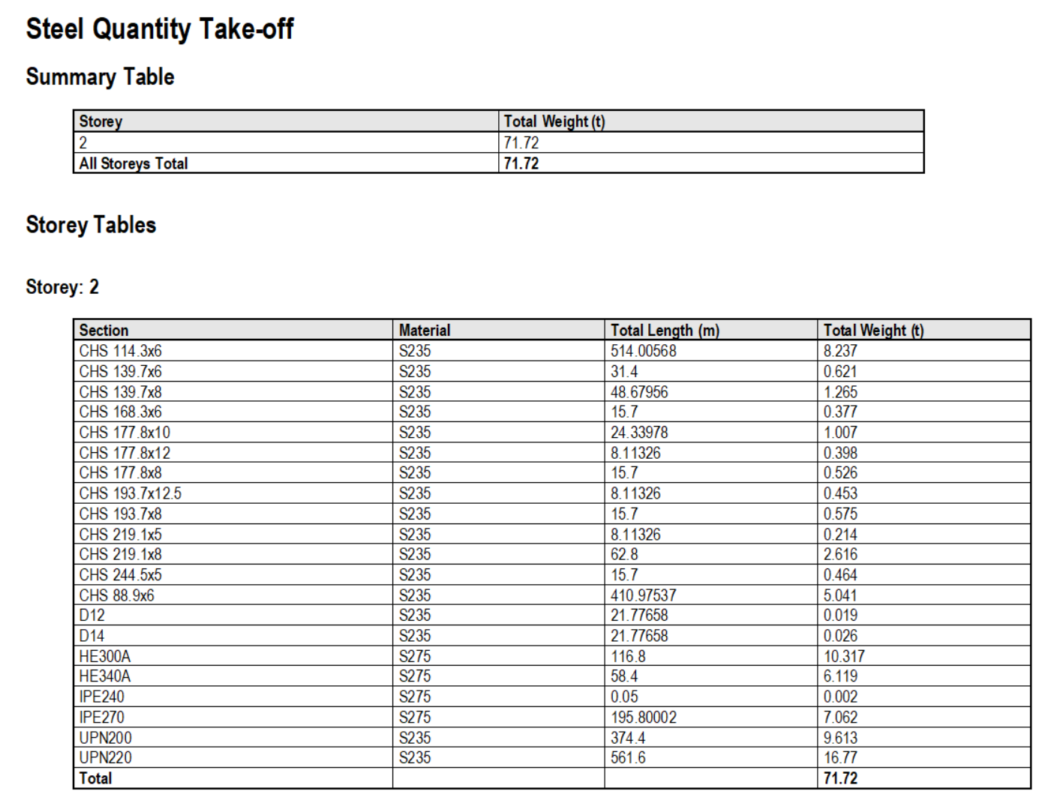

Remark:
In ProtaStructure, steel models do not include connections (except for base plates). Members are connected at the structural nodes, which means the member lengths might not be as accurate as in ProtaSteel, where all connections are precisely inserted, and member adjustments are made to avoid clashes. As a result, the steel material lists in ProtaStructure provide only a rough estimate for cost calculations.

Filtering and Post-processing Analysis Results
ProtaStructure 2026 introduces an improved analysis result filtering and postprocessing feature, enabling engineers to efficiently extract maximum forces among combinations and obtain amplified results due to seismic analysis and results with live load reduction. This enhancement streamlines the workflow, allowing for more precise and targeted evaluations, ultimately leading to optimized structural designs and improved project outcomes.

Results for All Member Types
All member types are now available for result extraction in the Structural Members category.
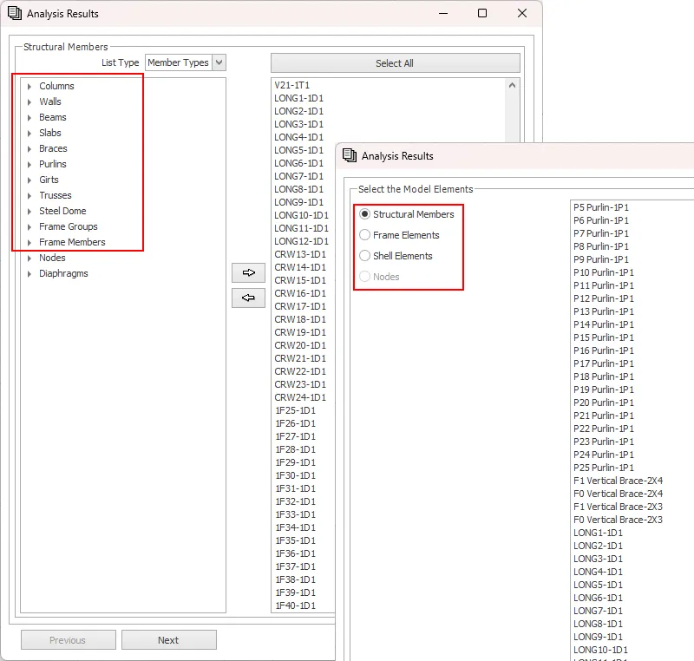

Automatically Extract Maximum Effects
Now, you can extract the combinations with maximum effects. To achieve this:
- Check “Display Combination Results with Maximum Effects Only” option and create the report.
- ProtaStructure will automatically do the post-processing and report the positive and negative maximum effects with their corresponding load combinations.
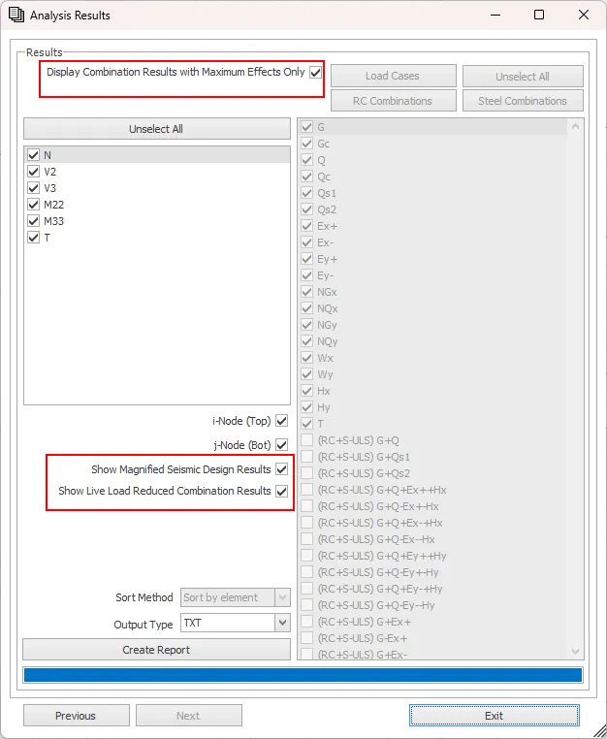
Note that this feature filters distinct results. If the maximum axial and shear results come from the same combination, then this combination is displayed only once saving you time and space.
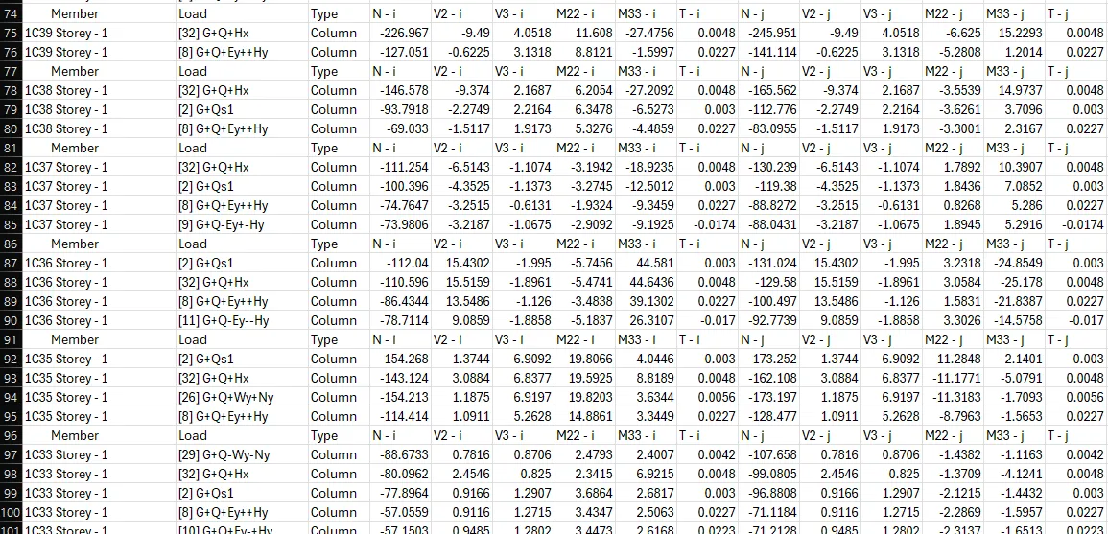
Note:
This option is particularly useful when you want to export only maximum effects to other software, such as IdeaStatica. You don’t need to export the results to an excel sheet and run formulas or macros to find the maximum effects.

Seismic Magnifications and Live Load Reduction
Seismically magnified analysis results and live load reduced combination results can also be automatically extracted as a report. This allows you to get analysis results consistent with Diagrams, Analysis Post Processor and the values on the Design UI.
Combination Results with Maximum Effects only is particularly useful when you want to copy the reactions to another software such as IdeaStatica.

Image Export with Transparent Background
This feature was not a part of the initial ProtaStructure 2025 release, and it was released with 8.0.257 maintenance package. It is included here for our users who may not be aware of this feature. Feel free to skip this title if you are already familiar with this feature.
If you need high-resolution images from your ProtaStructure model, a handy feature is the ability to export poster quality images, thanks to the vectoral graphics engine of ProtaStructure. With the latest version, you can now automatically remove the background while exporting. In this way, your graphics designer will thank you and continue enjoying the high-resolution model images with transparent background.
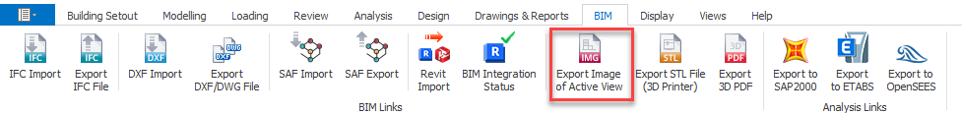
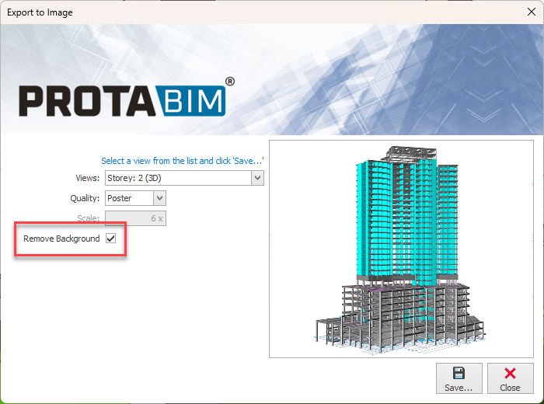

RC Detailing

Building Elevation Section
With ProtaStructure 2026, sections can be generated from the entire building.
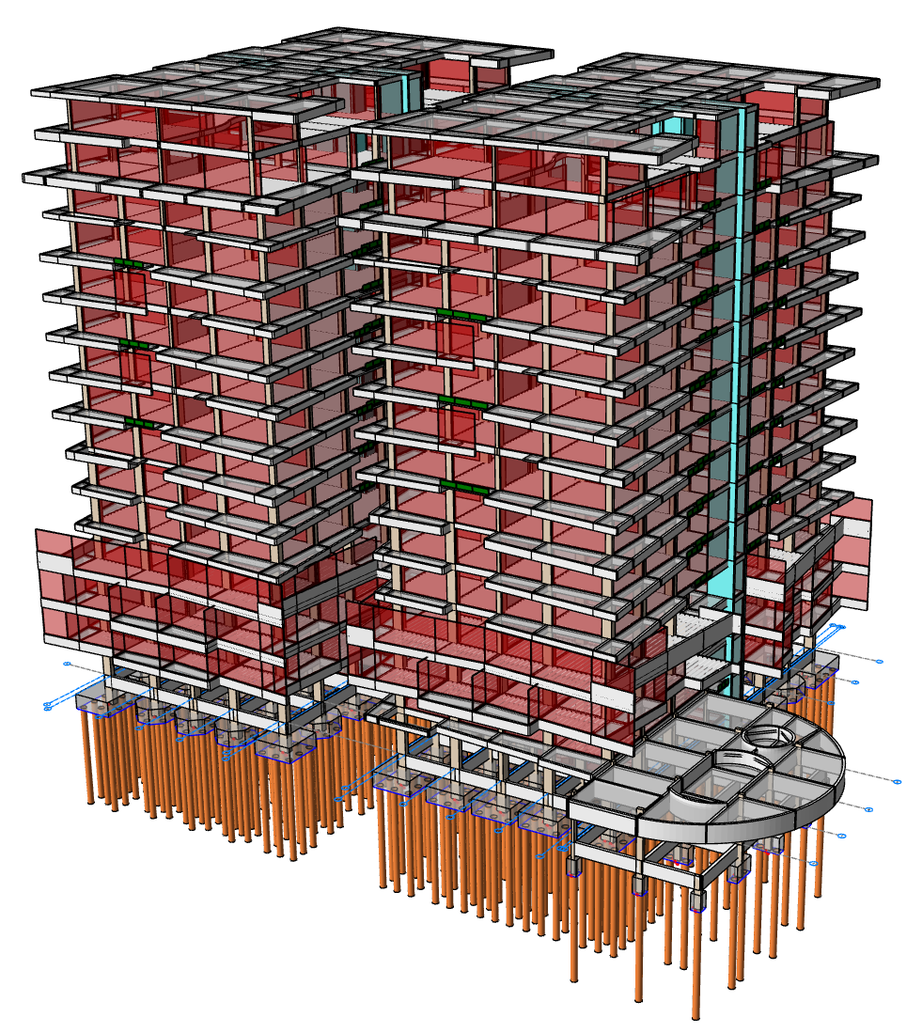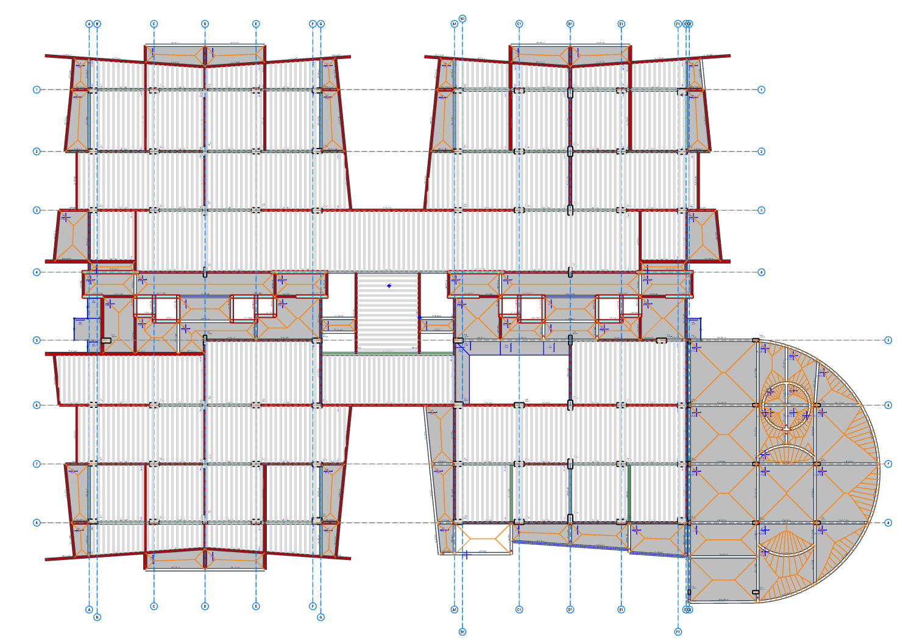
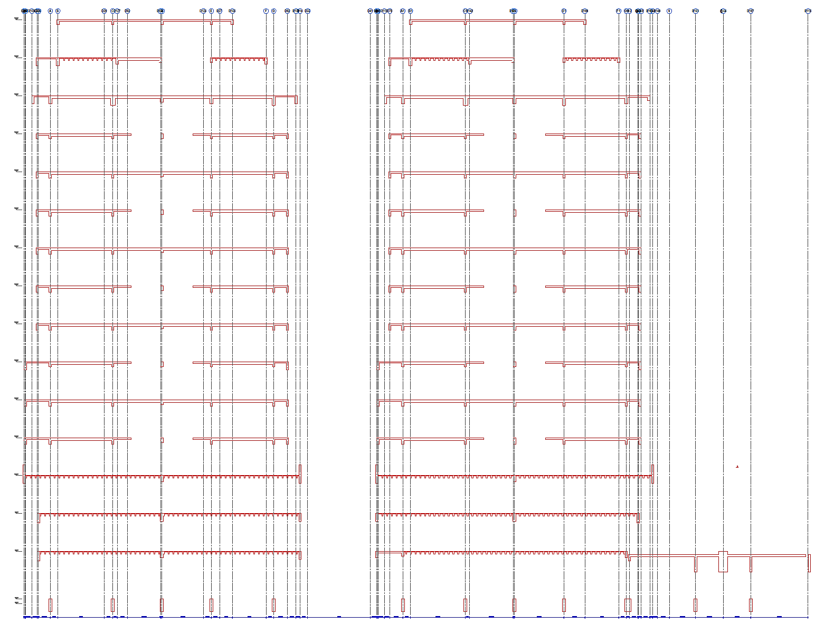

To generate a building section:
- Create a form plan drawing on the screen.
- Enter Building Section command on the command line or Details Library pulldown menu.

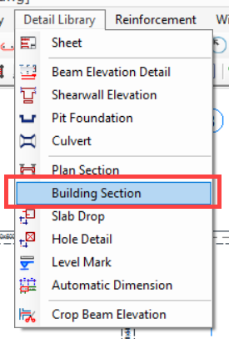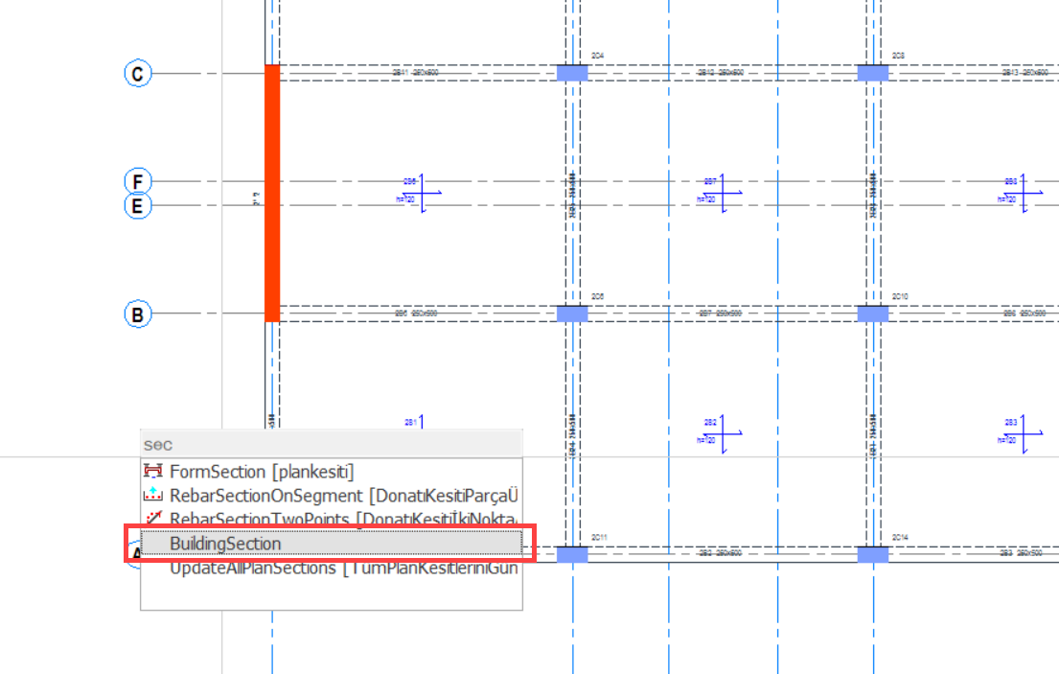

- The Building Section properties window will be opened. Edit the parameters as required:
  - Label: Assign a label to the section.
  - Show Intermediate Elements: Infill walls will be shown on the section if this option is checked.
  - Show Level Marks: You can use this to display the level marks on the section.
  - Show Dimensions: Additional dimensions will be shown if this option is checked.
  - Show Member Labels: Structural member labels will be shown next to the members.
  - Show Axes: Axis elements will be shown.
  - Show Axis Dimensions: Axis dimensions will be drawn.
  - Foundation Sections: You can use this group of parameters to adjust the excavation line display.
- Draw a line across the floor plan where you want to create a section.
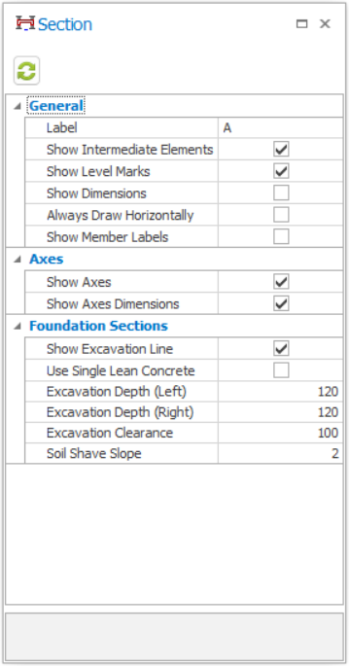

New Bent-Up and Straight Bar Patterns for Slabs
ProtaStructure already supports a symmetrical bent-up rebar pattern for slab detailing. In the new version, asymmetrical bent-up bars can be used in slabs. Additionally, new straight bar pattern enables users to use top reinforcement in span region.
You can access the slab rebar patterns using Options > Slab > Rebar.
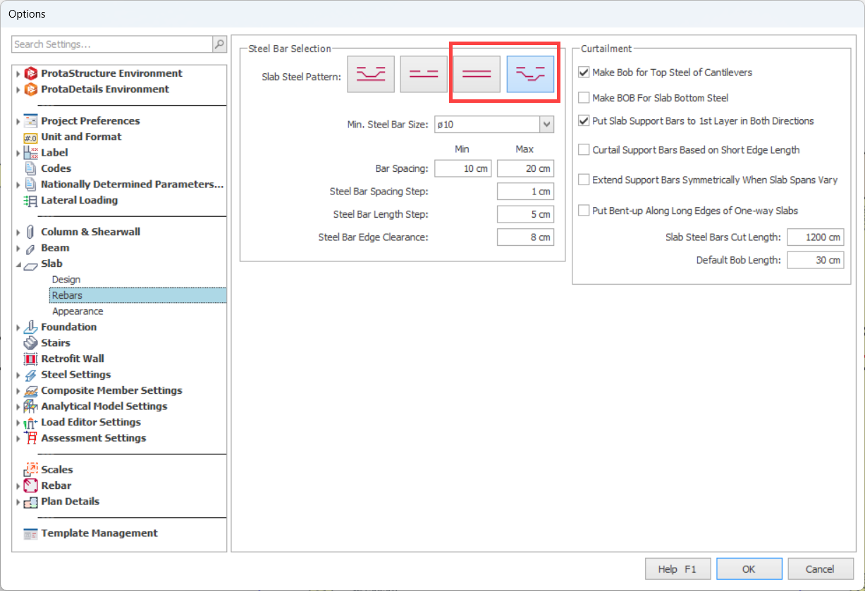
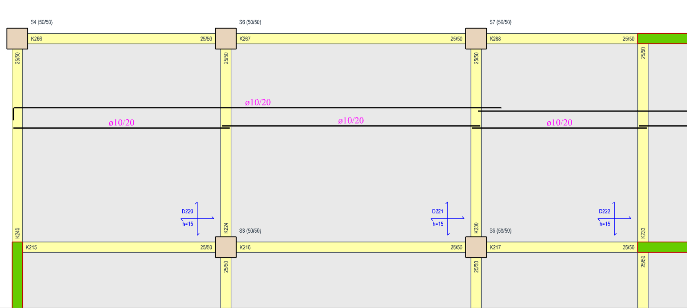
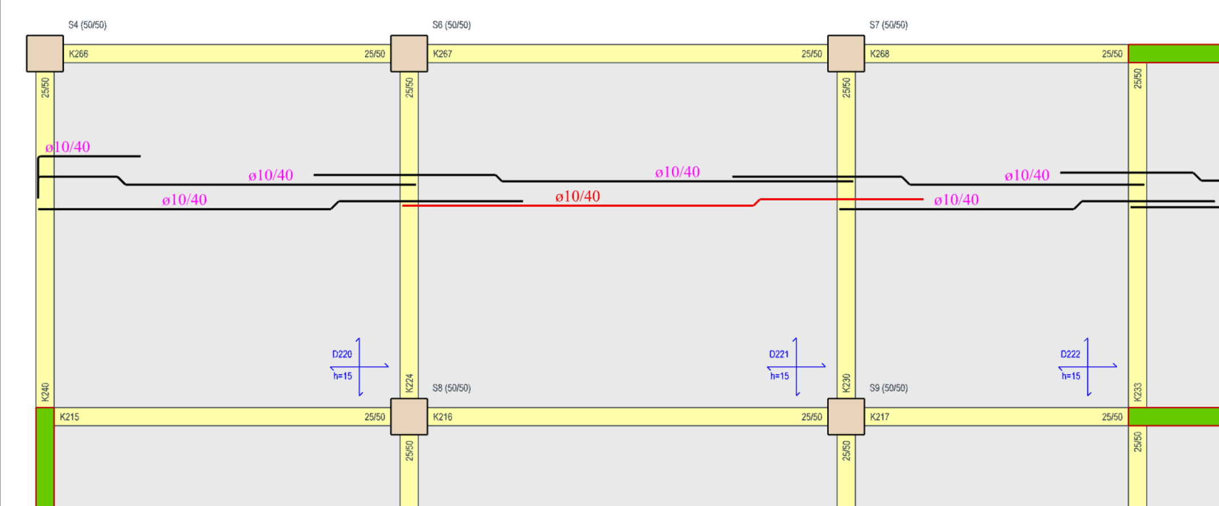

Foundation Beams, Rib Beams and Slabs Rebar Schedule
Foundation beams, rib beams and slab rebars are now neatly presented in a tabular format, like storey beams. This makes it easy to review the designed reinforcement information briefly.
To generate the foundation beam or slab rebar schedule:
- Pick Concrete Beam Rebar Schedule, Rib Beam Rebar Schedule or Slab Rebar Schedule command on the ProtaStructure pulldown menu.
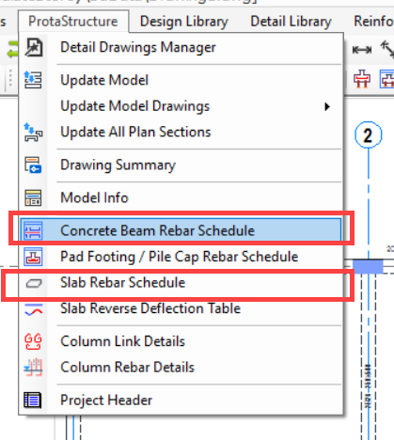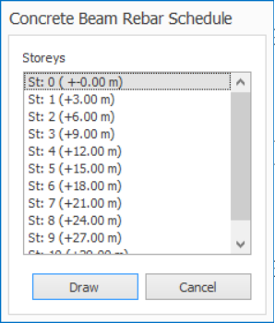
- If you picked Concrete Beams Schedule, select the Foundation Storey (Storey 0) on the list.
- If you picked the Slab Rebar Schedule, select the storeys for which you want to generate the schedule.
- Pick a point on the screen to complete the drawing.
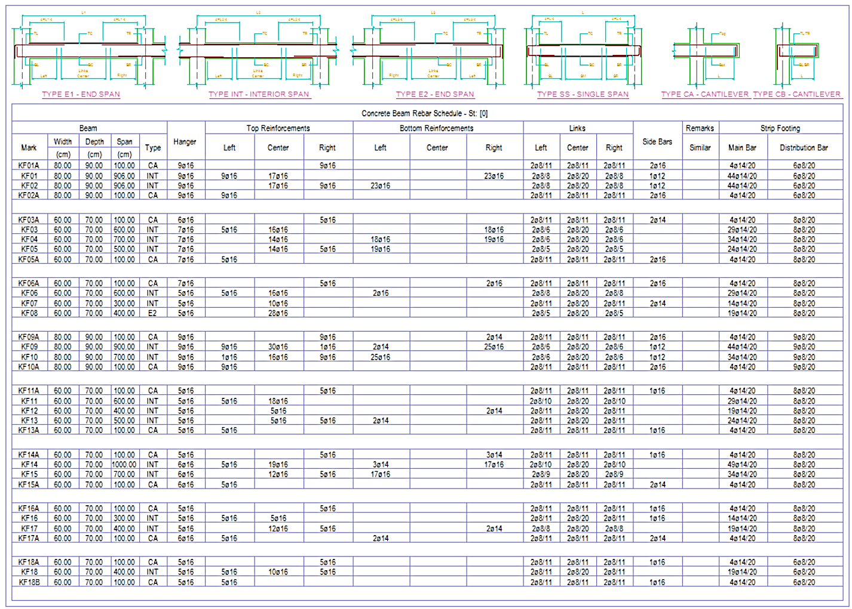

Subbasement Wall Details
Subbasement wall reinforcement design IS NOT performed by ProtaStructure. We expect the user to enter longitudinal and horizontal reinforcement information. Detail drawings are created accordingly. Rebar information for the subbasement walls can be introduced using the Rebar tab on the Wall Property window.
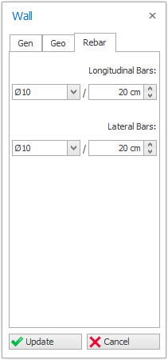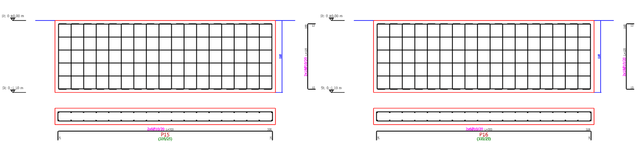
You can generate subbasement wall details using Shearwall Elevations and Shearwall Schedules or Column Application commands in ProtaDetails. Foundation Storey was added to these categories to draw the subbasement wall details.
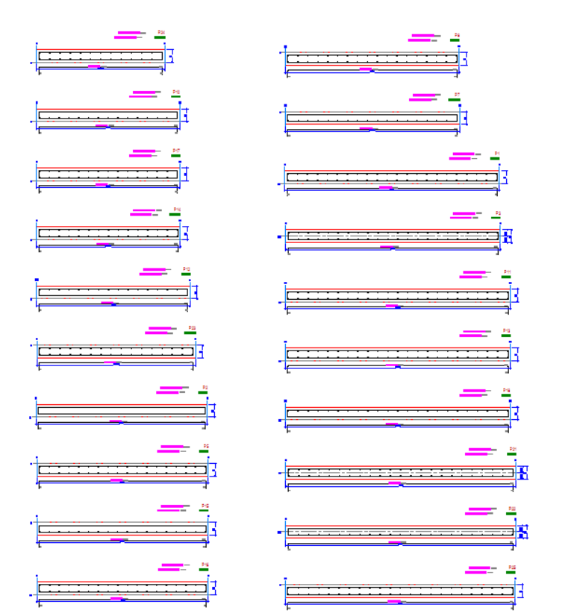

Pedestal Details
After you have designed pedestals in ProtaStructure, you can push them down to ProtaDetails for RC detailing just like other reinforced concrete members. You can use the Column Elevations and Column Application Details for generating the pedestal details. The Foundation Storey is added to these categories for this purpose.
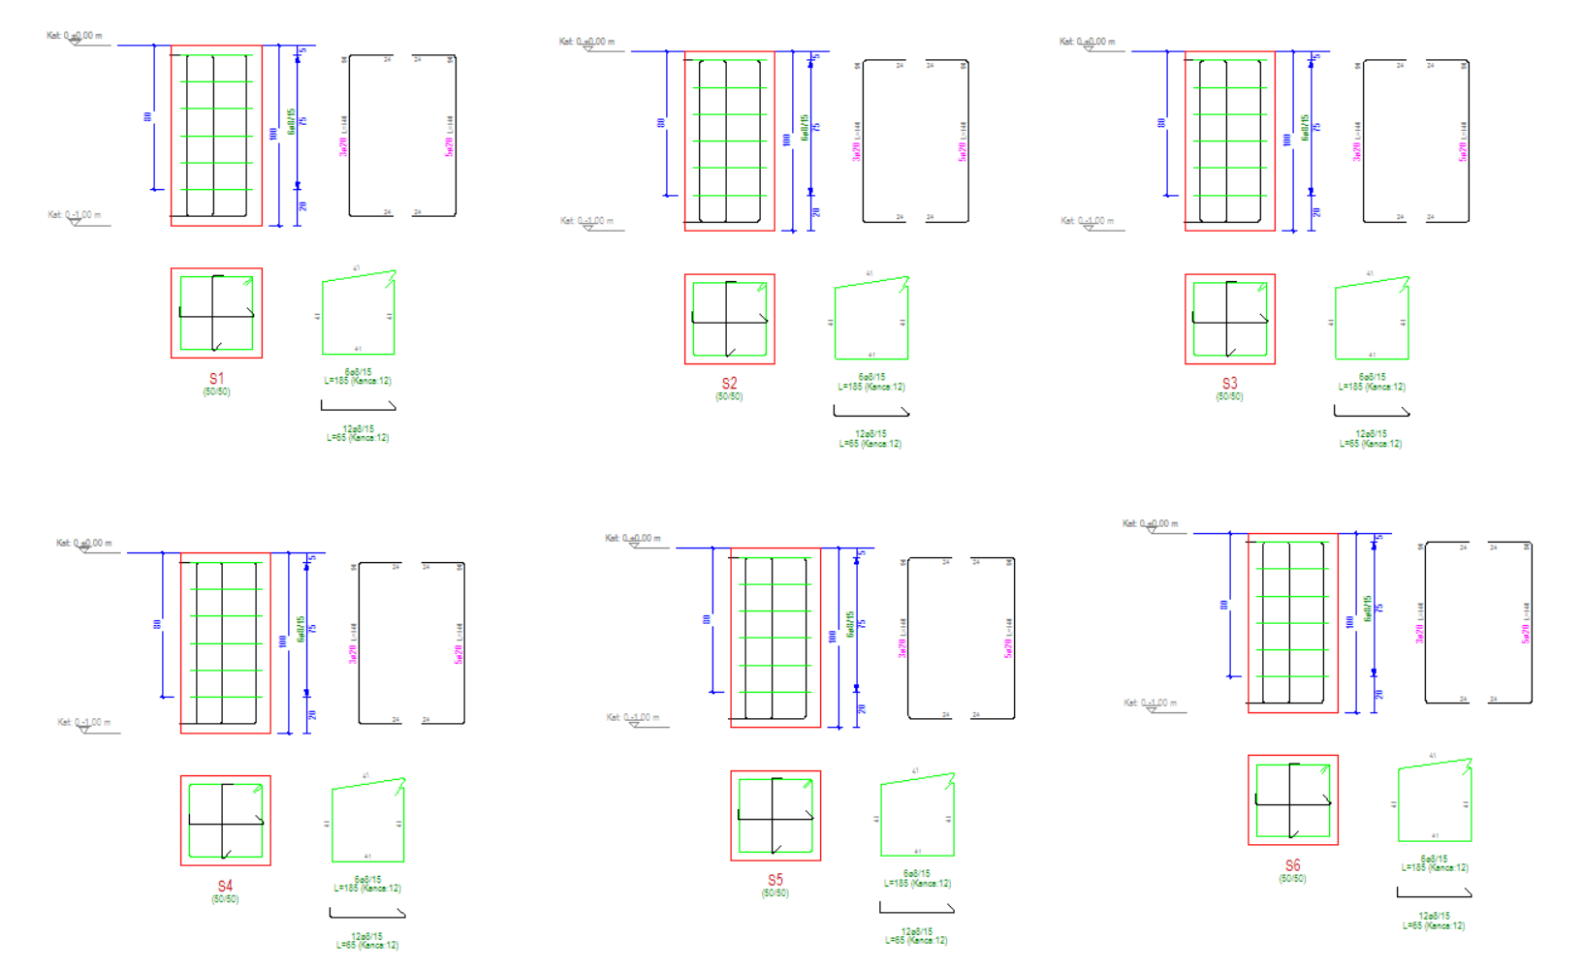
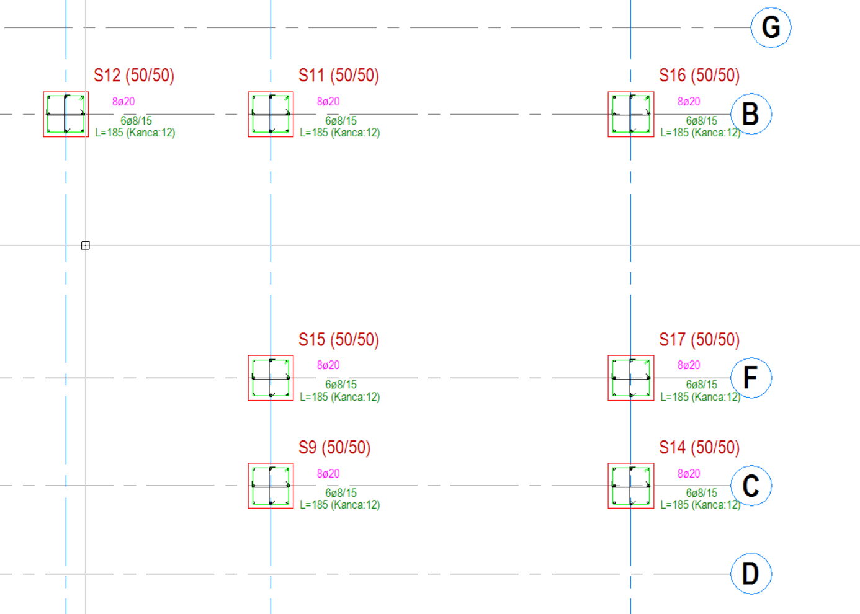
You can use ProtaSteel to obtain the anchor detail drawings of pedestals with steel base plates defined on top of them.
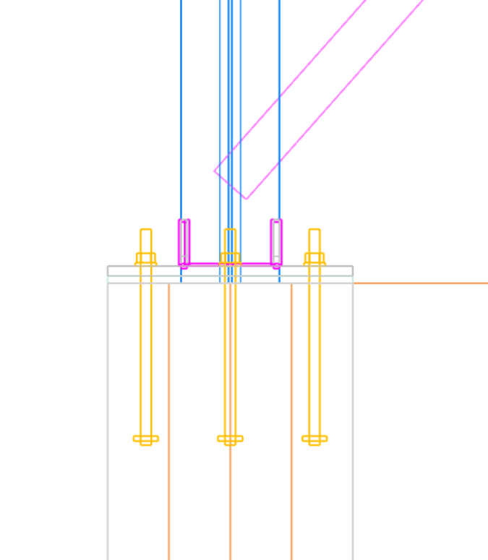

ProtaSteel: Innovating with Strength

Export Internal Forces to IdeaStatica
In our previous version, we introduced the IdeaStatica export feature, which received great feedback from our users. In this version, we have enhanced it further by allowing users to export the internal forces acting on the connections to IdeaStatica in a tabular format.

Purlin Connections on Curved Beams
The connection of purlins on curved beams can now be easily made with the purlin connection macro. Purlin connection macro supports different connection types. IntelliConnect tools can also be used to create connections more quickly.
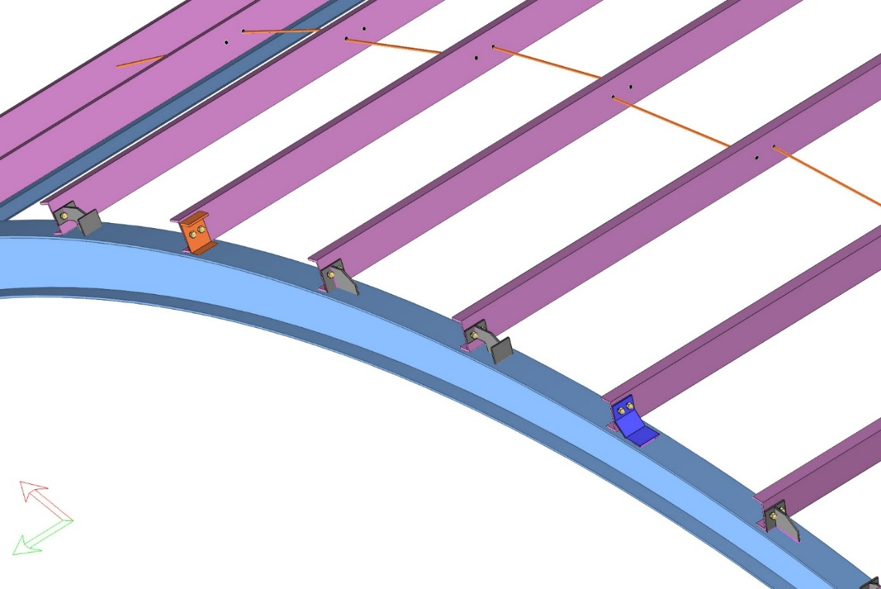

Splice Connections in Pipe and Box Sections
With ProtaSteel 2026, the splice connection details for pipe and rectangular section profiles can be easily created using the “End Plate Splice Macro”. In the macro properties window, the number of bolts and their arrangement can be adjusted after selecting the “circular section settings”.
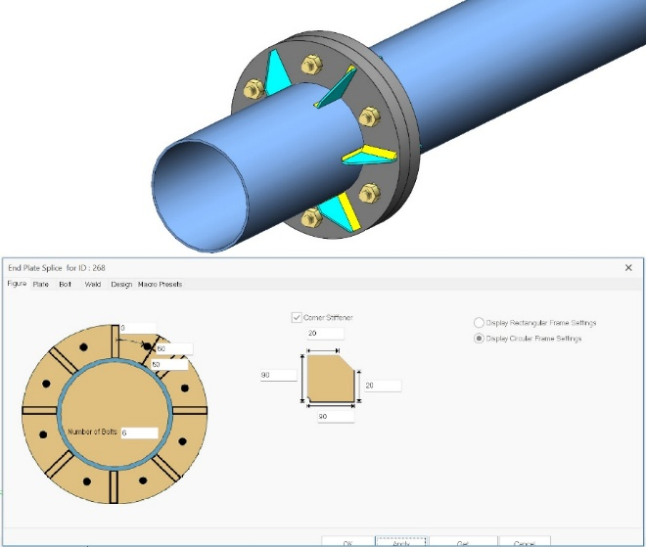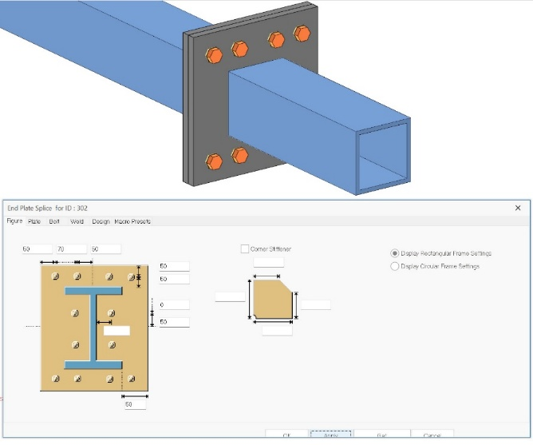

Fin Plate Connections to SHS and RHS Primary Members
The “Fin Plate Macro” that is used to create beam-to-column and beam-to-beam hinged connections now supports main profiles made of hollow sections, including SHS (Square Hollow Sections) and RHS (Rectangular Hollow Sections).
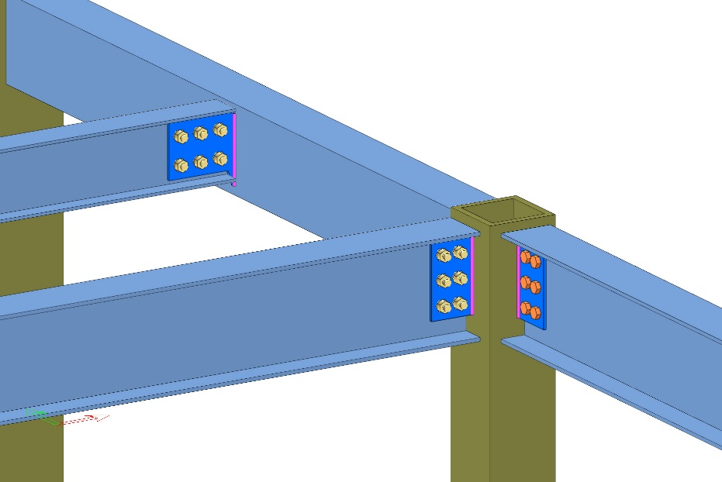

Connection Macros for Truss Top and Bottom Chords
In ProtaSteel 2026, truss-to-truss and truss-to-column connections are supported by beam-to-beam and beam-to-column connections such as Beam to Column End Plate, Stiffener End Plate, Fin Plate, Beam to Beam Angle Cleat, Beam to Beam End Plate. These connections can be applied on the strong and weak directions of the main members.
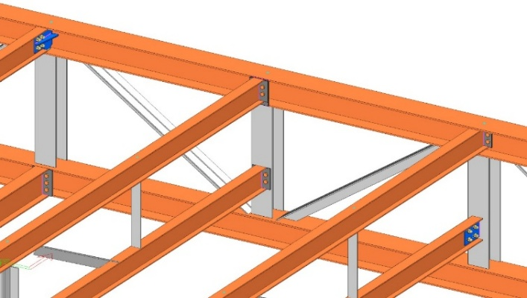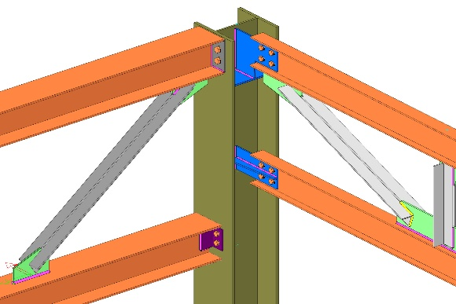

IFC 4 Support
ProtaSteel V2026 comes with IFC4 support. All detailing objects and the entire model created in ProtaSteel can be exported in IFC file. Thus, you can be involved in project development processes with globally accepted IFC files.
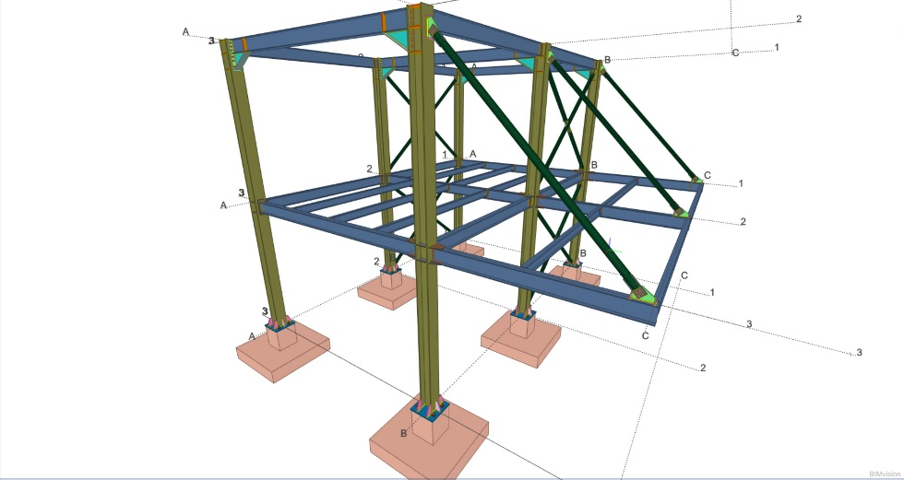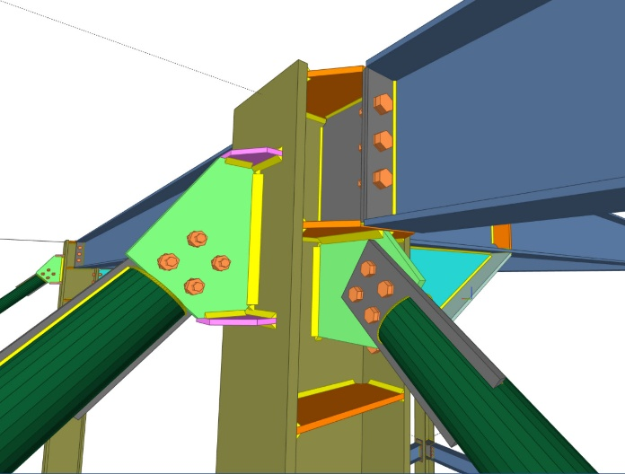

Improved Curved Beam Connections
You can now handle more cases with curved beams including a wider range of approach angles and purlin connections with the curved members.
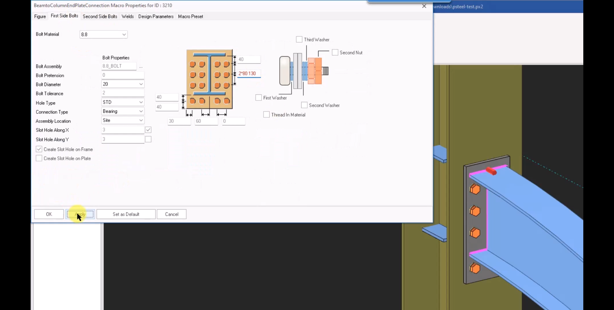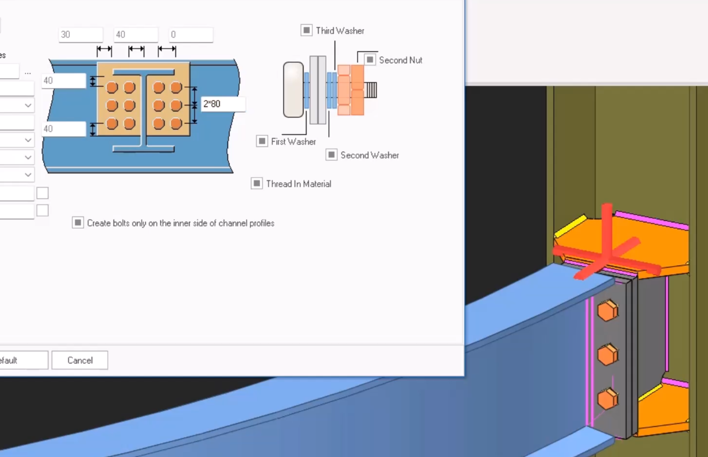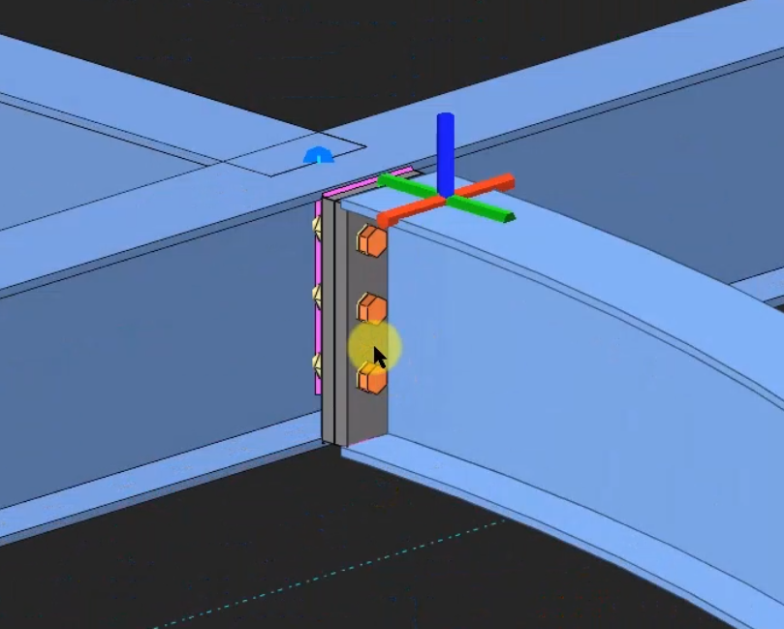

General Stability and Performance Improvements
Based on our quality control procedures and user feedback, significant stability and performance improvements have been made to all products in the 2025 family. Most of these improvements and new features have been delivered to you throughout the year with the ProtaStructure 2025 maintenance updates. The details of these updates can be found in the "Release Notes" section on our help center with references to relevant customer ticket numbers.

New Design Guides and Videos
We have been working hard to provide extensive documentation, videos, and webinars on numerous topics to improve your experience and knowledge of ProtaStructure.
New design guides have been published with ProtaStructure 2026 release. Visit Prota Help Center’s Knowledge Base and our website’s ‘Whitepaper’ section to learn about the latest design guides.
Prota Help Center Knowledge Base:
https://support.protasoftware.com/
Protasoftware.com Whitepapers:
https://www.protasoftware.com/whitepaper
In addition to design guides, we have been conducting new webinars and publishing recordings. Also, our technical team is always busy creating video content on ProtaStructure features, usage, and theory. Please subscribe to our YouTube channel to get notified of new content.
https://www.youtube.com/c/ProtaStructure

What’s Next?
While we strive to include as many improvements as possible in each major version, some items may be delayed beyond the initial release. Rest assured; we're committed to delivering them in subsequent updates to our user with active maintenance.

Thank You
Thank you for choosing the ProtaStructure Suite product family.
At Prota, our continual aim is to provide you with user-friendly, industry-leading technology for building design and documentation.
Should you have any technical support requests or questions, please do not hesitate to contact us at all times through globalsupport@protasoftware.com or asiasupport@protasoftware.com (Asia Pacific)
Our dedicated online support center is available to help you get the most out of Prota’s technology solutions with our responsive technical support team.
The Prota Team
