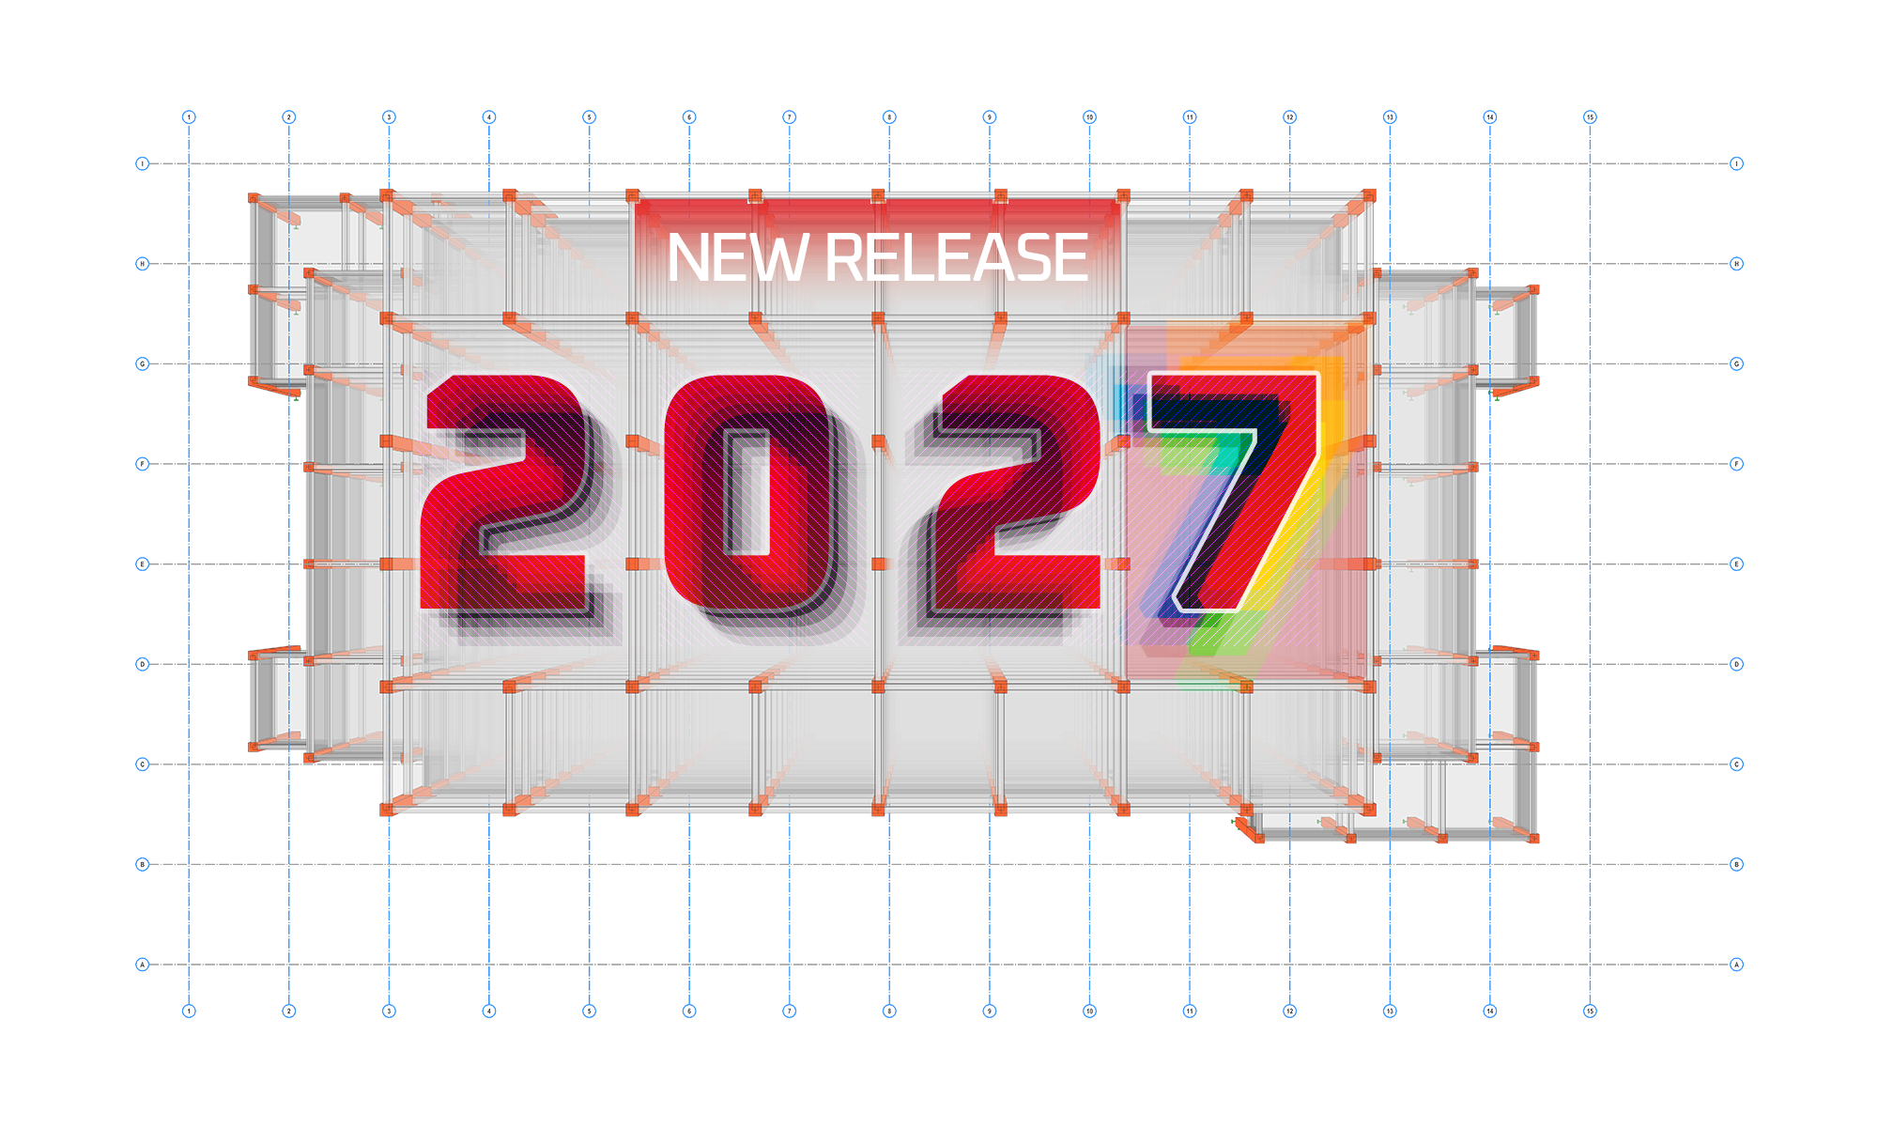


ProtaStructure Suite 2027 – New Features
Version: 1.0 | May 2026

Please get in touch with us for your training and technical support queries.
asiasupport@protasoftware.com | globalsupport@protasoftware.com

Limitation of Responsibilities |  | While Prota ensures every new update is tested, Prota shall not be held responsible for any losses caused by documentation, software, or usage errors.  In addition to Prota License Agreement Terms, it is the responsibility of the user:  - to check results generated by documentation and software,  - make sure that the users of the software and their supervisors have adequate technical capabilities,  - Ensure the software is appropriately used according to the reference manual and documentation.
Intellectual Property |  | ProtaStructure is a registered trademark of Prota Yazılım Bilişim ve Mühendislik A.Ş., and all intellectual property rights belong to Prota Yazılım Bilişim ve Mühendislik A.Ş. Documentation, training, reference manuals, and any program component cannot be copied, distributed, and used in violation of the license agreement.
Trademarks |  | ProtaStructure®, ProtaDetails®, ProtaSteel®, and ProtaBIM® are registered trademarks of Prota Software Inc. Prota logo is a trademark of Prota Software Inc.

Contents
Introduction 3
ProtaStructure Suite 2027: Engineering the Future 4
New Capabilities & Highlights 6
Cold-Formed Steel Design 6
More Centralized Report System 7
Spiral Staircase Modelling and Design 9
Import Models from ETABS 11
Renewed ETABS Export 12
Automatic Shearwall Checks per ACI 318-19 12
Indian Seismic Code IS 1893-2025 14
Target Displacement Calculation for NSR (Colombia) 15
RC Column & Beam Design to Thailand Code (DPT 1302-61) 16
Stability Checks in Footings 17
Floor Torsion: Perform at Corners or Selected Columns 18
Do Not Design VOM Members for Seismic Provisions 19
Wide Beam Link Arrangement 19
Performance Improvements 22
Improved Analysis Engine Performance 22
Enhanced Report Engine Performance 23
Improved Analysis Results Post-Processing Performance 24
Improved Modelling Performance 25
Modeling and Productivity Improvements 26
Member Grouping for Selection 26
Wind Columns 28
Staircase Modelling and Detailing Enhancements 29
Move and Copy Drawing Entities 30
Enhancements in Match Properties Command 31
Other Productivity Improvements 31
Foundation Design Settings Enhancements 34
Report Improvements 36
RC Slab Detailed Design Report 36
Truss Sketch in Truss Design Reports 37
New Excel Export Options 38
Quantity Take-Off Reports 40
Improved Post-Analysis Report: Behaviour Factor and Eccentricity 42
Additional Elements in Member Property Report 43
RC Detailing Improvements 44
Shearwall Detailing Enhancements 44
Grouping Similar Column Details 48
Draw Cranks in Lap Zones of Column Elevation Drawing 49
Confinement Along Beam and Column Splices 50
Full Anchorage Length for Beam Bottom Bar 50
Punching Reinforcement Detailing 51
Formwork Scaffold Quantity Take-Off Command 52
Manual Override for Column-Beam Joint-Region Link Spacing 53
PROTASTEEL 2027 — New Features 55
New Macros 55
BIM Integration / Interoperability 61
Drawing Module Improvements 62
Thank You 71

Introduction
As Prota, we have been developing leading structural BIM software for over 40 years.
- Priority on our product strategy has always been:
- Providing new practical modeling approaches
- Introducing innovative design technologies that will add value to your business and extend your toolset in your daily engineering practice
- To improve the existing functionalities
- To introduce more localization in our products, so that you can benefit from our technology much better
ProtaStructure 2027 is our brand-new release, a significant step taken to fulfill this strategy, raise the bar for competition, and meet expectations. Developing a comprehensive structural BIM analysis, design, and detailing solution is challenging teamwork in meeting user and industry expectations. We sincerely thank all our users for their trust in our products.
We are confident that you will enjoy and benefit from the features and improvements in ProtaStructure Suite 2027. You can find the details on the pages to follow.
Thank you for choosing ProtaStructure.

ProtaStructure Suite 2027: Engineering the Future
ProtaStructure Suite 2027 delivers a major leap forward across every discipline — from brand-new cold-formed steel design to a 4x faster analysis engine, a fully modernized reporting infrastructure, expanded international code coverage, and a wealth of productivity improvements in modeling, detailing, and BIM interoperability.
Key highlights of this release include:
- Cold-Formed Structure Design — AISI S100, Eurocode EN 1993-1-3, and Turkish CYTHYE codes
- 4x Analysis Engine Performance improvement
- New Report Engine (PDF-based) — up to 10x faster report generation
- Overhauled ETABS Import and Export for bidirectional BIM interoperability
- More Centralized Report System with drag-and-drop submission set and report creation in one location. No more collecting reports from design menus.
- Spiral Staircase Modelling and Design
- Automatic Shearwall Checks per ACI 318-19 (Special Boundary Elements)
- Stability Checks (overturning & sliding) in Footing Design
- RC Beam and Column Design extended to Thailand Code (DPT 1302-61)
- New Indian Seismic Code IS 1893-2025
- Wide Beam Link Arrangement — up to seven links
- Group Members for Selection with Ctrl+G shortcut
- New Excel Export options across analysis, design, and quantity reports

New Capabilities & Highlights

Cold-Formed Steel Design
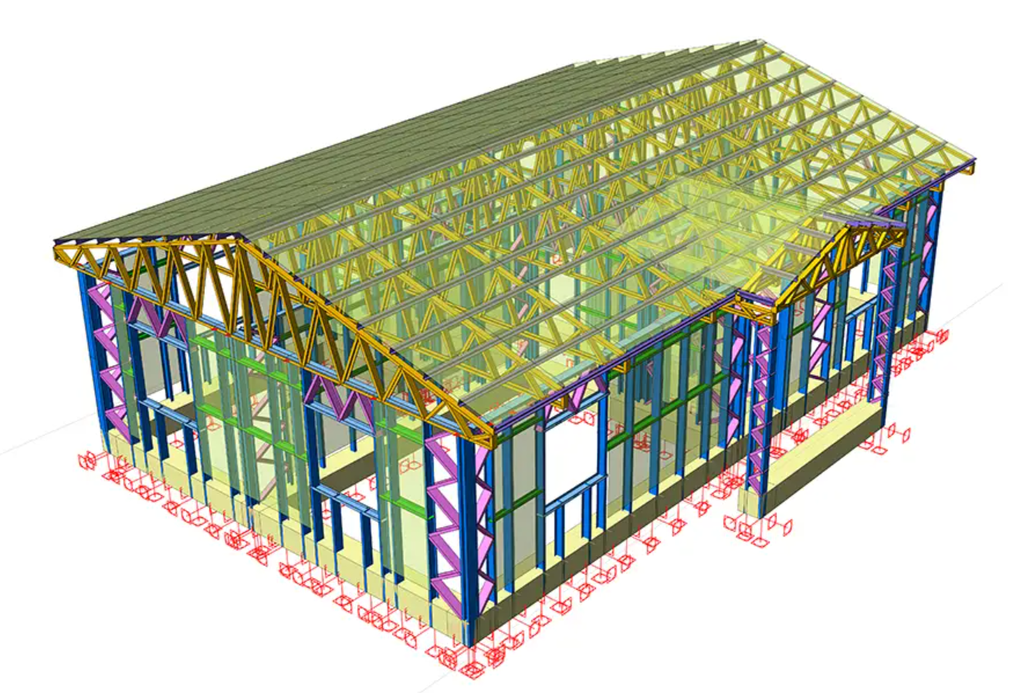
ProtaStructure 2027 introduces comprehensive cold-formed steel design, enabling structural engineers to model, analyze, and design cold-formed members directly within the platform. This eliminates the need for separate specialist tools and brings cold-formed steel firmly within the integrated ProtaStructure workflow.
Cold-formed steel members can be designed to three code families:
- AISI S100-16/20 — the AISC cold-formed specification (LRFD and ASD safety formats)
- Eurocode EN 1993-1-3
- Turkish CYTHYE / TSC2016 (draft at the time of development)

Checks Covered
The AISI implementation covers tension, compression (global flexural/flexural-torsional/torsional buckling, local buckling, and distortional buckling), bending (major and minor axes), shear, combined actions, and serviceability deflection. The Eurocode and Turkish code implementations cover equivalent limit states appropriate to each standard. Supported section shapes include open profiles (C/channel, Z, hat) and closed profiles (RHS, SHS, circular pipe).

Key Differences from Hot-Rolled Design
Member capacity is determined by the Direct Strength Method (DSM), computing strengths directly from elastic buckling loads of the gross cross-section for each buckling mode — no iterative plate-width reduction. Distortional buckling is treated as a standalone limit state. For singly symmetric open profiles, flexural-torsional buckling typically governs compression capacity due to low torsional rigidity.

More Centralized Report System
The Report Preparation and Management system has been developed from scratch with productivity in mind. The new report system now provides a more integrated and intelligent submission workflow:
- A single “Report Submission Set” sits centrally. Reports can be added from “Report Repository” and re-ordered by drag-and-drop. A final merged report is created from the submission set.
- You can now generate all the reports in your project using this centralized menu without even going to relevant design menus. Failed or expired designs are also listed on the report center for you to have a grasp on your project’s design status.
- Project is automatically examined for structure type, material, and components. A default submission set is generated and updated as the model evolves. ProtaStructure will recommend you add necessary missing reports (if they are not already part of your submission sets) when you click “Add Suggested Reports” button.
- Company logo, date/time, and QR code can be added to reports for customization and as a token of authenticity.
- The new presentable Cover page can now be included in the submission set
- The New Model Information and Layout Report with 3D and plan views
- Errors, warnings, and information items across all generated reports are visible at a single glance.
- Report repository shows both included and excluded reports — drag any unlisted report into the submission set.
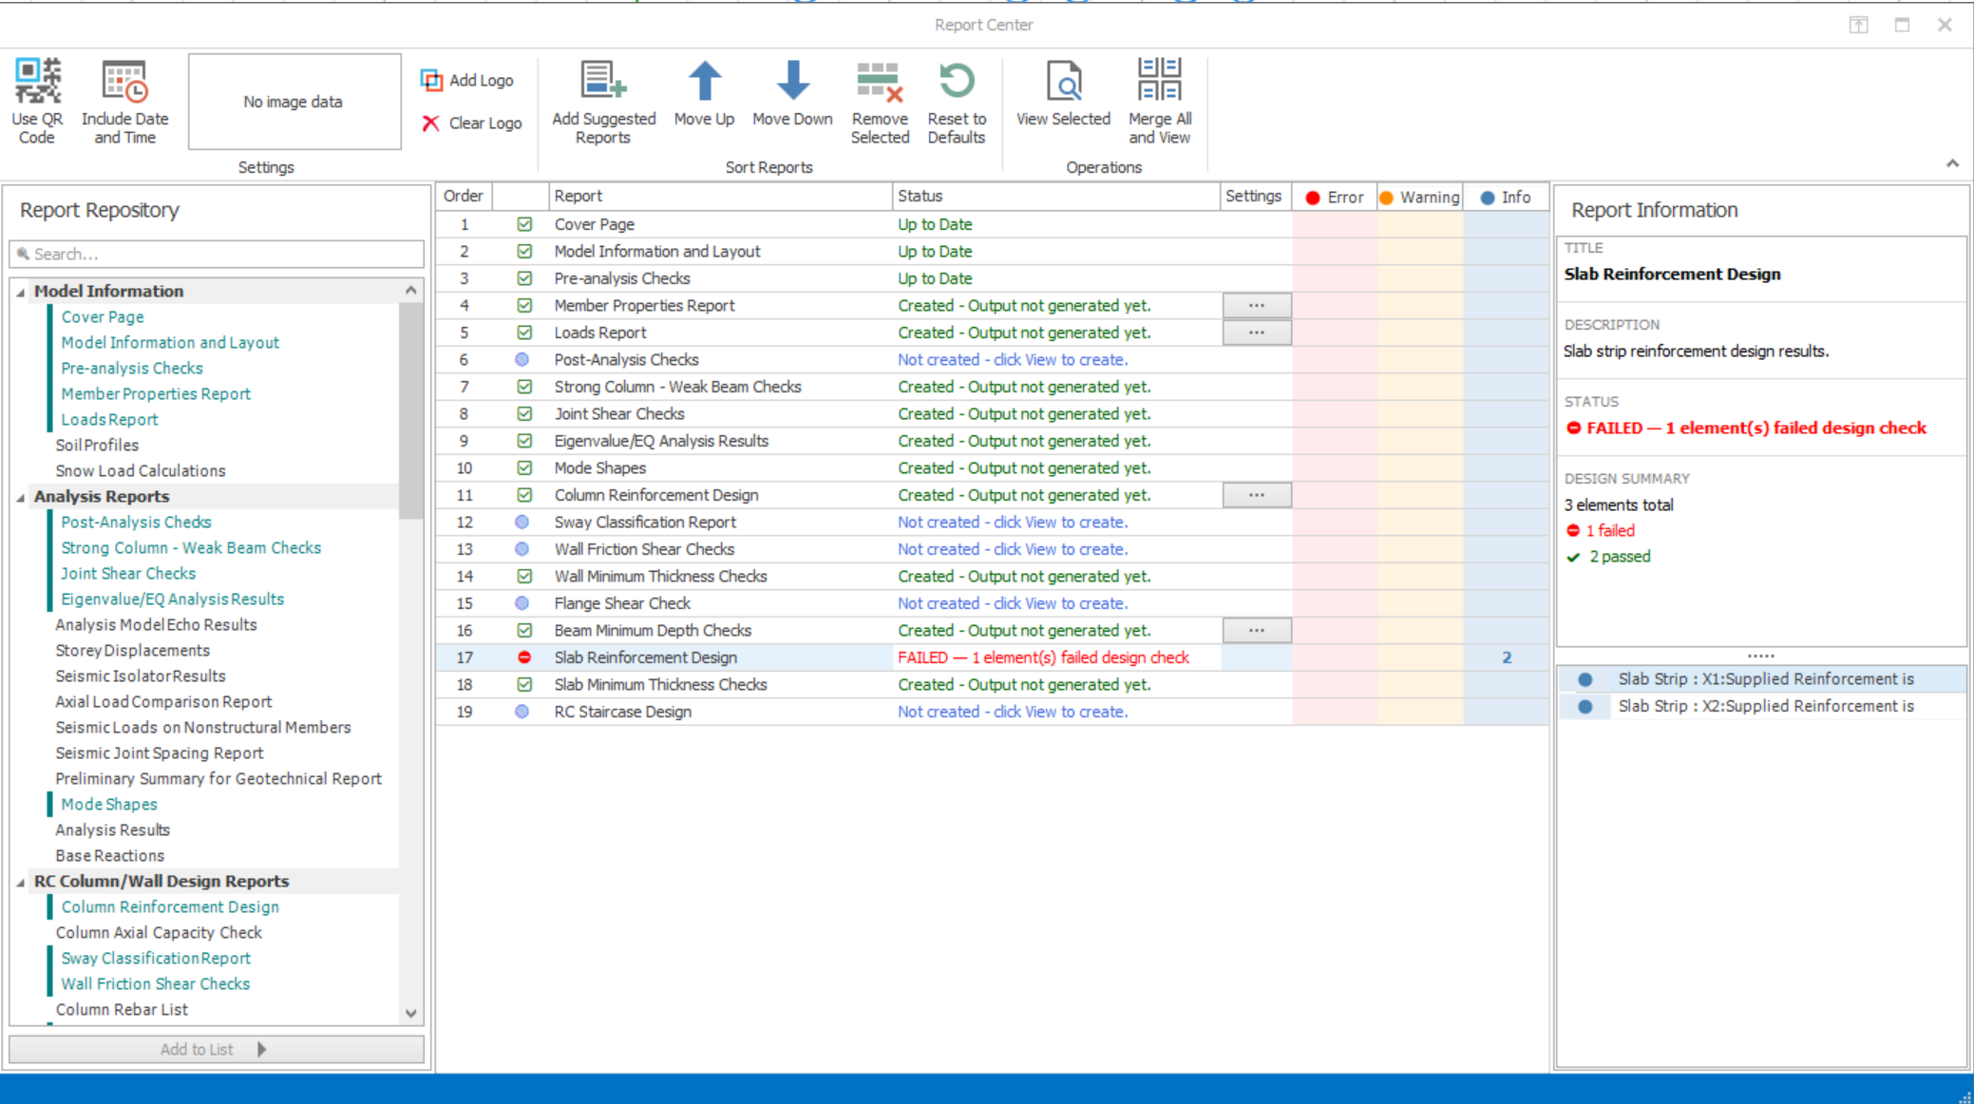
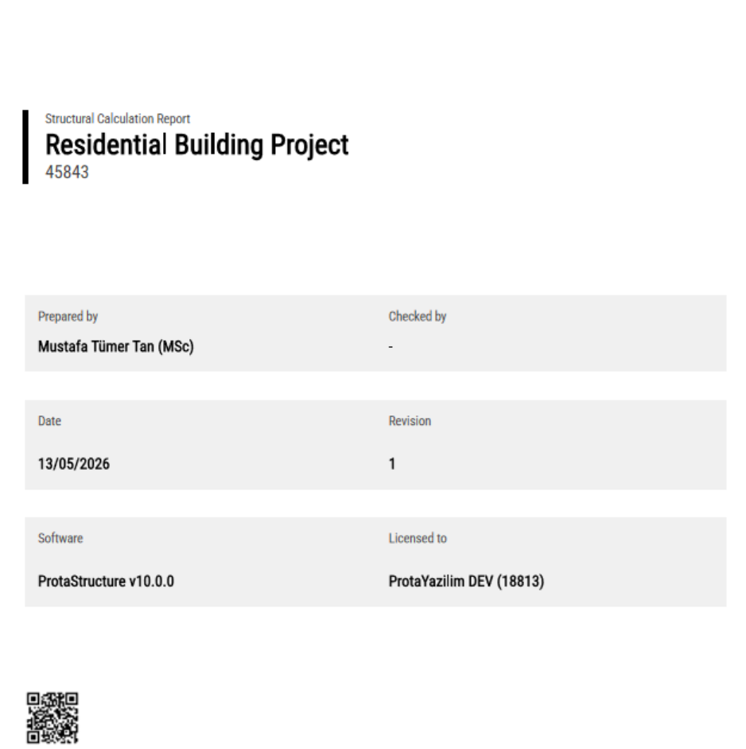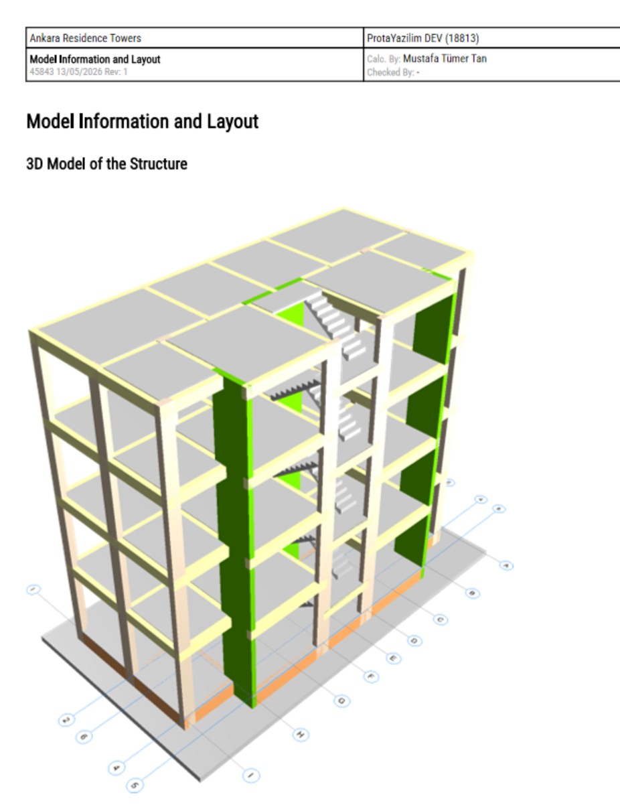
The newly introduced Cover Page and Model Information Report that includes 3D and floor plan images

Spiral Staircase Modelling and Design
ProtaStructure 2027 introduces spiral staircase modelling and structural design, supporting spiral staircases supported from the inner edge and/or flight ends. This long-requested capability enables engineers to model, analyze, and design spiral staircases within the same integrated environment as the rest of the structure.
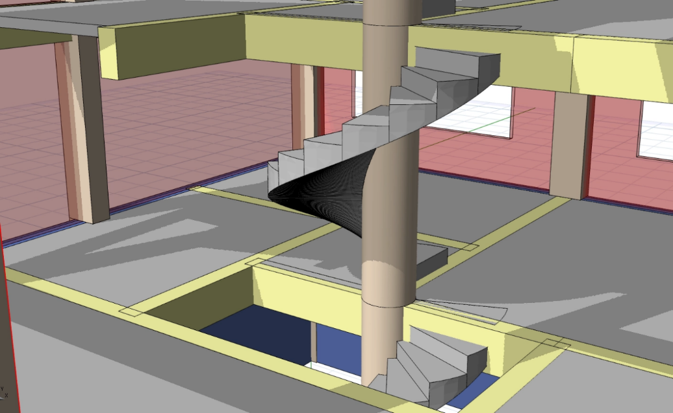
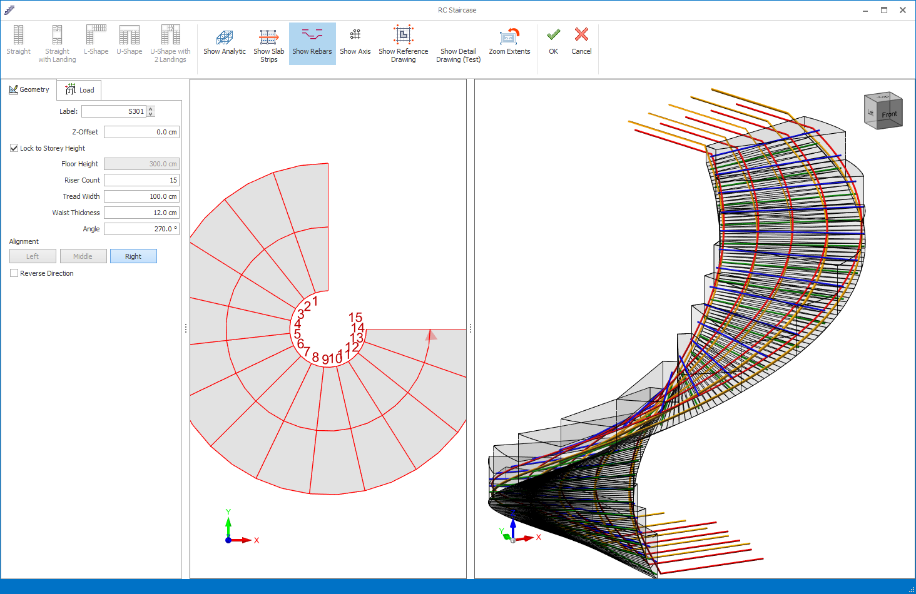

Import Models from ETABS
ProtaStructure 2027 introduces a robust ETABS import capability, allowing engineers to bring complete structural models from ETABS directly into ProtaStructure with high fidelity. This two-way BIM bridge eliminates manual remodeling and ensures that geometry, materials, sections, loads, and boundary conditions are faithfully transferred.

Units and Geometry
Automatic unit conversion (imperial or metric), intelligent grid mapping for orthogonal and skewed grids with all labels preserved, and cumulative story elevation management.

Materials, Sections and Structural Elements
Concrete and steel are automatically distinguished with full parametric support for rectangular, circular, pipe, L, T, U, and I/HE shapes. Shear walls are converted to column members. Ribbed, waffle, and deck slabs include specific spacing and rib data. Load cases are automatically categorized (DEAD to G, LIVE to Q), and load combinations are fully transferred.

Renewed ETABS Export
The ETABS Export module has been completely rebuilt from scratch, generating a high-fidelity e2k file that preserves every structural detail — from complex steel bracing to seismic mass sources — removing the need for any manual remodeling in ETABS. Full support covers ETABS versions v13 through v23.
Capabilities include flexible unit conversion, full story/grid hierarchy, cracked section modifiers per ACI 318-19, automatic rigid diaphragm assignment, response spectrum function export, and intelligent 3D geometry resolution to prevent flattening of roof trusses or cross-story bracing.
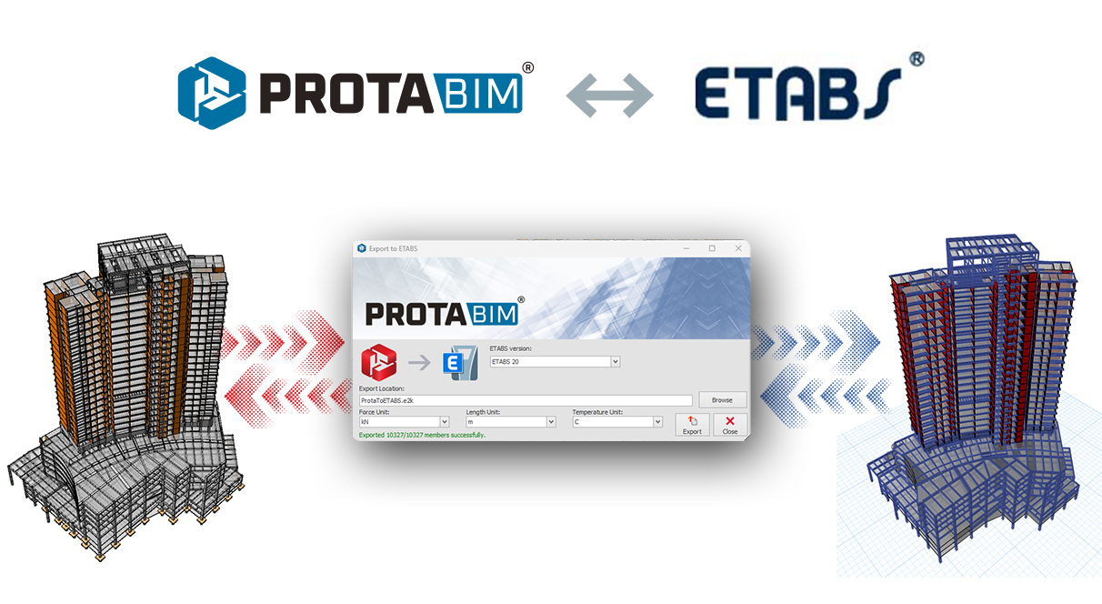

Automatic Shearwall Checks per ACI 318-19
ProtaStructure 2027 automates the determination of Special Boundary Element (SBE) requirements for structural walls per ACI 318-19, eliminating manual calculations and ensuring correct ductility provisions are applied in earthquake design.

Displacement-Based Approach
A special boundary element is required when c > l_{w} / (600 x d_{u}/h_{w}), where c is the largest neutral axis depth, l_{w} the wall length, d_{u} the design displacement, and h_{w} the wall height. The ratio d_{u}/h_{w} is not taken less than 0.005.

Stress-Based Approach
Special boundary elements are required where the maximum extreme fiber compressive stress exceeds 0.2f'_{c}, calculated using a linear elastic model based on gross section properties.
Both approaches are evaluated simultaneously and results presented in the RC Shearwall Design reports.
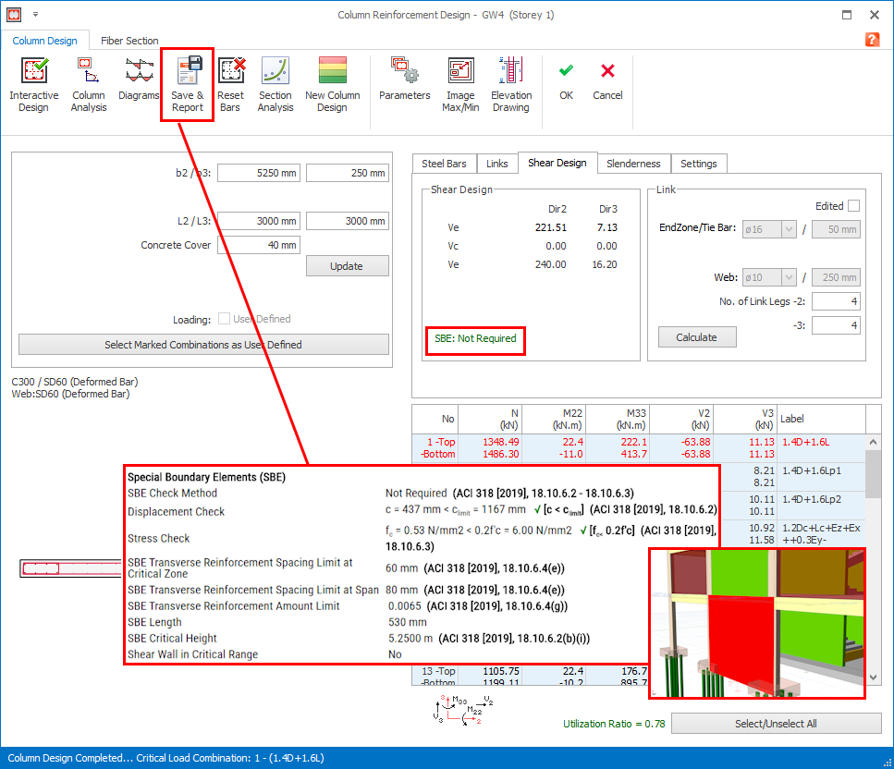

Indian Seismic Code IS 1893-2025
The Indian seismic design code IS 1893 has been updated to the 2025 edition. Engineers working on Indian projects automatically benefit from the latest seismic hazard maps, spectral acceleration parameters, and design provisions.
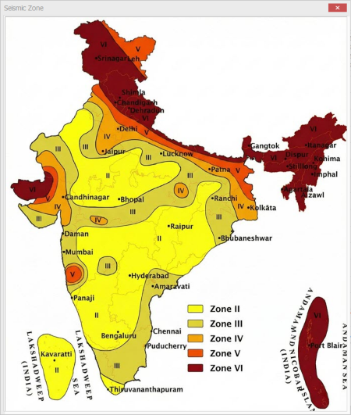
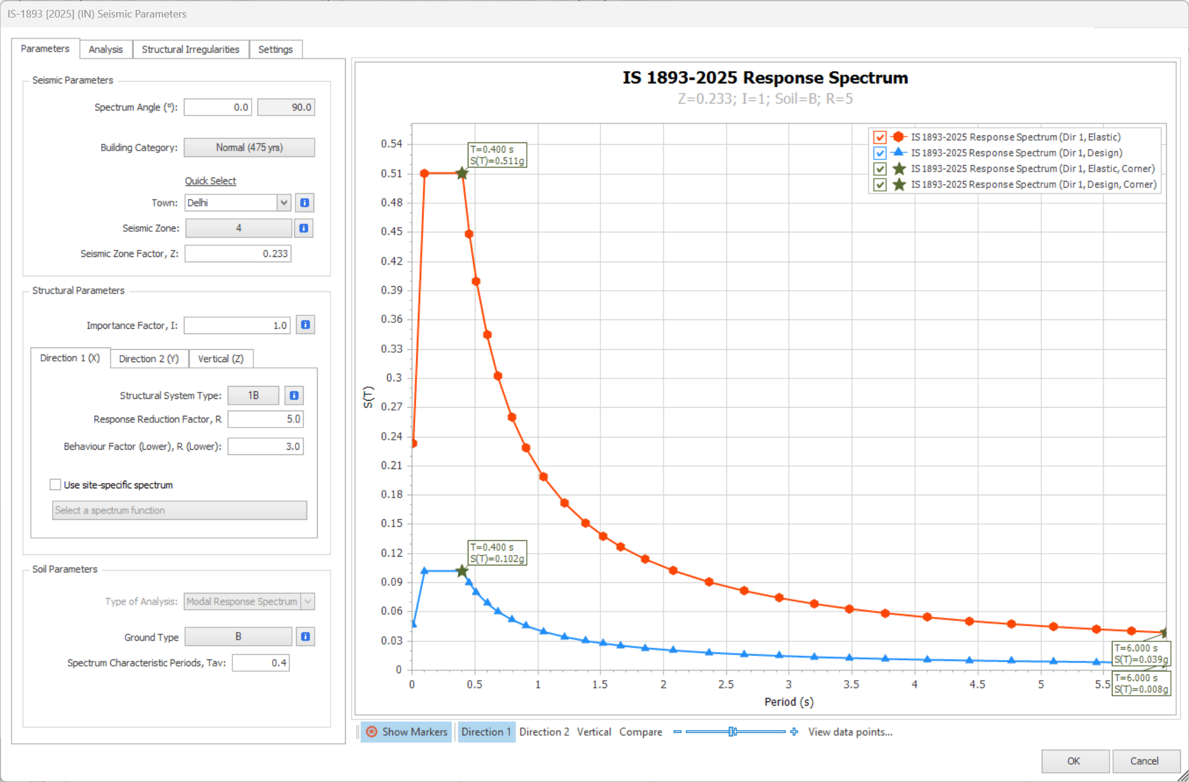

Target Displacement Calculation for NSR (Colombia)
Target Displacement Calculation for Pushover Analysis is now available for the Colombian Seismic Code NSR-10. Engineers working on Colombian projects can perform complete nonlinear static (pushover) analysis with code-compliant target displacement determination directly within ProtaStructure.
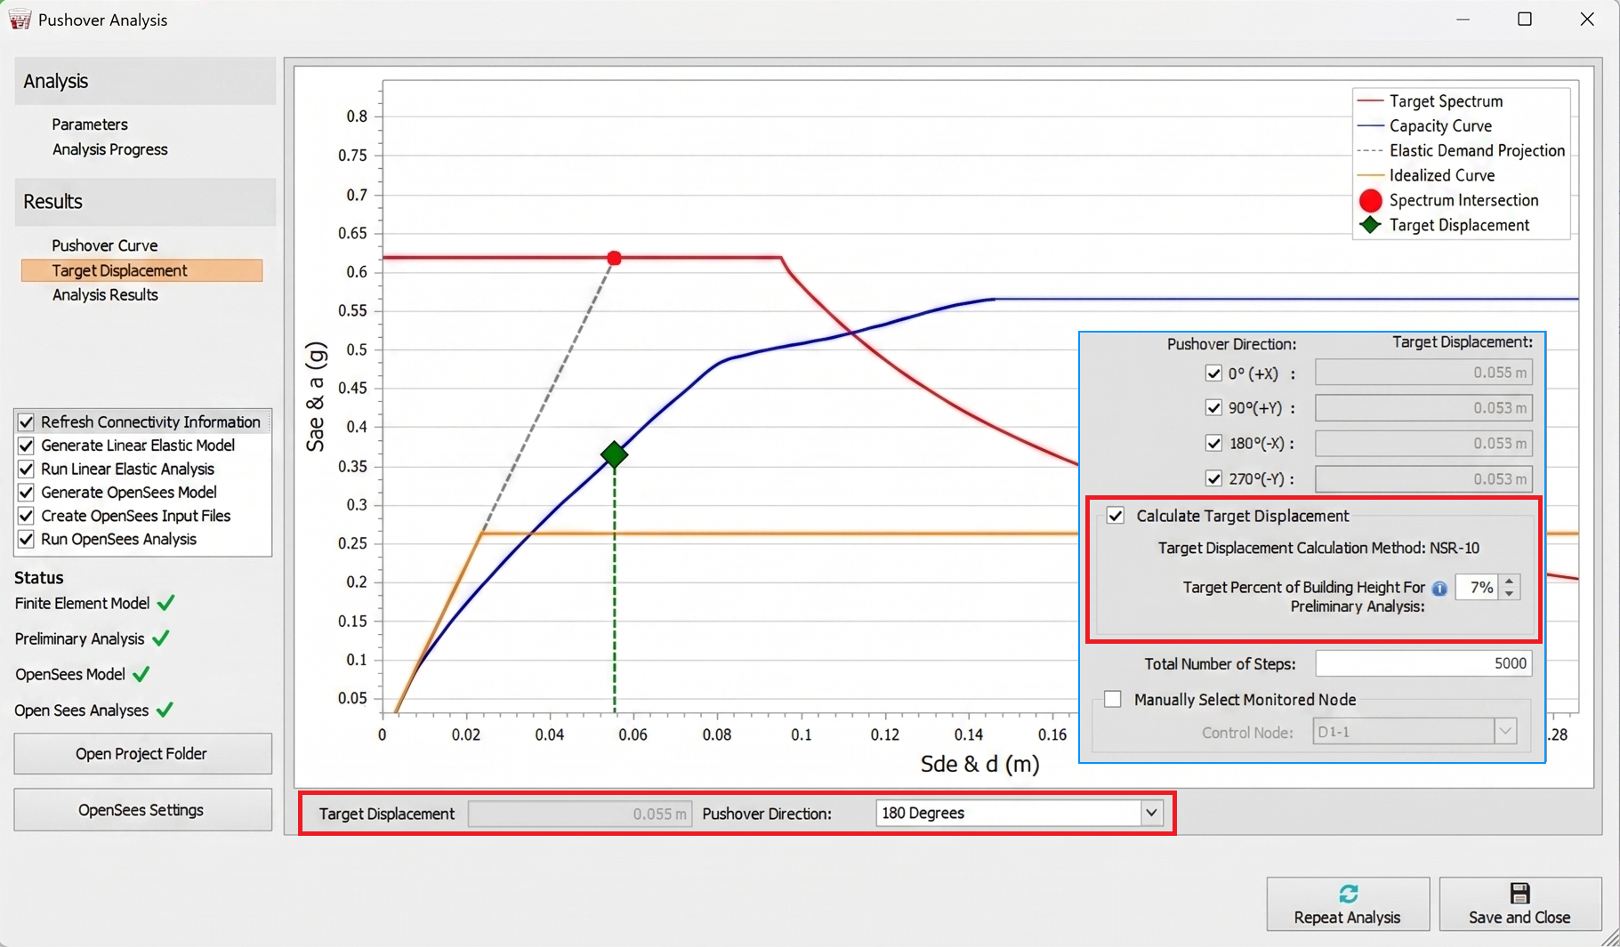

RC Column & Beam Design to Thailand Code (DPT 1302-61)
RC Column and beam design has been updated to cover DPT 1302-61 clauses over ACI 318. Fully integrated clauses include longitudinal reinforcement limits, column dimension checks, plastic hinge length, confinement zone spacing, mid-span spacing, and shear design logic.
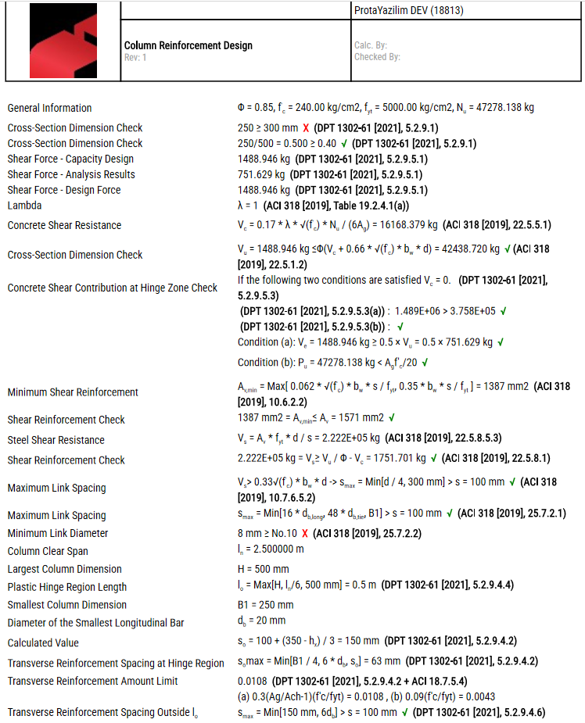

Stability Checks in Footings
Overturning and sliding stability checks have been implemented for pad footing design. Factor of Safety limits are automatically determined based on the selected design code and load combination type (static or seismic/wind), covering TBDY 2018/TS500, ACI 318, NBCI 2016/IS 1904, and Eurocode/BS. Critical FS values across all combinations are shown in the design summary; a detailed matrix table is included in the report.
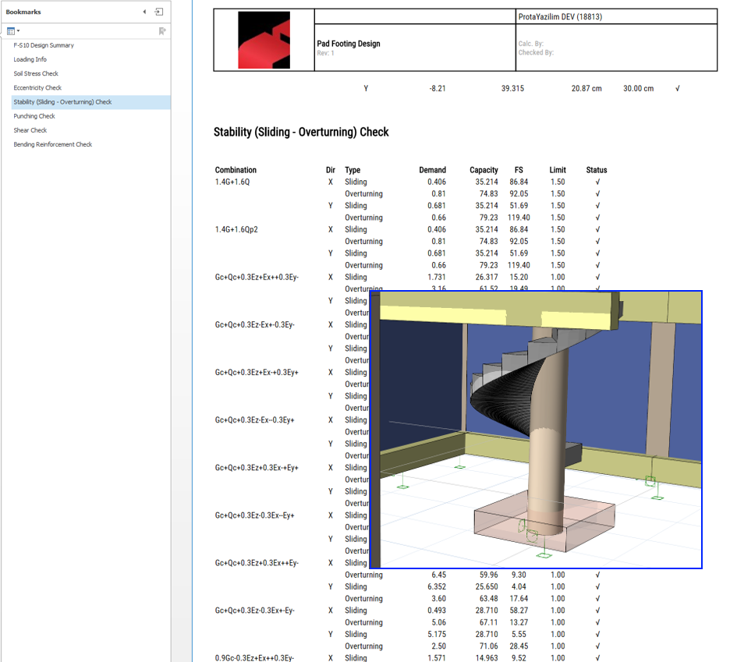

Floor Torsion: Perform at Corners or Selected Columns
The torsion check can now be performed at user-selected columns for each direction, rather than being limited to all vertical members. This is particularly useful for irregular floor plates where the governing torsion scenario does not occur at extreme corners. The columns used in the torsion check are now shown in the report.
The default is still to consider all vertical members to determine the maximum and minimum displacements.
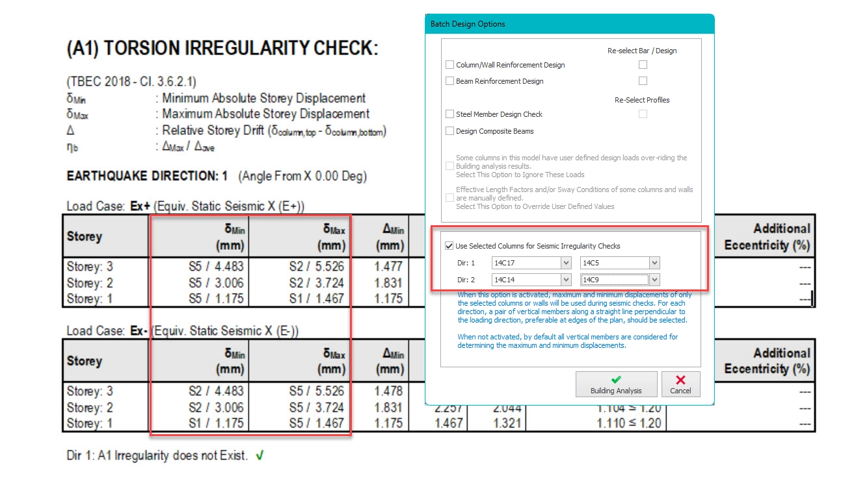

Do Not Design VOM Members for Seismic Provisions
Members designated as VOM (Vertical-Only Member) can now be excluded from seismic design and detailing provisions for Eurocode countries, ensuring seismic reinforcement requirements are not incorrectly applied.

Wide Beam Link Arrangement
ProtaStructure 2027 now supports up to seven links for wide beam design. Engineers set the minimum width limits, and the algorithm follows them incrementally, automatically selecting the appropriate number of links. A new link pattern for wide beam layout provides additional flexibility in meeting detailing requirements.
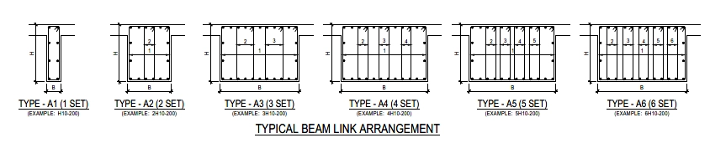
Set the minimum width limits and design. The algorithm will follow the limits incrementally, automatically picking the right number of links.
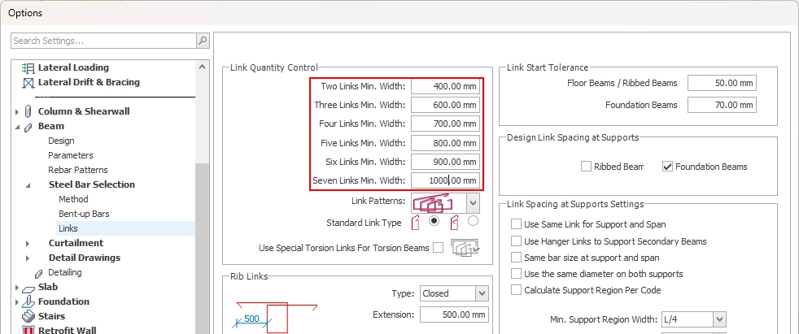

There's also a new link pattern for wide beam layout, giving you extra flexibility to meet your detailing requirements.
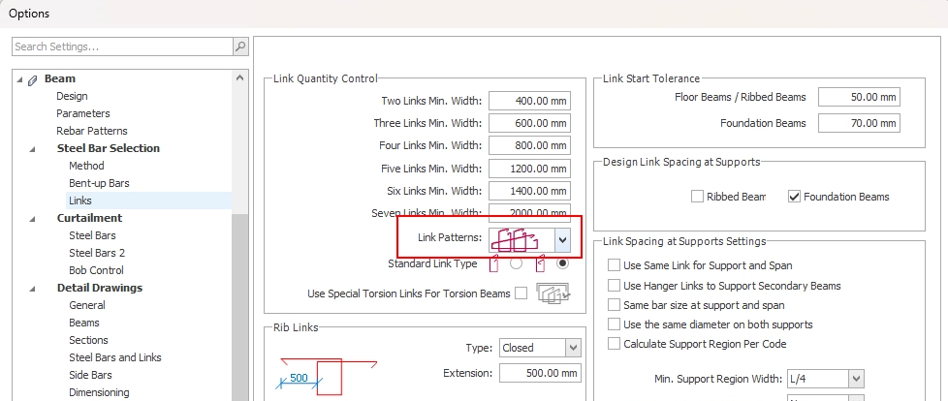
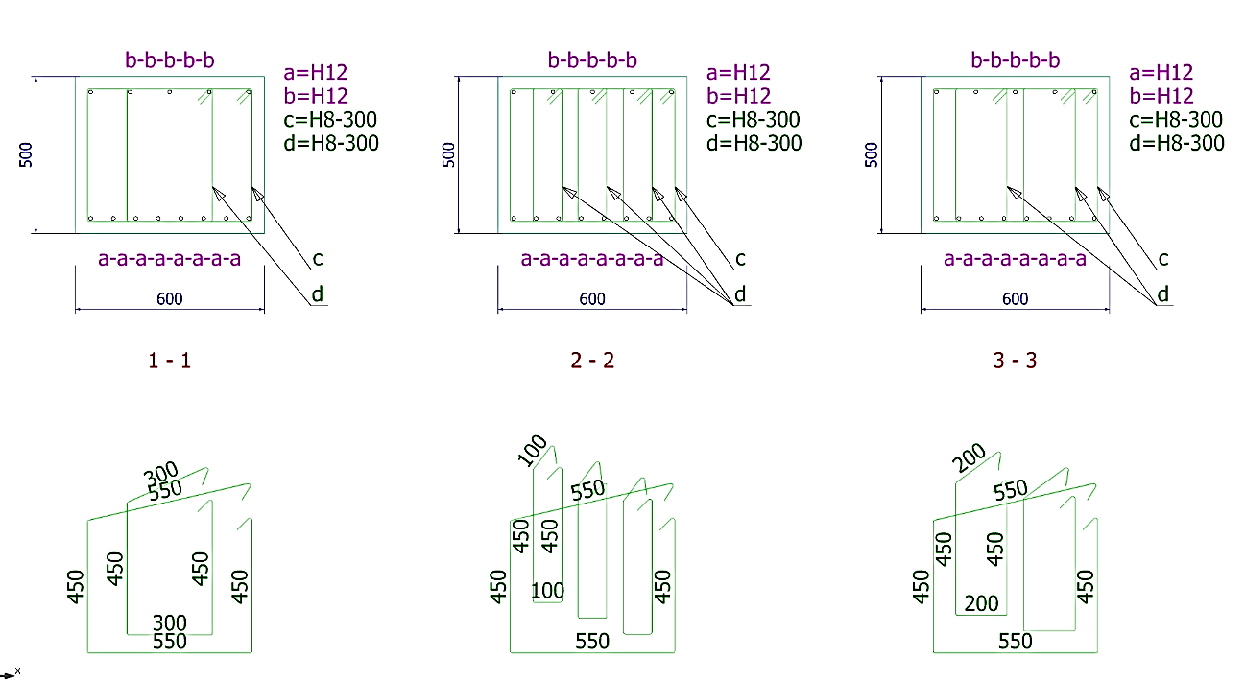

Performance Improvements

Improved Analysis Engine Performance
The analysis engine has been comprehensively re-engineered, delivering a 4x speed improvement across all model sizes. Engineers working on large, complex multi-storey structures will experience dramatically shorter run times, enabling faster design iteration and more productive workflows.
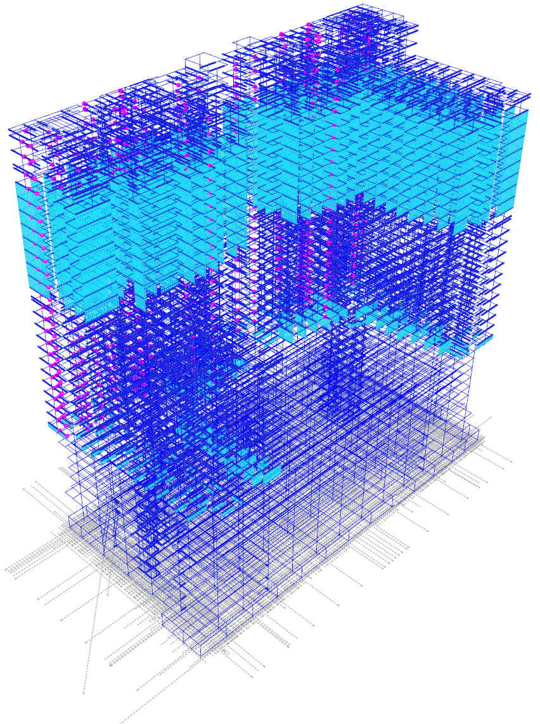

Enhanced Report Engine Performance
ProtaStructure 2027 migrates to a PDF-based report generation engine. This infrastructure change resolves slow report generation in large models — all reports are now generated up to 10x faster. Besides the significant performance upgrade, the new report engine provides visually more appealing reports and more quality print preview. Large design reports with intensive content will be prepared and rendered in seconds.
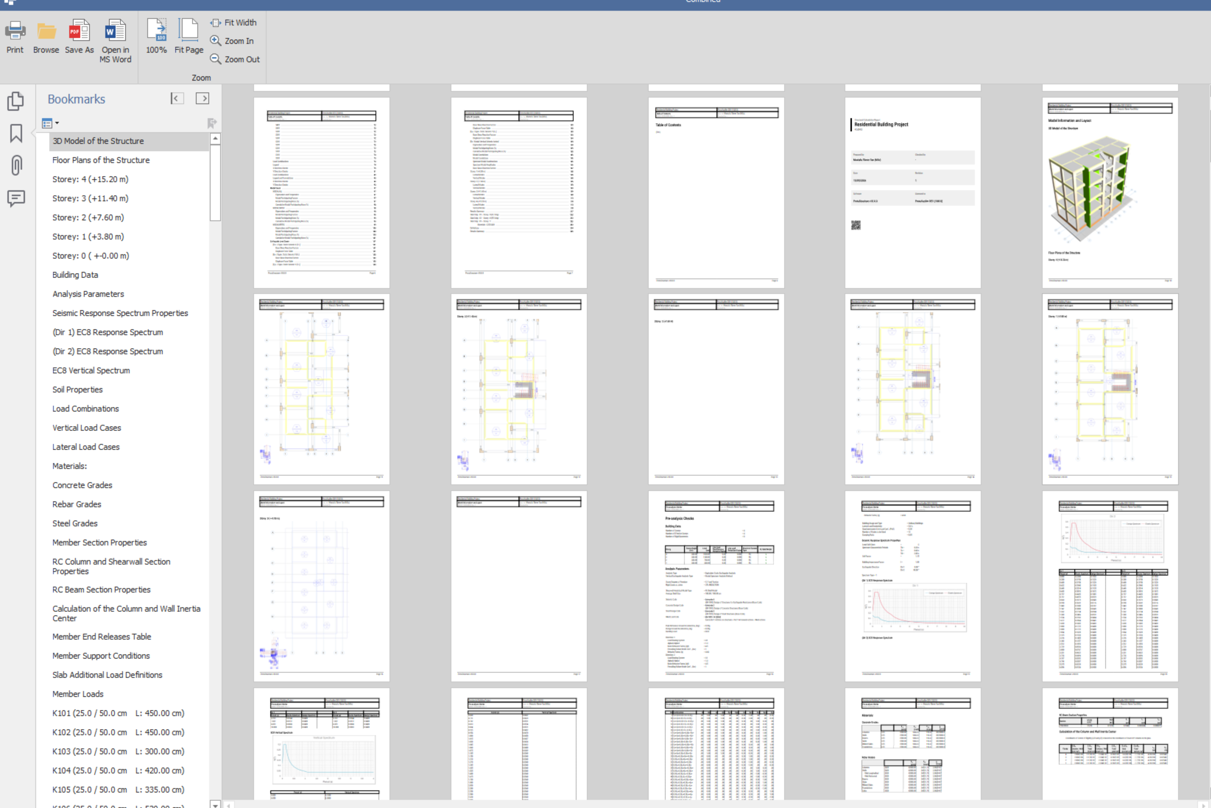

Improved Analysis Results Post-Processing Performance
Analysis results post-processing and contour generation are very time-consuming operations. Design and report generation algorithms also rely on these processed analysis results. The new algorithm significantly accelerates the result collection and processing operations. This means up to a 5x speed improvement in Finite Element Foundation Result reports.
The grouped beam design has also undergone to more than 2x speed improvement with this update.
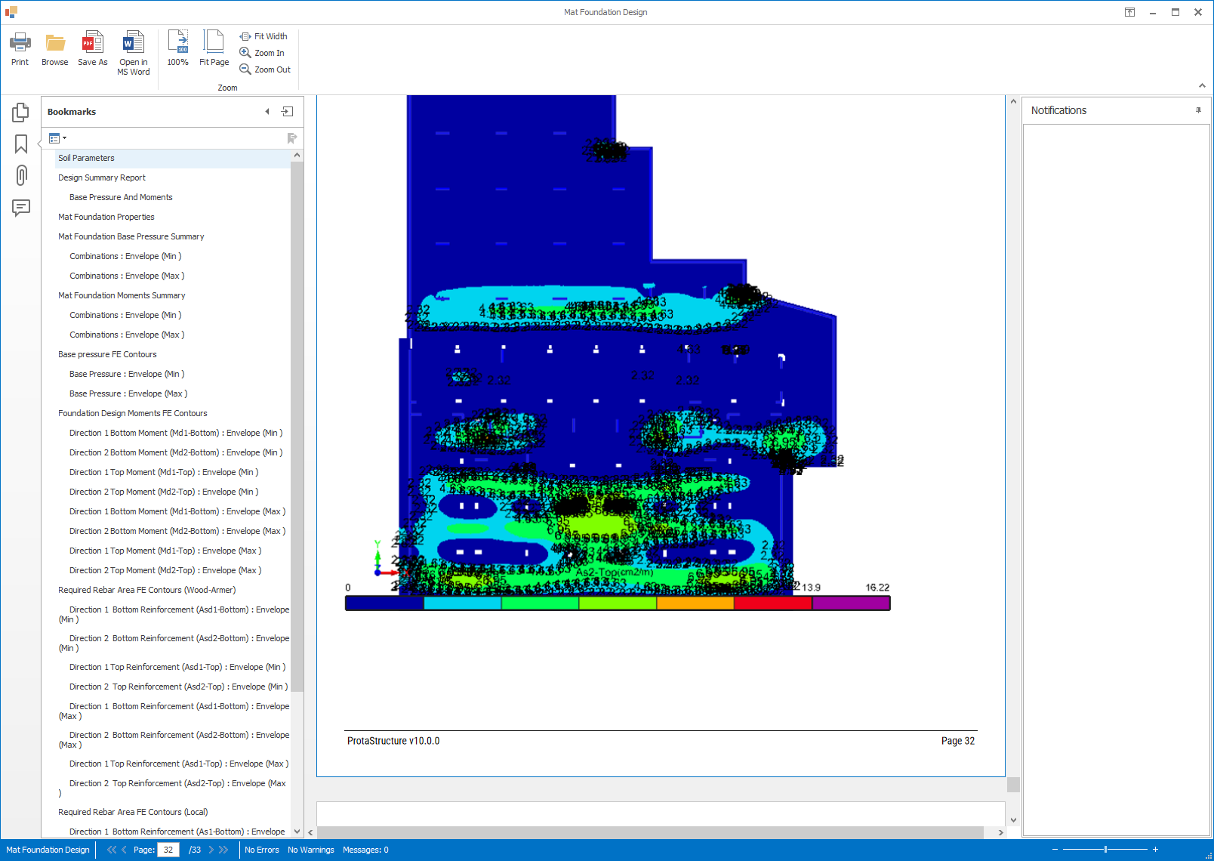

Improved Modelling Performance
We have revised the connectivity algorithm to perform up to 200x better depending on the size of the model when editing members in models with similar storeys.

Modeling and Productivity Improvements

Member Grouping for Selection
Engineers can now create named selection groups and assign any combination of members to them. In large models, this dramatically speeds up amendments, verification, and change management — select all members in a group instantly with Ctrl+G rather than re-selecting them individually each time.
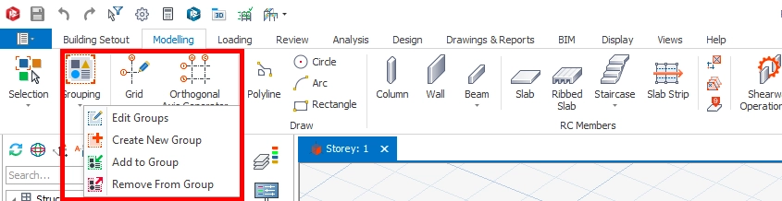
To create a group: select members on the arena > Right-Click (or Ribbon > Modelling Page) > Create New Group. Members can belong to multiple groups simultaneously.
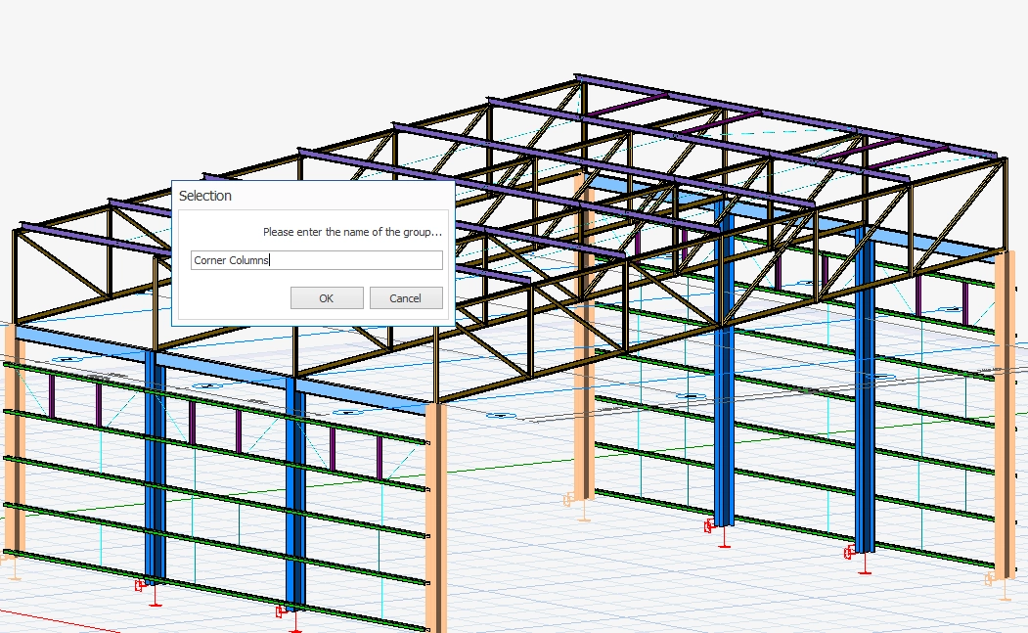
To Select all the members of a group of the selected member:
Right Click > Select Group Members or Hit “Ctrl+G” (default key binding can be changed via Short Key Bindings Setting)
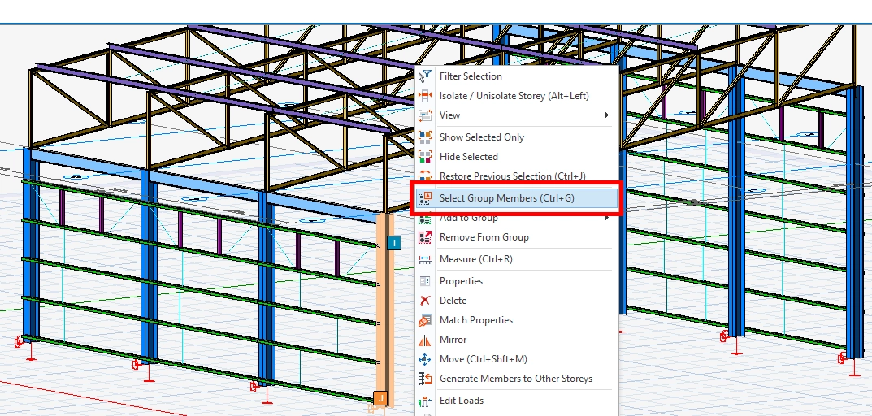
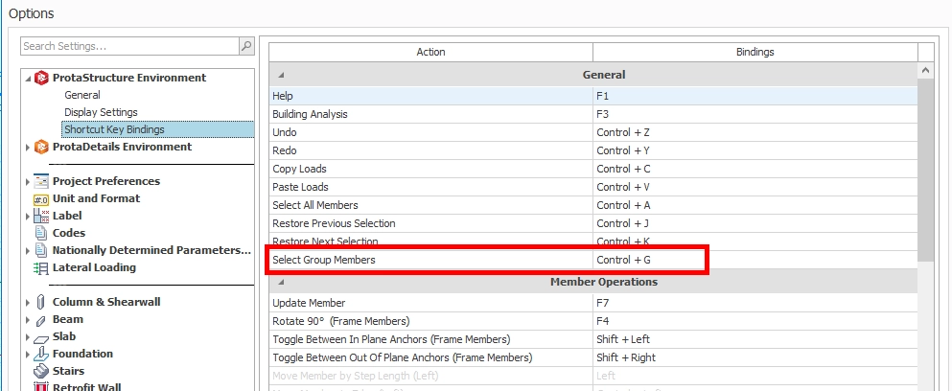
You can either add members to an existing group or create a new group for the selection…
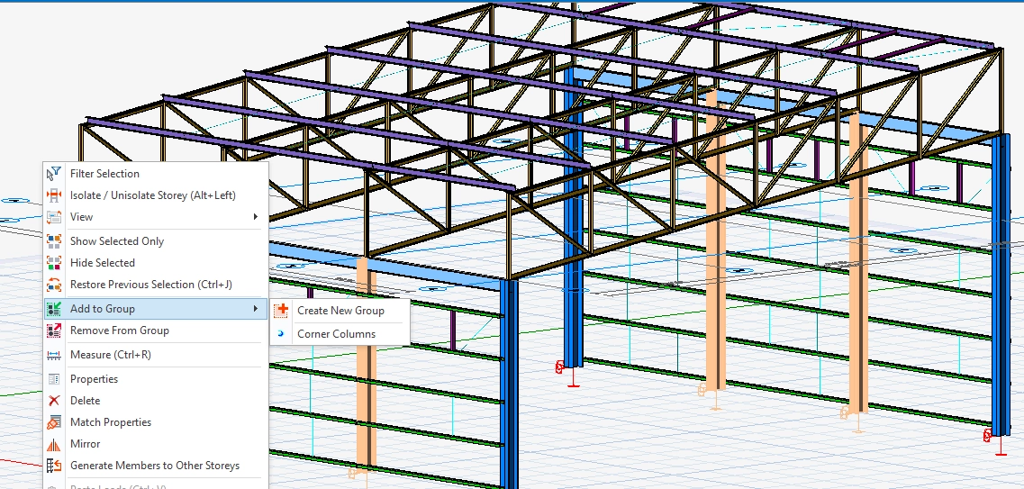

Wind Columns
A Wind Column option has been added to steel columns. When designated as a wind column, the member is designed only for vertical and wind loads — seismic forces are excluded. This enables accurate design of secondary structural elements that are not part of the lateral force-resisting system.
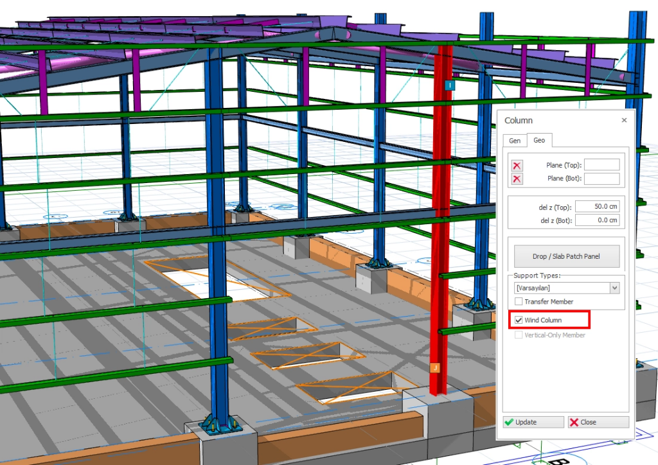

Staircase Modelling and Detailing Enhancements
Staircase loads can now be copied to other staircases, significantly reducing repetitive data entry when a project contains multiple identical stair configurations.
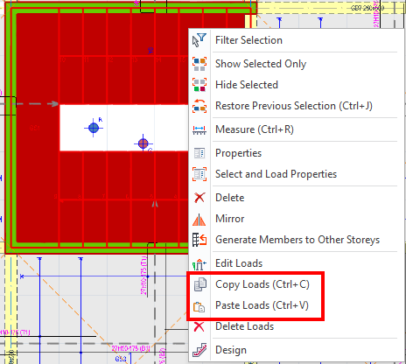

Non-orthogonal landing arrangements are now supported. Stair configurations with inclined and asymmetric landing boundaries can now be modelled and detailed more accurately.
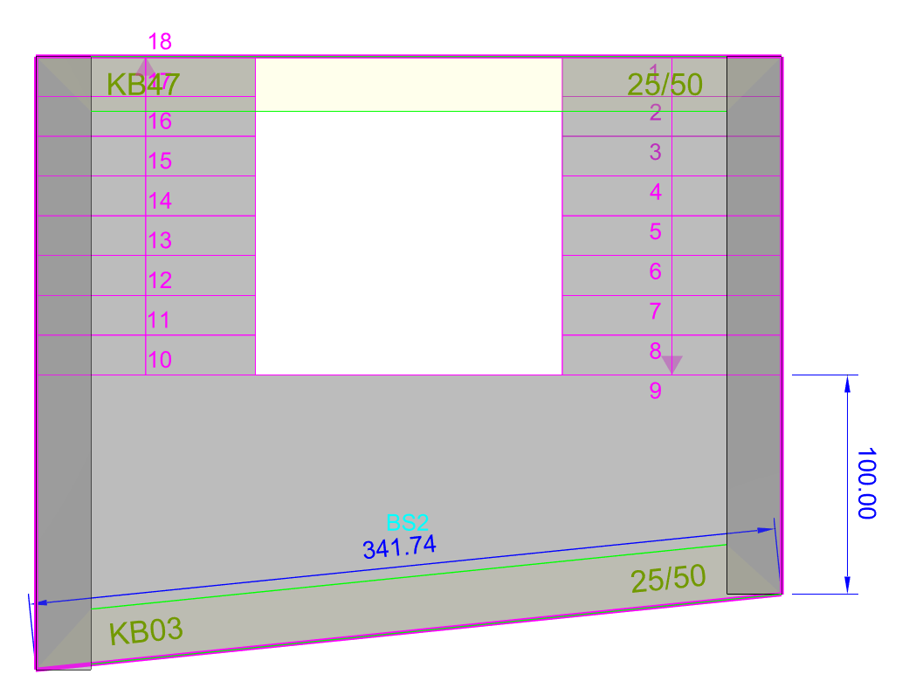
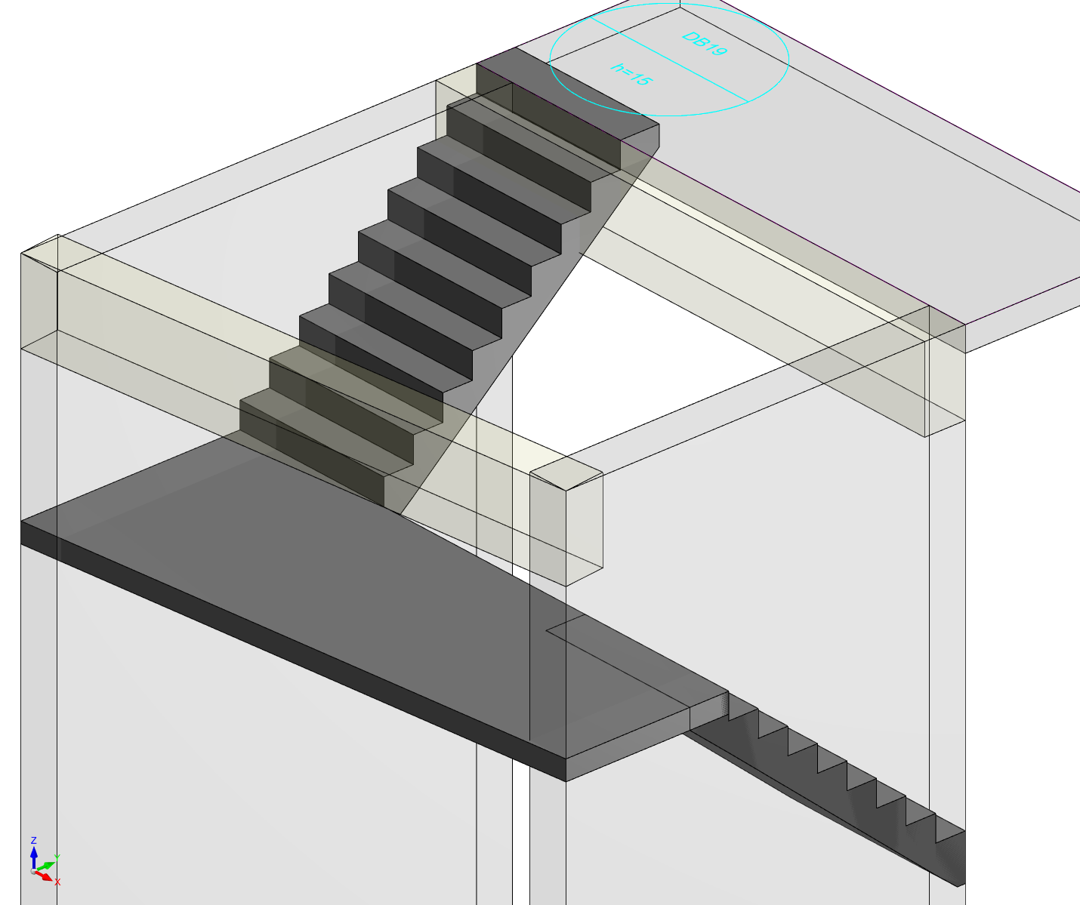

Move and Copy Drawing Entities
Primitive drawing entities can now be copied in the drawing environment, streamlining sheet layout and annotation work and allowing engineers to quickly replicate drawing elements without redrawing from scratch.
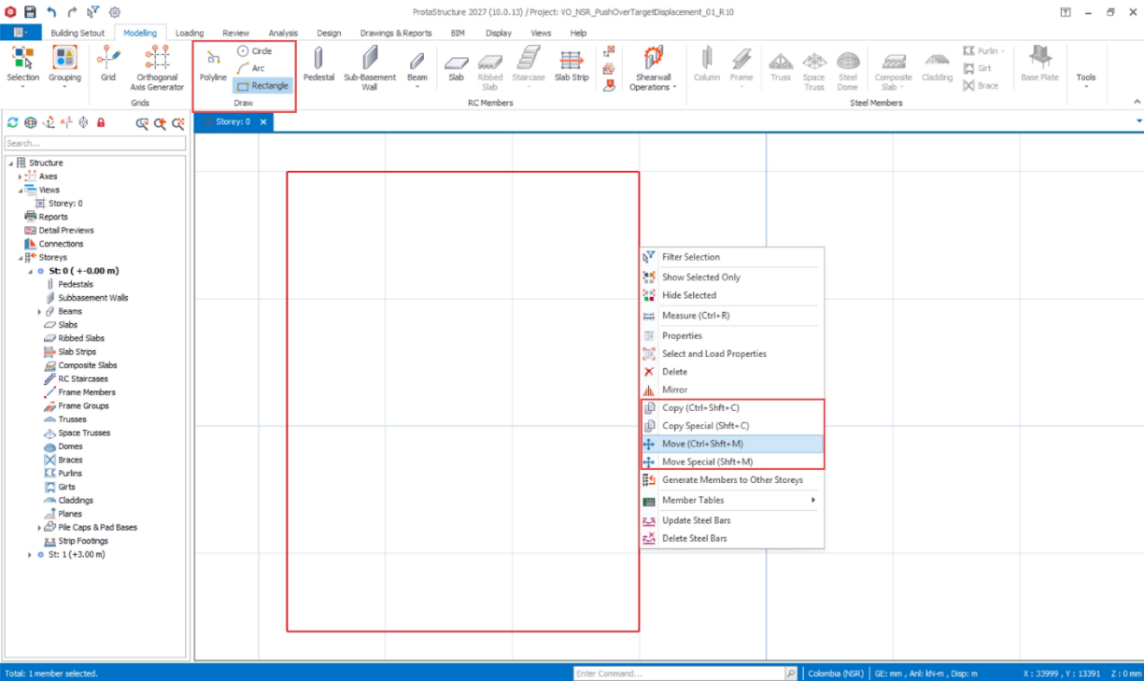

Enhancements in Match Properties Command
The Match Properties command has been extended to cover a broader range of member types and properties, including rib slabs, space trusses, domes, loads across all member types, del-z values, materials, splices, and alignment/offset properties.

Other Productivity Improvements
A range of targeted improvements to the modelling environment enhance everyday productivity:
- New option to display template label and insertion axes together as column plan labels

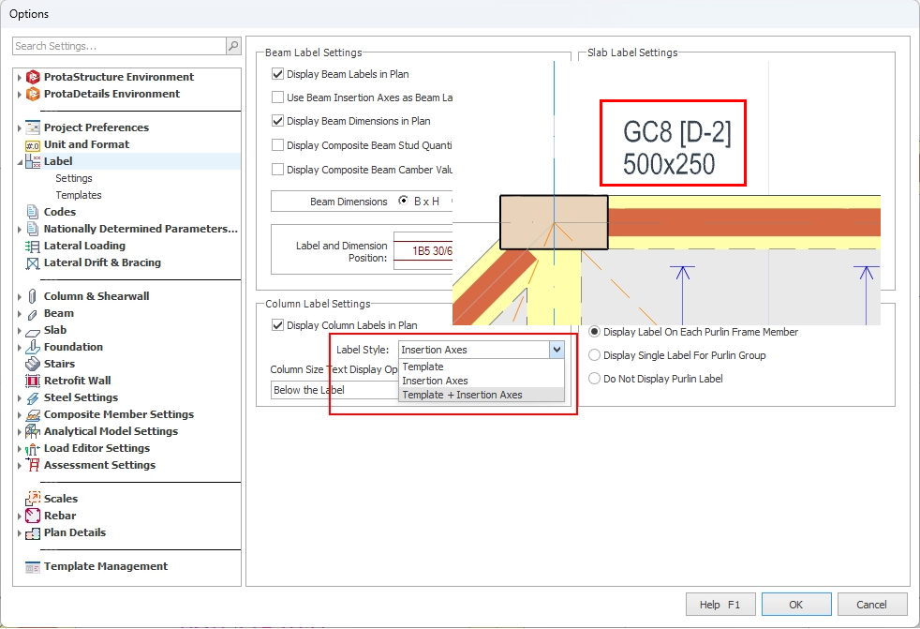

- Structure Tree tracking can now be locked to avoid auto-scrolling in models with many axes

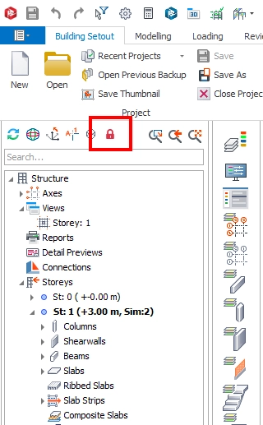

- Search feature added to the Analysis Results Report

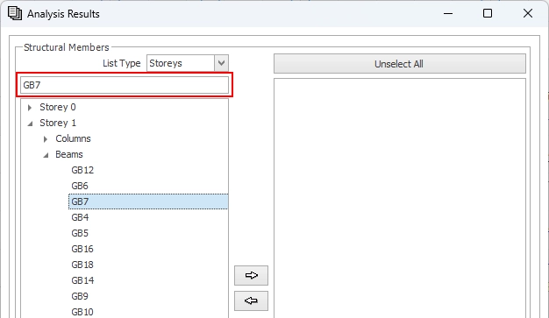

- Steel Bar Optimization window is now modeless — switch between columns while the window stays open
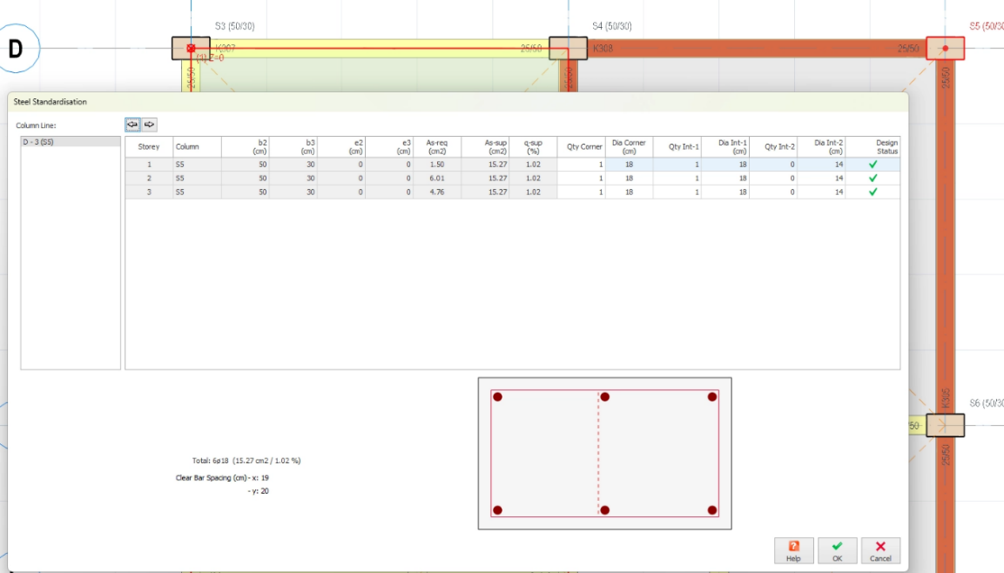

- Multiple composite slabs can now be edited simultaneously via the Member Table

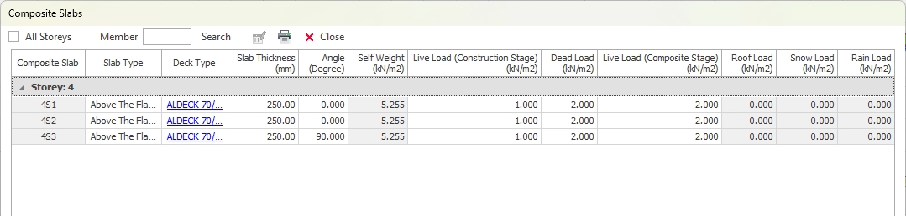
- "Align to Story Levels" option added to brace properties for vertical braces between story-transferred columns.“ This feature allows braces to automatically align with story levels for improved modeling consistency. It helps ensure more accurate and standardized vertical bracing definitions across stories.

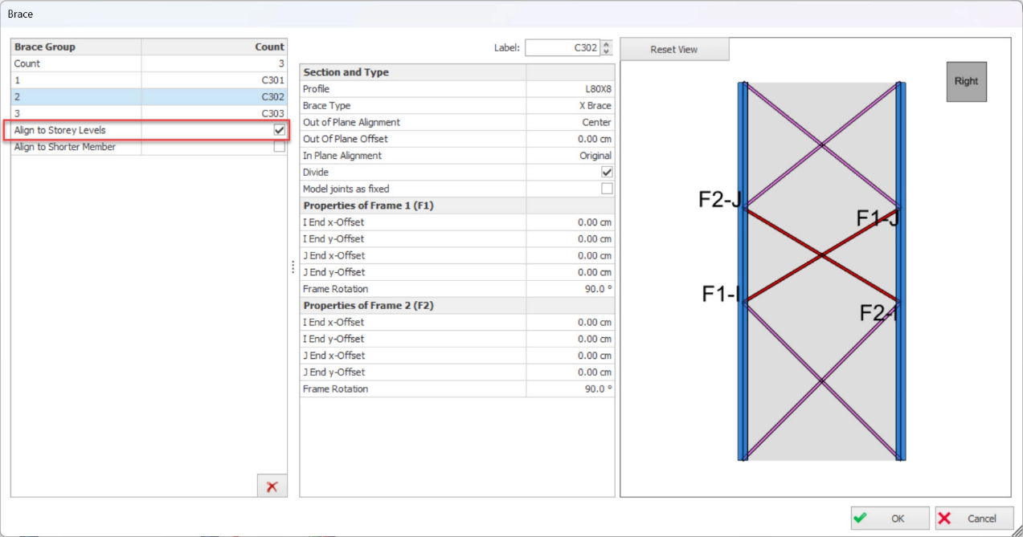

Foundation Design Settings Enhancements
Foundation Design Settings have been reorganized and categorized by foundation type, making it easier to locate and adjust relevant parameters. A new Minimum Foundation Depth to Use Top Bars setting has been introduced for pad footings.
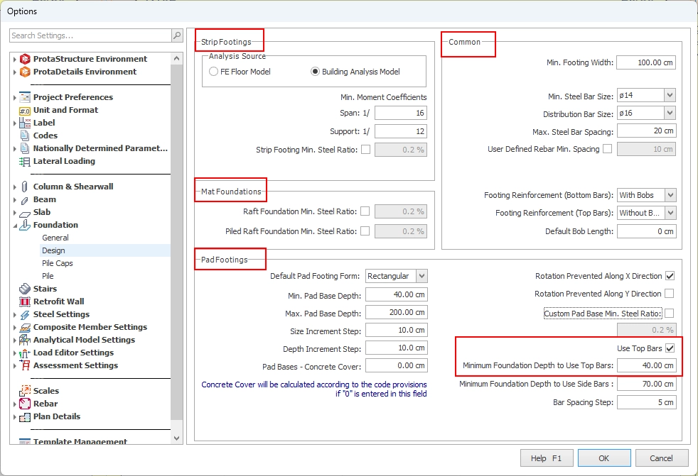

Report Improvements

RC Slab Detailed Design Report
A comprehensive slab design report has been introduced, including strip profile images with deflection/shear/moment values, detailed bending design and deflection check calculations with formulas and code clause references, and moment and steel bar area contours for finite element strips in flat slab systems.
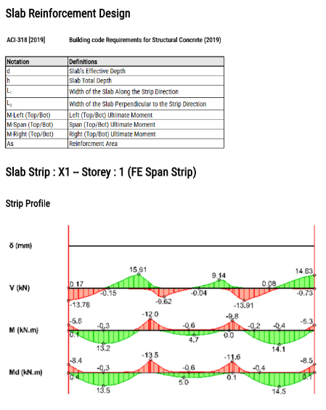
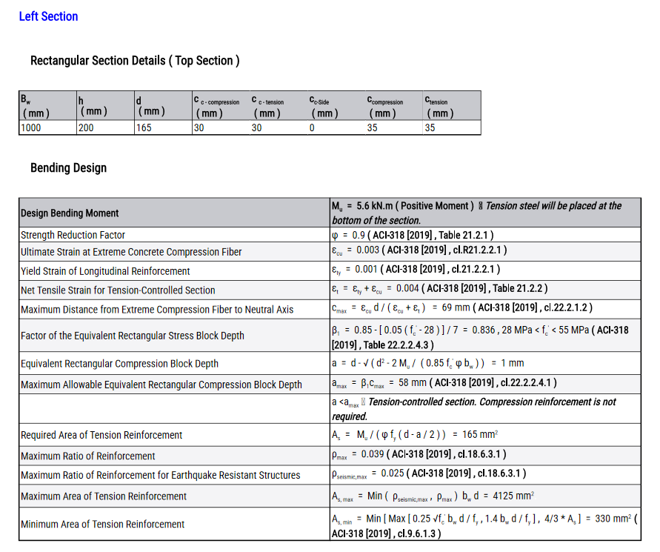
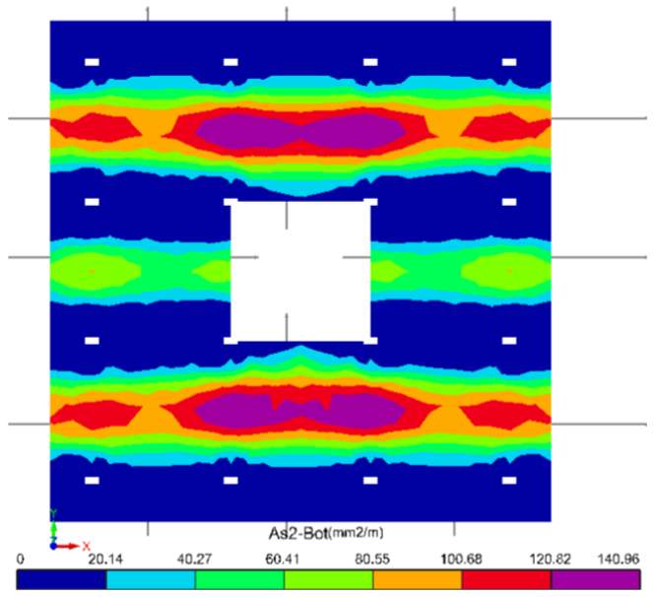
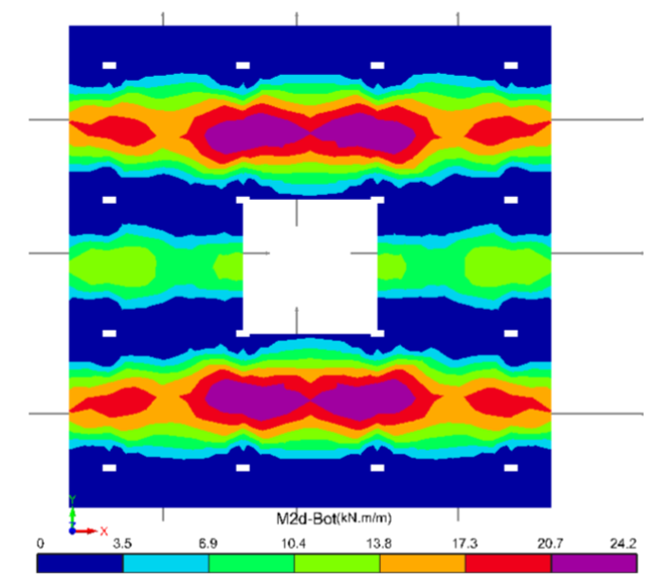

Truss Sketch in Truss Design Reports
Truss diagrams are now displayed directly in truss design reports. This enhancement improves report clarity by providing a visual representation alongside the calculation results.
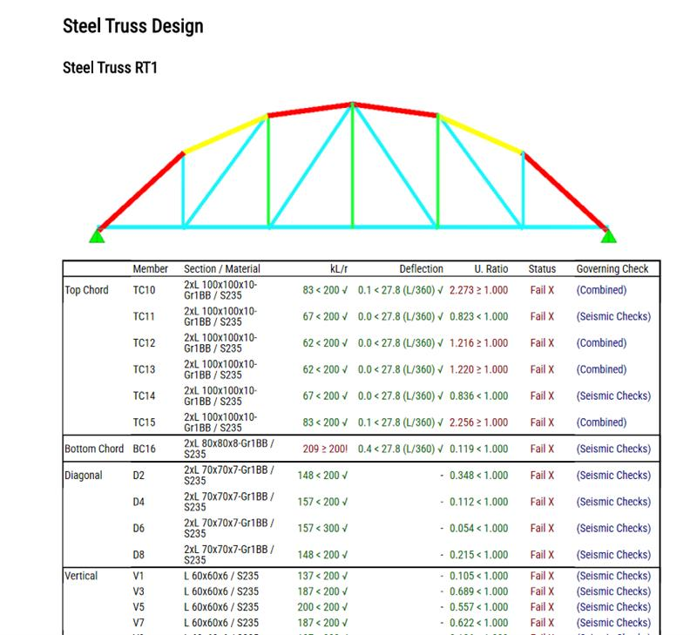

New Excel Export Options
Export to Excel has been introduced across a wide range of reports. Reports now exportable to Excel include Analysis Results, Base Reactions, Column/Wall Design Forces, Beam and Column Rebar Tables, and Concrete/Formwork/Steel/Sheeting/Shear Stud Quantity Tables.
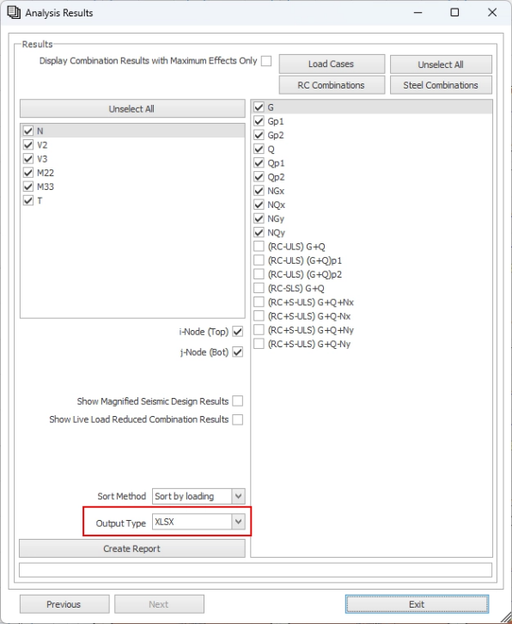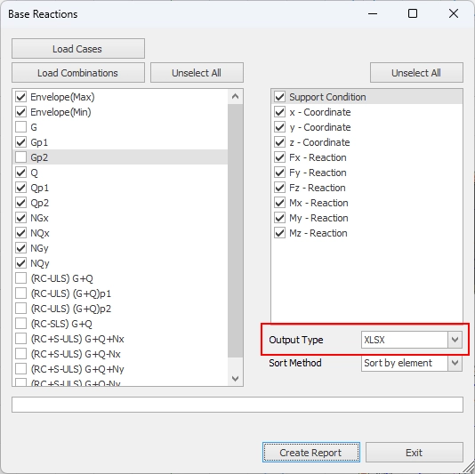

Column/Wall Design Forces
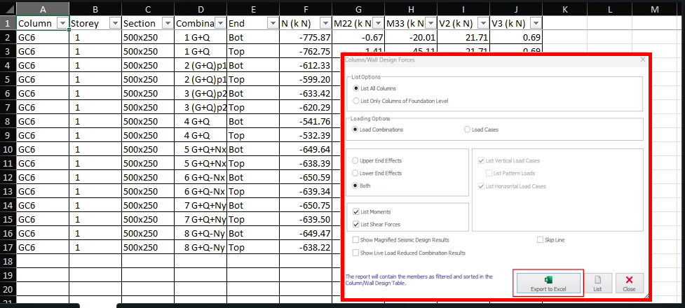

Beam & Column Rebar Tables
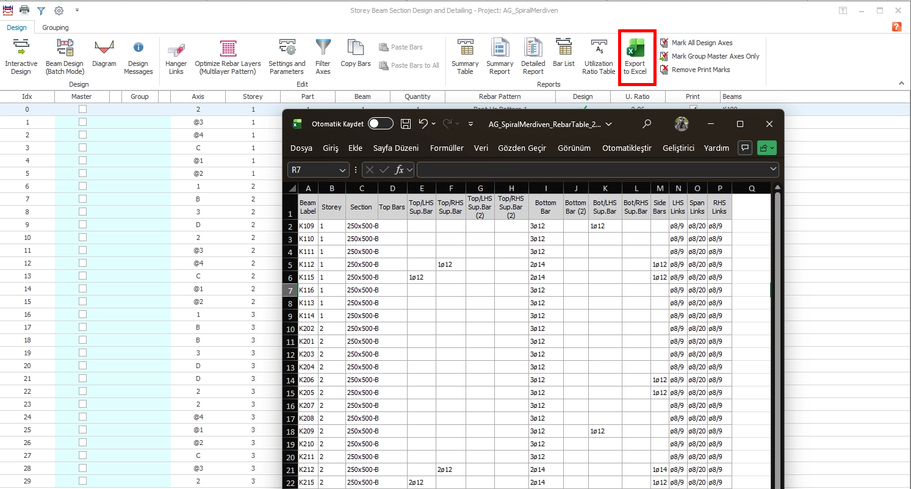

Concrete, Formwork, Steel, Sheeting and Shear Stud Quantity Tables
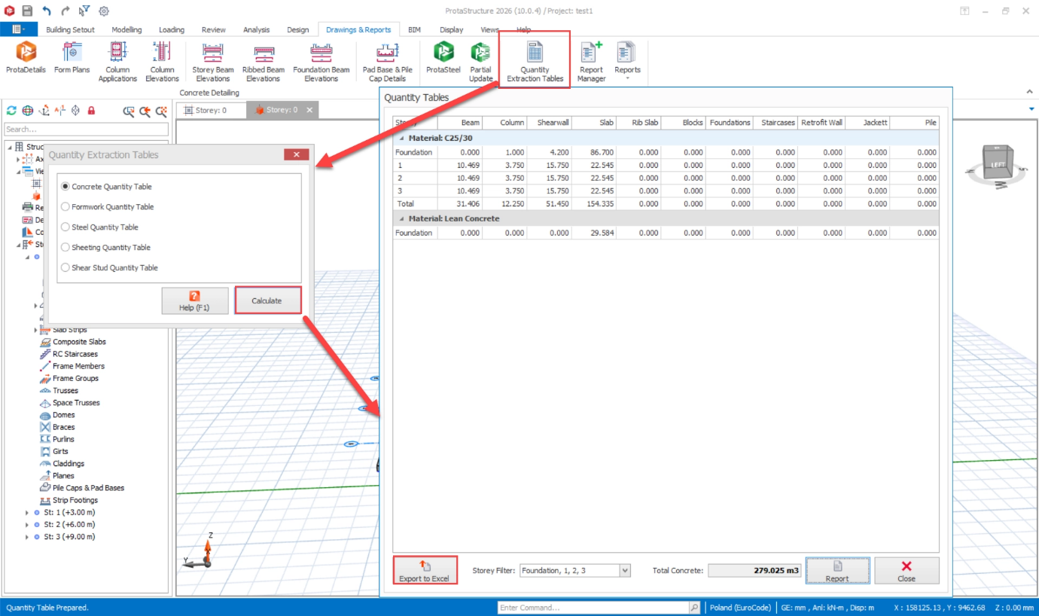

Quantity Take-Off Reports
Concrete and Formwork Quantity Reports can now be filtered by storey. All quantity reports can be exported to Excel.
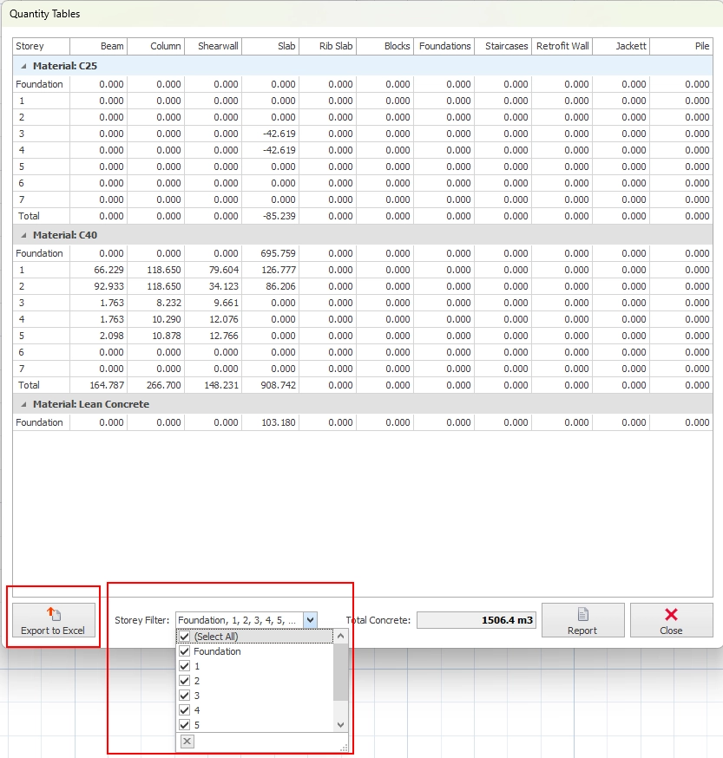

Steel member quantities are now broken down by member type.
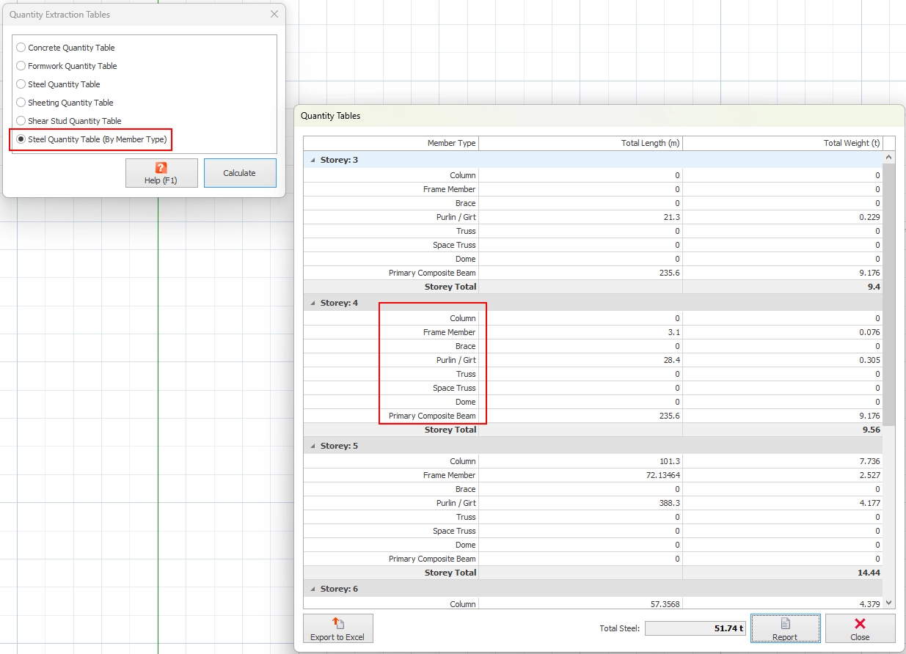
Retrofit wall, column jacket, and pile quantities have separate columns in the quantity tables.
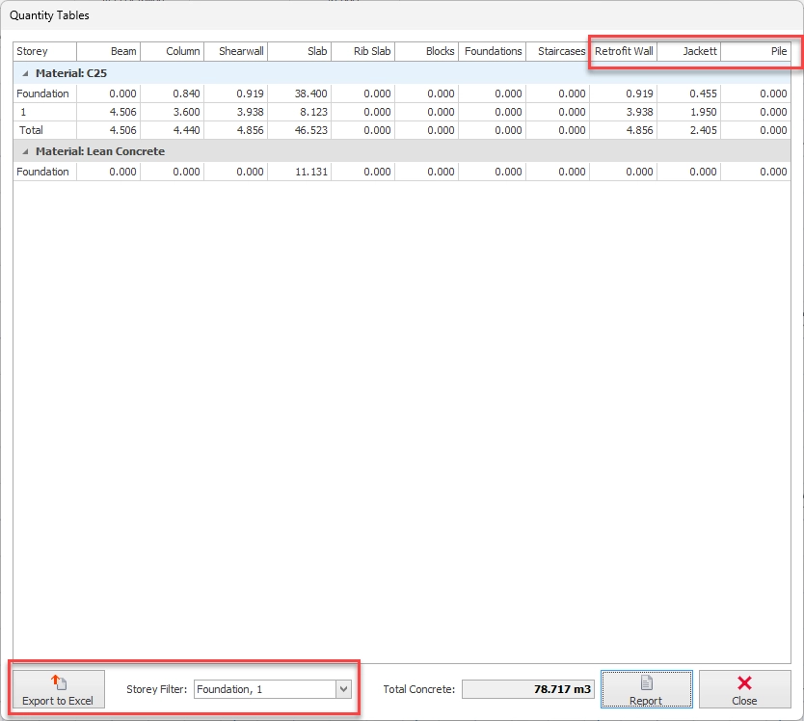

Improved Post-Analysis Report: Behaviour Factor and Eccentricity
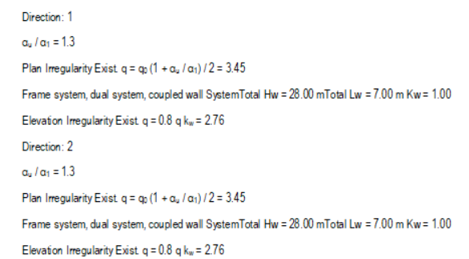
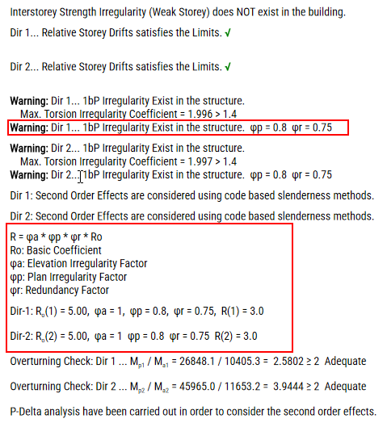
The post-analysis report has been enhanced to better communicate behaviour factor and eccentricity calculations for all seismic codes, providing clearer traceability from input parameters to code-compliance verification.

Additional Elements in Member Property Report
Space trusses, domes, and frame groups are now listed in Member Property Assignment Reports, with Member Support Conditions also added.
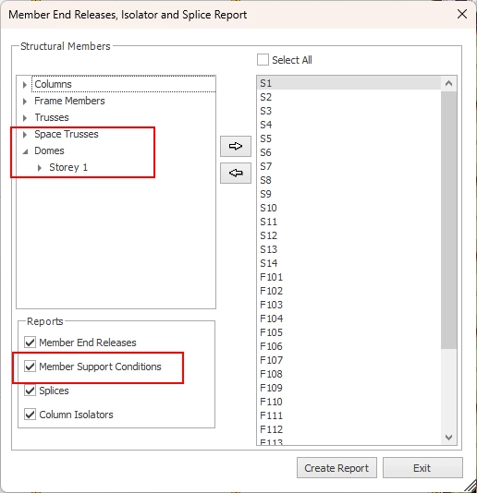

RC Detailing Improvements

Shearwall Detailing Enhancements
Several targeted improvements have been made to shearwall detailing:
- Per-spacing labeling: a new 'Display Bar Spacing' setting shows longitudinal bar labels as diameter/spacing rather than quantity and diameter
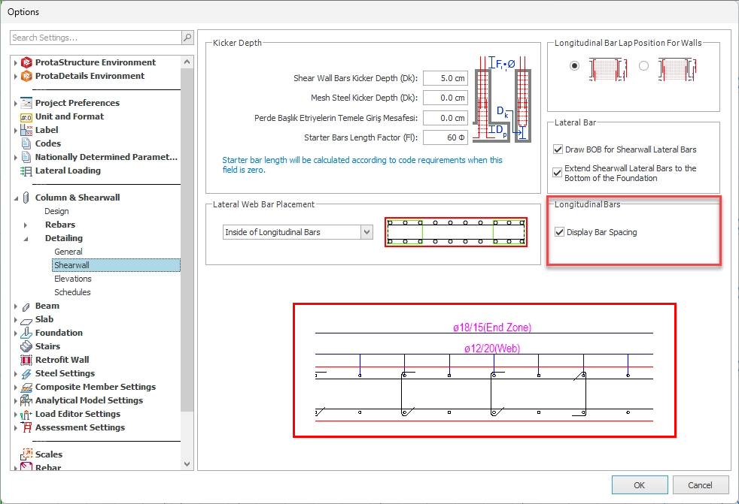
- Separate containment settings for basement walls, aligning detailing correctly for merged wall and column details at basement level

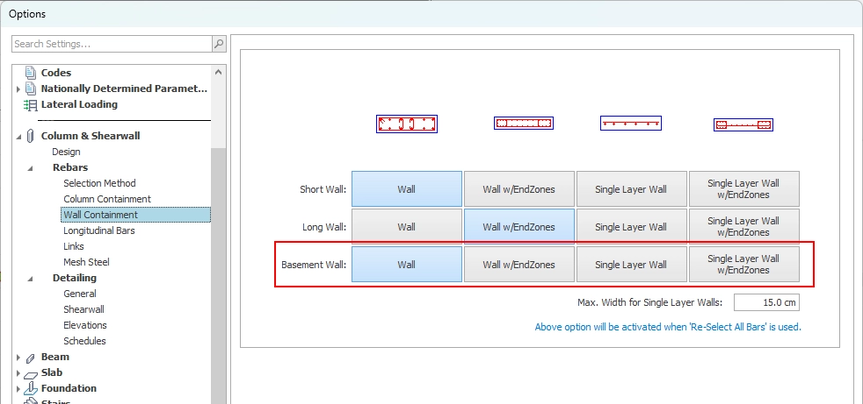

- Basement wall elevations can now be drawn alongside connected column elevations and merged along the axis.

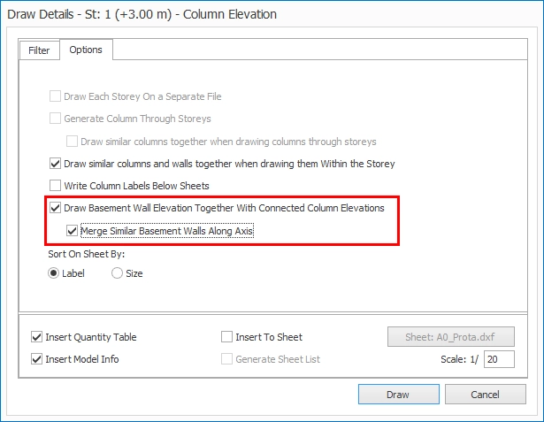

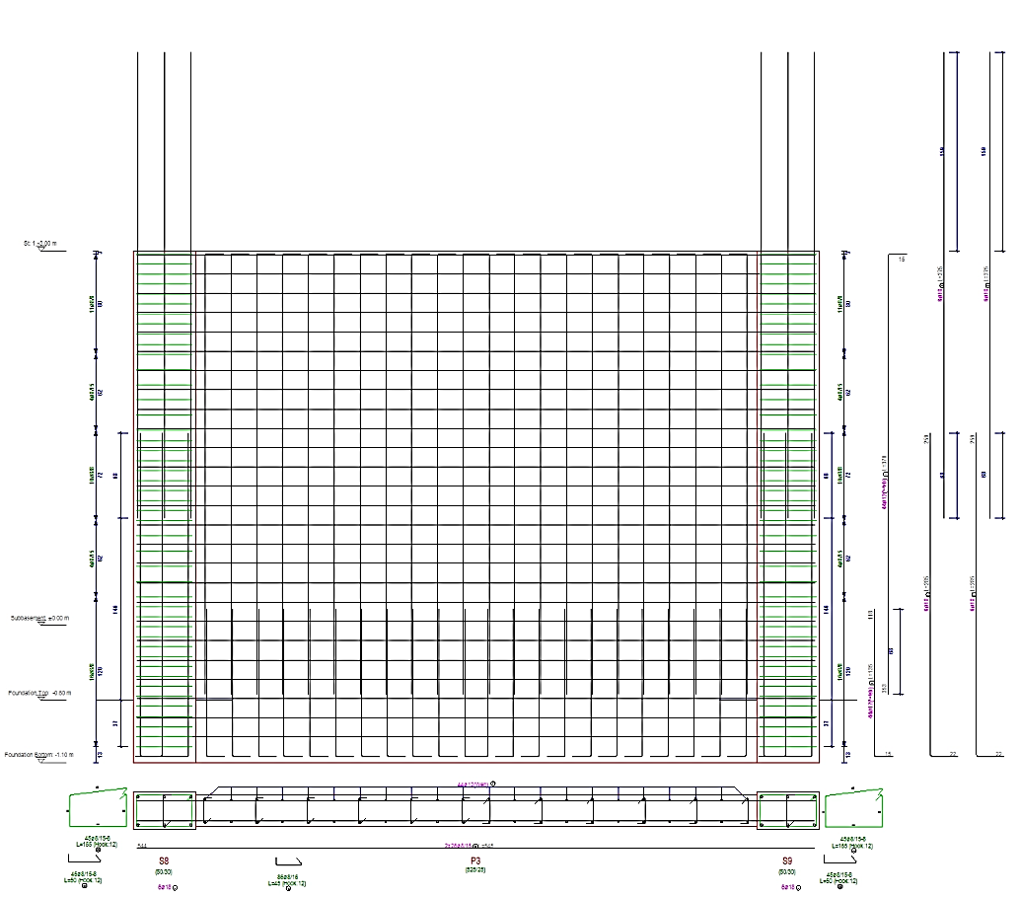

- Shearwall elevations can now be drawn with narrow side view displayed.

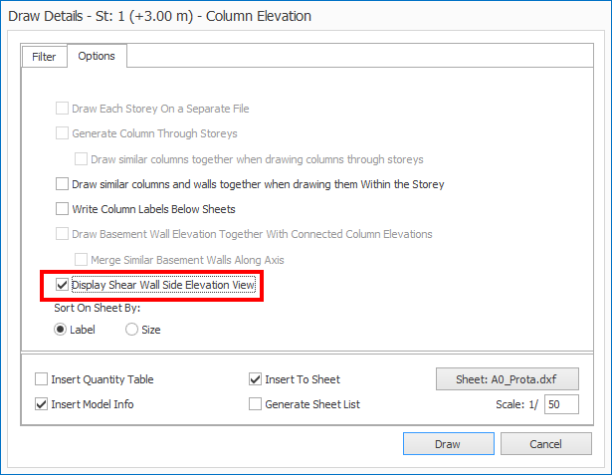

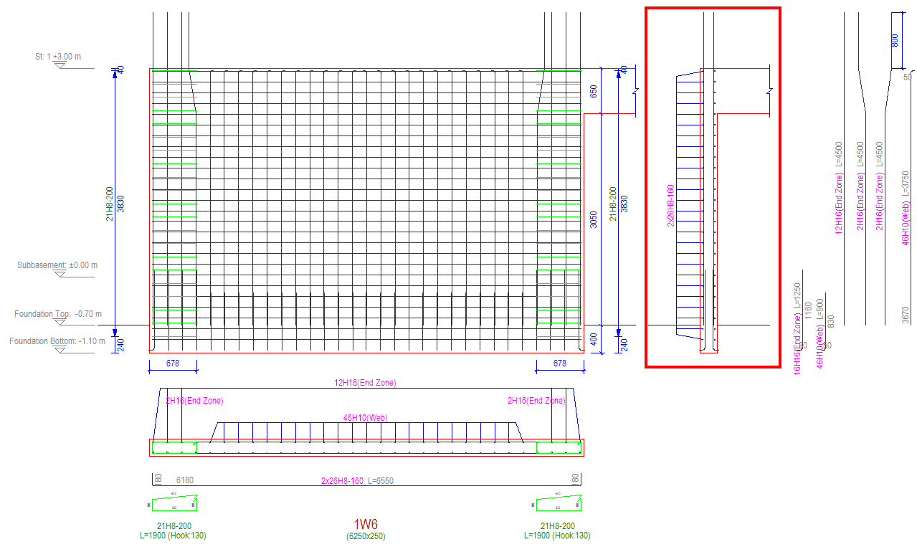

Grouping Similar Column Details
Similar columns and walls within a storey can now be represented together in a single elevation detail, saving sheet space. The quantity take-off automatically accounts for the grouping.
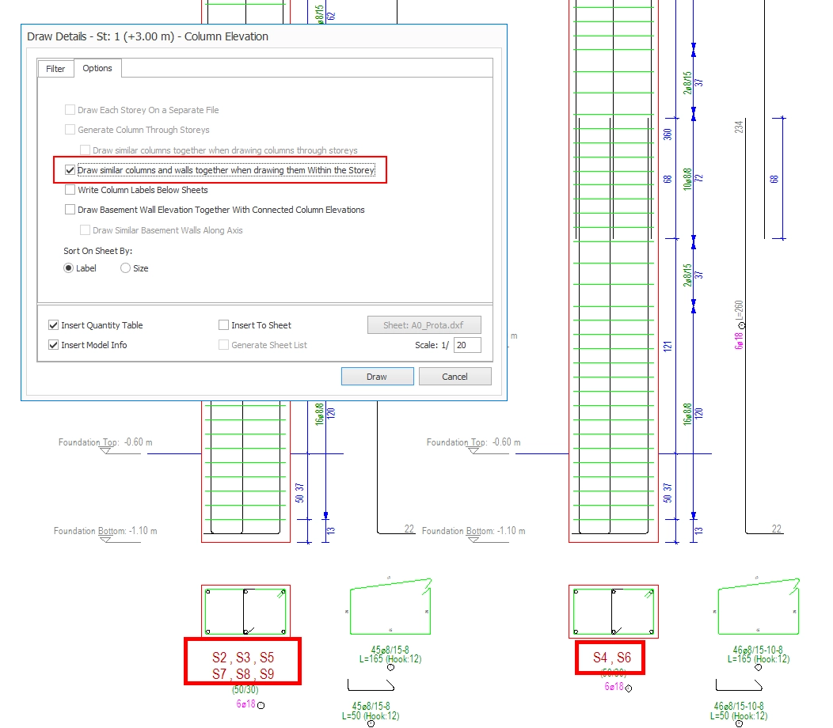

Draw Cranks in Lap Zones of Column Elevation Drawing
A new option applies cranks to column elevation rebar laps — a commonly required detailing practice in Europe and India where lapped bars at floor levels must show the crank geometry explicitly in the elevation drawing.
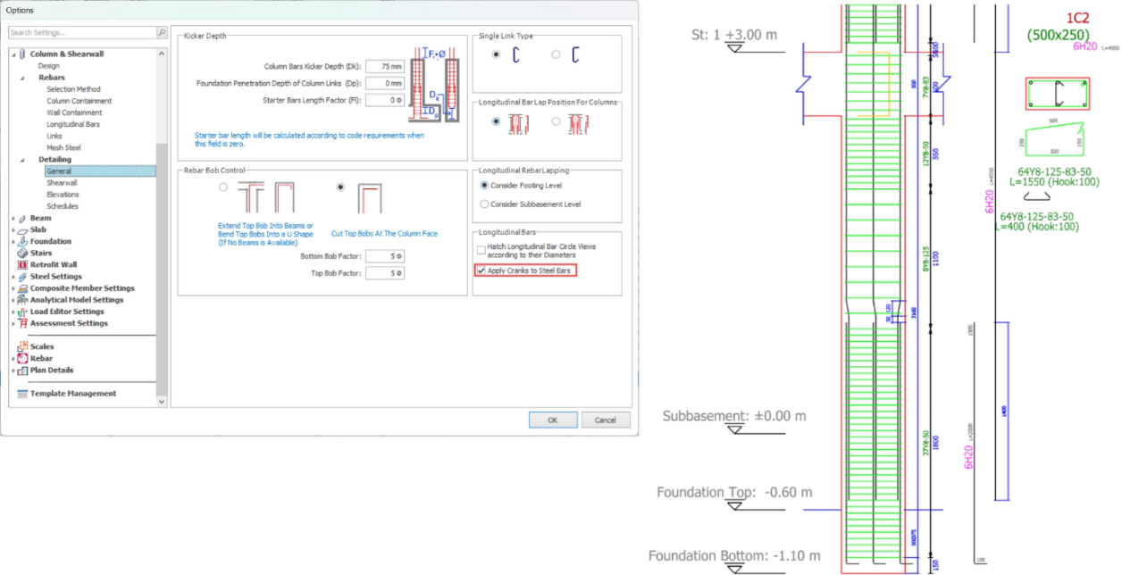

Confinement Along Beam and Column Splices
Confinement reinforcement along beam and column splice regions is now automatically detailed in accordance with applicable code requirements, ensuring correct transverse reinforcement is provided in splice zones for US Code and South American projects.
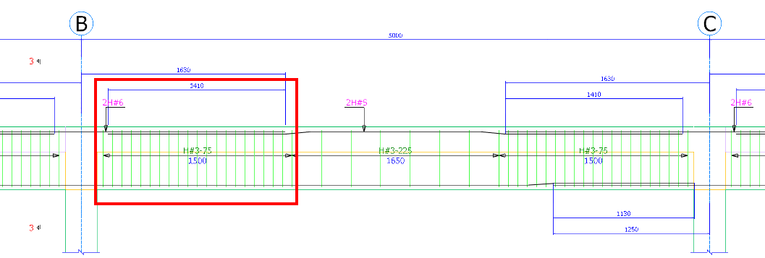
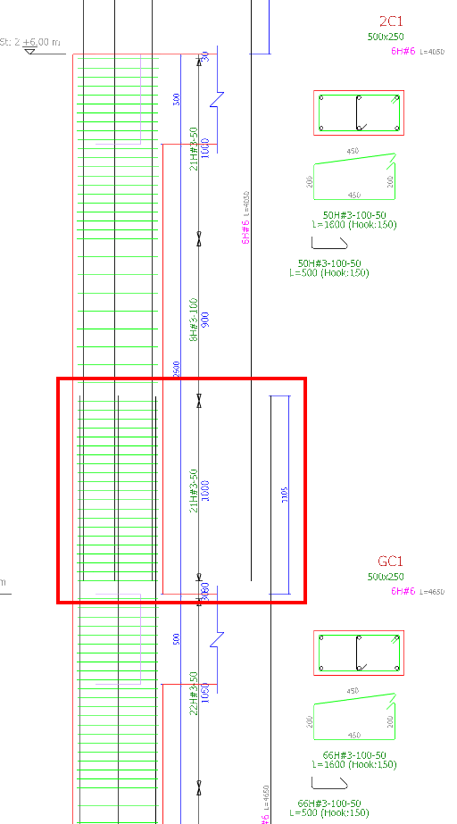

Full Anchorage Length for Beam Bottom Bar
Bottom bar anchorage options are now available for cases where bob length is greater than beam depth. This allows anchorage definitions to be applied even when the bob length exceeds the beam depth.
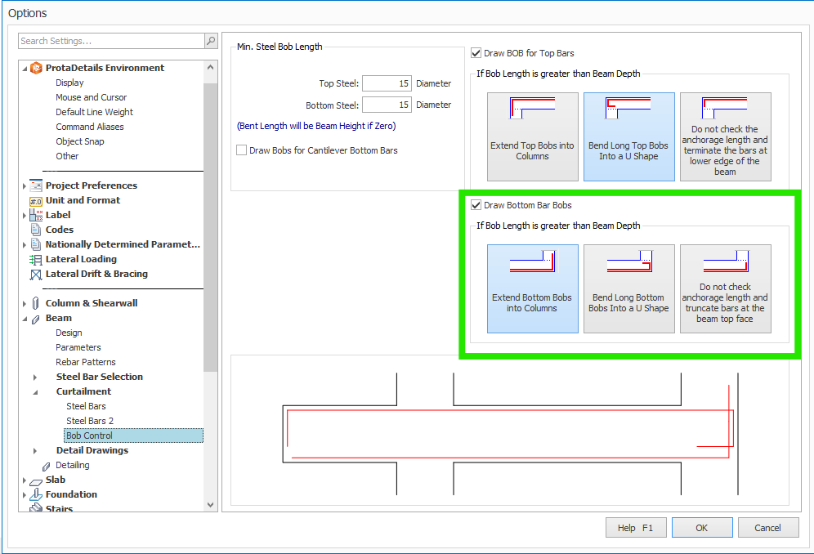

Punching Reinforcement Detailing
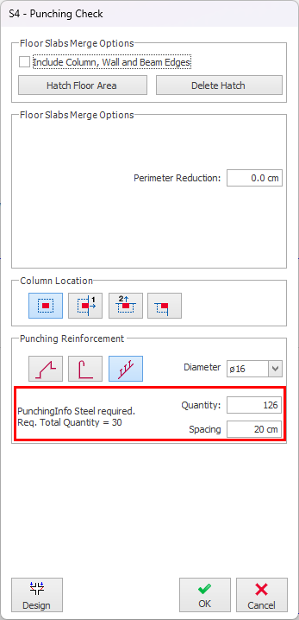
Punching Reinforcement requirements are calculated according to the code standards and required vs. provided reinforcement area is printed on the reports. Users now have control over the quantity and spacing of the selected punching reinforcement. Full detail drawing generation is available in ProtaDetails. All three types of punching reinforcement can be drawn and included in the quantity take off.
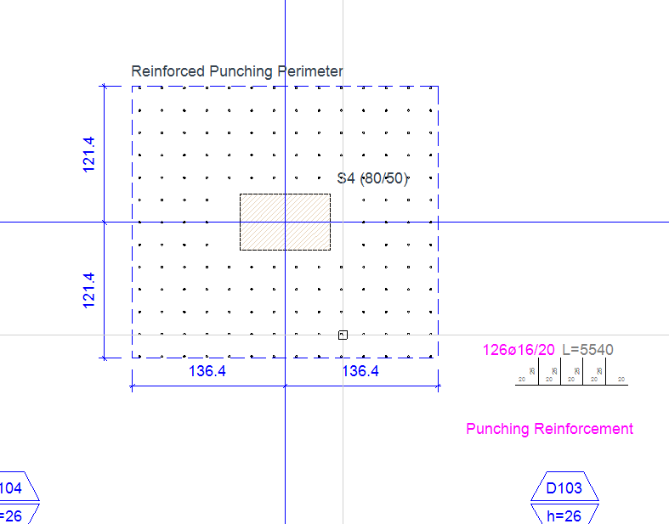

Formwork Scaffold Quantity Take-Off Command
ProtaDetails now includes a dedicated take-off command for formwork scaffolds. Select a region on the drawing containing formwork applications and details, and a cumulative quantity take-off table is automatically generated.
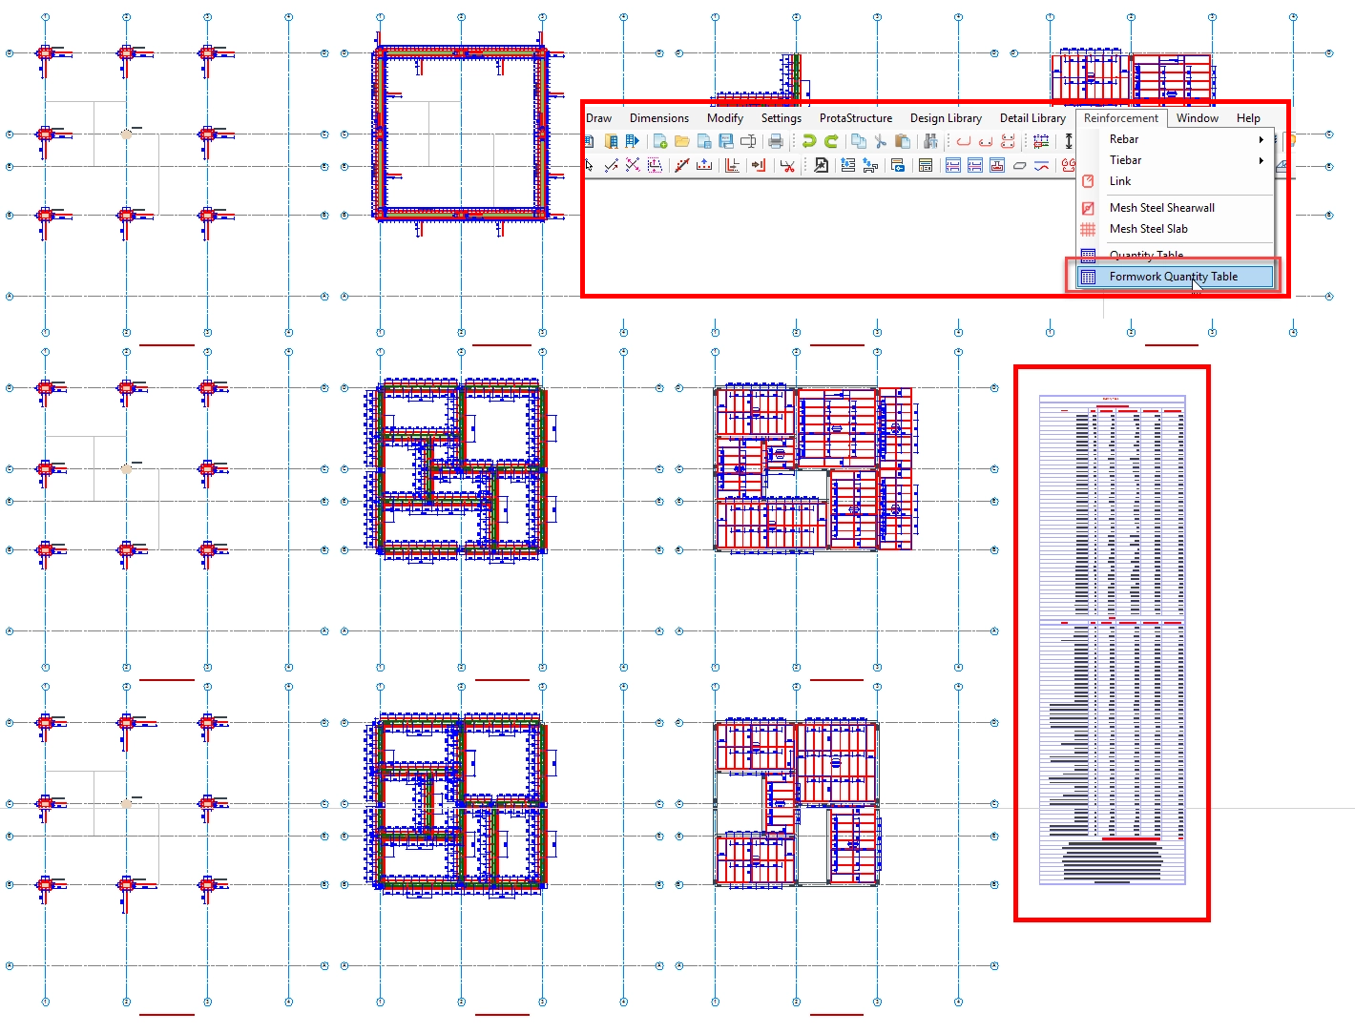

Manual Override for Column-Beam Joint-Region Link Spacing
Two new settings allow manual override of the column-beam joint region link spacing, giving engineers precise control over joint region detailing where the automatically calculated spacing needs to be adjusted.
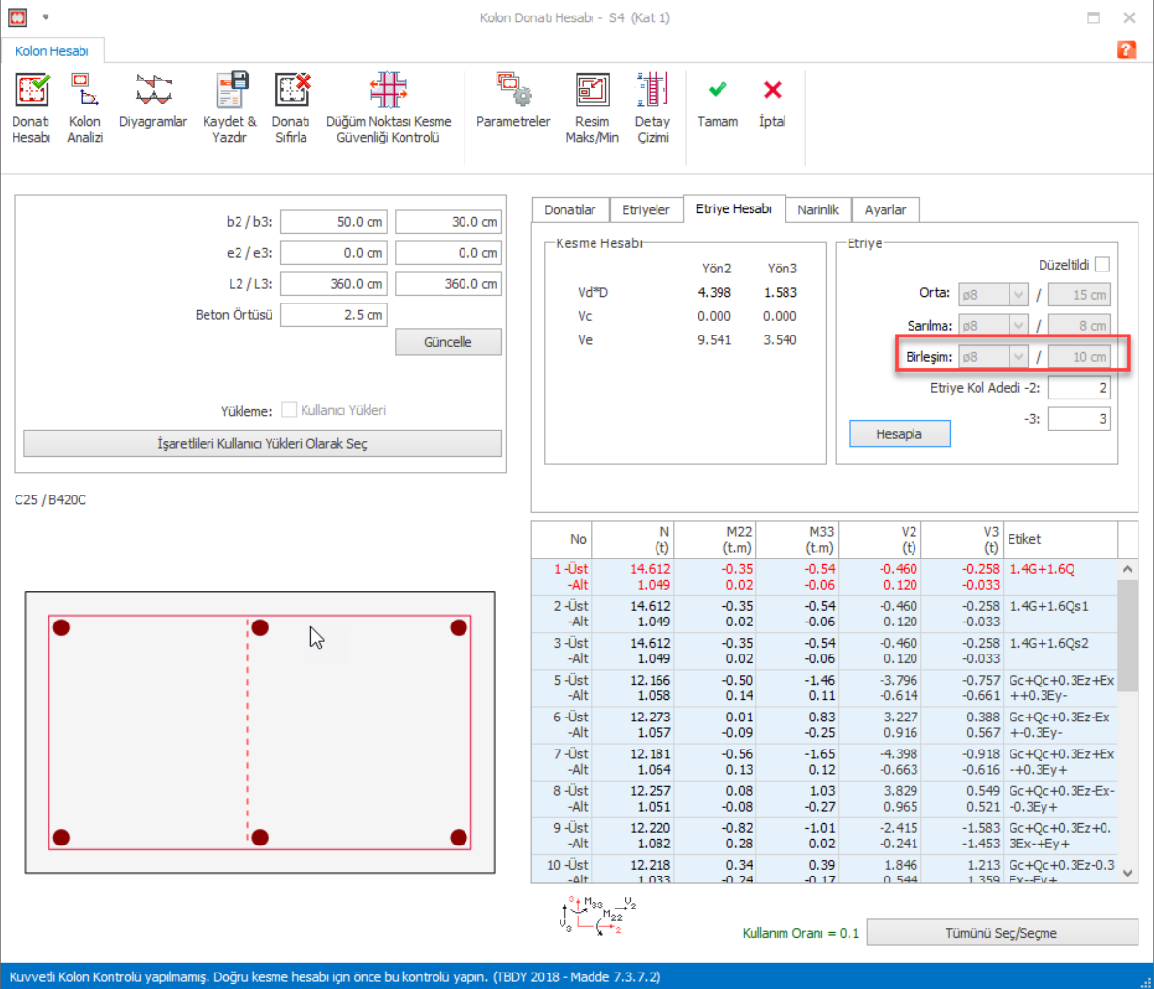

PROTASTEEL 2027 — New Features

New Macros
- Handrail Post Connection Types
Two new handrail connection macros have been added to simplify the modeling of post connections. The Simple Connection for Posts macro provides a straightforward and efficient solution for standard post-to-member connections, while the Removable Connection for Posts macro creates a bolted connection that allows posts to be easily removed when required for maintenance, transportation, or site installation. These new macros help engineers model common handrail details more quickly and consistently.
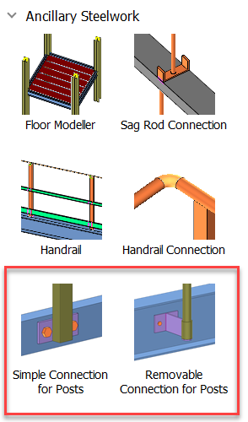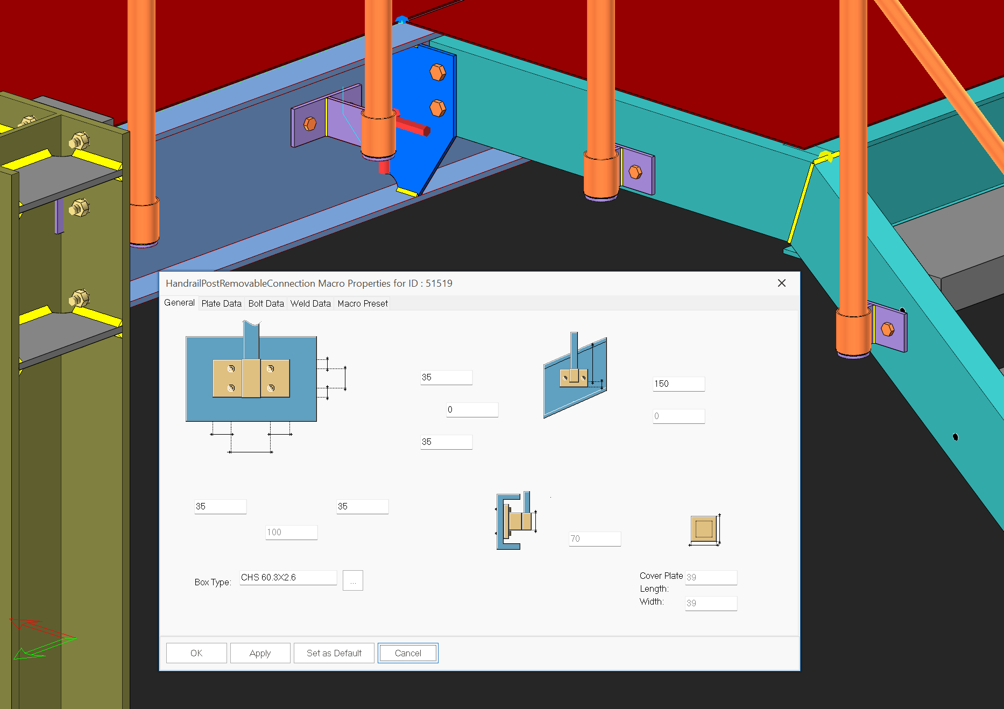

- Purlin and Girt Flush Connections
Purlin Flush Connection and Girt Flush Connection are new macros developed for situations where purlins and girts are positioned within the depth of the main member. These macros can be used when the purlin or girt is located inside the web region of the supporting member and aligned with either the top or bottom flange. They provide a simple and efficient way to model flush connections without the need for manual detailing.
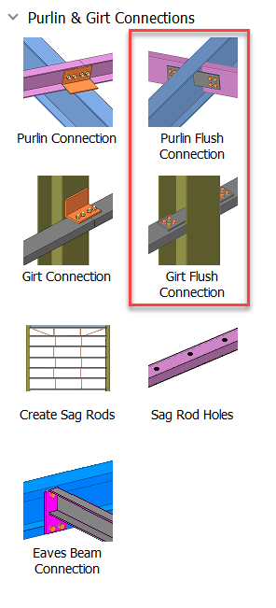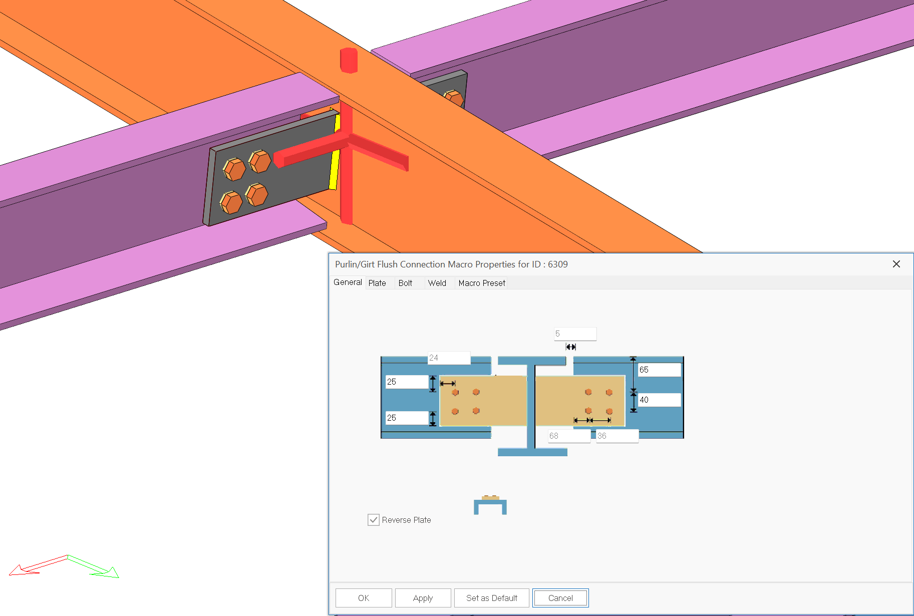
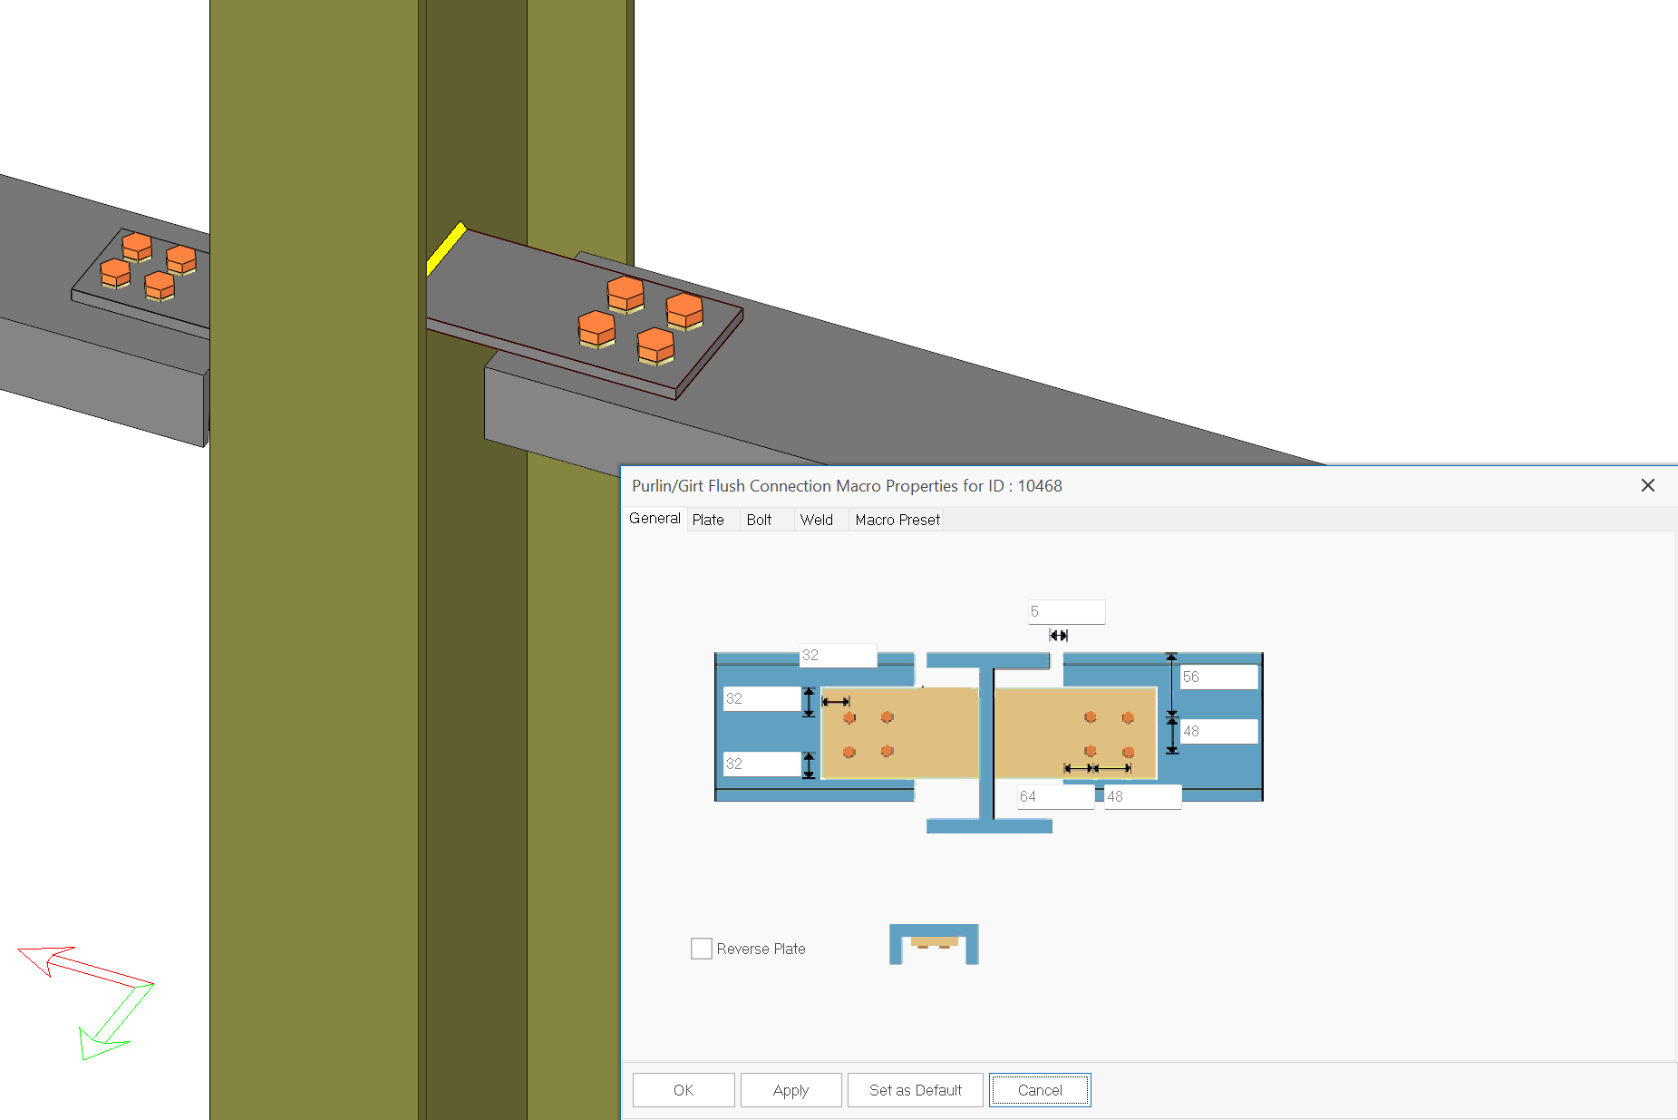

- Hollow Section End Plate Connection
The new Hollow Section End Plate macro provides a fast and efficient way to create end-plate moment connections between hollow structural sections (RHS, SHS, and CHS) and open steel sections such as I-beams and channels. Supporting a wide range of beam-to-column, column-to-beam, and continuous member configurations, the macro automatically generates connection geometry and detailing, significantly reducing modeling time while improving consistency and accuracy. This enhancement enables engineers to design complex hollow section connections with greater confidence and productivity.
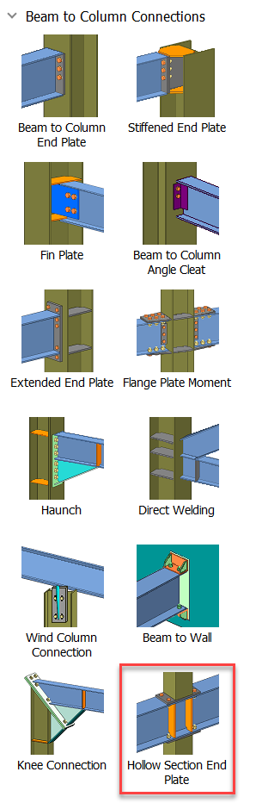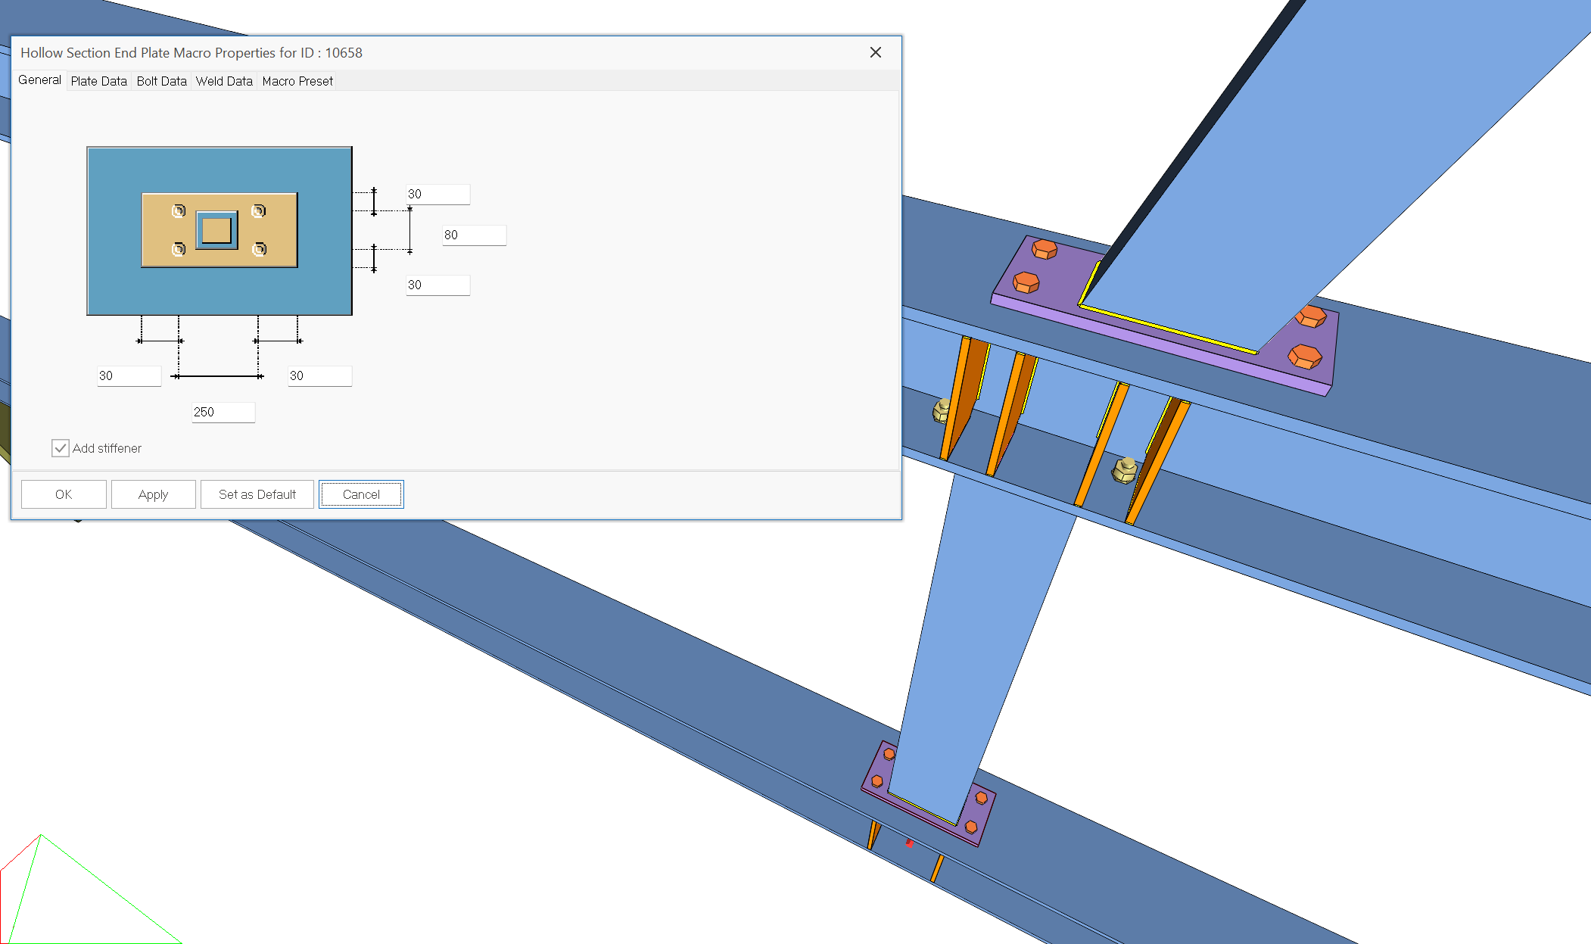

- End-Plate Splice Connection for Curved Beam
The End Plate Splice macro can now be applied to curved steel beams. In previous versions, this connection type was limited to straight beam members; with this enhancement, it can also be used on beams with curved and arc-shaped geometries.
This improvement enables engineers to model end-plate moment splice connections for curved beams used in architecturally complex steel structures quickly and reliably. The macro automatically recognizes the beam geometry and generates the connection components in their appropriate locations, providing accurate detailing with minimal manual effort. As a result, modeling efficiency is improved, detailing consistency is enhanced, and production-ready connection details can be created more easily.

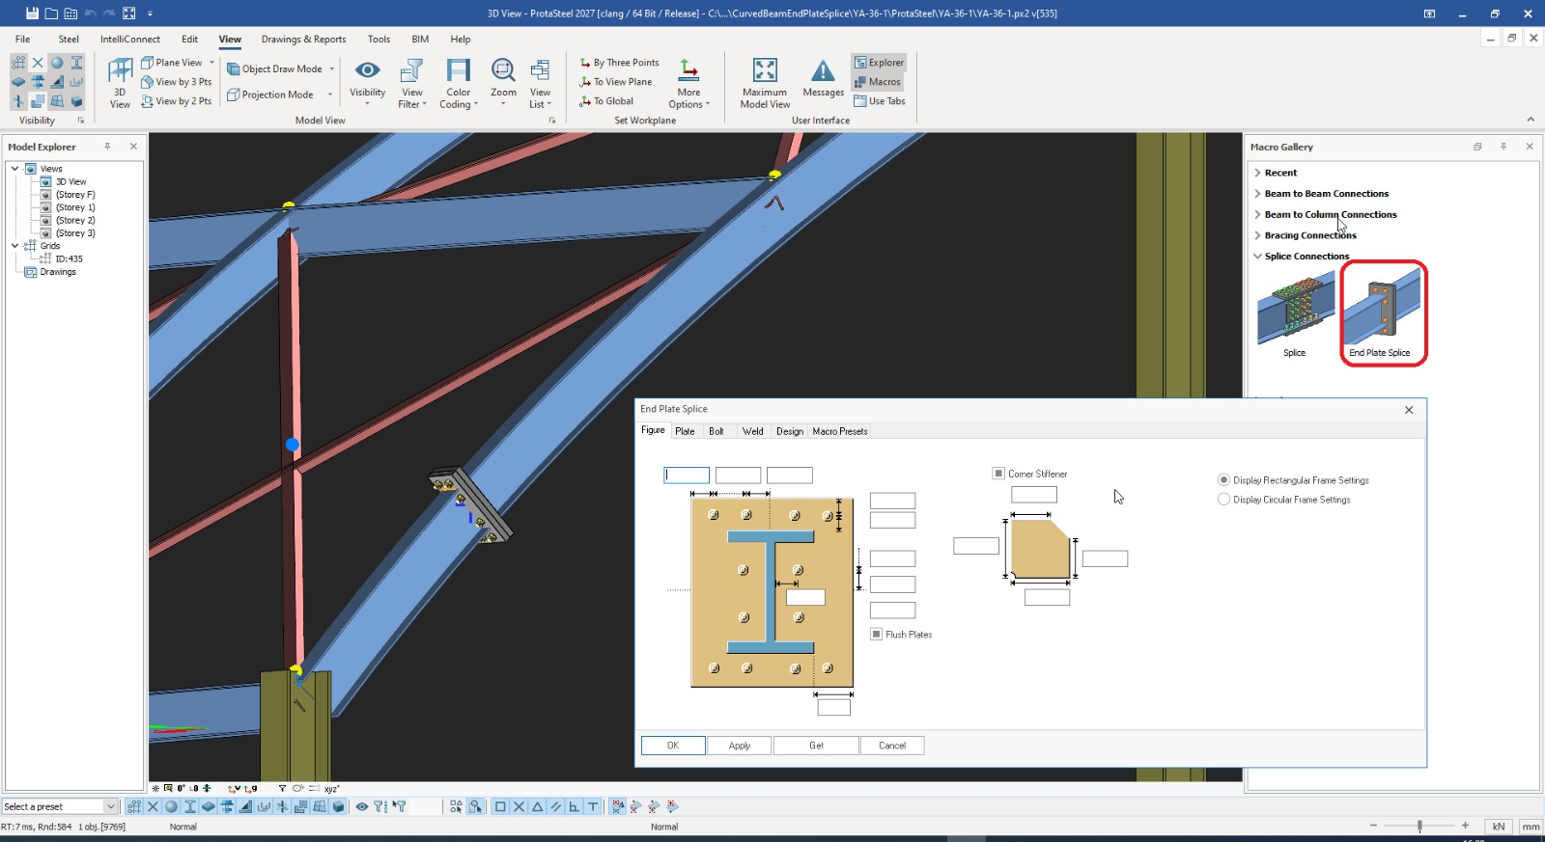

- Fin Plate Macro Extended for Hollow Sections
The Fin Plate macro now supports connections to hollow section beams. To facilitate bolt installation, a suitable access opening can also be automatically created on the hollow section member. This enhancement improves the practicality and detailing efficiency of Fin Plate connections for hollow section applications.
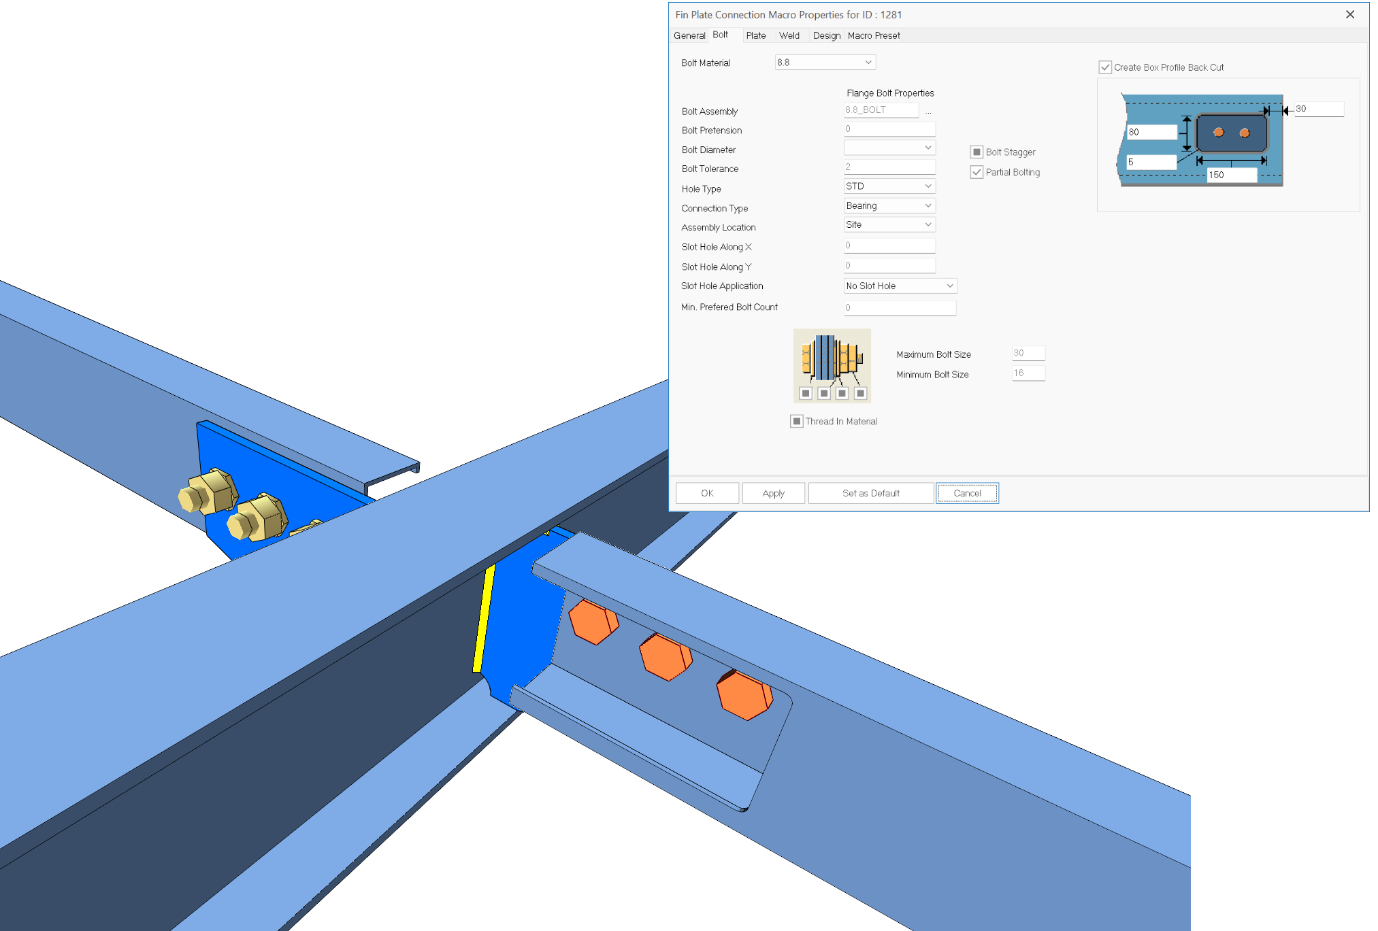

- Fin Plate Macro Extended for Hollow Sections
With V2027, enhancements have been made to the Bolted Gusset Plate macro. A new Plate Boundary option has been introduced, allowing gusset plates for horizontal braces at beam-to-column connections to be generated directly from an existing plate boundary by simply selecting the plate and the brace.
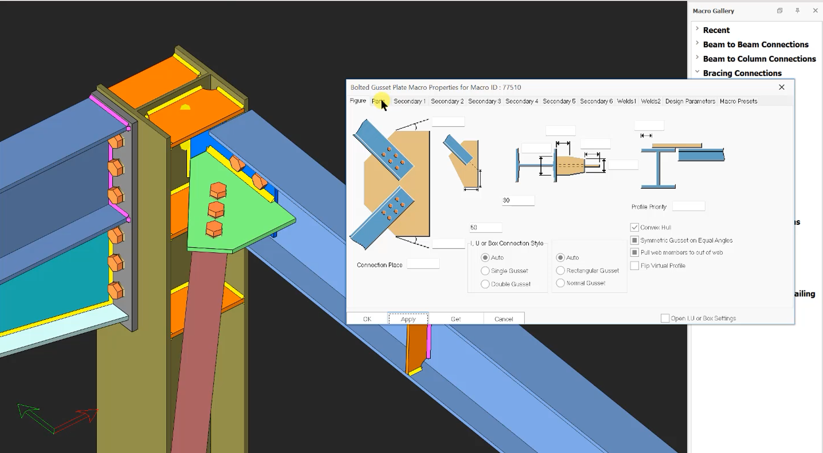

BIM Integration / Interoperability
Building on ProtaSteel's commitment to seamless open-BIM and specialty analysis workflows, connection integration has been significantly refined.
Enhanced IDEA StatiCa Integration
The workflow for transferring member internal forces from the ProtaStructure analysis model to IDEA StatiCa through ProtaSteel has been enhanced. These improvements provide a more accurate and consistent transfer of member forces and load combinations used in connection design.
The integration interface with IdeaStatica has been comprehensively upgraded. Structural analysis forces, critical combination loads, and complex multi-axis member actions are now transferred with higher fidelity and precision, ensuring seamless code-compliance and connection stress verification between the physical model and the analysis engine.
The enhanced workflow improves data consistency between the analysis model and the connection verification model while reducing the need for manual adjustments. As a result, engineers can transfer analysis results from ProtaStructure to IDEA StatiCa more efficiently and perform connection checks with greater confidence.
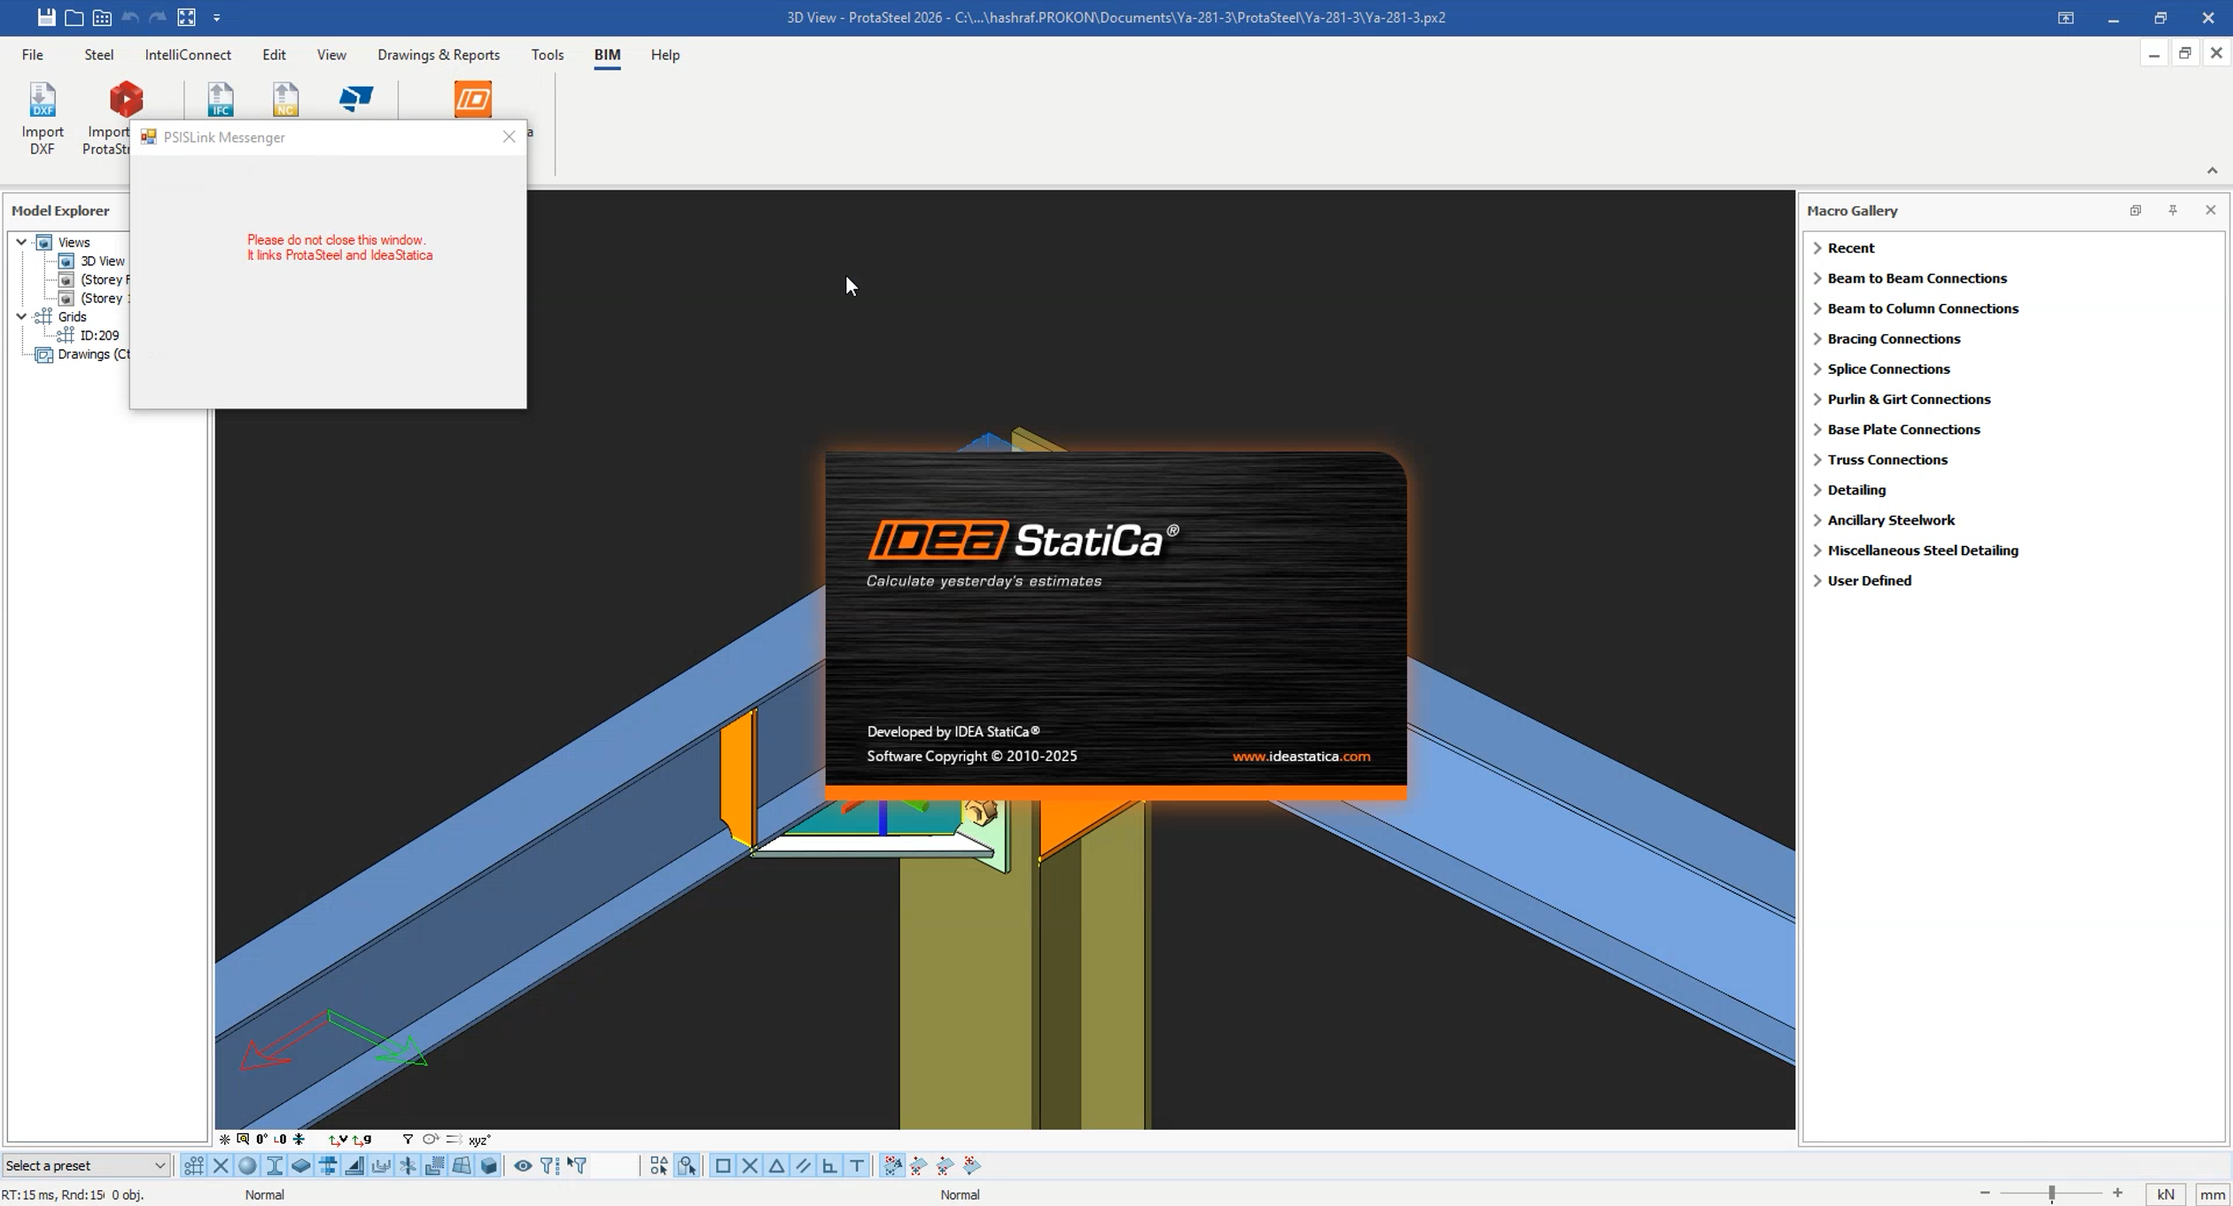
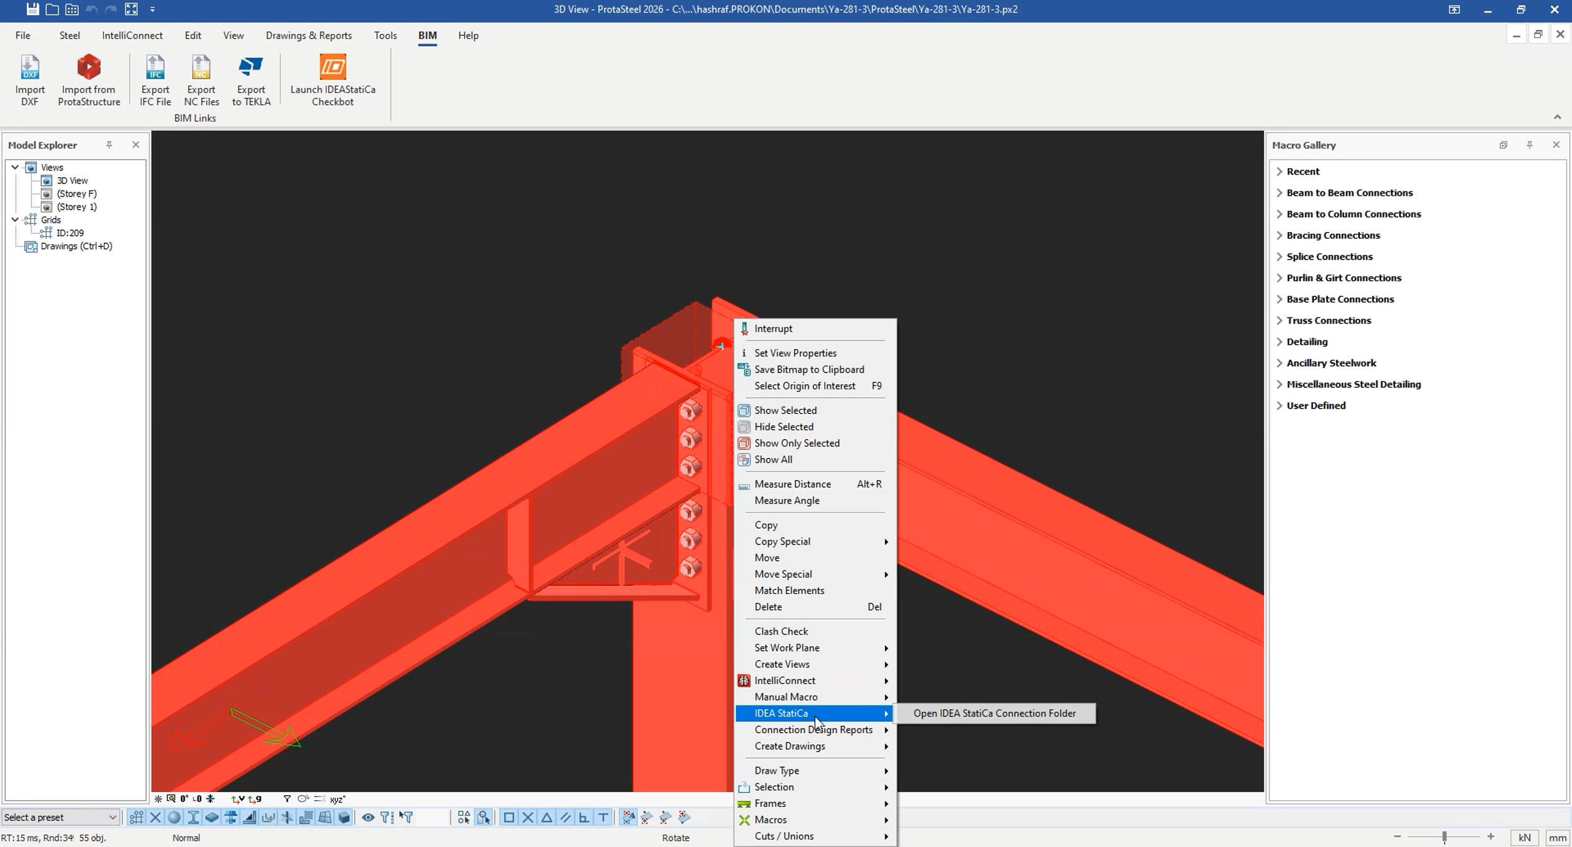
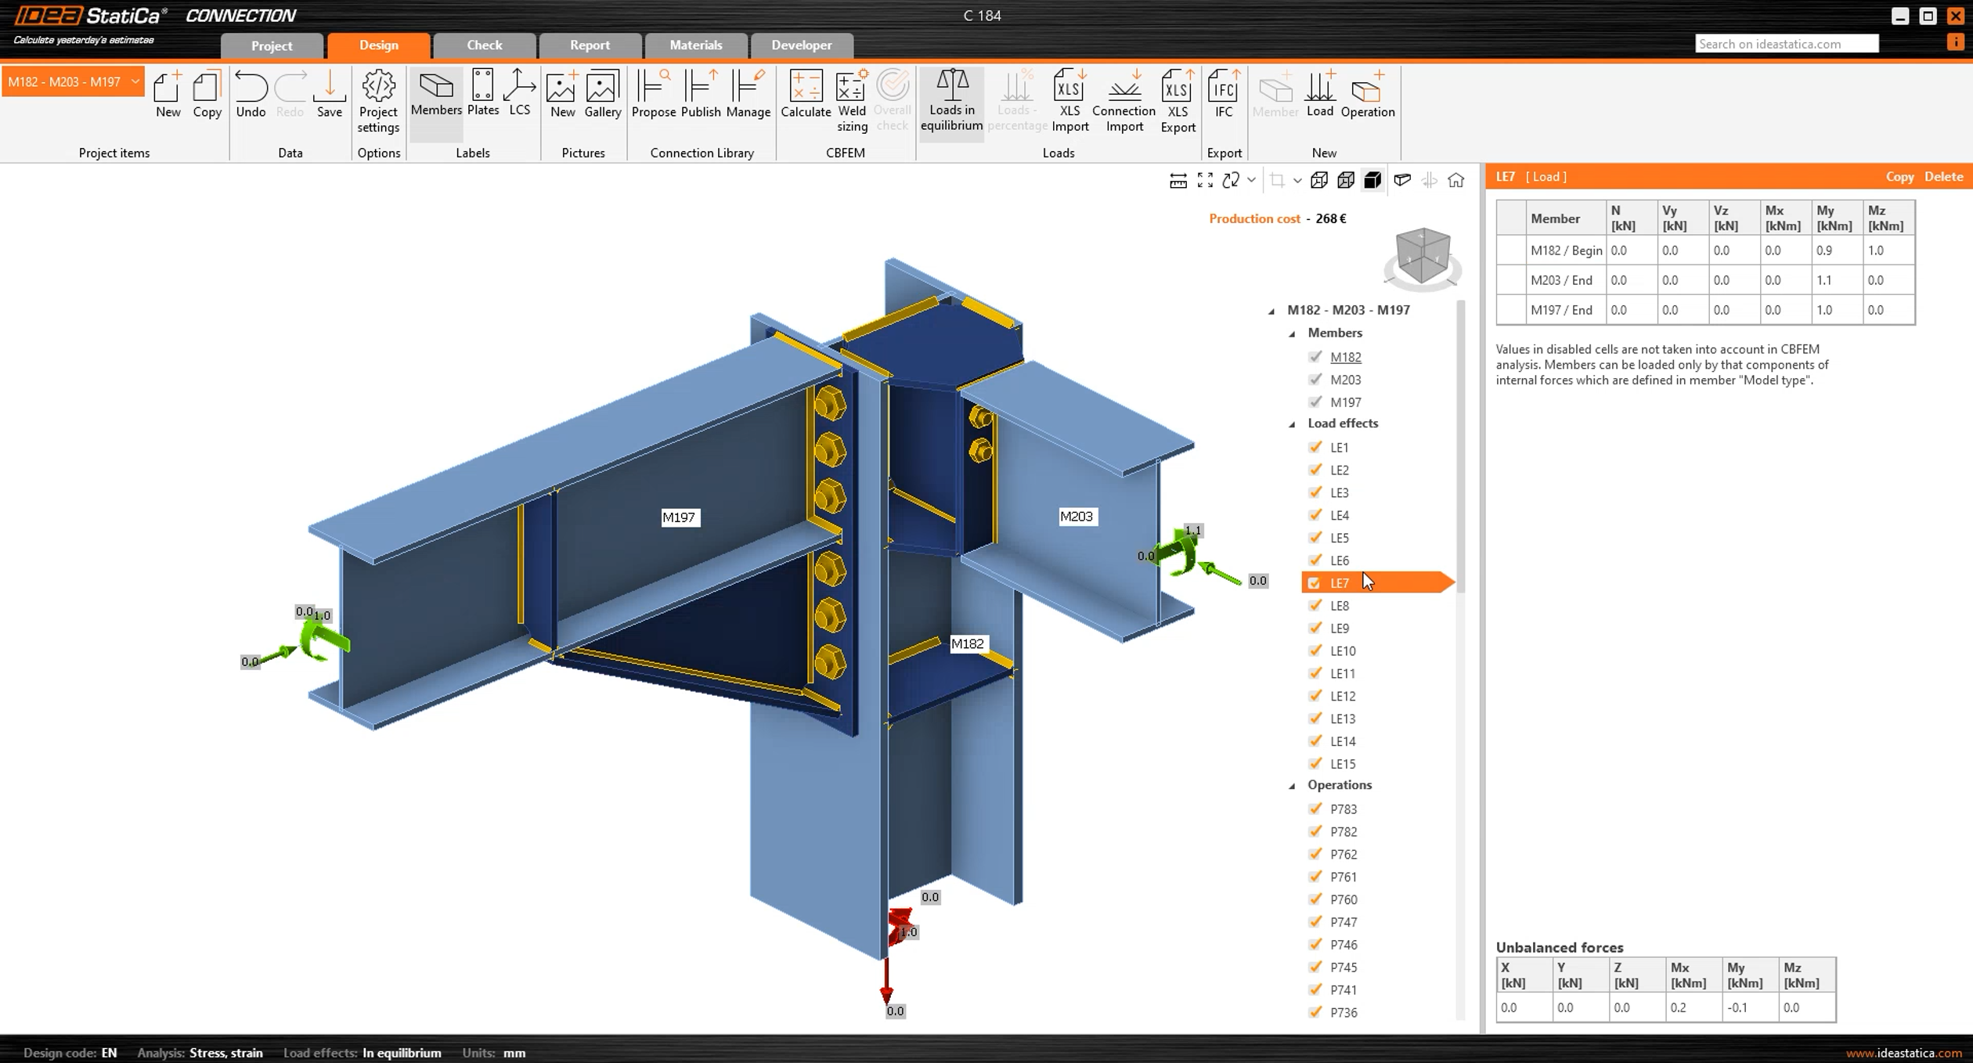

Drawing Module Improvements
Enhanced Manual Editing and Persistence
Persistent Manual Detailing in Automatic Drawings: Users can now manually add custom views, sections, and detailed callouts directly to automatically generated assembly drawings. Crucially, ProtaSteel 2027 ensures these manual additions are strictly preserved and kept intact even if the master model or drawing is updated.
This release introduces major workflow optimizations, precise visual controls, and enhanced detailing capabilities within the drawing environment, granting engineers and detailers unprecedented flexibility over production-ready documentation.

Granular View and Section Overrides
Single Part View Overrides in Assembly Drawings: Users now have individual control over which specific views of each single part are rendered within assembly drawings, eliminating unnecessary visual clutter.
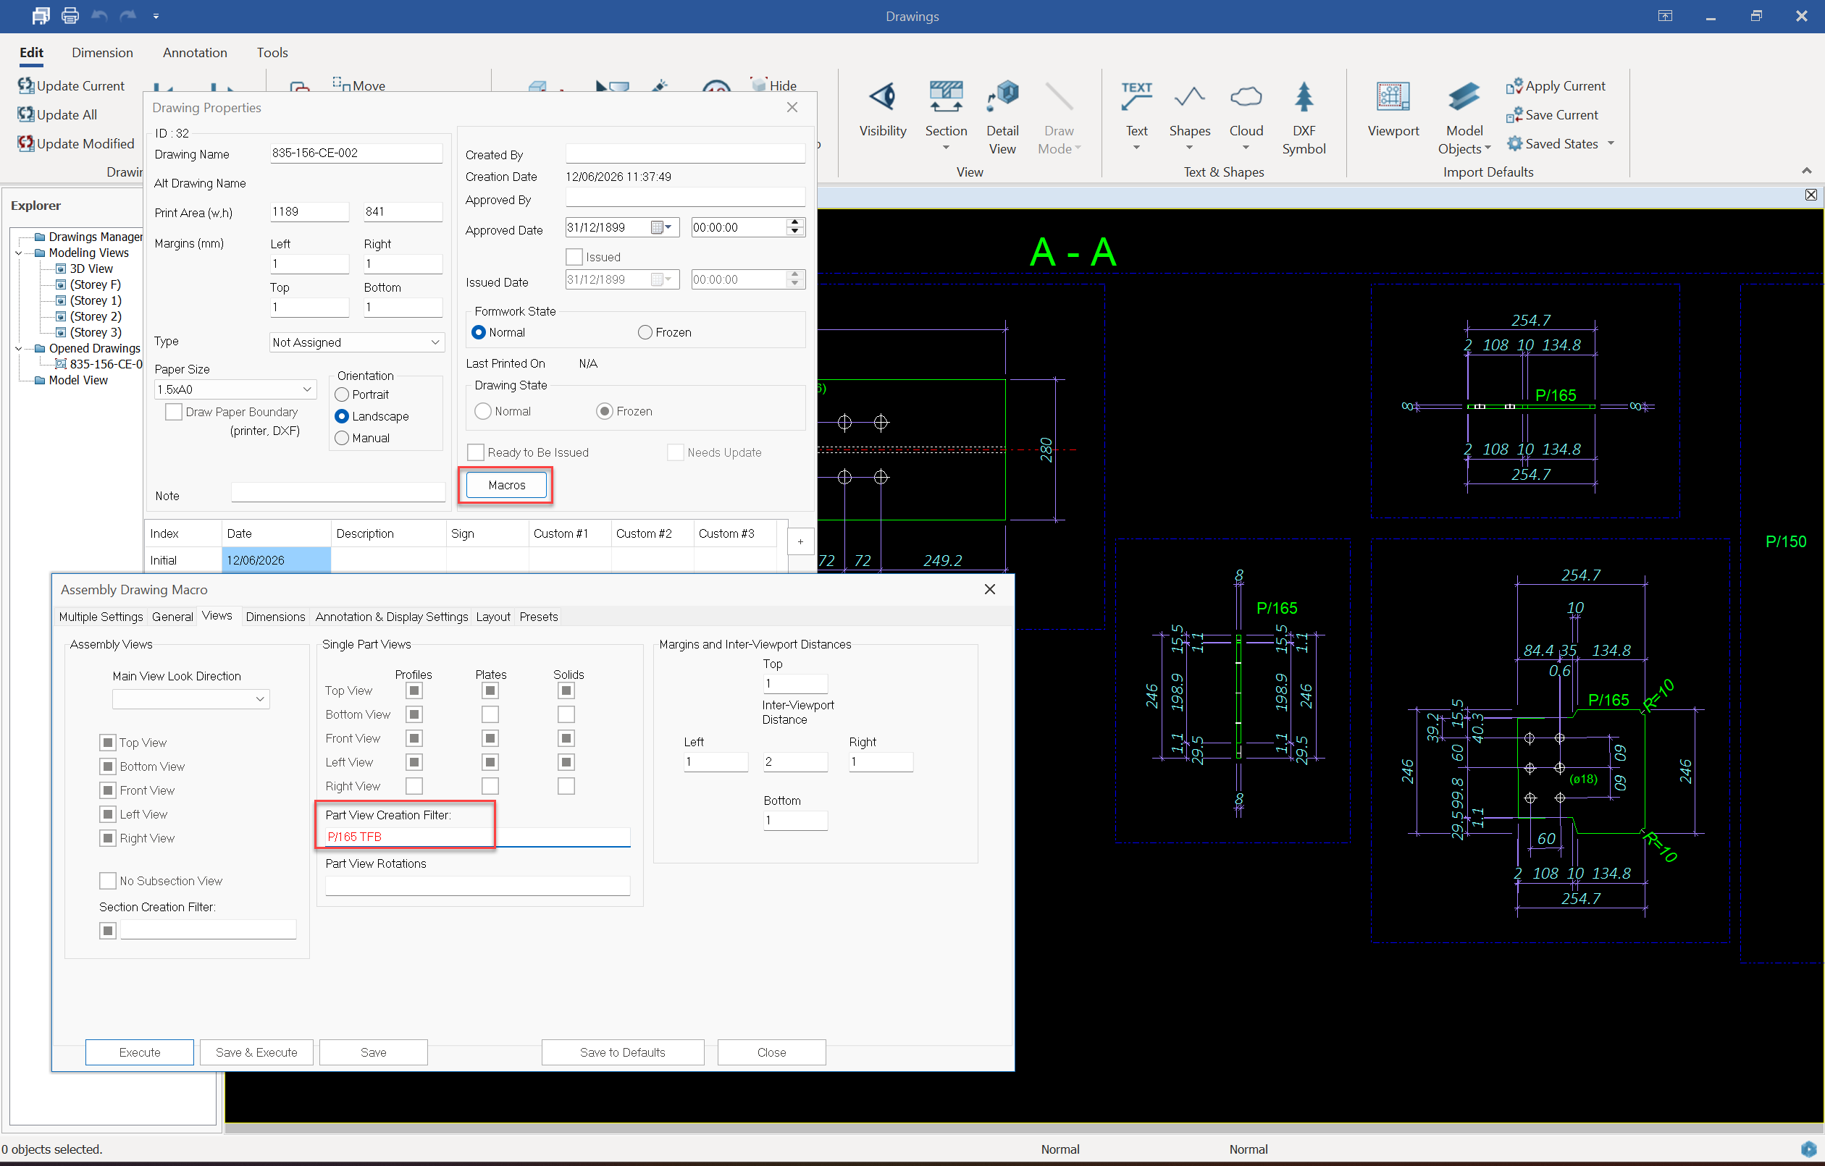
Assembly View Overrides for Sections: Individual control is introduced for cross-sections taken on assemblies, allowing users to precisely decide which specific sectional views are generated.
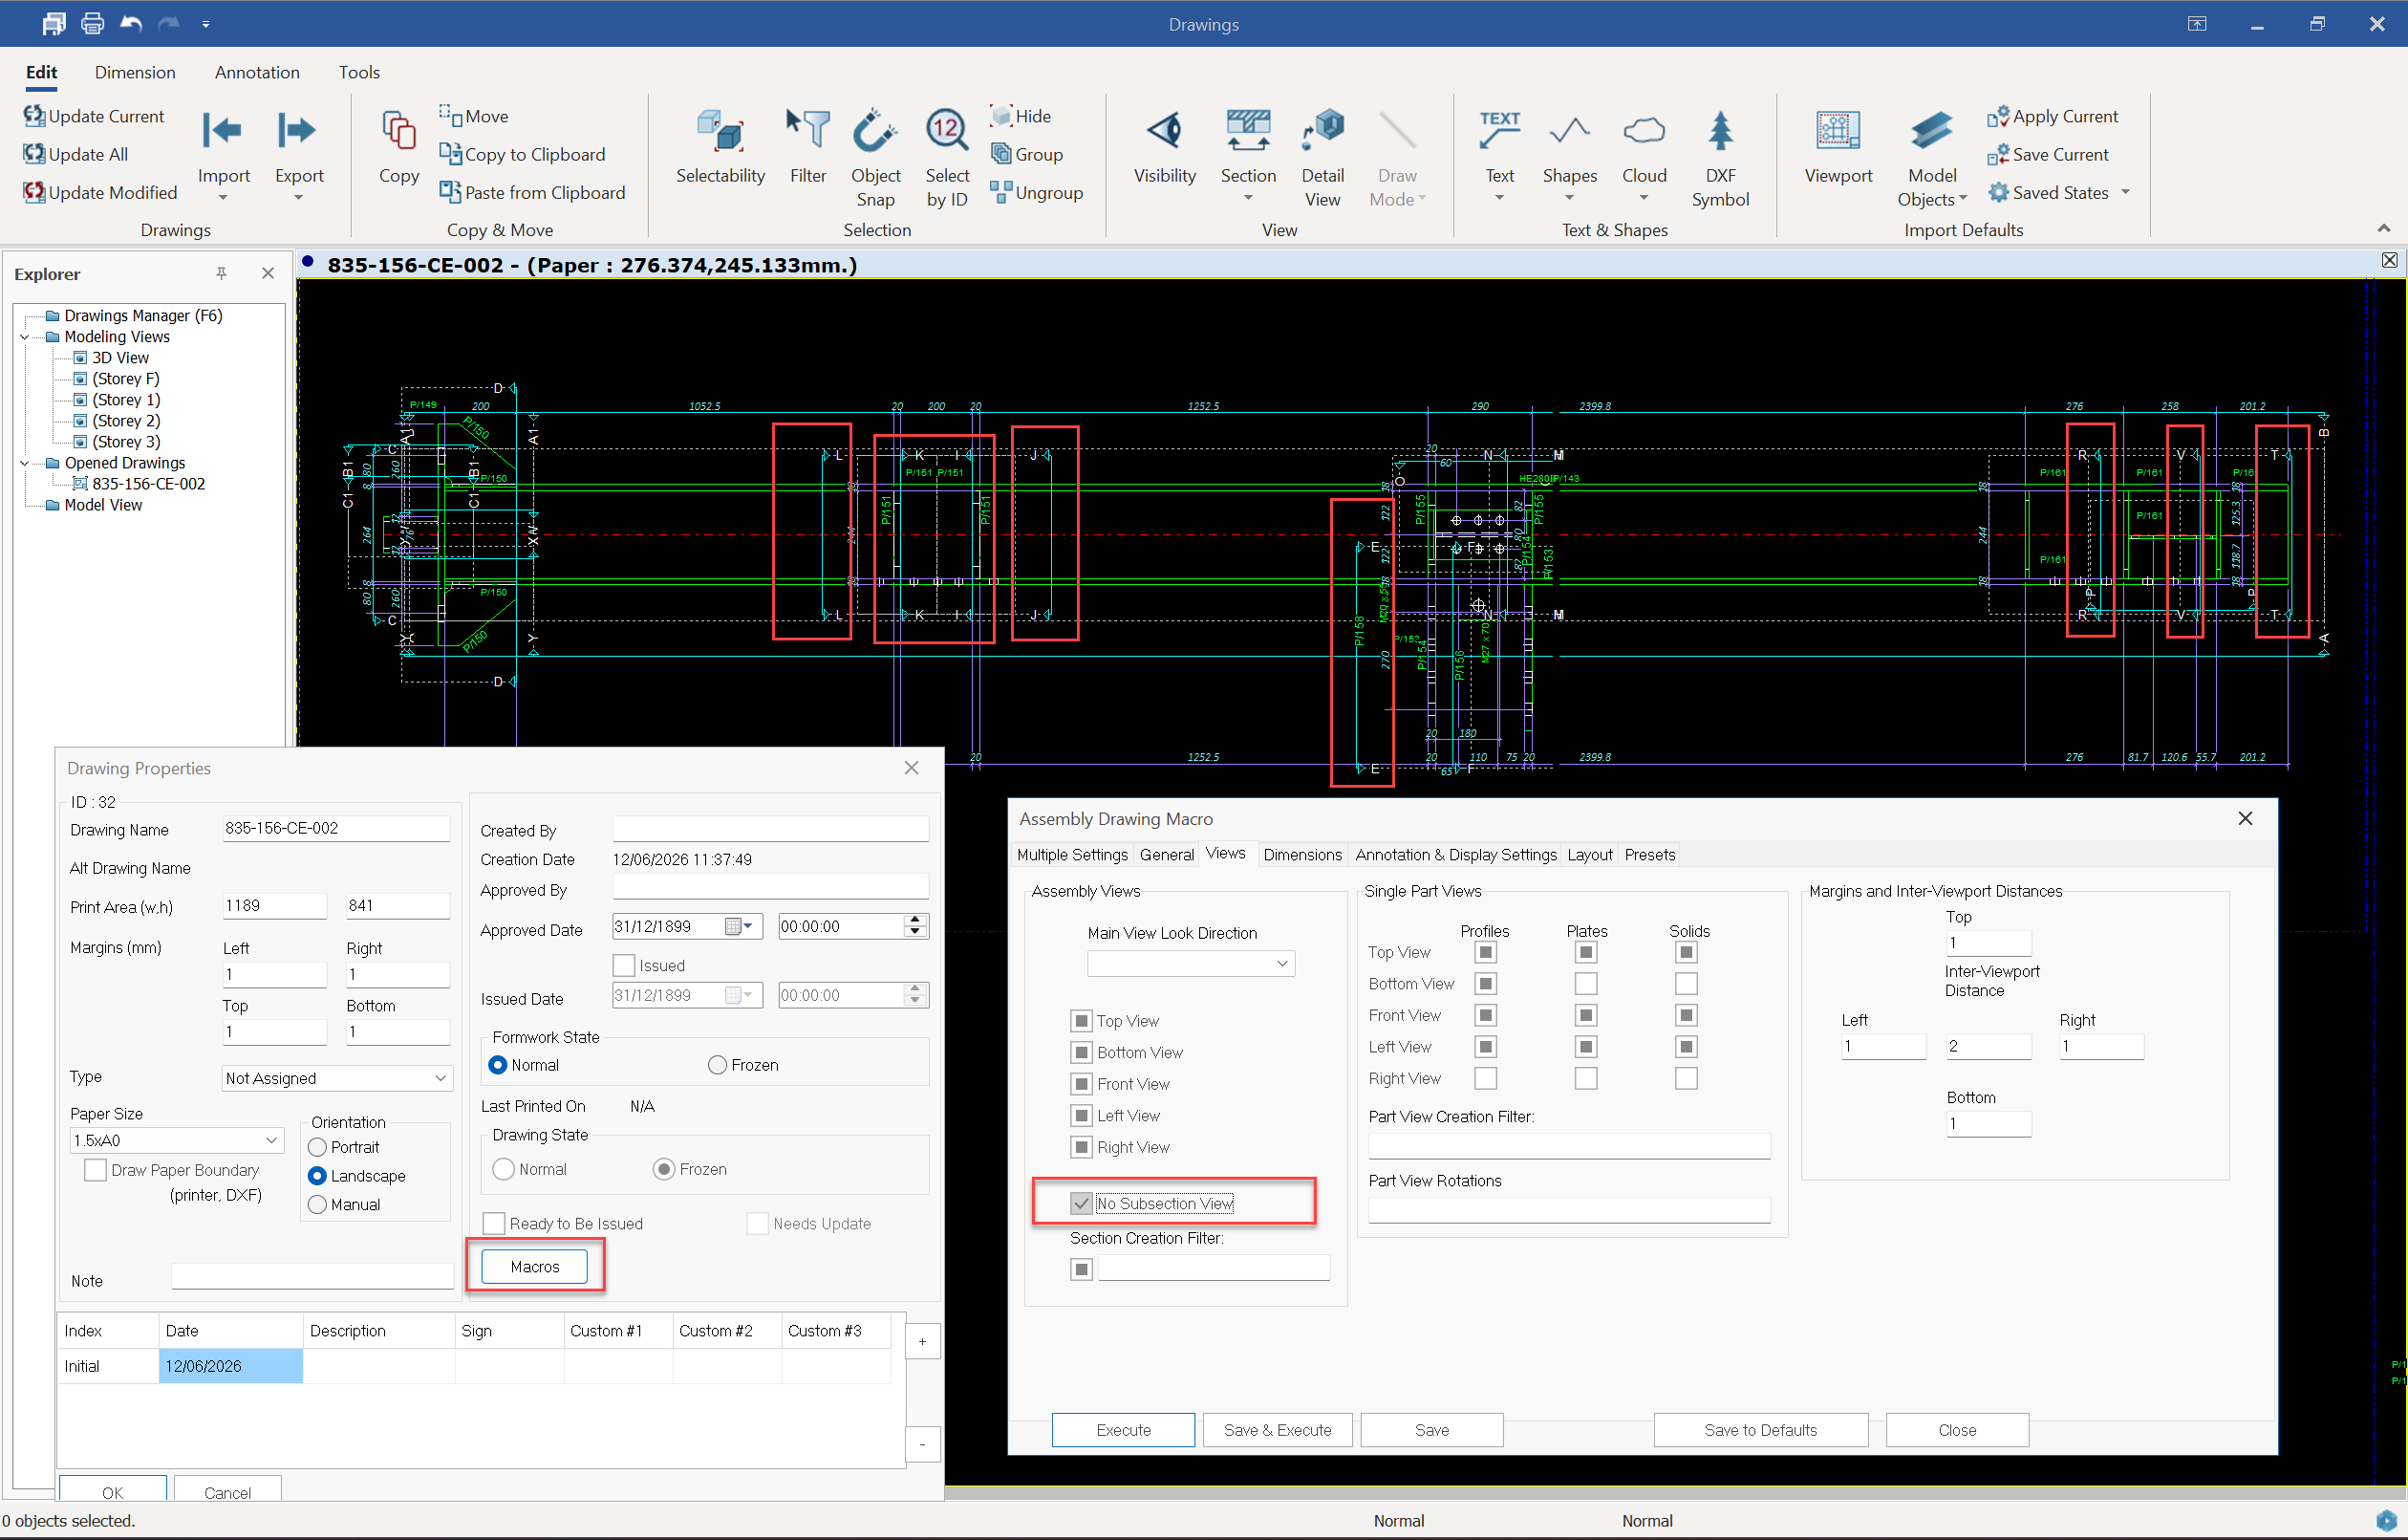
Removing section views of specific parts results in a cleaner and more readable drawing.
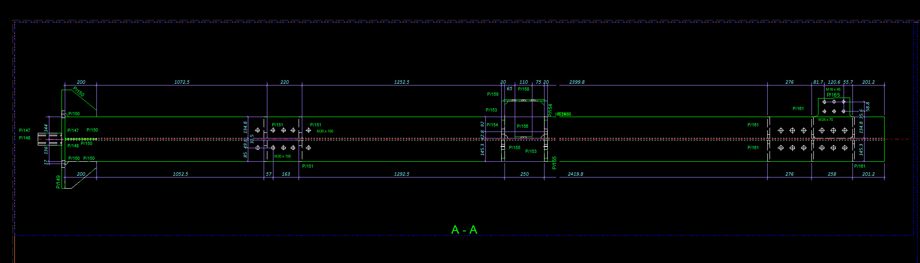

In assembly drawings, the generation of section views for specific parts can be disabled. This allows users to precisely control which elements are included in section creation and prevents unnecessary section views from being generated. This improvement ensures cleaner and more targeted section outputs, especially in complex assembly models.
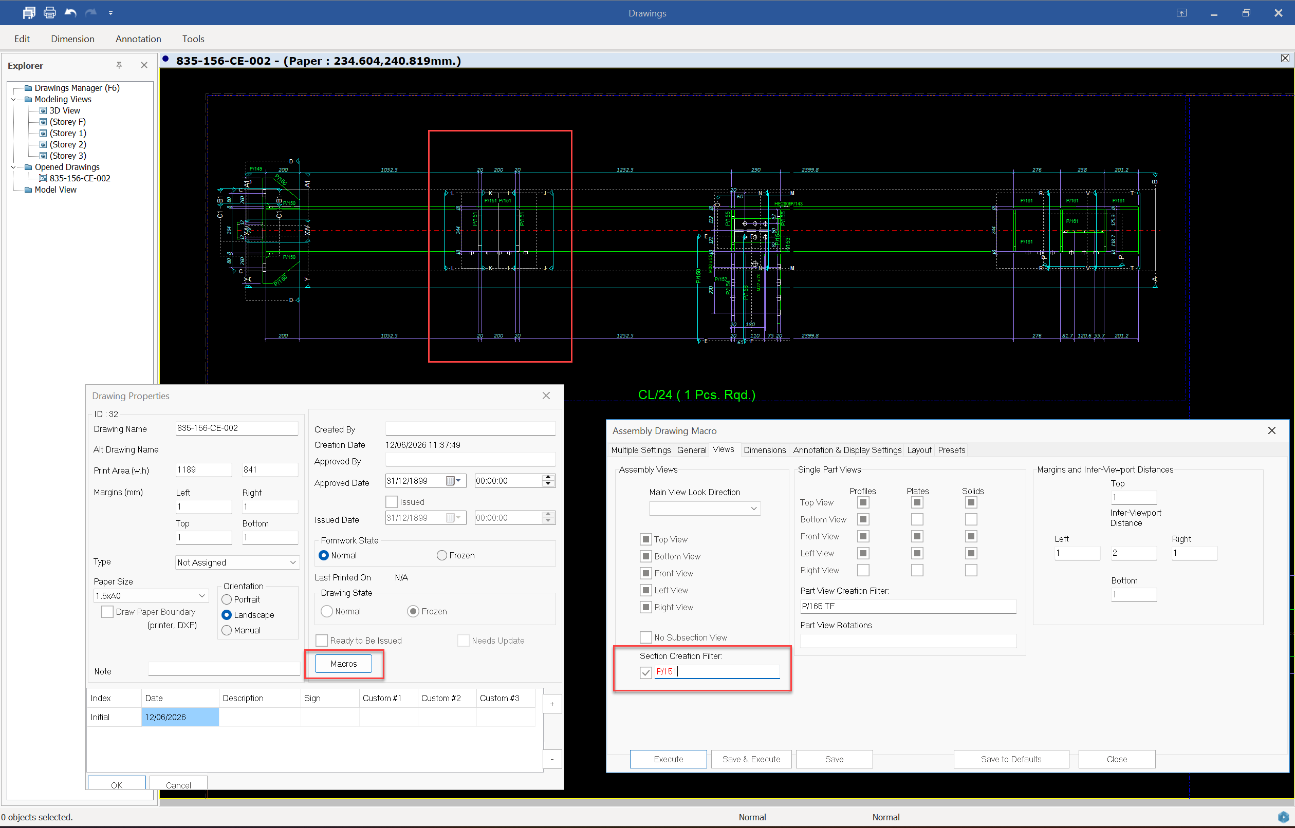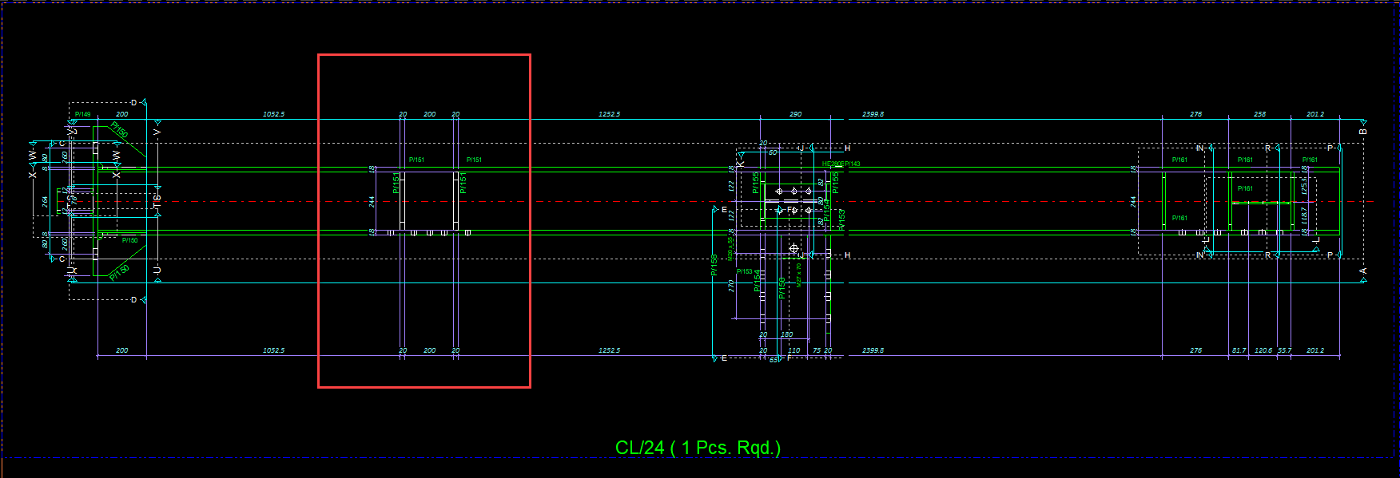

To find the number of the part whose section you don't want to include in the drawing, double-click on the section line.
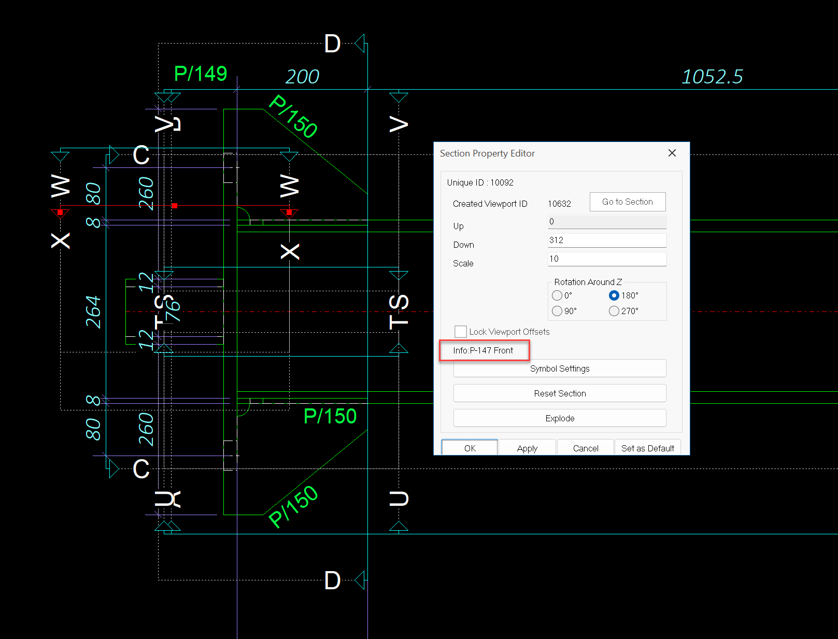
Single Part Drawing View Rotation Angle: Dedicated rotation angle controls have been added for single part views, ensuring drawings can be aligned perfectly to fit standard sheet layouts or specific detailing preferences. Rotating the part view can also help achieve clearer dimensioning and improve the overall readability of fabrication drawings.
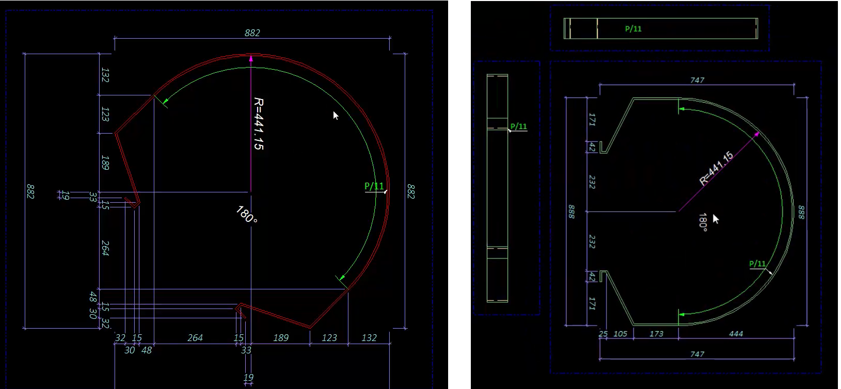

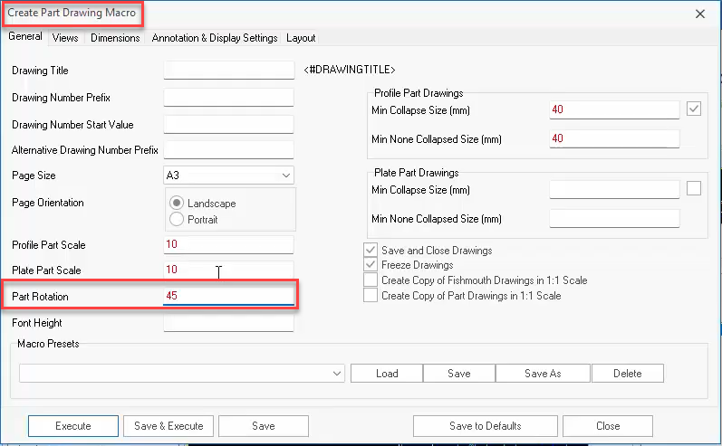

Advanced Dimensioning, Annotating, and Filtering
Dimensioning, annotation, and filtering capabilities in ProtaSteel have been improved to provide faster and more controlled detailing workflows. Users can now perform dimensioning and labeling more efficiently, while advanced filtering options make it easier to isolate and navigate specific model elements.

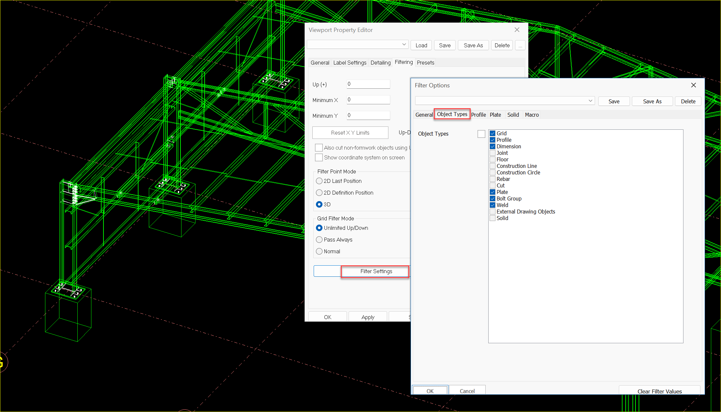
Generic Solid Dimensioning and Annotation
New dedicated settings are available in assembly drawings specifically for dimensioning and annotating generic solids, standardizing documentation for non-profile objects.
Multi-Leg Welding Symbols
Support has been added for drawing complex welding symbols with multiple leader legs, accommodating intricate fabrication requirements within a single annotation.
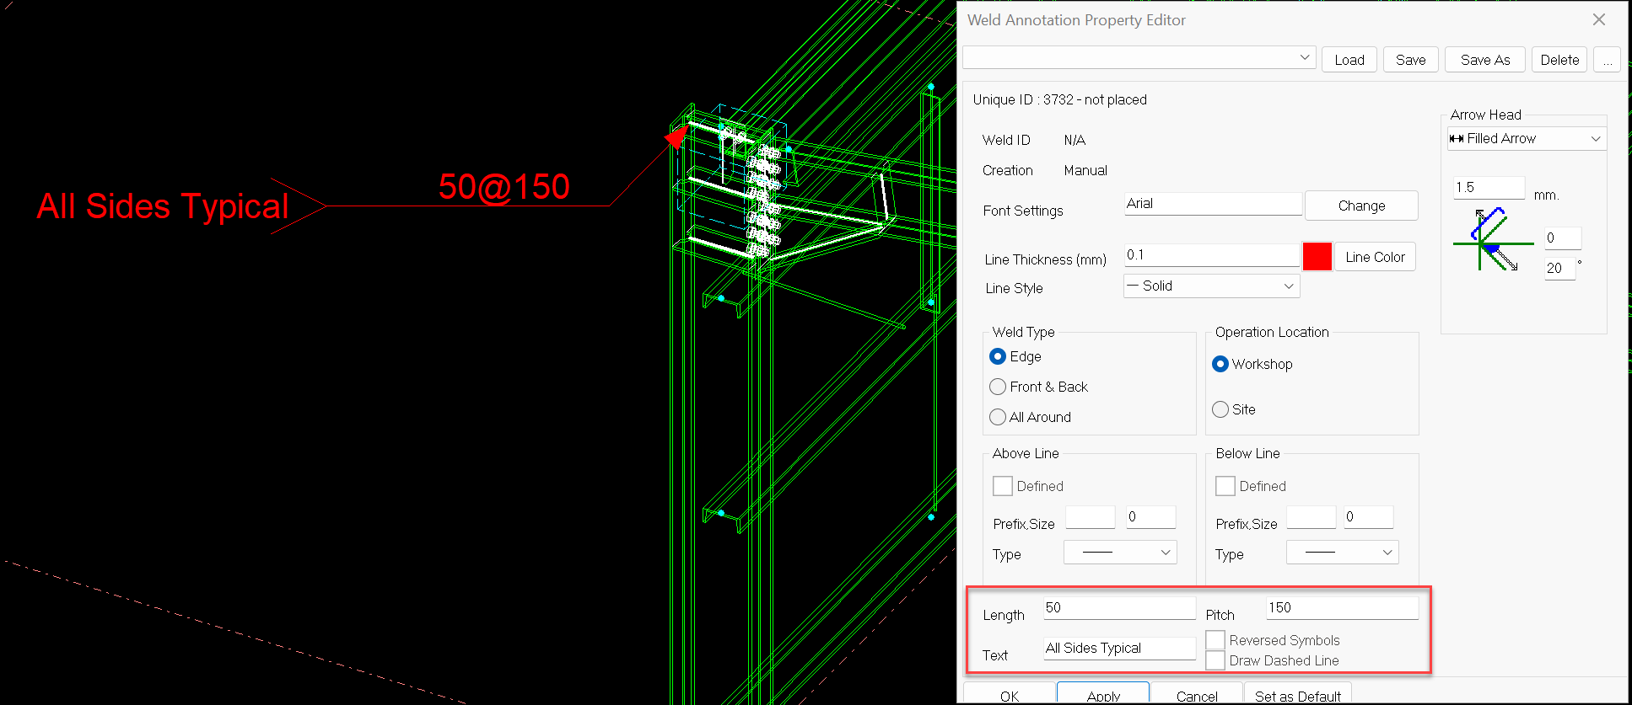
Drawing Side Filtering for ID Holes
A smart drawing-side filter automatically identifies and includes any holes located on an internal diameter (ID) or reverse face the moment the main part is added to the sheet.

Viewport-Bounded Element Cutting
Plates, profiles, and generic solids are now intelligently cut and cropped strictly according to the up/down depth limits of the viewport, eliminating overlapping or out-of-bounds geometry.

Workflow Efficiency and Quality Control
“Ready to be Issued” Status Flag: A new revision-tracking flag, "Ready to be Issued," has been integrated into the drawing management system to streamline quality assurance workflows and signal drawing approval.
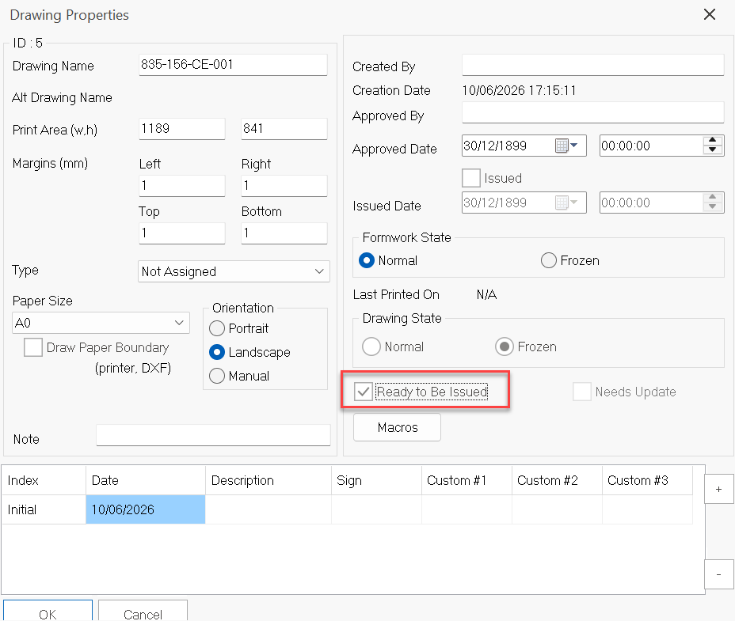
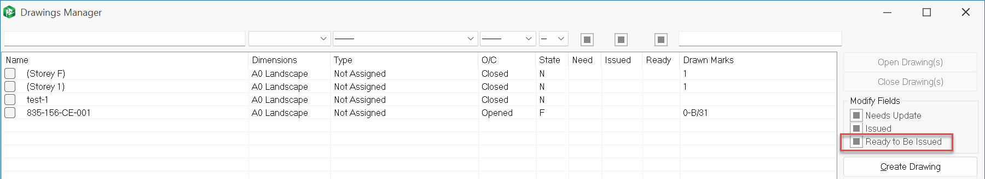

Multi-Drawing Side-by-Side View
Detailers can now open and work on more than one drawing simultaneously side-by-side, vastly improving cross-referencing speeds and multi-sheet editing.
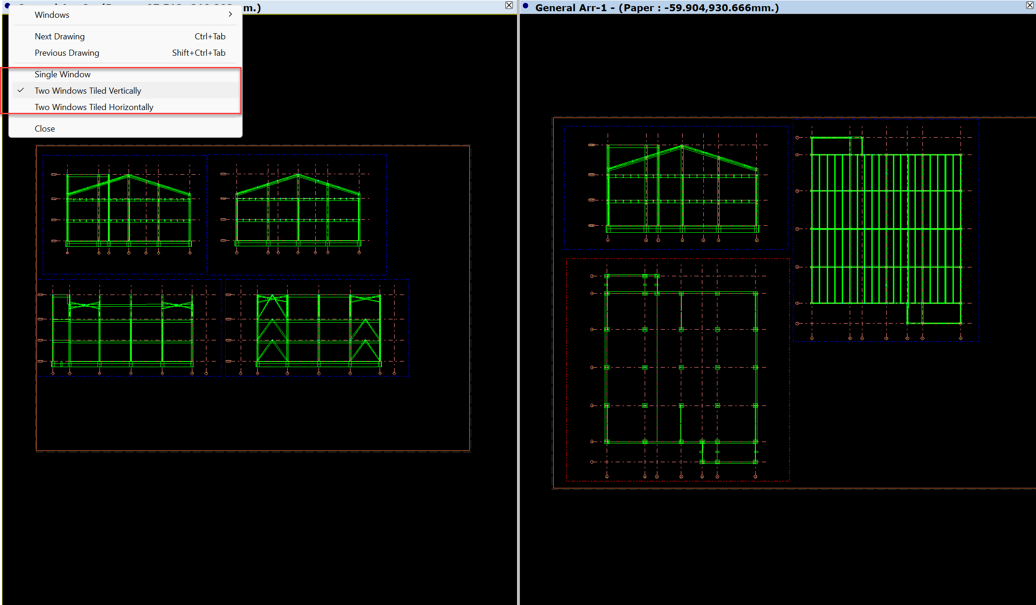

Drawing Module UNDO System
To safeguard engineering time and reduce repetitive tasks, ProtaSteel 2027 rolls out a highly requested, robust recovery and undo framework tailored specifically for the detailing module.
Full contextual Undo/Redo capabilities are now available directly within the drawing environment, allowing detailers to instantly revert drafting, dimensioning, or layout changes without risking sheet integrity.
A specialized safety net has been implemented to protect project data. If an entire drawing sheet or document is deleted, the new backup system retains a secure temporary copy, allowing full restoration of the deleted asset and preventing accidental data loss.

Thank You
Thank you for choosing the ProtaStructure Suite product family.
At Prota, our continual aim is to provide you with user-friendly, industry-leading technology for building design and documentation.
Should you have any technical support requests or questions, please do not hesitate to always contact us through globalsupport@protasoftware.com or asiasupport@protasoftware.com (Asia Pacific)
Our dedicated online support center is available to help you get the most out of Prota’s technology solutions with our responsive technical support team.
The Prota Team
