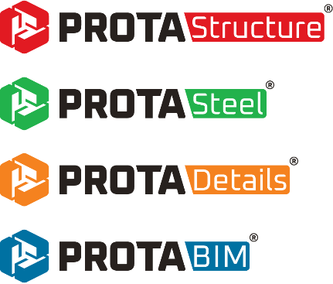

Prota Help Center
End-User Guide

Please contact us for your training and technical support queries
asiasupport@protasoftware.com
globalsupport@protasoftware.com

Limitation of Responsibilities |  | Prota shall not be held responsible for any losses caused by documentation, software or usage errors.  In addition to Prota License Agreement Terms, it is the responsibility of the user  - to check of results generated by documentation and software,  - make sure that the users of the software and their supervisors have the adequate technical capabilities,  - make sure that the software is properly used in accordance with the reference manual and documentation,
Intellectual Property |  | ProtaStructure is registered trademark of Prota Software Inc. and all intellectual property rights belongs to Prota Software Inc. Documentation, training and reference manuals and any program component can not be copied, distributed and used in violation of license agreement.
Trademarks |  | ProtaStructure®, ProtaDetails®, ProtaSteel® ve ProtaBIM® are registered trademarks of Prota Software Inc. Prota logo is a trademark of Prota Software Inc.

Table of Content
Welcome to Prota Help Center 4
Well, How a Successful Technical Support Service Should Be? 4
Traditional Support Methods: Via Phone or E-mail 4
A Modern Approach To Support Services: Prota Help Center 5
Up-to-Date Knowledgebase 5
Prota User Community Forums 5
Self Service Support 6
Support Ticket 6
Introduction 7
What Are The Benefits of Prota Help Center? 7
Konwledgebase 9
Prota User Community Forums 11
How to Create Forum Topics? 12
Forum Rules 13
Forum Moderation 13
How To Create a Support Ticket? 13
Steps and Recommendations When Submitting A Support Ticket 13
Follow-Up and the Life-Cycle of Support Tickets 15
Thank You… 17

Welcome to Prota Help Center
As Prota Team, our main priority is to offer an excellent post-sales customer experience and technical support services for our clients. For this purpose, we have been substantially investing in our technical support team and technology infrastructure.
We understand that the quality of technical support is the main factor to sustain customer satisfaction and loyalty. Always striving for the best technical support, we are proud to introduce our new Prota Help Center which is shaped around our years of customer service experience.
We strongly believe that once you understand how the support services and processes work, you will be more willing and equipped to claim for the best.

Well, How a Successful Technical Support Service Should Be?
Recent researches provide very interesting results on this topic. According to a study done by ‘Dimensional Research’, the following considerations surface as the most important ones when defining an excellent technical support service:
- The problem was resolved quickly
- The person who helped me was nice
- The problem was resolved in one interaction – no passing around to multiple people

Traditional Support Methods: Via Phone or E-mail
Traditional support methods such as phone or e-mail support are far from being measurable and effective methods. Although these methods are adequate for small-scaled firms, it is rather ineffective for medium and large-scaled firms with broad userbases like Prota. Several researches show that these methods are infact decreasing both the satisfaction of users and technical support specialists over the long term as well as making it quite difficult to make tangible success measurements within the business.
Technical support via phone is time-consuming and ineffective both for the end-user and for the technical support specialist. Generally, most of the technical support specialists are only able to spend their limited energies and time on just a few users which in turn creates a difficulty for the other users waiting on the line. On top of that, when the issues are not resolved or the same support agent is not reachable, users result in explaining the same issue over and over again.
Technical support services given via e-mail is generally a more effective way than phone support. However, there are also some problems in this method such as bounced, lost or spam e-mails. In addition, technical support requests via e-mail cannot be traced properly by the end user. It is also time-consuming and ineffective to try to distribute support e-mails to support specialists or to relay the proper information to end user when providing support via e-mail.
In both conventional customer support tools mentioned above, it is almost impossible to track the life-cycle of the support request and to integrate directly with CRM systems. Clashes occur when more than one support specialist provides technical support to the same user. A support request could also be left unanswered due to these clashes. Besides, answering the same questions with the same answers over and over again prevents a sustainable corporate knowledgebase. Absence of corporate knowledgebase is the biggest obstacle for the end user to get a fast and an efficient technical support service. Most importantly, in traditional support methods, the end-user needs to wait until the working hours of the company to have technical support services.
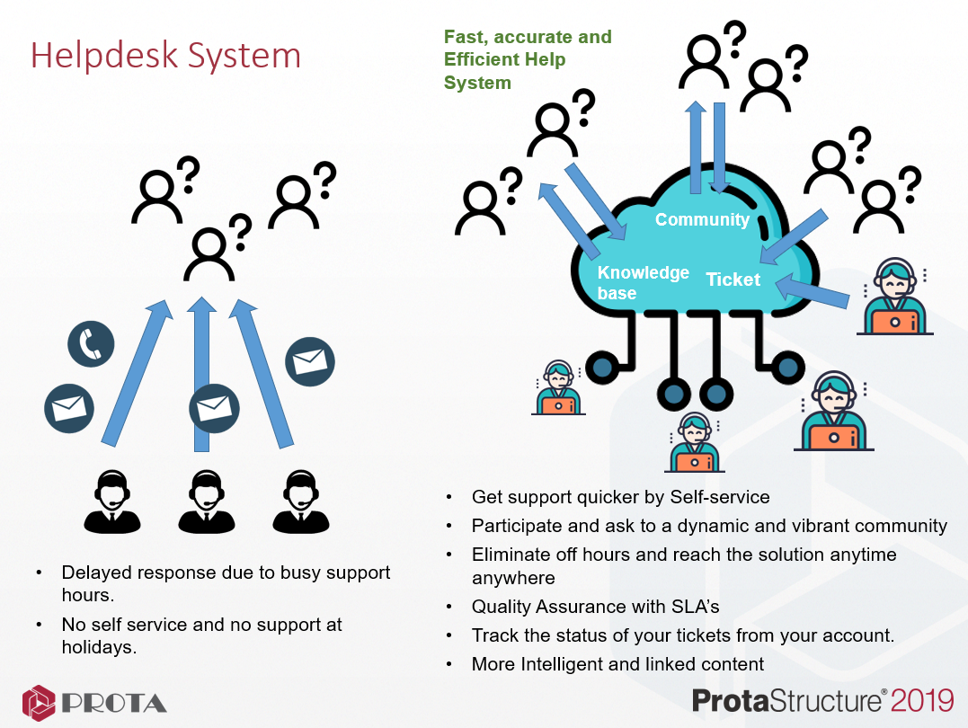

A Modern Approach To Support Services: Prota Help Center
To minimize the problems caused by traditional support methods mentioned above and to place the user to the center of its focus, Prota Help Center was created.

Up-to-Date Knowledgebase
You can browse through our collection of articles about our technology solutions in Prota Help Center. All you have to do is to search the topic of your interest.

Prota User Community Forums
Community Forums can be considered as an essential part of Self-Service support. In Prota User Community Forums, you can answer questions, add comments and find answers by looking at the existing topics. You can also share your experience with other users and create new topics. Knowledge only improves when shared.

Self Service Support
Knowledgebase and User Community Forums together create the backbone of the self-service support for our users. When you are about to submit a ticket or do a quick search, the keywords you have entered will be automatically searched on the entire support center to suggest you with an instant solution and save you valuable time. You can also exchange information with more experienced users and get answers to your questions immediately. You don’t need Prota Support Engineers for any of these. You can get help during the weekends or any time in Prota Help Center.

Support Ticket
Don’t worry if you can’t find the answer that you are looking for in the Community Forums and Knowledgebase. All you have to do is to create a Support Ticket. When you start creating your support ticket, your keywords are analyzed and related articles from Community Forums and Knowledgebase automatically recommended for you. Thus, you may find the answer you have been looking for in these recommended articles.
Furthermore, the Support Ticket that you created automatically will automatically be assigned to one of Prota Support Specialists and you can easily track the status (life-cycle) of your Support Ticket in Prota Help Center.
We hope, you will take full advantage of Prota Help Center.

Best of Wishes,
Prota Team

Introduction
New Prota Help Center has been put into service in June, 2019. Our users are now able to submit and follow-up their technical support queries through this system.
Prota Help Center has been designed specifically for ProtaStructure users. ProtaStructure users need to log-in to the system with their credentials. The system is closed for everybody except licensed users of ProtaStructure. If you do not know your username and password Please contact our support team at globalsupport@protasoftware.com or asiasupport@protasoftware.com
You can reach Prota Help Center through https://support.protasoftware.com.
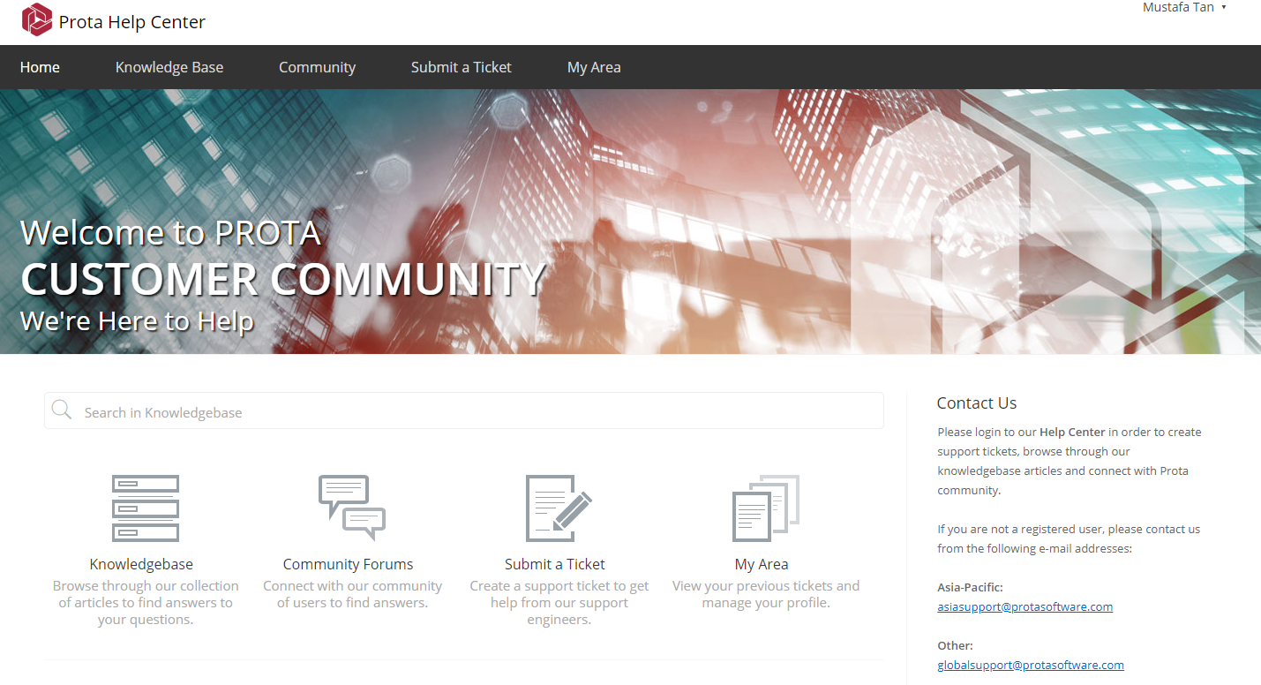

What Are The Benefits of Prota Help Center?
Prota Help Center has been designed for you the get your answers to your questions about Prota’s technology solutions as quickly as possible. Prota Support Center holds Support Tickets, Knowledgebase articles and Community Forums side-by-side in an integrated manner to offer you instant self-service supoort and save you valuable time. You can do the following at Prota Help Center;
- Use keywords to browse through the entire Prota Help Center to find answers to your questions. Entire Knowledgebase and Community Forums will automatically be searched to suggest the related content to your need.
- Browse through our collection of Knowledgebase articles to find answers to your questions.
- Ask questions in Community Forums and easily share information. Your question could already be answered in forums. Alternatively, you can also help your colleagues who have similar questions with you.
- Create a Support Ticket to get help from Prota Support Team.
- View your previous tickets and follow-up their status.
- Manage your Profile.
- Earn experience points by simply publishing articles, commenting or voting to other articles in Community Forums.
- Help us increase the quality of our Technical Support Service by simply submitting the Customer Satisfaction Mini Survey after each support you get from our team. You can also track general user satisfaction through Prota Help Center.
- Fastest way to reach out the information you are looking for: Searching with Keywords.
The fastest way we recommend for you to find an answer to your question in Prota Help Center is to browse through Knowledgebase and Community Forums before submitting a ticket. In this case, the chances for you to find the quickest answer to your question increase.
For this purpose, click Search on the main page. Relevant content will be suggested for you based on your keywords.
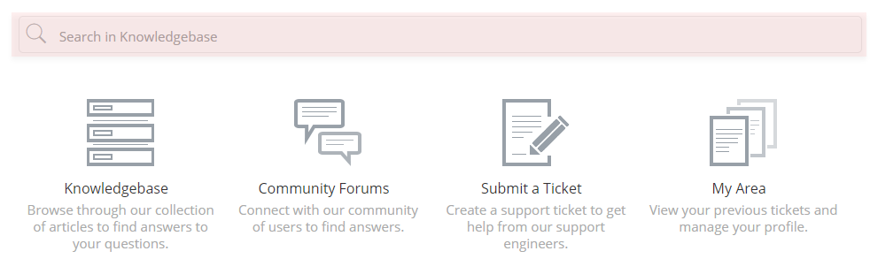
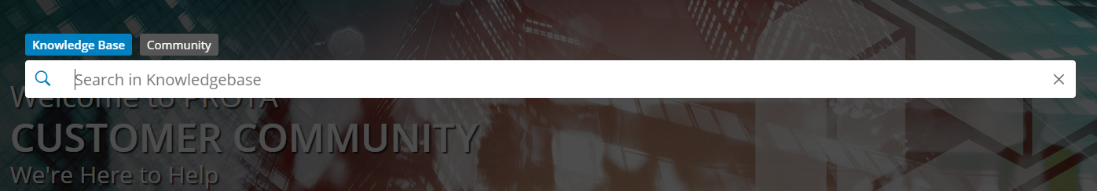

Konwledgebase
To access the entire Knowledgebase articles, click “Knowledgebase” icon which is located at the left hand side or the upper menu of the main page.
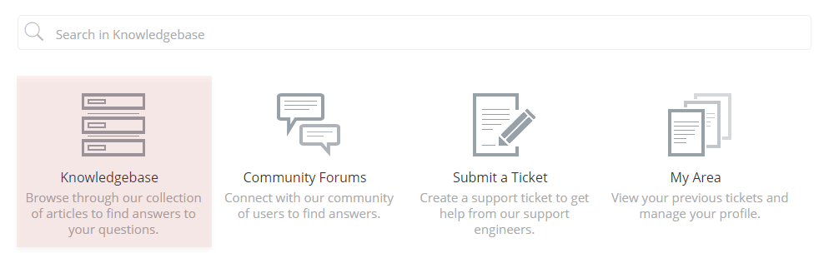
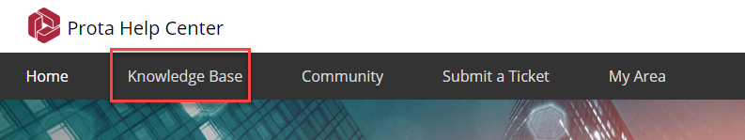
You can think of the Knowledgebase section as an encyclopedia. To get the most out of ProtaStructure, ProtaDetails, ProtaSteel ve ProtaBIM software solutions, you can take advantage of quick start guides, modelling techniques and reference manuals which are classified as categories inside the Knowledgebase platform. You can simply click to read the articles which interest you.
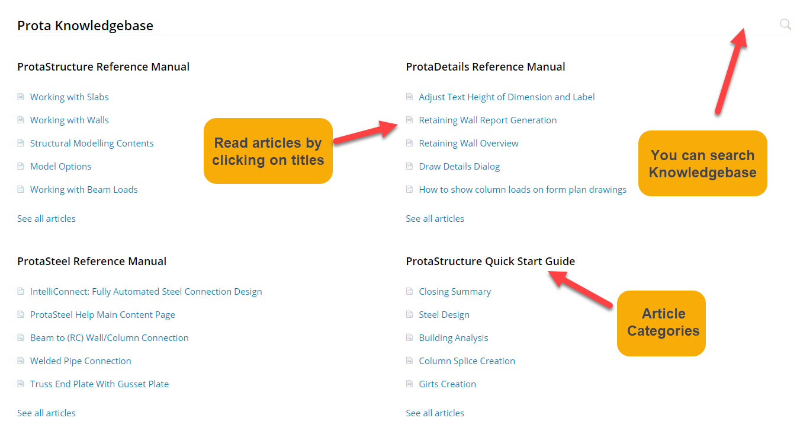
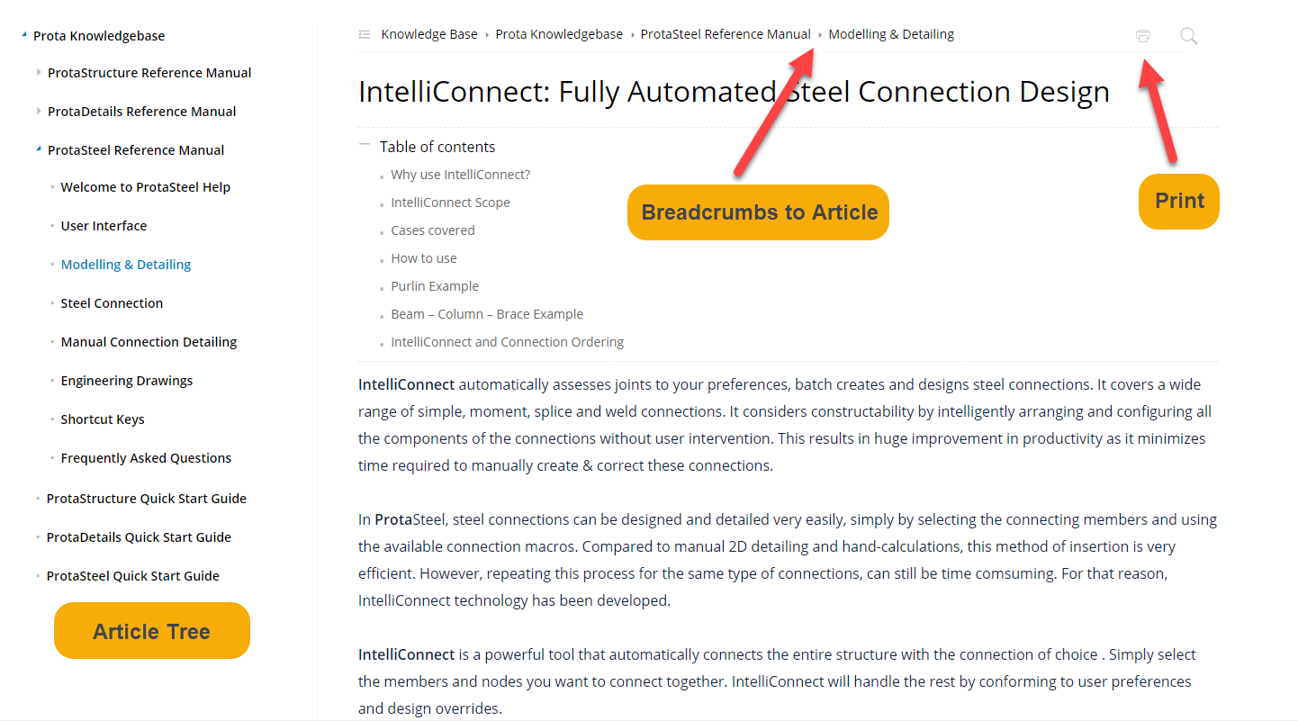
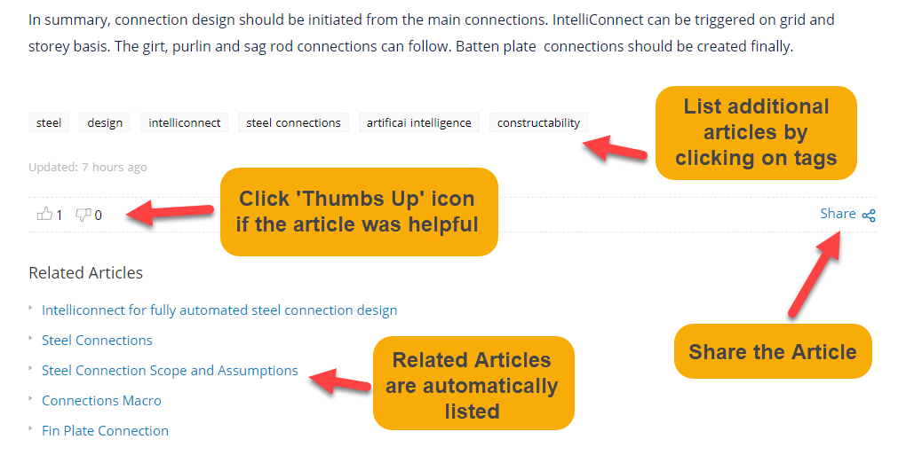

Prota User Community Forums
Prota User Community forums have been designed to enable Prota users to share their knowledge and information on the topics related with civil engineering and Prota software solutions. Forums are not directly targeted for technical support queries. We recommend “Submit a Ticket” section for your technical support requests.
To view forums, click “Community Forums” section which is located at the right hand side or the upper menu at the main page.
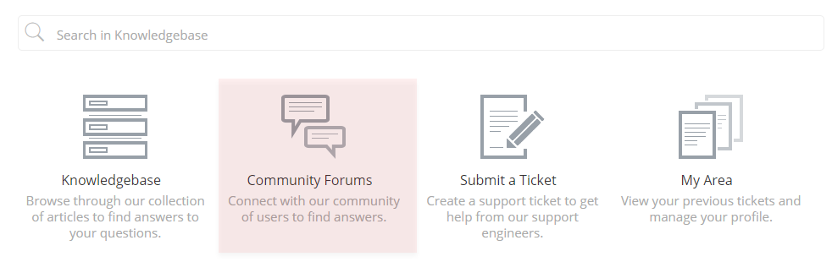


Prota User Community is categorized into different Forum Titles
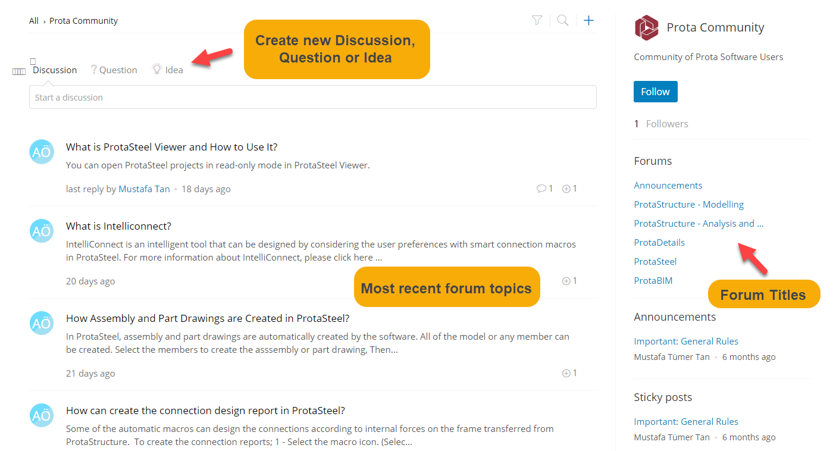

How to Create Forum Topics?
In Community Forums, You can create new topics in one of Discussion, Question or Idea categories. Topics created by you can be viewed, responded, tracked and voted (by clicking the “+” icon) by other users.
You can use the upper section of the forum page or you can click + button to create your forum topics.
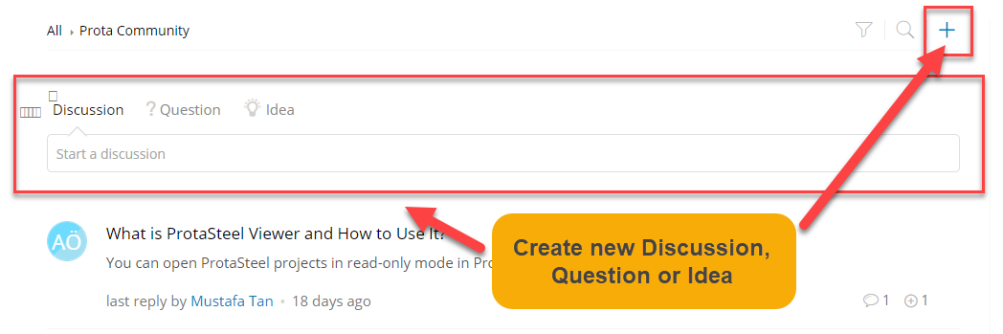
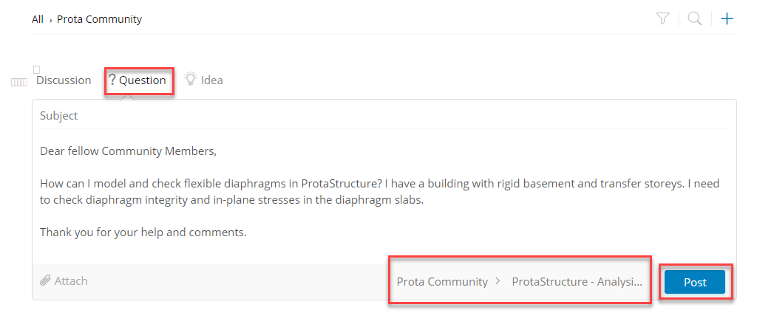
If you would like to present your opinion on a specific topic or to start a discussion, we recommend to create a Discussion topic.
To ask a question in the community forum, we recommend you to create a Question topic.
If you have any ideas or suggestions that you want to share with us regarding the enhancements and new features for our solutions, you can create an Idea topic. Other community members may agree with your ideas and cast additional votes on your suggestion. Hence, you can raise your voice more powerfully.
Important Note
Please make sure that you have done sufficient search in the forums and the before creating a new forum topic. A similar question may have already been answered in the past which will enable you to acquire the solution instantly. You can also subscribe to the forum and the topics of your interest to get instant notifications when new content is created or a comment is posted.

Forum Rules
Being a social platform inevitably brings certain rules for Prota Community Forum. Forum rules are included in the Announcements section at the right hand side in Community Forum platform. Please take your time to read these rules before using this platform.

Forum Moderation
Prota User Community forums are monitored and moderated by Prota Support Team.

How To Create a Support Ticket?
If you can not find any answers to your questions in Knowledgebase or commmunity forums, you can create a Support Ticket.
Create a Support Ticket by clicking “Submit a Ticket” icon located at the home page or the upper menu.
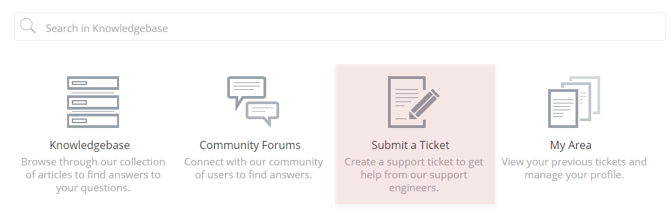


Steps and Recommendations When Submitting A Support Ticket
Please consider the topics mentioned below to get the best and the fastest response to your Support Tickets. Response time may increase for unclear and incomplete Support Tickets.
- Make sure you browse the information you are looking for at Knowledgebase and Community Forums before submitting a ticket.
- Specify the Name and Current Version of your product. This information will help our support team to focus on the right product.
- Similarly, enter the Service Pack Number of your product. With this information, our support team will be able to determine the service pack in which you are encountering the issue. Otherwise, the same issue may not be able to be repeated by our development and support teams.
- Enter the Serial Number of your product.
- Enter the Subject for your Support Ticket. The subject needs to be short and summarizing the content of your ticket. This field can not be left blank. Unrelated subjects will increase the duration of response times as they slow down the process and make it difficult to classify the support request.
- As you enter the subject of your support request, recommended articles will automatically be listed on the right hand side for you. We suggest you to quickly look through these articles as you may find the answer to your question.
- Enter the Description of your support request. Support Tickets with no descriptions may be left unanswered by our support team since we will have no choice but try to make assumptions about your problem. A good description must address the issue transparently and preferably be supported with screenshots and the steps of the process. The duration of the response time increases in some cases where the description seems to be insufficient or if the same issue can’t be repeated by our development and support teams. In this case our Support Engineers may request for more information from you.
- A sample project in which the issue is repeated can be attached to the support ticket. The file size limit is 20 MB.
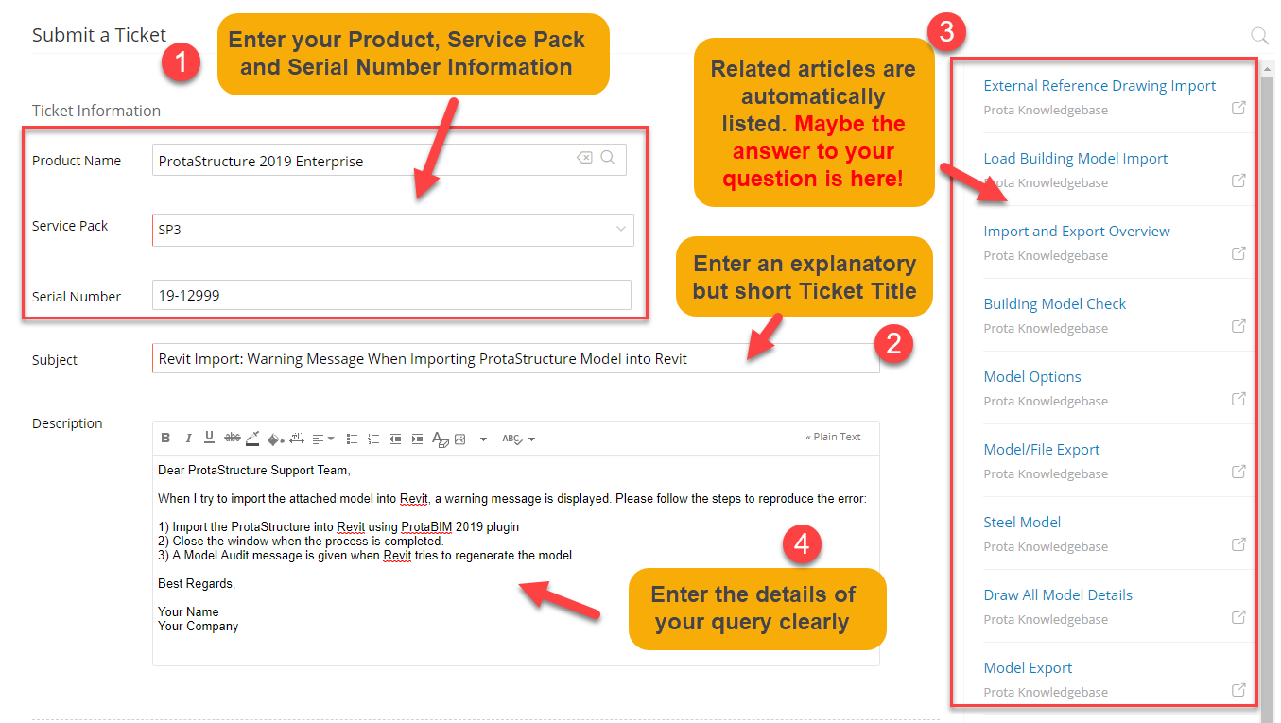
Important
Technical support service is a process which is subject to a certain work-flow such as Understanding the problem, Categorization, Reproduction of the problem, Solution or Workaround proposal and Fix. The support request should be supported with clear and concise description. It may take longer period of times to process a support ticket if it is unclear or technically too complicated.

Follow-Up and the Life-Cycle of Support Tickets
When you submit a support request, it passes through certain processes. The main purpose is to fix or propose a solution/workaround for the issue. In other words, the main purpose is to convert the status of the support ticket to CLOSED. The status of the support ticket is OPEN when it is first submitted. If the user submits another response to a CLOSED ticket, it’s status automatically changes back to OPEN. In some cases where the Support Engineers requests for more information from the user, the ticket status converts to ON HOLD. SLA (Service Level Agreement – the level of support service) time is automatically stopped during ON HOLD (Waiting for Customer) status. If the Support Engineer needs to assign the ticket to another Support Engineer or his/her Support Manager, the ticket status is raised to ESCALATED. The life-cycle continues until the ticket is CLOSED. A support ticket may be closed with the following results;
- A Support Engineer may change the status of the Support Ticket to CLOSED if he or she is satisfied with the answer. However, the user may reply back on the same thread and change the ticket status back to OPEN if he or she is not satisfied with the provided solution. If the solution does not solve the problem, user may reply back and change the ticket status back to OPEN.
- If the Support Ticket is OPEN for a very long period of time and the user does not update the status for any reason, then the ticket automatically changes back to CLOSED due to timeout.
- The user may set ticket status to CLOSED if the provided answer solves the issue.
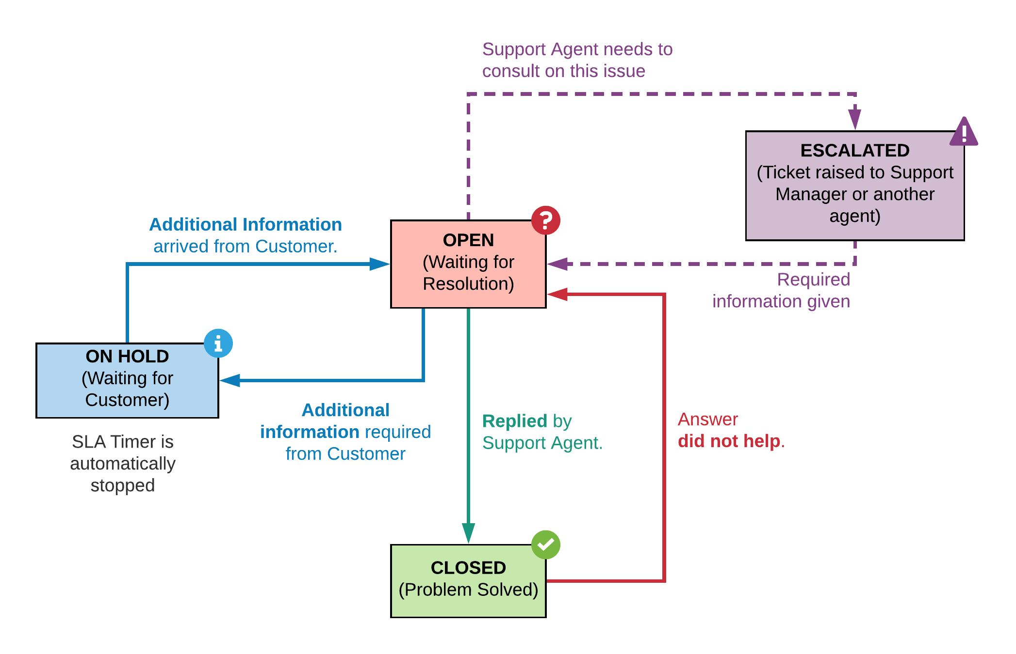
To view your previous tickets and to manage your profile, you can click My Area section which is located at the top menu of the main page. In this section, you can view your OPEN, EXCALATED or CLOSED tickets and make new comments and replies on these tickets. The ticket status of replied tickets automatically changed back to OPEN. Added comments won’t change the status of your support tickets.
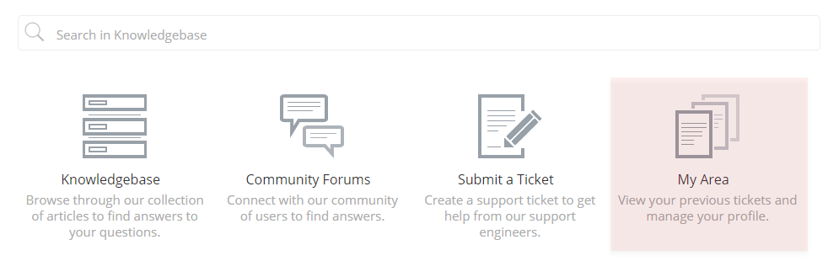
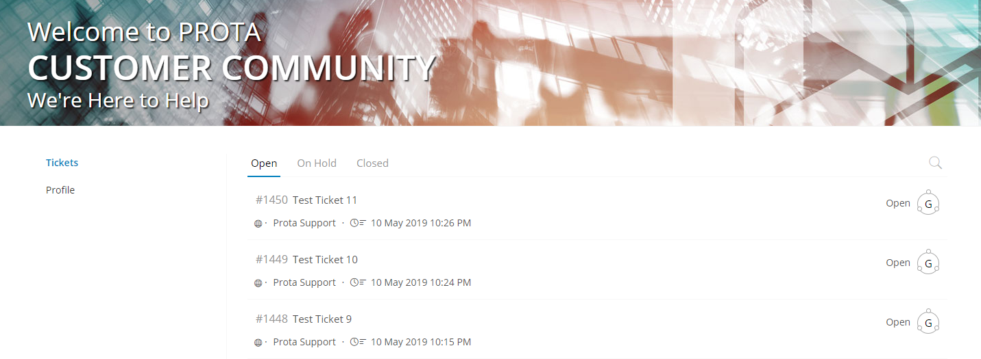

Thank You…
Thank you for choosing ProtaStructure Suite product family.
It is our top priority to make your experience excellent with our software technology solutions.
Should you have any technical support requests or questions, please do not hesitate to contact us at all times through globalsupport@protasoftware.com and asiasupport@protasoftware.com
Our dedicated online support center together with our responsive technical support team are available to help you get the most out of Prota’s technology solutions.
The Prota Team
