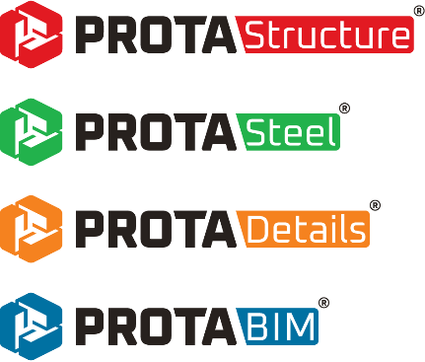

ProtaStructure Licensing System
End-User Guide
Version 10.0 September 2026

Please contact us for your training and technical support queries
asiasupport@protasoftware.com
globalsupport@protasoftware.com

Limitation of Responsibilities |  | Prota shall not be held responsible for any losses caused by documentation, software, or usage errors.  In addition to Prota License Agreement Terms, it is the responsibility of the user.  - to check results generated by documentation and software,  - make sure that the users of the software and their supervisors have adequate technical capabilities,  - make sure that the software is used correctly following the reference manual and documentation,
Intellectual Property |  | ProtaStructure is the registered trademark of Prota Software Inc., and all intellectual property rights belong to Prota Software Inc. Documentation, training, and reference manuals. Any program component cannot be copied, distributed, and used in violation of the license agreement.
Trademarks |  | ProtaStructure®, ProtaDetails®, ProtaSteel® ve ProtaBIM® are registered trademarks of Prota Software Inc. Prota logo is a trademark of Prota Software Inc.

Table of Content
Welcome 4
Cloud-based Online Licensing 5
Advantages of Online Licensing 5
How to Activate Your Product with Online Licensing 5
Internet Connectivity 6
How to Return Your License to Server 6
Network Licensing (Concurrent Usage) 7
Online Network License (Cloud Hosted) 7
Managing Your Licenses and Devices 7
Your Licenses 7
Device Management 8
Product Comparison 9
Thank You 11

Welcome
Thank you for choosing Prota as your technology partner. As Prota Team, our main priority is to offer our clients an excellent post-sales customer experience and technical support services.
ProtaStructure Suite is a highly specialized engineering software with powerful features that will keep you ahead of your competition. Hence, protecting your investment and providing you with a flexible and easy-to-use licensing system is of utmost importance to us. Our licensing system is shaped around years of experience and the latest security technologies for that purpose.
Sincerely,
Prota Team

Cloud-based Online Licensing
When you purchase a license(s) for ProtaStructure Suite, you will receive an Activation Code from Prota. Your license rights are immediately defined after your purchase, including Product Edition, Product Version, Company Information, Contract Number, Number of Seats.
Note:
The activation code is intended only for your use. It is a breach of the license agreement to share it with anyone outside your organization.

Advantages of Online Licensing
- You can use your license on any computer if you don’t exceed the number of license seats you have purchased. For example, if you have three licenses of ProtaStructure Suite, you can activate and use ProtaStructure on three different computers simultaneously. If you want to activate the product on a fourth computer, you must deactivate one of your licenses from the previous three.
- You don’t need to invest in server hardware or software with cloud licensing. Prota handles all hardware, software, and license management.
- Online licensing has inherent WAN support. You can split your licenses among your different teams at different geographic locations.
- It has secure encryption and anti-tampering mechanisms to protect your investment better.

How to Activate Your Product with Online Licensing
When you launch ProtaStructure Suite, an activation screen will welcome you. Follow the steps below for activating your product:
- Ensure that the computer you will use ProtaStructure Suite is connected to the internet.
- If you want to try the software, click “I Want to Try” button on the activation window and enter the trial activation code received from Prota Software.
- If you want to use the educational version, click “I Am a Student” button on the activation window and enter the educational activation code received from Prota Software.
- If you have purchased a license, click “I Have Already Purchased” button on the activation window.
- Select the product edition that you have purchased from Prota.
- Enter the ‘Activation Code’ that you received from Prota.
- Click on the ‘Activate’ button.

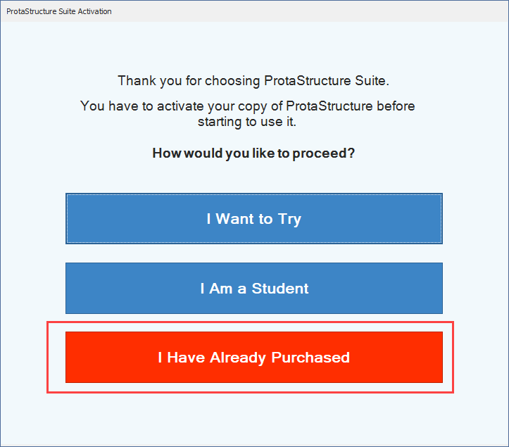
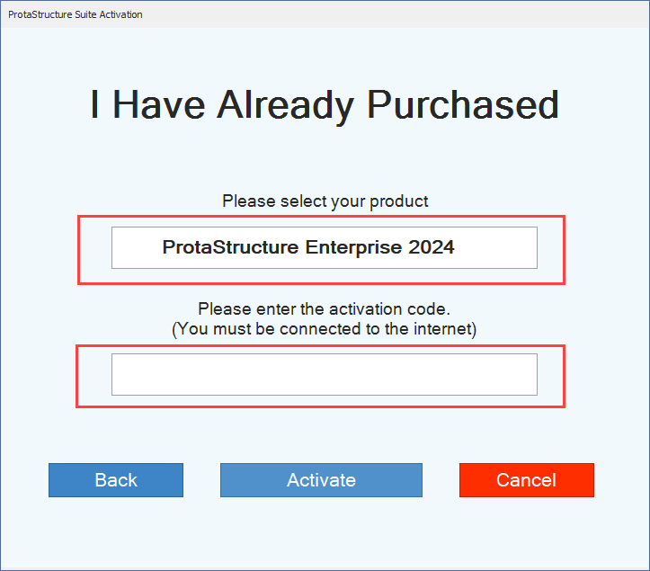

Internet Connection
After your product is activated, ProtaStructure will require a brief internet connection to verify your license status at least once every 3 hours. If you work with a continuous internet connection, you will not notice any difference in your workflow. The verification process is automatic and runs in the background. If you need to work offline, you can do so for periods of up to 3 hours. To continue working beyond that, you will simply need to briefly reconnect to the internet to refresh your session.
Warning: Save Your Work to Prevent Data Loss
We strongly recommend saving your work periodically and activating the automatic save and backup features within ProtaStructure.
As explained above, the software must connect to the license server at least once every three hours. If the program cannot connect for longer than this period, program will issue a warning and ask you to save your project. Activating auto-save ensures that your progress is protected in case of a sudden or prolonged internet outage.

How to Return Your License to Server
A license will be exclusively checked out (reserved) for your computer once you start using it, and it will not be available for other computers. When you don’t need to use the license anymore or if you want to deactivate your license on an existing computer, go to Help Menu and select the Return License to Server option. Your license will be deactivated, and the program will shut down. The deactivated license will be returned to your license pool and available for later use.
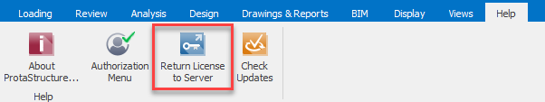

Network Licensing (Concurrent Usage)
If you have more than one license seat, you may want to use them concurrently in your organization. In this case, you can use the network licensing option. There are two options for network licensing:

Online Network License (Cloud Hosted)
With the cloud-hosted network licensing option, concurrent usage is provided out-of-the-box. You don’t need to install any local license servers or invest in server hardware. Please refer to the “How to Activate Your Product with Online Licensing” section above. Regardless of the number of licenses you have, the procedure and approach are the same.

Managing Your Licenses and Devices
You can manage your standalone and network licenses and devices directly from our device management portal. Access your dedicated user area here: https://account.protasoftware.com.
Important: Before You Begin
You must have an account on the user portal to use this functionality. Please register using the same email address associated with your license purchase.
If a different email is used, the portal will not be able to display your licenses and devices.

Your Licenses
After logging into your account, click “Licenses” button under “User Area” menu at the top-right. Your products and associated licenses will be listed for your review.
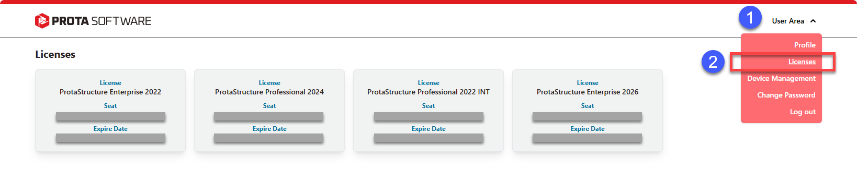

Device Management
Click “Device Management” button under “User Area” menu to see a list of devices currently using your licenses.
From this page, you can remotely return a license from a device to the server. This gives you immediate control to move your license between machines as needed. For example, if you forget to check in your license on one computer and need to use ProtaStructure on another, you don’t have to contact our support team to release the license.
In a concurrent network licensing scenario, you can use the same Return License function to deactivate a license on one client computer to make it available for another. The device from which the license is revoked will not be able to run ProtaStructure until another license is returned to the server.
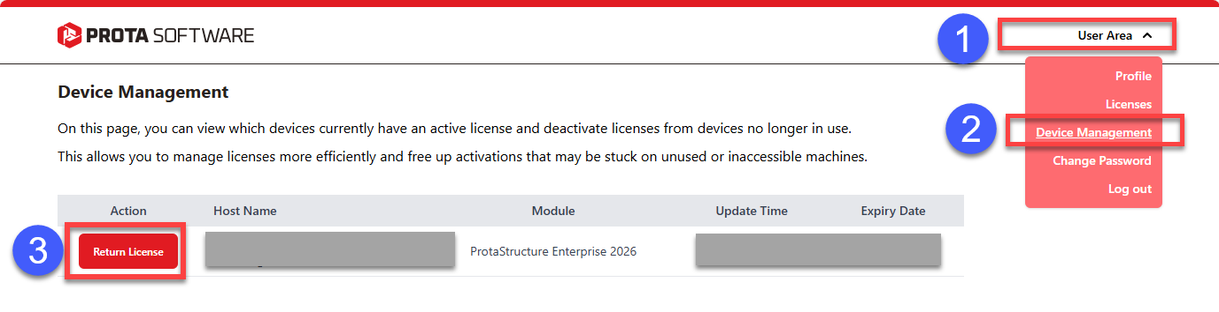

Product Comparison
General | Std. | Pro. | Ent. | Trial | Edu. | Acad.
Max. Number of Stories | 6 | ∞ | ∞ | ∞ | ∞ | ∞
Max. Number of Columns and Walls per Storey | 50 | ∞ | ∞ | ∞ | ∞ | ∞
Max. Number of Free Frame Members per Storey | 30 | ∞ | ∞ | ∞ | ∞ | ∞
Time Limitation | ∞ | ∞ | ∞ | 30d | 12m | 12m
Project Compatibility with Commercial Versions | + | + | + | x | x | x
Export to DXF, DWG, PDF, DOCX | + | + | + | x | x | +
Export to Tekla Native Objects | x | x | + | + | + | +
Export Steel Connections to IdeaStatica with Internal Forces | x | x | + | + | + | +
Coordinate with other disciplines using IFC (Import & Export) | + | + | + | + | + | +
Coordinate with other disciplines using SAF Files (Import & Export) | + | + | + | + | + | +
Bi-directional bespoke BIM Link with Autodesk Revit | + | + | + | + | + | +
Calculation reports without watermark overlay | + | + | + | x | x | x
Customized Report Headers with License and Company Information | + | + | + | x | x | x
Multilingual User Interface and Documentation | + | + | + | + | + | +
International Design, Loading, and Seismic Codes | + | + | + | + | + | +
Physical Modeling | Std. | Pro. | Ent. | Trial | Edu. | Acad.
Intuitive modeling with physical objects  - Interactive RC Stair modeling  - Subbasement Walls, Slabs and Beams  - RC Pedestals | + | + | + | + | + | +
Command Shortcut editor with customizable key bindings | + | + | + | + | + | +
Modeling and visualization of Steel Base Plates in ProtaStructure | x | + | + | + | + | +
3D Central RC, Steel & Composite Structural BIM Model | + | + | + | + | + | +
Merge Different Models into one single model | x | + | + | + | + | +
Retrofit Walls, Column Jackets, and FRP confinement | x | + | + | + | + | +
Analysis | Std. | Pro. | Ent. | Trial | Edu. | Acad.
Lateral and Vertical Earthquake Loads using EQS and RSA Analyses | + | + | + | + | + | +
Seismic Building Checks and Irregularities | + | + | + | + | + | +
Construction Stage Analysis | x | + | + | + | + | +
Soil-Structure Interaction | x | + | + | + | + | +
Nonlinear Seismic Isolators | x | + | + | + | + | +
P-Delta Analysis | x | + | + | + | + | +
PBD and Assessment of Buildings *  - ASCE41 Support | x | + | + | + | + | +
Nonlinear Time-History Analysis with OpenSees Integration *  - ASCE41 Support | x | + | + | + | + | +
Single-Mode Pushover Analysis with OpenSees Integration *  - ASCE41 Support | x | + | + | + | + | +
Multi-Mode Pushover Analysis with OpenSees Integration *  - ASCE41 Support | x | + | + | + | + | +
Vertical Modal Earthquake Analysis, Vertical Mode Shapes | + | + | + | + | + | +
FE Floor Design under gravity loads & Short-Frame Chase-down | + | + | + | + | + | +
FE Slab Load Decomposition | + | + | + | + | + | +
One-Way Slab FE Analysis with Orthotropic Shells and Edge Releases | + | + | + | + | + | +
Advanced and Detailed Analysis Results Visualization (Time History, Pushover and Plastic Hinge Mechanism Visualization) | x | + | + | + | + | +
Design, Documentation, and Detailing | Std. | Pro | Ent | Trial | Edu. | Acad.
Flexible Load Combination System | + | + | + | + | + | +
Separate ULS and SLS Combinations for Steel and RC | + | + | + | + | + | +
Reinforced Concrete Member Design | + | + | + | + | + | +
Comprehensive NDP (Nationally Dependent Parameters) Editor for Eurocodes and National Annexes | + | + | + | + | + | +
Seismic Checks in RC Member Design *  - Extended Code Support. Eurocode 8 support | + | + | + | + | + | +
Complete RC Detailing, Smart Rebars, Design Libraries (ProtaDetails) | + | + | + | + | + | +
Seismic Detailing of Beams, Columns and Walls  - Improved Support in | + | + | + | + | + | +
Composite Slab Design | x | + | + | + | + | +
Design Checks for Steel Members  - Castellated beam design. Eurocode 8 support | x | + | + | + | + | +
Seismic Checks for Cold-Formed Steel Members * | x | + | + | + | + | +
Seismic Checks in Steel Member Design *  - Extended Code Support. Eurocode 8 support | x | + | + | + | + | +
Steel Connection Design and Documentation *  - New connection macros in | x | x | + | + | + | +
Steel Shop Drawings and Fabrication, IntelliConnect, User Defined Connections, Clash Checks, and more (ProtaSteel) | x | x | + | + | + | +
Summary and/or step-by-step design reports  - Extended calculation details and more seismic checks* | + | + | + | + | + | +
Foundations | Std | Pro. | Ent. | Trial | Edu. | Acad.
Merge Different Models for Shared Foundation | x | + | + | + | + | +
Stepped Foundations and Elevator Pits in FE Model | + | + | + | + | + | +
Pad bases, strip footings, pile caps, raft and piled raft foundations | + | + | + | + | + | +
Design of RC Pedestals | + | + | + | + | + | +
Subbasement Walls, Slabs and Beams | + | + | + | + | + | +
Steel Base Plates in ProtaStructure | x | x | + | + | + | +
* Only available for some of the design codes.

Thank You
Thank you for choosing the ProtaStructure Suite product family.
Our top priority is to make your experience excellent with our software technology solutions.
Should you have any technical support requests or questions, please do not hesitate to contact us at all times through globalsupport@protasoftware.com and asiasupport@protasoftware.com
Our dedicated online support center is available to help you get the most out of Prota’s technology solutions with our responsive technical support team.
The Prota Team
